Name:
Marvelous Mrs. Tsiropoulos: Heritage Research Project Cornell Notes
TOR Library Media Center Mrs. Murray, Library Media Specialist
November 2018

SPS Resources: Books, Encyclopedias, Grolier and Newsbank!!!
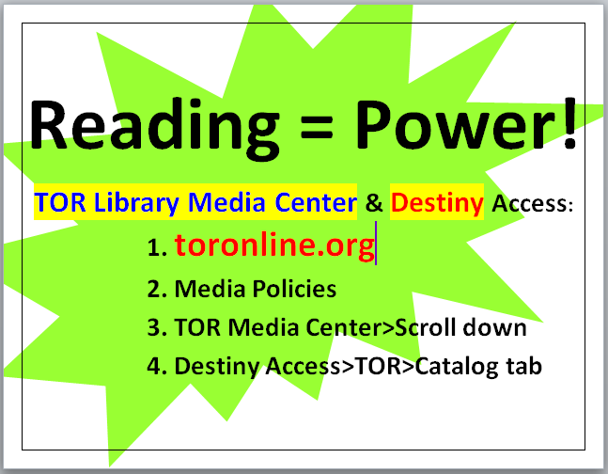
Topic/Country:
GRAPES | Subtopics | Details
Geography | Official name
 | Location
 | Natural resources
Religions | Religion
Achievements | Major Language
 | Agricultural Products
Politics/  Government | Government Type
 | Head of State
 | Capital
Economics | Major Imports
 | Major Exports
Social Structure | Literacy Rate

