How to Create Cornell Notes on Microsoft Word!!! 3
Document Created by Lynn Murray

Steps to create Cornell Notes:
- CTRL N>Split the computer screen and place this document on the left and a new Word document on the right.
- Insert>Table>2*8
- Hover over the center vertical line of the table until you see a double headed arrow and then slide it to the left to create a Subtopic column.
- Type Topic, Subtopic, Details, and Summary
Topic:
Subtopic | Details
Summary

- 1 Highlight the rows underneath Subtopic and Details to the row above Summary.
- Right click>2 Insert>3 Insert Rows below
- (Repeat the steps above to add additional rows)
3
2
1
- Add bullets to the Details column: 1 Highlight the Details column>2 Home tab>3 Bullets
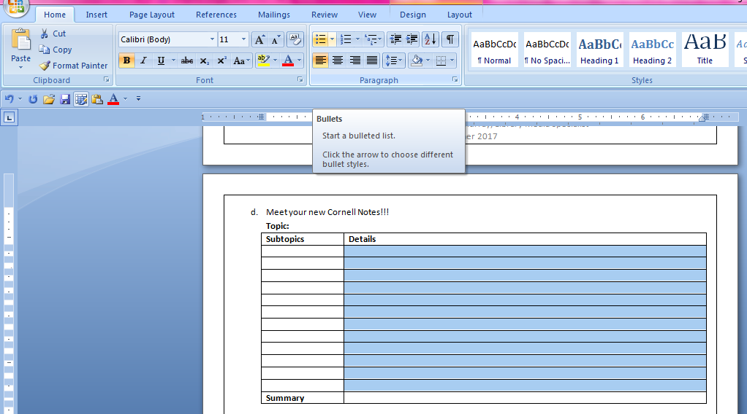
3
2
1
Meet your new Cornell Notes and HOORAY for YOU!!!
Topic:
Subtopics | Details
Summary

