Name:
Class:
Date:

Artist Research
Super Ms. Stevens ☺
January 2018

Assignment: You will be randomly assigned an artist to research. Using the following pages as a guide, you will research your artist utilizing many different resources- books, encyclopedias, magazines, newspaper articles and databases. Please keep track of sources used for your works cited.

Resources:
- Everyone will use hard cover book and encyclopedia resources first, and then use Grolier and Newsbank databases for their subsequent research.
- Read the steps below about how to use book and database resources to successfully write Cornell Notes about your assigned artist.
- Cornell Notes begin on page four.

Summary of steps about how to write Cornell Notes about pasted SPS database text:
- Open TOR Media Center Cornell Notes.
- Ctrl N=New Word document. Write the topic of the assignment and “text” at the top of the document.
- Locate SPS Database text from Grolier, Newsbank, and Bigchalk, about a curriculum and CCSS-related topic from toronline.org.
- Copy (Right-click>Copy) and Paste (Right-click>A) the: URL, MLA citation, and ALL of text about the topic from the database onto the blank Word document.
- Split the computer screen and read>annotate>organize>cite>write/create an original piece of work about high- pasted SPS database text.
- After you complete your Cornell Notes, create an original final masterpiece based upon your notes by splitting the screen once again. Refer to the Cornell Notes on the left to create sentences/paragraphs IN YOUR OWN WORDS on the right! How exciting!!!
- Final product SPS applications: ActivInspire, Inspiration, Photostory, Movie Maker, Scratch, and Office Suite
- Save pasted database text, Cornell Notes, and final product work to a student number and USB drive to work on the assignment securely locally and remotely.
- File>Save As>Computer>Student login number and USB drive>SAVE

Detailed steps:
- Open TOR Media Center Cornell Notes.
- At TOR=Start>Computer>TRNshared>TOR Library Media Center folder>Date Modified>2016-2017 TOR Media Center Cornell Notes>Date Modified>Click on the Cornell Notes at the top of the list
- Online=toronline.org>Media Policies>TOR Media Center Website>Click on Graphic Organizers & Cornell Notes at the top of the website>Download Blank Cornell Notes
- Ctrl N=New Word Document. Write the topic of the assignment and “text” at the top of the blank document.
- Ctrl N=Blank new Word page.
- Write the topic of the assignment and “text” at the top of the blank Word document. 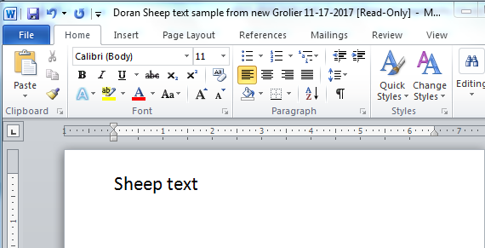

- Locate SPS Database text from Grolier, Newsbank, and Bigchalk, about a curriculum and Common Core-related topic from toronline.org.
- toronline.org>Media Policies
- TOR Media Center Website>Scroll DOWN to the bottom of the homepage and click on Destiny Book Catalog & SPS Database Access>TOR
- Click on Grolier, Newsbank, or Bigchalk & E-Library to search for and access high-quality SPS database text.
  - Be sure to pick up a printed copy of database access codes to access Grolier, Newsbank, and Bigchalk text outside of TOR.
- Copy (Right-click>Copy) and Paste (Right-click>A) the: URL, MLA Citation, and ALL of text about the topic from the database onto a blank Word document. Example:
Microsoft Word
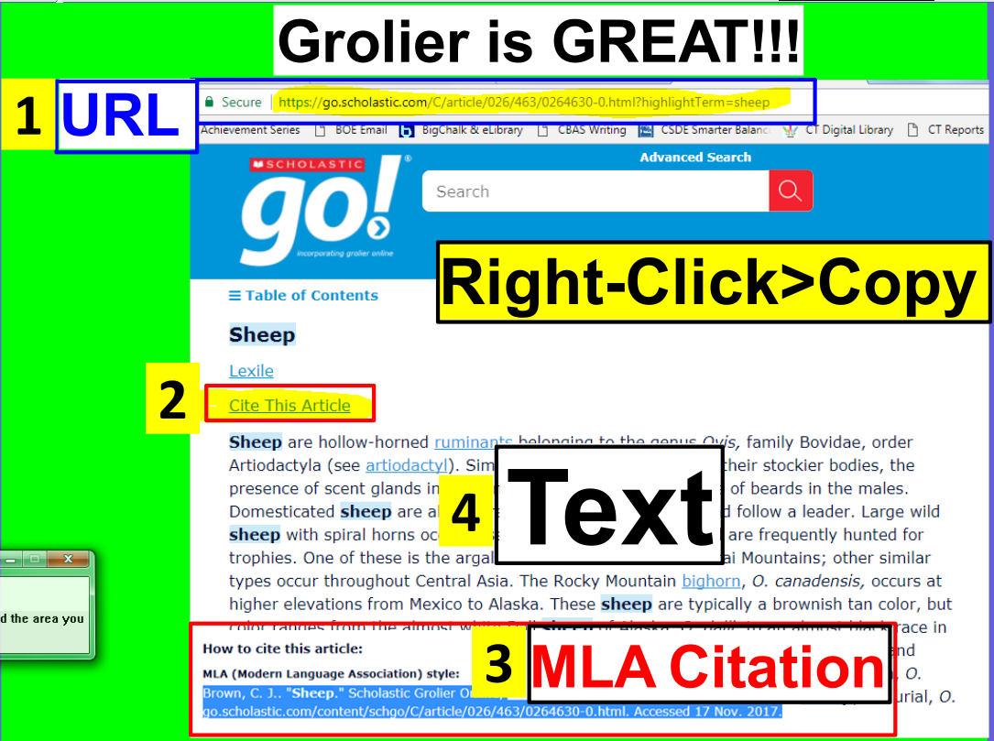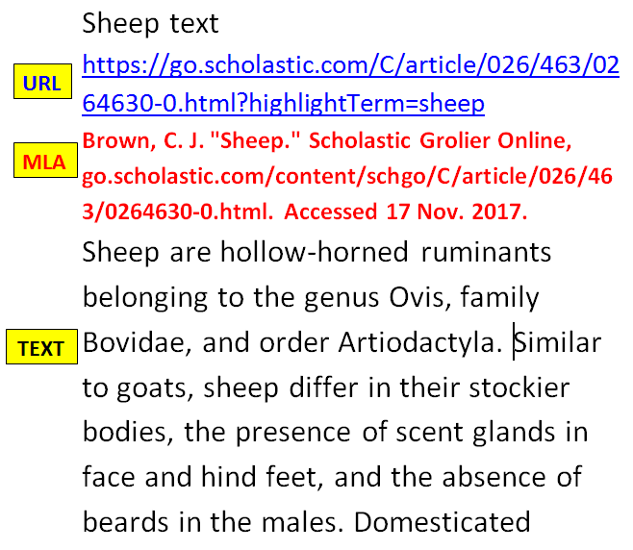
Paste: Right-click>A
Grolieronline
- Split the computer screen, and read>annotate>organize>cite>write/create an original piece of work about pasted SPS database text. Here’s how…
- Split your computer screen.
- Place your pasted SPS database text on the left.
- Place your Cornell Notes on the right.
- Preview the text.
- Scroll down to see how long it is.
- Notice if there are any headings.
  - Headings=automatic subtopics
- Read the text in its entirety.
- Reread the first paragraph.
- After you’ve read the first paragraph again, ask yourself, “What is this paragraph about?”
- Type the topic of the first paragraph in the Subtopic section of your Cornell Notes.
- Highlight the subtopic in a color of your choice.
- Reread the first paragraph one more time
- Highlight details about the subtopic in the pasted text in the same color as the subtopic.
- Detail fact-phrases should not be longer than six consecutive words in length.
- Organize details by their classification on Cornell Notes.
  - Larger details are solid bullet points.
  - Smaller details about the larger details are indented and appear as hollow bullet points.
    - How to add and indent/outdent bullet points=1) Enter on the keyboard 2) Indent/Outdent arrows
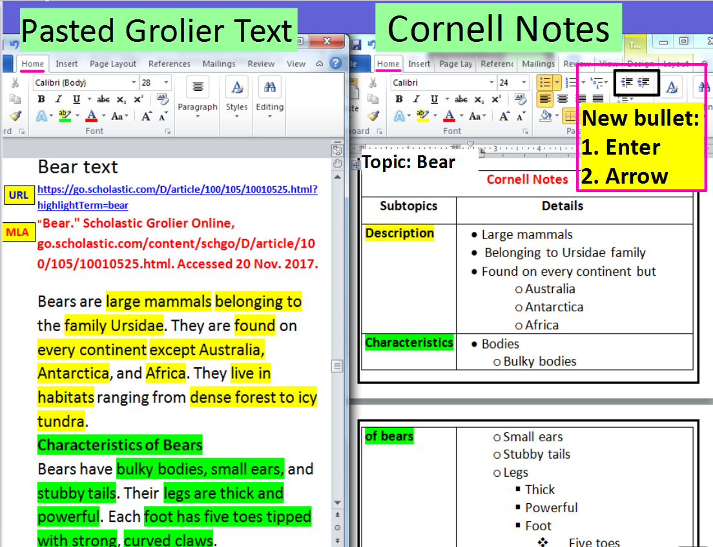
- After you complete your Cornell Notes, create an original final masterpiece based upon your notes by splitting the computer screen once again. Refer to the Cornell Notes on the left to create sentences and paragraphs about your assigned topic IN YOUR OWN WORDS on the right!
- Final product SPS tutorials and applications: ActivInspire, Inspiration, Photostory, Movie Maker, Scratch, and the Office Suite
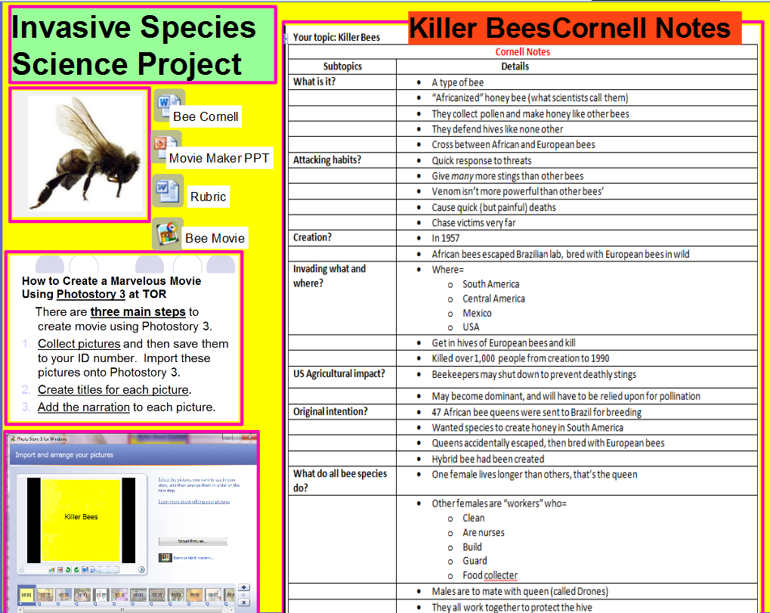

Sources:
Location #1=Destiny! TOR’s Online Card Catalog for Media Center Books and Applicable Websites
Internet>Favorites>Destiny Library System OR toronline.org>Media Policies>TOR Media Center Website>Scroll down
- Click on TOR>Catalog tab
- Type “Your topic” in the Search Box. Click Enter.
- A listing of books about your topic will emerge. Locate your book by its call number.
Location #2= Grolier.com
- Internet>Favorites>TRN Online folder>Grolier
- Type “Your topic” in the Search box.
- Copy and Paste your Internet information onto Microsoft Word. (Right-click>Paste>click on the A)
- You can access Grolier at home! See Mrs. Murray for a printed listing of databases, usernames, and passwords.
Location #3=Bigchalk and ELibrary
- Internet>Favorites>TRN Online folder>Bigchalk and ELibrary
- Click on Curriculum Edition (the first link)
- Type “Your topic” into the Search box.
- Copy and Paste your Internet information onto Microsoft Word. (Right-click>Paste>click on the A)
- You can access Bigchalk and elibrary at home!
        - See Mrs. Murray for a printed listing of databases, usernames, and passwords.
Location #5=Newsbank.com
- At TOR>Internet>Favorites>TRN Online folder>Newsbank
- At home… See Mrs. Murray for a printed listing of databases, usernames, and passwords.

Works Cited information: The EASY way to cite your sources=Copy and paste your MLA Citations below in alphabetical order from our SPS databases.
Works Cited

Full name of assigned artist:
Cornell Notes
Subtopics | Details
Born date
Where
Died date
Where
Age of death
Cause of death
Style of art known for
What period of art was this artist most famous?
Short definition of that style/period
Media (materials) used
Names of most famous works
Where is the work displayed (galleries, museums, etc)?
Other fun/interesting facts: (Example questions: Be sure to label the answers in your notes.)
- How much the artist’s artwork sell for?
- Where they received their education?
- Did they study to be an artist, family life, challenges faced?
- Who inspired them?
- Artists they worked with?
- Other accomplishments
Pick one of the artist’s works.  Write a few sentences describing the work.  - What do you think the work is about?  - Why do you think the artist chose the subject? (Elements, principles, color families, textures, etc)  - What feeling does the work give you, and why?  - Do you like this work? Why/why not?  - What part is your most or least favorite and why? | Title of the artist’s work:
 | Sentences that describe the work:
Summarize your notes here:

Name: ____________________________________________________
Class: __________________________________________

Sketch something that reminds you of the artist (you can use this page when you create your self-portraits):

Notes:

