Name:
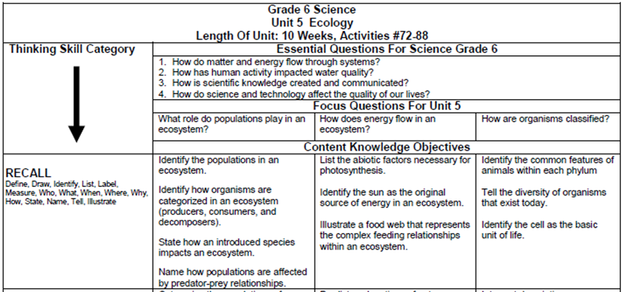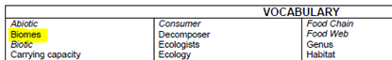
Sims Biome Research Project Overview,
Split Screen Note Taking & Cornell Notes ☺
December 2017

Resources:
- Hard cover books and encyclopedias on reserve
- Use the Table of Contents and Index to locate information about your biome. Record the information in the Details section of your Cornell Notes.
- Destiny book catalog access=toronline.org>Media Policies>TOR Media Center> Scroll down to Destiny Book Catalog>TOR>Click on the Catalog tab
- Grolieronline
- Grolieronline access=toronline.org>Media Policies>TOR Media Center> Scroll down to Destiny Book Catalog and SPS Database Access>TOR> Click on Grolieronline
  - Moonman
  - Search your biome
  - Click on the biome’s name
Split Screen Note Taking research process:
- Copy and paste Grolier text from the internet to Microsoft Word.
- Click on this Cornell Notes sheet.
- Press Ctrl N on the keyboard.
- Type your biome’s name at the top of the blank page and add the word text.

- Click on biome text from Grolieronline by clicking on the internet at the bottom of the screen.
- Copy (Right-click>Copy) and paste (Right-click A) the URL, MLA citation, and text from Grolier onto the blank Word document.
Grolieronline:

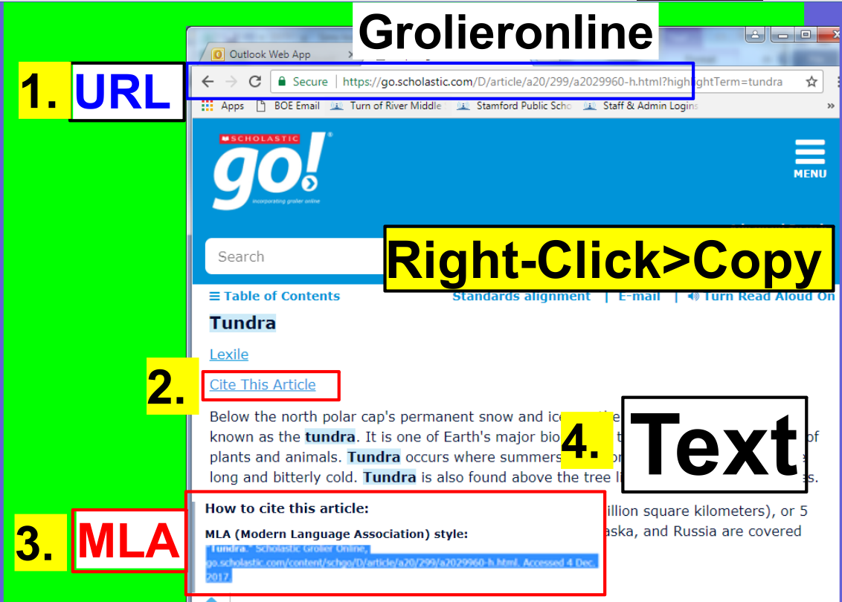

Word:
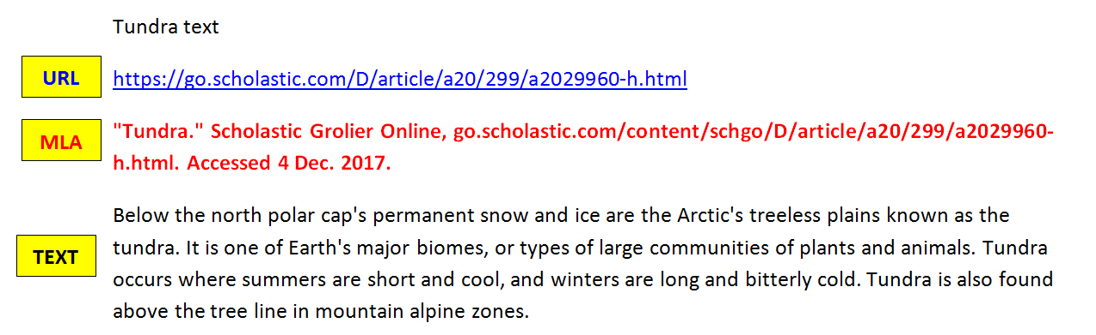
- Grolier and Word copying and pasting process so students can learn without distractions:
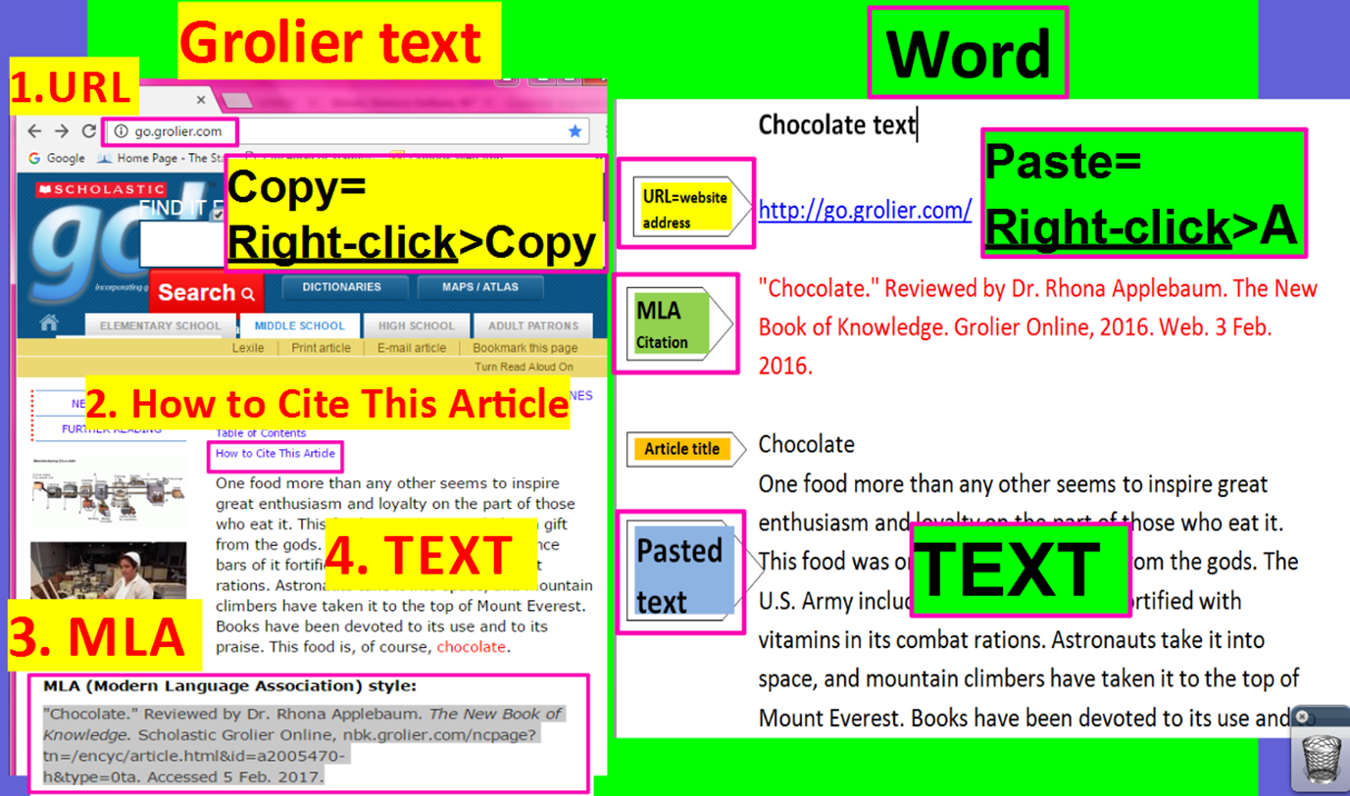

- Look for additional information about your biome on Grolier and paste it at the bottom of your text.
- Scroll down and click on Web Sites.
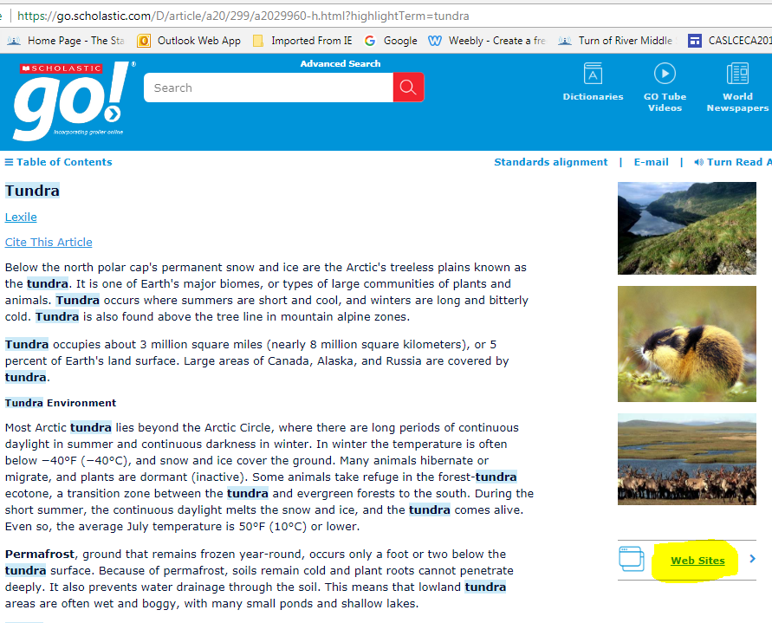

- Click on the Web Sites links about your topic and locate additional information about your biome.
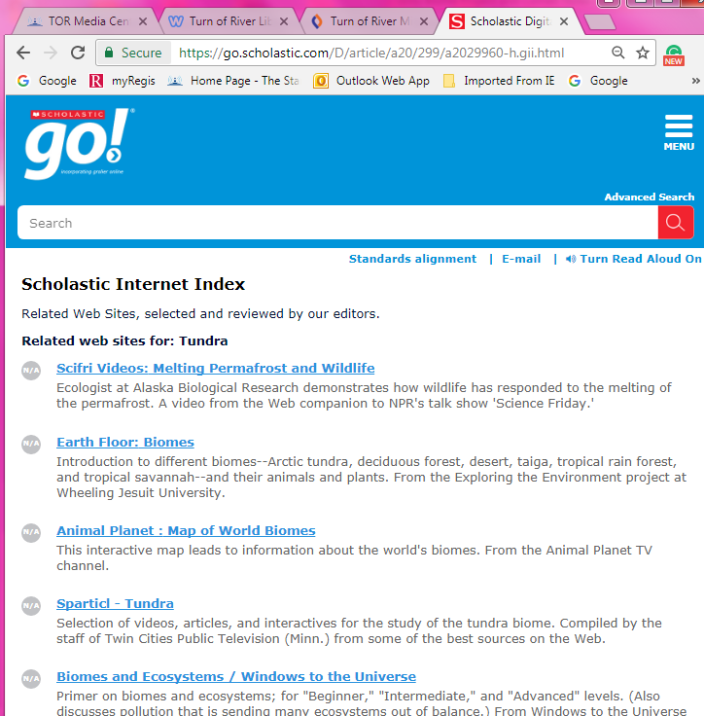
- Copy (Right-click>Copy) and paste (Right-click A) URL information from the website about your biome to the BOTTOM of your pasted text on Word.
Example of a Web Sites link from Grolieronline:
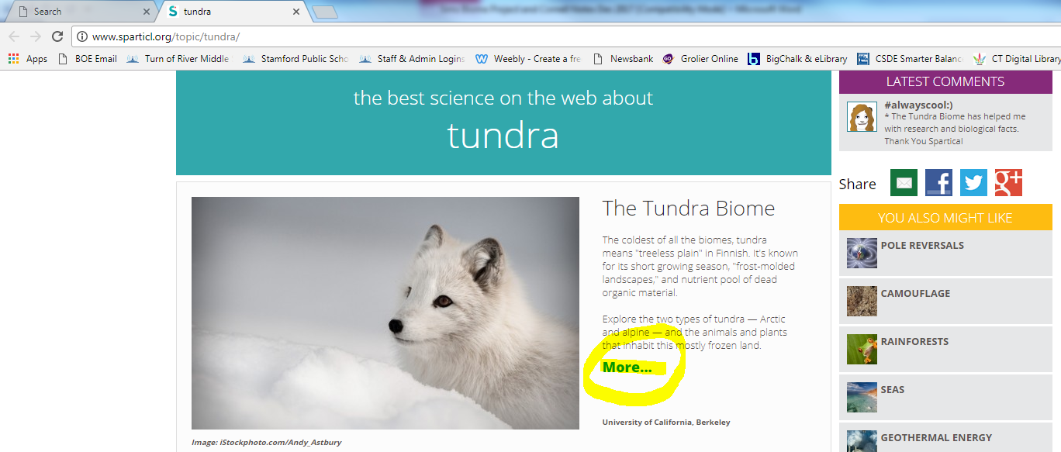

  - Copy and paste the URL and Text to the bottom of your pasted Grolier text.

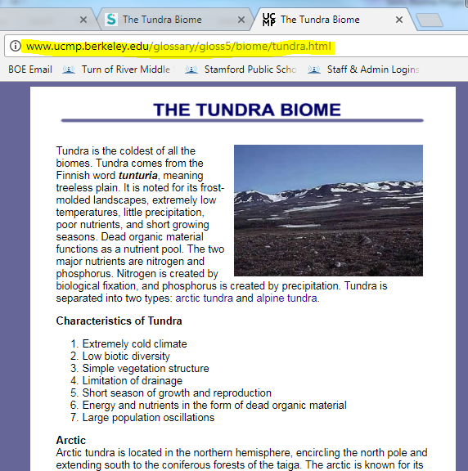
URL
TEXT

b. Paste (Right-click A) the new URL and website text underneath your Grolier text.
Pasted Grolier text

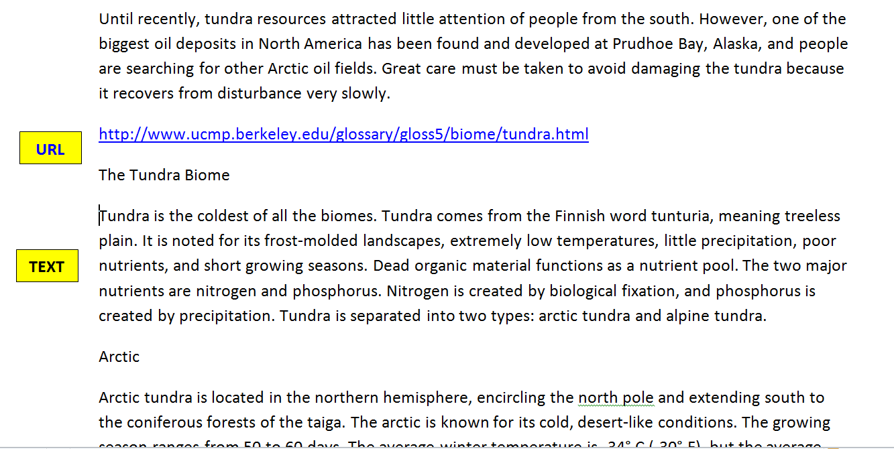

d. Split the computer screen and place your Grolier text on the left and your Cornell Notes on the right.
- Copy and paste the MLA Citation from the pasted text underneath Works Cited on top of the Cornell Notes.
Pasted Grolier Text
Cornell Notes
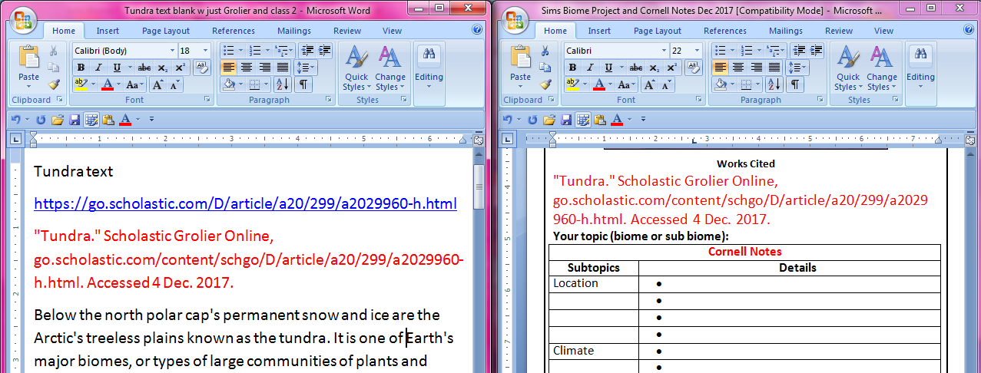
Pasted Grolier Text
Cornell Notes
Copy (Right-click>Copy) >
Paste (Right-click>A) the MLA Citation
e. How to Write Cornell Notes about your pasted Grolier text.
- Split your computer screen.
- Place your pasted SPS database text on the left.
- Place your Cornell Notes on the right.
- Preview the text.
- Scroll down to see how long it is.
- Notice if there are any headings.
  - Headings=automatic subtopics
- Read the text in its entirety.
- Reread the first paragraph.
- After you’ve read the first paragraph, ask yourself, “What is this paragraph about?”
- Type the topic of the first paragraph in the Subtopic section of your Cornell Notes.
- Highlight the subtopic in a color of your choice.
- Reread the first paragraph one more time
- Highlight details about the subtopic in the same color as the subtopic in fact phrases in no more than six words in a row.
- Organize details by their classification on the Cornell Notes.
  - Larger details are solid bullet points (munchkins ☺)
  - Smaller details are indented and are hollow bullet points (donuts)
    - Add and indent bullet points=1) Enter on the keyboard 2) Indent/Outdent arrows
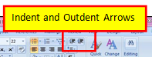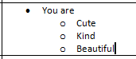

Example of Split Screen Note Taking with pasted text and Cornell Notes:
Indent and Outdent Arrows

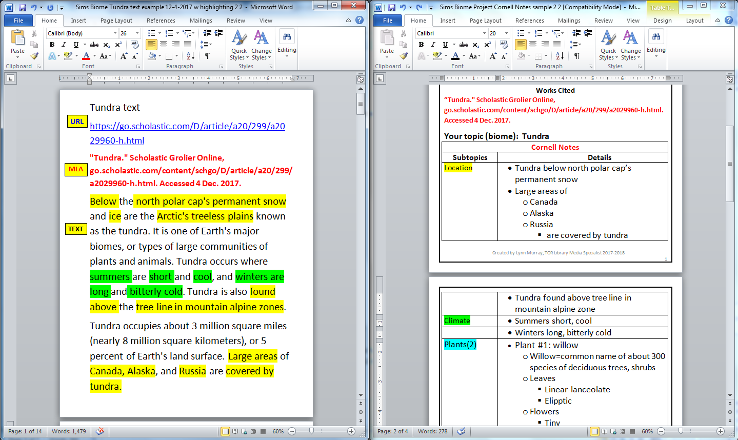

Works Cited

Your topic (biome or sub biome):
Cornell Notes
Subtopics | Details
Location
Climate
Plants(2), Flora, Vegetation | - Plant #1:
 | - Plant #2:
Animals(3), Fauna | - Animal #1:
 | - Animal #2:
 | - Animal #3:
Factoids (3) | - Factoid #1:
 | - Factoid #2:
 | - Factoid #3:
Summarize your notes here:

