Marvelous Mrs. Riggs: Photostory Movies about Judith Altman and Holocaust
Script organizer
11-8-18
Objective: Students will use their experience with Judith Altman, a Holocaust survivor, and their Cornell Notes as the basis of their movies. Students will use the SPS application, Photostory, to create their movies and upload them to Googledrive to share the project with the TOR community.
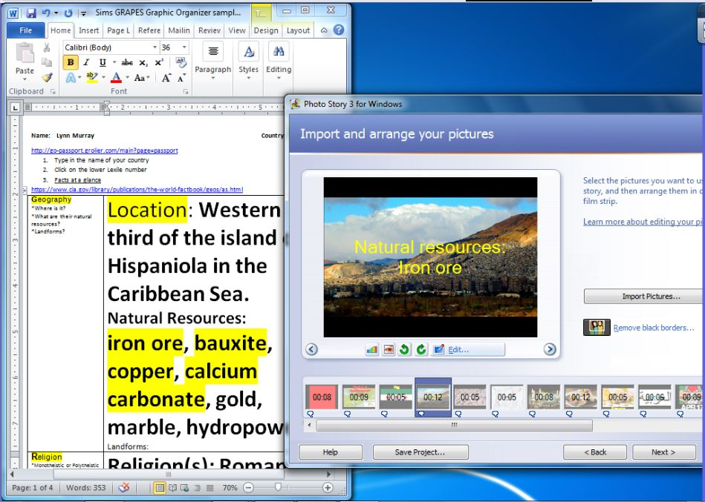

Movies will have three parts:
- Information about Judith Altman and her visit to TOR
- Information about the Holocaust
- Conclusion

Script organizer
- Answer the following questions using complete sentences.
- Use RACER to answer the questions and be sure to recycle the question in your answer.

Part one: Information about Judith Altman and her visit to TOR
Q: Who is Judith Altman?
A:

Q: What is she famous for? What did she live through?
A:

Q: When did Judith Altman visit TOR?
A:

Q: What did Judith Altman share with our school?
A:

Q: What was most memorable for you from her talk?
A:

Part two: Information about the Holocaust.
- Split the screen and use your Cornell Notes to answer the following questions using complete sentences.
Q: Define the Holocaust.
A:

Q: When did the Holocaust take place?
A:

Q: Where did the Holocaust take place?
A:

Q: Who was responsible for the Holocaust?
A:

Q: What was the name of the party that Adolf Hitler led?
A:

Q: What is Adolf Hitler responsible for?
A:

Conclusion
Q: What did you think about meeting Judith Altman?
A:

Q: What do you think about the Holocaust?
A:

