NEW Argument and Research Project
Name:
Date:
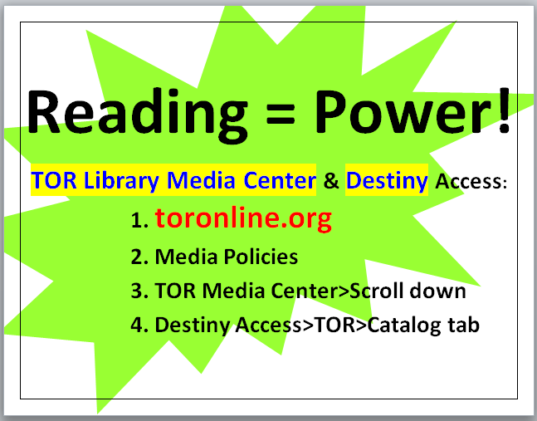
7th Grade ELA: Fields and Konrad
March 2019 3
Objective: Students will use the Split Screen Note Taking format to locate SPS text and
read, annotate, organize, cite, and write an argument in favor or against a chosen topic
Standard: CCSS.ELA-Literacy.W.7.1= Write arguments to support claims with clear
reasons and relevant evidence.

Argument Word Bank:
- Argument=a statement of an author’s major point or position based on evidence.
- Position=the point of view that a person takes in an argument.
- Claim (simple) =your basic belief about a particular topic, issue, event or idea. It’s an opinion, proposal, evaluation, cause and effect statement or interpretation.
- Think in terms of good or bad/right or wrong/pro or con.
- Thesis statement=sentence that summarizes the main point or claim of an essay or paper that is developed, supported, and explained by examples and evidence.
- Counter claim=a solid and reasonable argument that opposes or disagrees with your claim.
- Support= specific evidence or examples to show that your claim is true.
- Evidence=facts, statistics, quotes, or examples. http://valenciacollege.edu/wp/cssc/documents/TypesofEvidenceinPersuasiveFINAL.pdf
- Facts=cannot be disputed, can be proven.
- Statistics=amounts and numbers. Should come from reliable sources.
- Quotes=what leading experts or authorities said about your topic.
- Examples=anecdotes from your own experience
Step One: Highlight a topic that interests you.
Coffee
Grolier | Newsbank
Grolier: toronline.org > Media Policies > TOR Destiny > Grolier > Search: Coffee  - Ctrl N >Copy and Right-click > A the URL, MLA and text | Newsbank: toronline.org > Media Policies > TOR Destiny > Newsbank > Access World News or Research Rocket>Search: Coffee health benefits risks> Click on Best Choice  - Ctrl N >Copy and Right-click > A the URL, MLA and text
Vaccines
Grolier | Newsbank
Grolier: toronline.org > Media Policies > TOR Destiny > Grolier > Search: Vaccines  - Ctrl N >Copy and Right-click > A the URL, MLA and text | Newsbank: toronline.org > Media Policies > TOR Destiny > Newsbank > Access World News or Research Rocket >Search: Vaccines health benefits risks> Click on Best Choice  - Ctrl N >Copy and Right-click > A the URL, MLA and text
Steroids
Grolier | Newsbank
Grolier: toronline.org > Media Policies > TOR Destiny > Grolier > Search: Steroids  - Ctrl N >Copy and Right-click > A the URL, MLA and text | Newsbank: toronline.org > Media Policies > TOR Destiny > Newsbank > Access World News or Research Rocket >Search: Steroids health benefits risks> Click on Best Choice  - Ctrl N >Copy and Right-click > A the URL, MLA and text
Chocolate
Grolier | Newsbank
Grolier: toronline.org > Media Policies > TOR Destiny > Grolier > Search: Chocolate  - Ctrl N >Copy and Right-click > A the URL, MLA and text | Newsbank: toronline.org > Media Policies > TOR Destiny > Newsbank > Access World News or Research Rocket >Search: Chocolate health benefits risks> Click on Best Choice  - Ctrl N >Copy and Right-click > A the URL, MLA and text
Diets
Grolier | Newsbank
Grolier: toronline.org > Media Policies > TOR Destiny > Grolier > Search: Diet  - Ctrl N >Copy and Right-click > A the URL, MLA and text | Newsbank: toronline.org > Media Policies > TOR Destiny > Newsbank > Access World News or Research Rocket >Search: Diets health benefits risks> Click on Best Choice  - Ctrl N >Copy and Right-click > A the URL, MLA and text
 | Different Searching on Newsbank below
Topic: Gun Control
Grolier | Newsbank
Grolier: toronline.org > Media Policies > TOR Destiny > Grolier > Search: Gun Control  - Ctrl N >Copy and Right-click > A the URL, MLA and text | Newsbank: toronline.org > Media Policies > TOR Destiny > Newsbank > Scroll down to View All Special Reports > Issues in the news > Click on Gun Control for articles  - Ctrl N >Copy and Right-click > A the URL, MLA and text
Grolier | Newsbank
Topic: Immigration
Grolier: toronline.org > Media Policies > TOR Destiny > Grolier > Search: Immigration  - Ctrl N >Copy and Right-click > A the URL, MLA and text | Newsbank: toronline.org > Media Policies > TOR Destiny > Newsbank > Scroll down to View All Special Reports > Issues in the news > Click on Immigration for articles  - Ctrl N >Copy and Right-click > A the URL, MLA and text
Grolier | Newsbank
Topic: Social Media
Grolier: toronline.org > Media Policies > TOR Destiny > Grolier > Search: Social Media  - Ctrl N >Copy and Right-click > A the URL, MLA and text | Newsbank: toronline.org > Media Policies > TOR Destiny > Newsbank > Scroll down to View All Special Reports > Issues in the news > Click on Social Media for articles  - Ctrl N >Copy and Right-click > A the URL, MLA and text
Grolier | Newsbank
Topic: Video Games
Grolier: toronline.org > Media Policies > TOR Destiny > Grolier > Search: Video Games  - Ctrl N >Copy and Right-click > A the URL, MLA and text | Newsbank: toronline.org > Media Policies > TOR Destiny > Newsbank > Scroll down to View All Special Reports > Issues in the news > Click on Video Games for articles  - Ctrl N >Copy and Right-click > A the URL, MLA and text
Grolier (Capital Punishment) | Newsbank (Death Penalty)
Topic: Capital Punishment / Death Penalty
Grolier: toronline.org > Media Policies > TOR Destiny > Grolier > Search: Capital Punishment  - Ctrl N >Copy and Right-click > A the URL, MLA and text | Newsbank: toronline.org > Media Policies > TOR Destiny > Newsbank > Scroll down to View All Special Reports > Issues in the news > Click on Death Penalty for articles  - Ctrl N >Copy and Right-click > A the URL, MLA and text
Grolier (Animal Experimentation) | Newsbank (Animal Justice)
Topic: Animal Experimentation
Grolier: toronline.org > Media Policies > TOR Destiny > Grolier > Search: Animal Experimentation  - Ctrl N >Copy and Right-click > A the URL, MLA and text | Newsbank: toronline.org > Media Policies > TOR Destiny > Newsbank > Scroll down to View All Special Reports > Issues in the news > Click on Animal Justice for articles  - Ctrl N >Copy and Right-click > A the URL, MLA and text
Grolier | Newsbank
Topic: Video Games
Grolier: toronline.org > Media Policies > TOR Destiny > Grolier > Search: Video Games  - Ctrl N >Copy and Right-click > A the URL, MLA and text | Newsbank: toronline.org > Media Policies > TOR Destiny > Newsbank > Scroll down to View All Special Reports > Issues in the news > Click on Video Games for articles  - Ctrl N >Copy and Right-click > A the URL, MLA and text

Step Two: Locate books, encyclopedias and articles from Grolier and Newsbank about your chosen topic. Paste articles onto one new document. (Ctrl N)
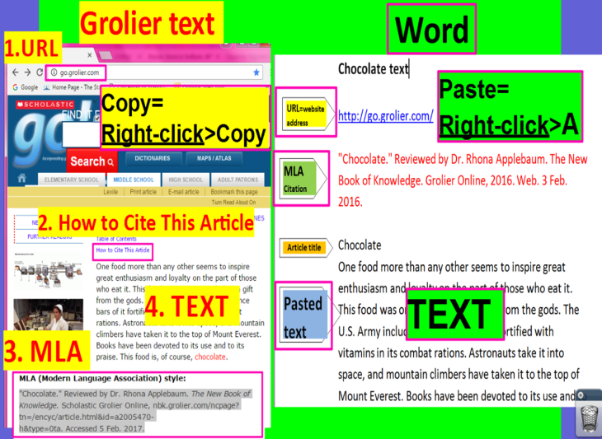 | 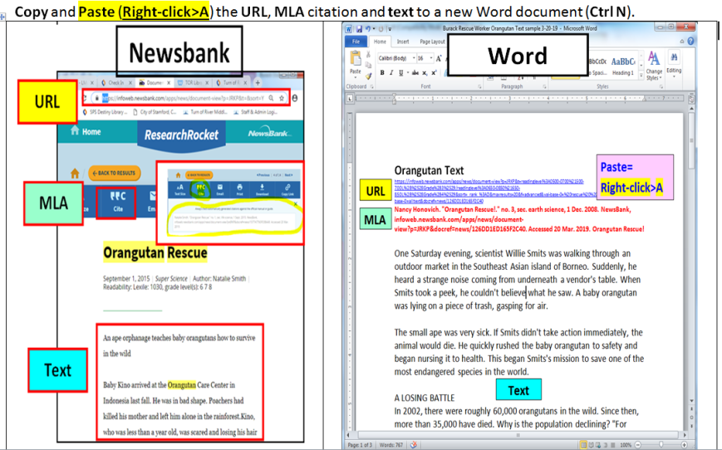

Step Three:
- Fill in your topic and claim on the graphic organizer below.
- Split the screen and place your text on the left and the graphic organizer on the right.
- READ the article without highlighting anything!!!
- After you’ve read the article, highlight details accordingly:
  - Yellow highlighting=background information
  - Green highlighting =evidence that supports your claim
      - Evidence=fact, statistic or quote
  - Red highlighting=evidence that doesn’t support your claim
      - Evidence=fact, statistic or quote
- Fill in the graphic organizer with background information, and evidence supporting or disputing your claim in the appropriate field.

Step Five: Once your graphic organizer is complete, split the screen again and place it on the left. Write an essay in favor or against the topic you’ve chosen using evidence cited from the text. (See below for an essay exemplar.)

Step Six: Share your work with your teacher on Google.
- See the bottom of the TOR Library Media Website for a tutorial about how to do so.

Argument Research Graphic Organizer
Introductory Paragraph | Topic:
Claim:
Claim= Your basic belief about a particular topic, issue, event, or idea. An opinion, proposal, evaluation or cause and effect statement. Think in terms of good or bad/right or wrong/pro or con.
Claim examples: Video games are harmful. Social media is harmful. Animal experimentation helps people. I am in favor of the death penalty. Coffee is beneficial.
 | Background Information about Your Topic (5 W Facts highlighted in yellow about your topic)
 | Subtopics | Details
 | MLA Citation:
Thesis Statement
1st Body | First reason for your claim:
Paragraph | Evidence (facts, statistics, quotes) that supports your claim:
 | MLA Citation:
 | Evidence (facts, statistics, quotes) that supports your claim:
 | MLA Citation:
2nd Body | Second reason for your claim:
Paragraph | Evidence (facts, statistics, quotes) that supports your claim:
 | MLA Citation:
 | Evidence (facts, statistics, quotes) that supports your claim:
 | MLA Citation:
3rd Body  Paragraph=  Counterclaim | Counterclaim: (What those who disagree about your claim say.)  What is the position of their claim?
 | What reason do they have for their claim?
 | Evidence (facts, statistics, quotes) that supports their claim:
 | MLA Citation:
Rebuttal | Reason why their evidence isn’t persuasive:
 | Evidence that proves you’re right :
 | MLA Citation:
Concluding  Paragraph | Restate your thesis statement:
 | Summary of reasons for your claim:

In text citations=grey highlighted text
Exemplar: Chocolate Essay by Ms. Carpenter
It’s Out of This World
THESIS=
claim plus three reasons
By Ms. Carp
COUNTER CLAIM

It has been called “food of the gods”. The explorer Hernando Cortes referred to it as “the divine drink that builds up resistance and gives strength”. The U.S. army hands it out as part of its combat rations. Astronauts take it into space. It’s a favorite flavor for candy, cookies and other sweets. Surprisingly, there are those who say that chocolate actually promotes health issues like weight gain and acne. Research however, provides compelling news that eating chocolate contributes to our emotional and physical health and it makes us happy, is good for our heart, and, amazingly, it even helps fight disease. Many people, from the rich and famous to the average citizen, seem to know this.
Consider actress Jennifer Hudson who says that chocolate makes her happy. She’s right. Elizabeth Furhman, in Candy Industry, says that when we eat chocolate, our body releases 'happy hormones' (also called endorphins) that make us feel happy and content. Who hasn’t curled up with a good book and a hot CHOCOLATE? Pastry chef Alexandra Leafs agrees: “Chocolate brings out THE BEST in us, inspiring generosity, affection, and, it turns out, good health. It makes us HAPPY. Those first foil-wrapped chocolate kisses we receive as children seem to initiate us into a LIFE WITH CHOCOLATE.” Chocolate, it seems, is near and dear to our hearts.
Next, while binging on chocolate won’t prevent a heart attack, studies show that dark chocolate is good for our heart. A 2010 issue of Employee Benefit News, says, “Dark chocolate has lots of epicatechins, which is actually a plant flavonoids. Flavonoids have been proven to keep cholesterol from gathering in blood vessels, reduce the risk of blood clots and slow down the immune responses that lead to clogged arteries. They are also the same compounds found in red wine that give it its antioxidant properties.” A new study backs up the best excuse ever to eat a Milky Way Midnight: People who ate a little chocolate every day were 40 percent less likely to have a heart attack or stroke, according to the study in the European Heart Journal. What great news!
COUNTERCLAIM
This is such encouraging news, and yet it’s heartbreaking that there are those who say that chocolate actually promotes health issues like weight gain and acne. Chocolate, they contend, is high in fat and is very caloric. "It all comes down to insulin," says Nell Mann, a professor of human nutrition at RMIT University in Melbourne, Australia, and the study's lead researcher. Foods with a high glycemic index cause blood sugar to rise, forcing the body to bring it down with a surge of insulin. And insulin can lead to acne, both by accelerating cell growth in the pores and stimulating oil-producing hormones called androgens. But if the total fat intake does not exceed the recommended levels, there is no reason to assume that consumption of chocolate would represent an increased risk to health. People who eat confections of any kind actually have a lower body-mass index and a smaller waist than their candy-skipping pals, researchers at Louisiana State University find. Balancing healthy eating with the occasional treat is key. And as for the risk of acne, research suggests that the flavonoids found in chocolate might help protect the skin from inflammation, or perhaps even cancer.

It’s obvious that, most importantly, chocolate helps fight disease. Yes, a Harvard study credits the antioxidants naturally found in chocolate as disease-fighters. "It's pretty, healthy, and satisfies everyone's chocolate craving," says recipe author Melanie Polk, RD, director of nutrition education at the American Institute for Cancer Research in Washington, DC. And, when you add fruit like strawberries and raspberries to chocolate, you have double the antioxidant power.
Heart protection comes from chocolate's antioxidants, called catechins that fight clot formation. (Dark chocolate has more than milk chocolate.) Oranges and raspberries contribute more antioxidants, such as vitamin C, plus fiber--all thought to fight heart disease and cancer. Psychology Today even reports that drinking hot cocoa helps lower you blood pressure!

In the final analysis, eating chocolate is not cheating; it’s actually smart. It enhances our lives in mental, emotional and physical ways. It’s that “feel good” confection that makes us happy; it also promotes heart health. Finally, munching on chocolate, rich in antioxidants, will help prevent disease. There is simply no reason to fear the calories or the onset of acne. Eaten in moderation, chocolate will not promote weight gain and may actually help your skin. What a relief! Overwhelming evidence proves that our beloved chocolate is good for us.

