Start>Computer>TRN_Shared>date modified>TOR Library Media Center folder>date modified>Konrad Grolier & Touching Spirit Bear Research Project folder> Konrad Touching Spirit Bear Research and Cornell Notes 3
Cool Mr. Konrad’s Touching Spirit Bear Research Project
November 2017

Objective: Students will use the Split Screen Note Taking method to research information in Grolier Online about a symbol in Touching Spirit Bear, and then explain its significance in the book in an essay afterwards.
Standard: Grade 6 ELA Quarter 2: During this quarter, teachers will continue to address narrative reading, speaking and listening, and language standards via a core text, assured core text, book club text or genre set supplemented with related informational texts.
Touching Spirit Bear symbols to research in Grolier Online:
- Bear
- Feather
- Rock
Research project steps: Use the Split Screen Note Taking method complete this assignment
- Split Screen Note Taking=Locate>Read>Annotate>Organize>Cite>Write about high-quality and accurate SPS text.

- Open Cornell Notes (this document) and save it to your number.
- File>Save As>Computer>Student number>Save
- Ctrl N>Type “Bear text” at the top of your blank new document.
- Locate information in Grolier Online about your chosen symbol.
- toronline.org
- Media Policies
- TOR Media Center Website
- Scroll down to access Destiny, our media center book catalog, and SPS databases:
  - Grolier
  - Bigchalk
  - Newsbank
- Grolier:
- Click GO! on the right
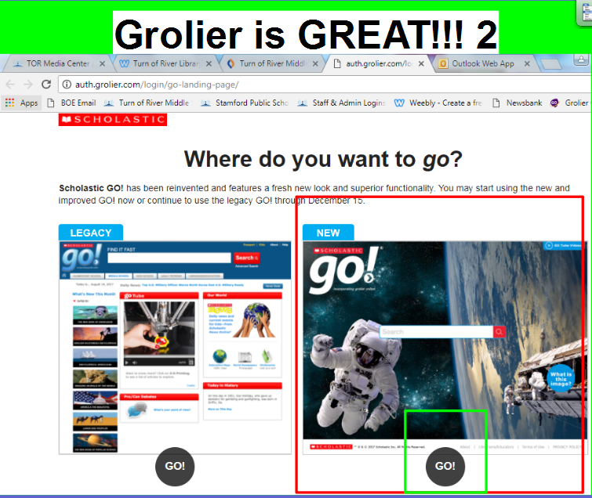
- Type your topic in the search box.
- Click on your symbol with the 1234 Reading Level as your guide
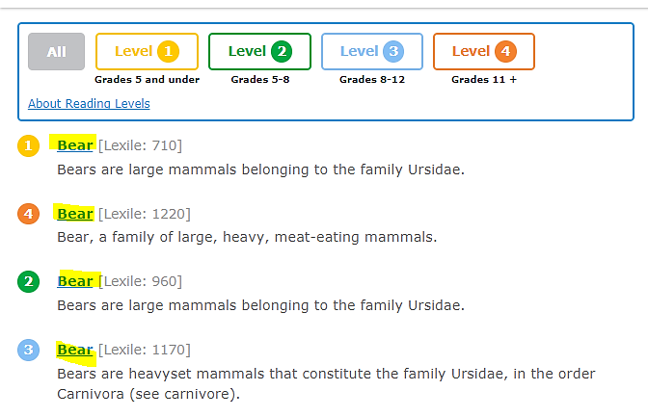

- Set up your Grolier text in a URL, MLA and text format: 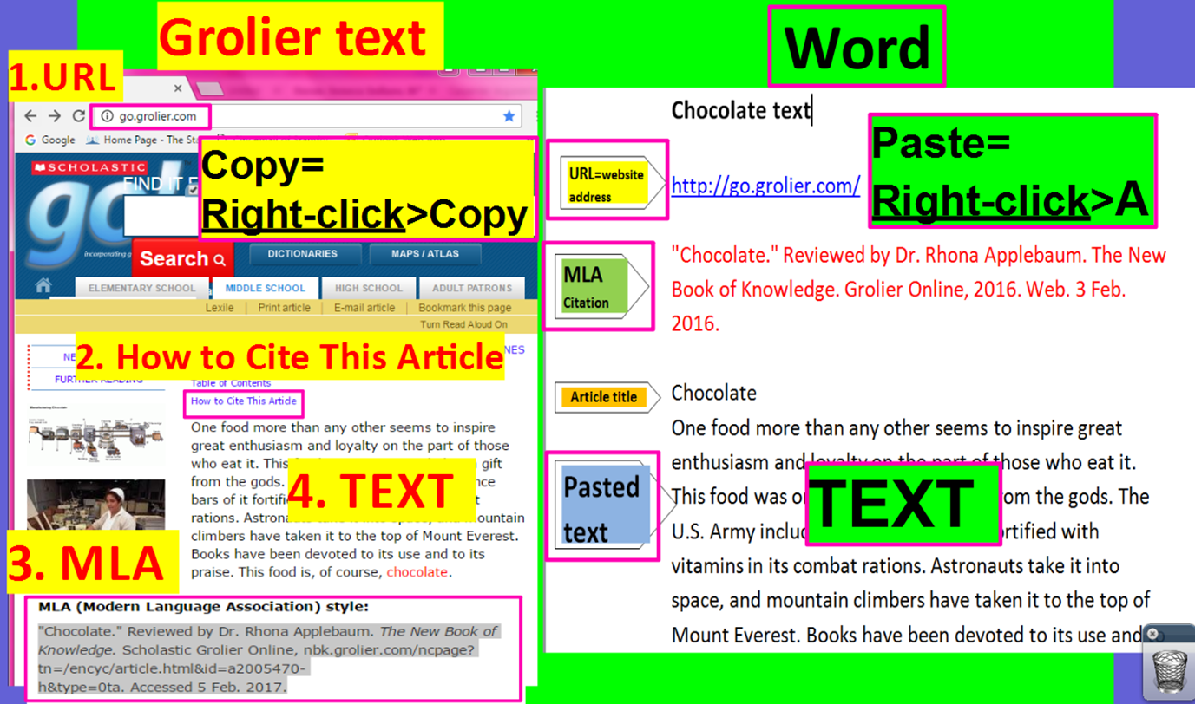
Your pasted Grolier text should look like this:
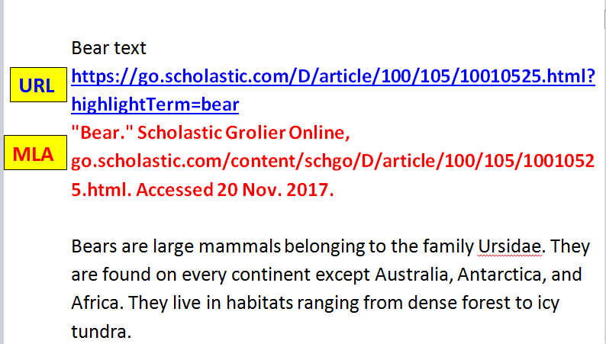
Paste: Right-click>A

- Split your computer screen and place your text on the left and your Cornell Notes on the right.
Cornell Notes
Pasted Grolier text
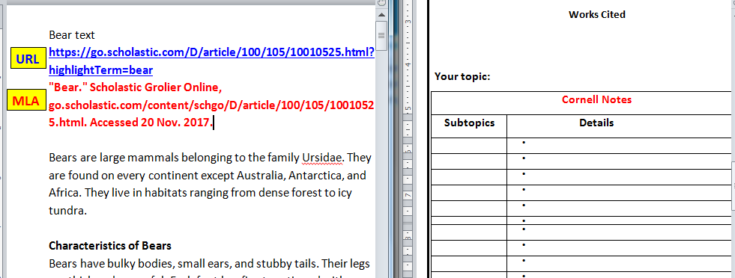
- Copy and paste your MLA citation underneath Works Cited.
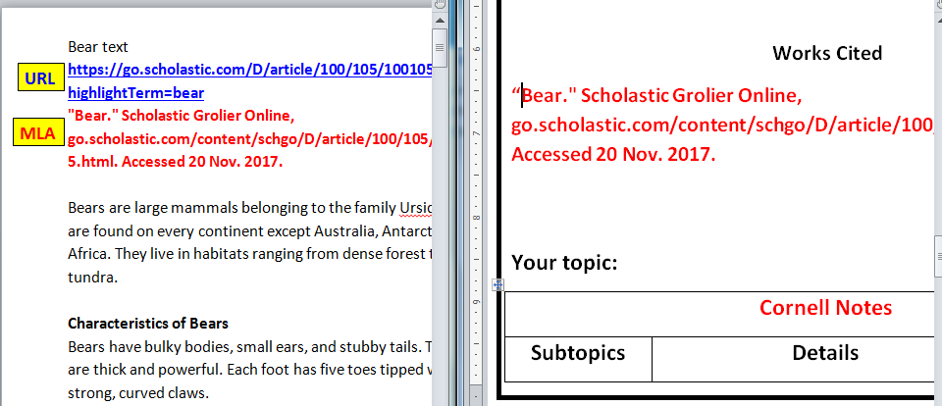
- Read, annotate, and organize information about your chosen symbol on Cornell Notes at the bottom of this page.
- Read the text in its entirety for meaning.
- Look at the first paragraph and the topic sentence. What is this paragraph about? This will be your Subtopic.
- As you read the remaining sentences in the paragraph, write larger details next to solid bullet points and indent smaller details by using the Indent and Outdent arrows.
- Highlight subtopics on Cornell Notes and correlating details from the text in the same color.
Example:
Indent and Outdent arrows
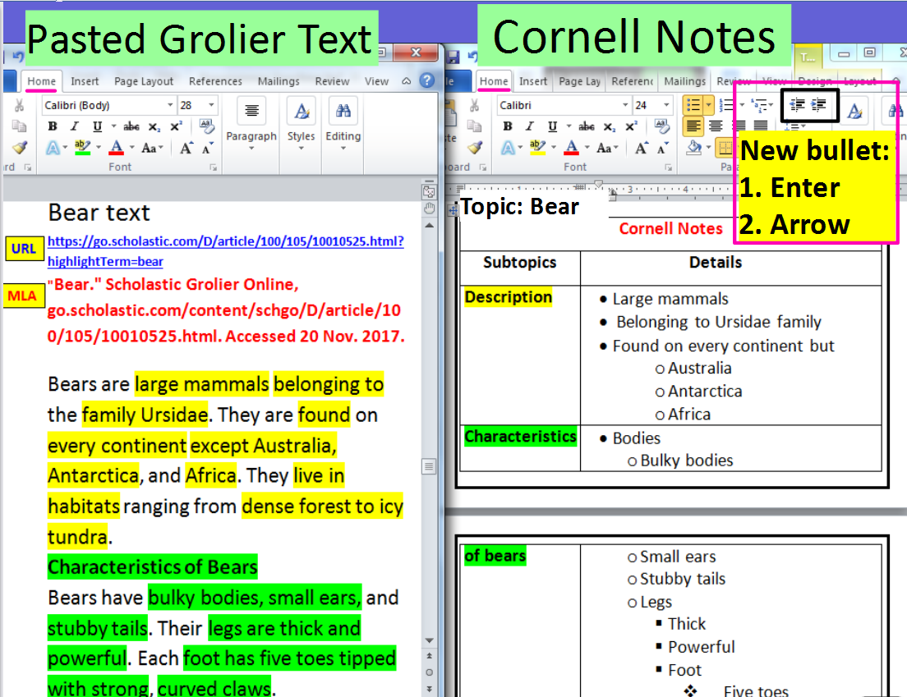
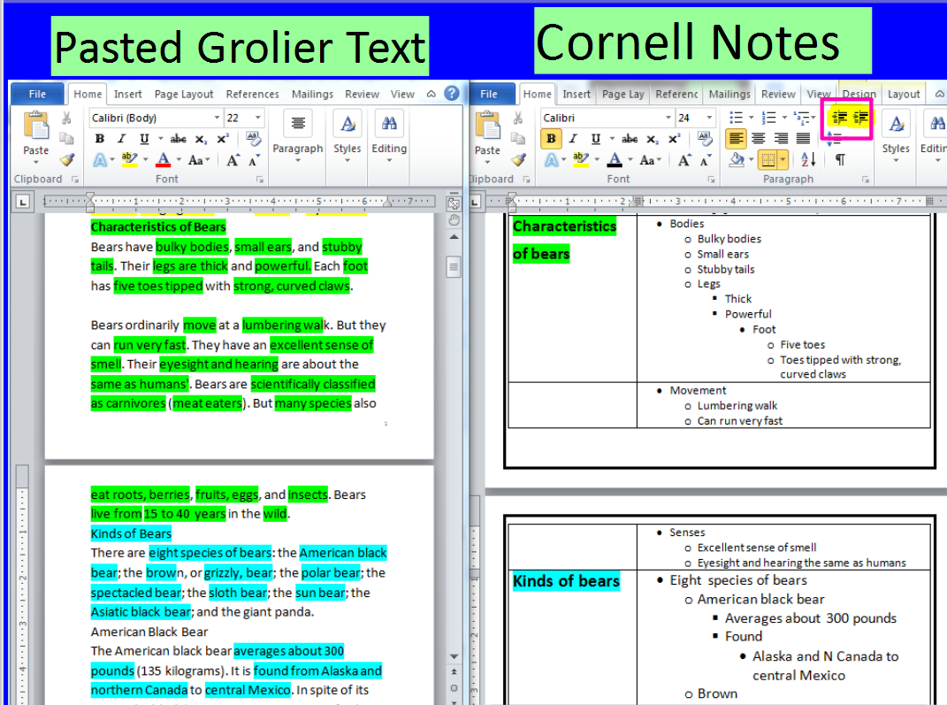
- Finish writing your Cornell Notes. Split the screen again and place your Cornell Notes on the left and a blank Word document on the right.
- Look at your notes and write an essay that explains the significance of your symbol within the book Touching Spirit Bear.
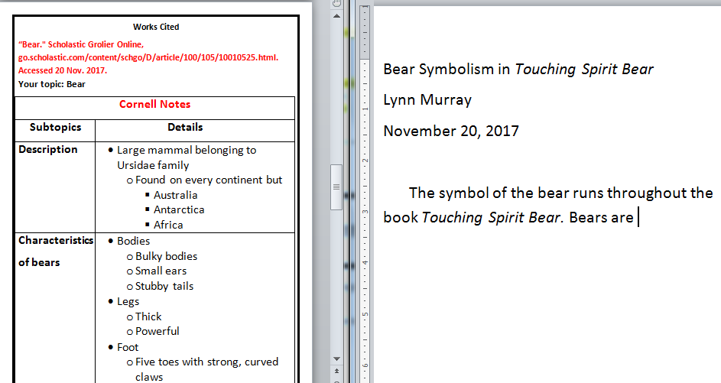
Works Cited

Your topic:
Cornell Notes
Subtopics | Details
Summarize your notes here:

