Name: Date:
Argument and Research Project
Konrad and Fields 7th Grade ELA
Are video games good for people?
Newsbank Text

- Locate video games background text from Grolier
- Grolier=toronline.org>Media Policies>TOR Media Website>Scroll Down to Destiny link>TOR>Grolier
- Search video games
- Copy and paste (Right-click>A) the article’s URL, MLA citation and text to a blank Word document (Ctrl N).
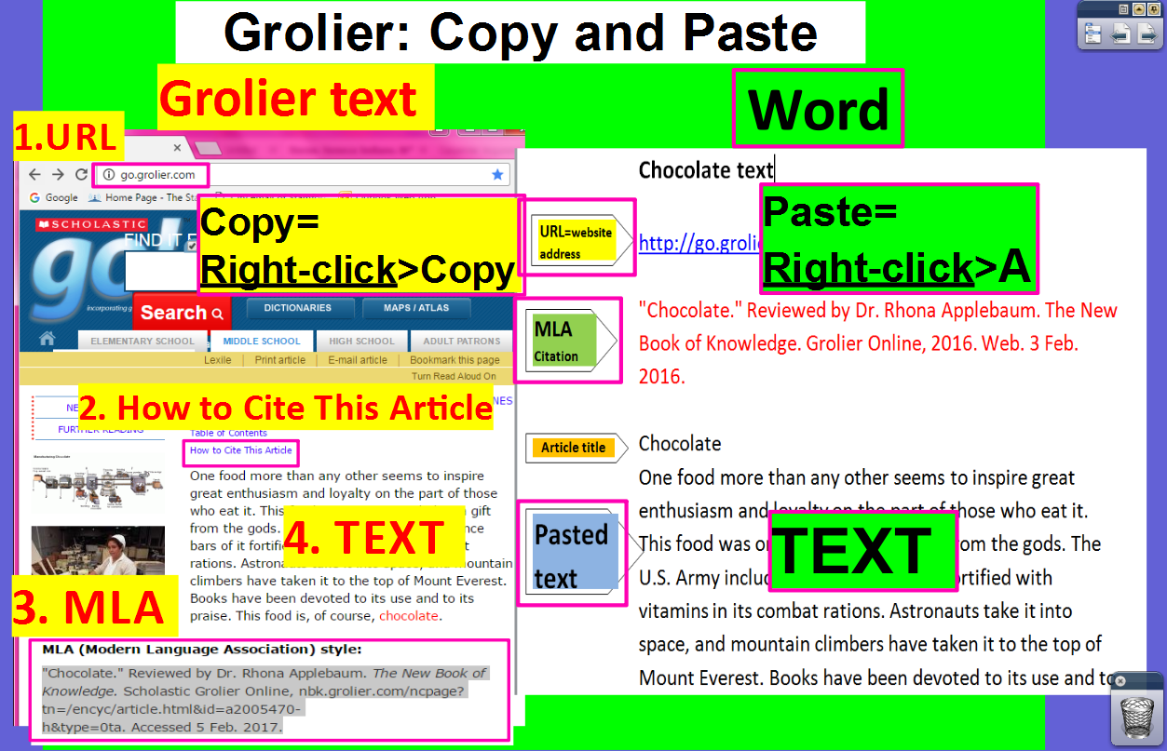
- Locate video games text from Newsbank
- Newsbank=toronline.org>Media Policies>TOR Media Website>Scroll Down to Destiny link>TOR>Newsbank>Access World News
- Search the article title below OR click on the link (Ctrl Click)
- Copy and paste (Right-click>A) the article’s URL, MLA citation and text to a blank Word document (Ctrl N).
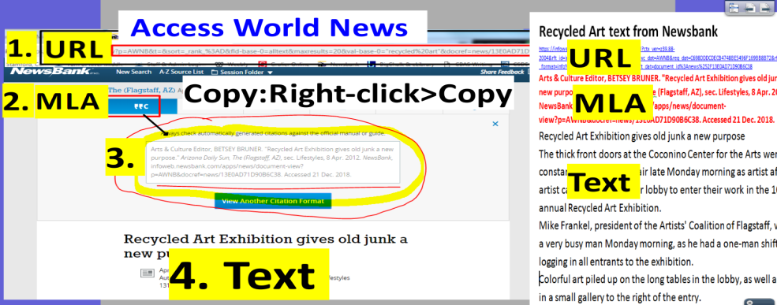

- Find evidence (fact, statistic, quote) to support or dispute your claim.
YES, video games are good for people:
- Age Restrictions Sought for Video Game Sales
  - https://infoweb.newsbank.com/apps/news/document-view?p=AWNB&t=readinglevel%3A0850-1050%21850-1050L%2B%2528Grade%2B6%2529&sort=_rank_%3AD&fld-base-0=alltext&maxresults=20&val-base-0=video%20games%20violent%20behavior&docref=news/14CD6F124B8CD068
- Can Good Come Of Video Games?
  - https://infoweb.newsbank.com/apps/news/document-view?p=AWNB&t=readinglevel%3A0850-1050%21850-1050L%2B%2528Grade%2B6%2529&sort=_rank_%3AD&fld-base-0=alltext&maxresults=20&val-base-0=video%20games%20violent%20behavior&docref=news/1493EDAC4619C868
- GAMES'S ON - FACE-TO-FACE COMPETITION ADDS SOCIAL SKILLS TO THE COMPUTER WORLD
  - https://infoweb.newsbank.com/apps/news/document-view?p=AWNB&t=readinglevel%3A0850-1050%21850-1050L%2B%2528Grade%2B6%2529&sort=_rank_%3AD&fld-base-0=alltext&maxresults=20&val-base-0=video%20games%20violent%20behavior&docref=news/101F47272B7D3E49

No, video games are bad for people:
- STUDIES FIND LINK BETWEEN VIDEO GAMES, VIOLENCE
  - https://infoweb.newsbank.com/apps/news/document-view?p=AWNB&t=readinglevel%3A0850-1050%21850-1050L%2B%2528Grade%2B6%2529&sort=_rank_%3AD&fld-base-0=alltext&maxresults=20&val-base-0=video%20games%20violent%20behavior&docref=news/0EB76CAE8470F3C4
- VIOLENT VIDEO GAMES A HEARTLESS HOBBY
  - https://infoweb.newsbank.com/apps/news/document-view?p=AWNB&t=readinglevel%3A0850-1050%21850-1050L%2B%2528Grade%2B6%2529&sort=_rank_%3AD&fld-base-0=alltext&maxresults=20&val-base-0=video%20games%20violent%20behavior&docref=news/1088D3D5352C3181
- Video games affect children's aggressiveness
  - https://infoweb.newsbank.com/apps/news/document-view?p=AWNB&t=readinglevel%3A0850-1050%21850-1050L%2B%2528Grade%2B6%2529&sort=_rank_%3AD&fld-base-0=alltext&maxresults=20&val-base-0=video%20games%20violent%20behavior&docref=news/13DED5A7408FAD40

Introductory Paragraph
Introductory  Paragraph | Topic = Video games. Are video games good for people?
 | Background information about video games from Grolier:
 | MLA Citation of Source:
Claim= Your basic belief about a particular topic, issue, event or idea.
- An opinion, proposal, evaluation or cause and effect statement.
- Think in terms of good or bad/right or wrong/pro or con.
 | Claim |  | Video games are
 | Thesis statement =sentence that summarizes the main point or claim of an essay or paper that is developed, supported, and explained by examples and evidence.
 | Thesis statement
Gather evidence from the text to support your claim
2nd Paragraph | First reason to support your claim:
 | First reason evidence (fact, statistic or quote):
 | MLA Citation of Source:
3rd Paragraph | Second reason to support your claim:
 | Second reason evidence (fact, statistic or quote):
 | MLA Citation of Source:
4th Paragraph | Third reason against your claim (counter claim):
 | Third reason evidence (fact, statistic or quote):
 | MLA Citation of Source:
Conclusion
5th Paragraph | Restate your claim and explain whether video games are good or bad for people.

