Water Pollution Research & Photostory Movies
Resources: Books, Encyclopedias, Newsbank, Microsoft & Google
Miss Klein & Mr. Butera
Document Created by Lynn Murray 10-2-19

Objective: You will read SPS resources, research types of water pollution and create a Photostory movie about the topic.

Steps:
- Ctrl N. At the top of the new Word document type Water Pollution Text.
- Resources
- Books and Encyclopedias
- Newsbank
- toronline.org > Media Policies > TOR Media Website > Scroll down to Destiny & Database Access >TOR
  - Click on Newsbank > Scroll down and click on Research Rocket
    - Search: Water Worries
- Click back on Word and split your computer screen. Place Newsbank text on your left and Word on your right.
- Highlight and RIGHT-CLICK > Copy the URL, MLA Citation and Text from Newsbank
- RIGHT-CLICK Paste > A (unformatted text) the URL, MLA citation and text to this document.
Word
Newsbank Text

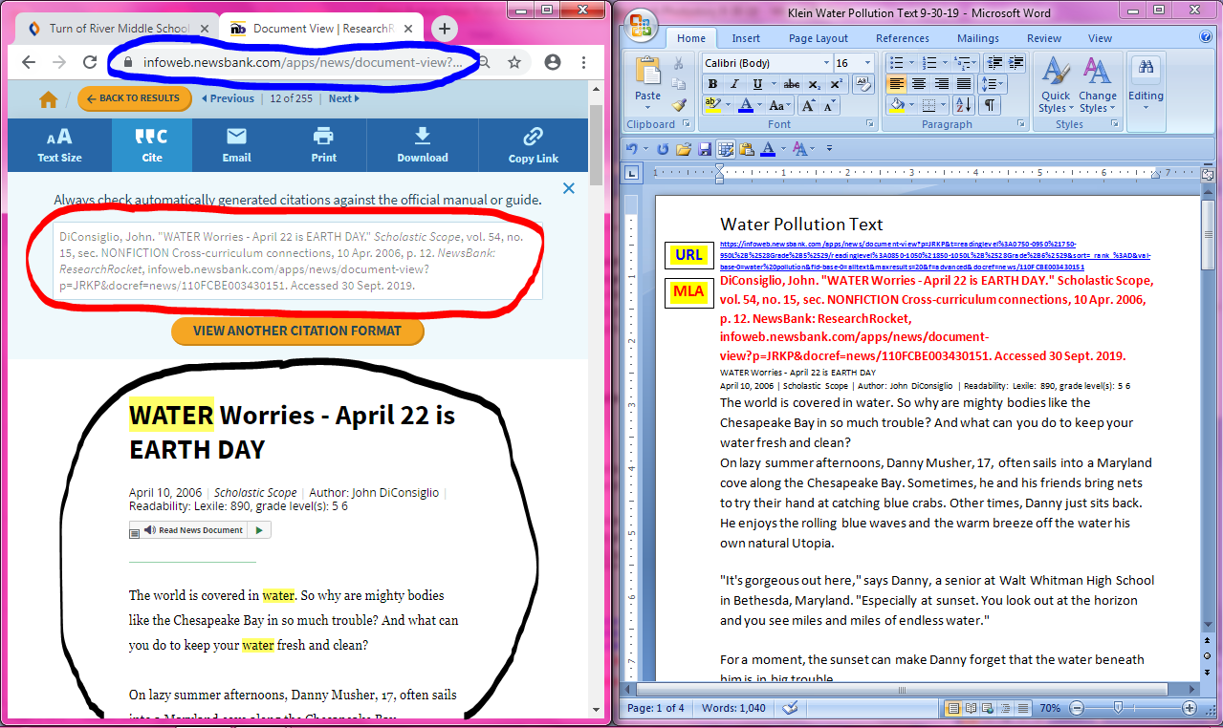
Text
Text
MLA
URL
- Read the text on Word and highlight contaminants.
- Contaminant: a polluting substance
- Create a listing of pollutants at the end of the text.
- Save your text to your number and upload it to Google.
- Save text to Number=File > Save As > This Computer > Login Number > Save
- Upload to Google=Login to Google> New > Upload document >Computer > Number >OK
- Follow directions about How to Create a Photostory Movie on the TOR LMC Website. Create a movie about water pollution contaminants and use your highlighted text to locate pictures. Good Luck & Happy Learning!!!

