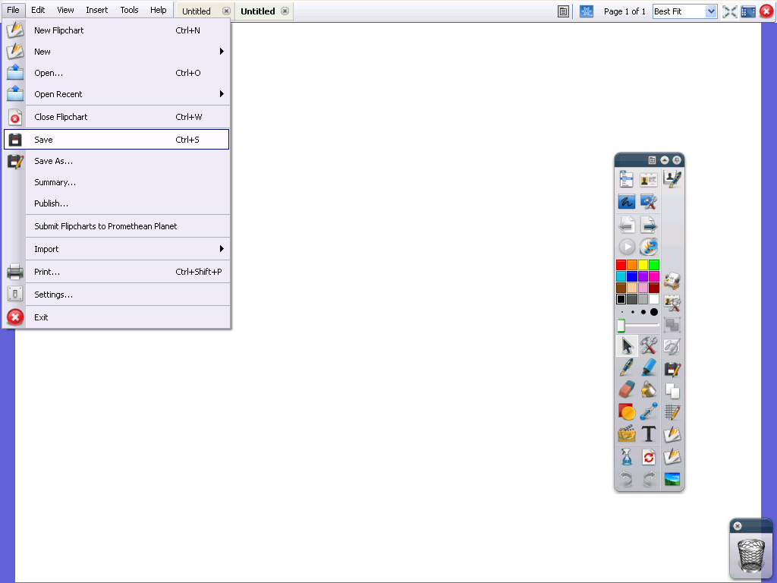

Click on File to either create a new flipchart or save or print flipchart.
Save As …
-Click on the pull down arrow.
-Click on your name on the H drive
-Give your flipchart a name>Save.
Exit to close the program.
- Open ActiveInspire from either your Desktop or Start>Programs>Activ Software>Activ Inspire
- On the “ActiveInspire Dashboard,” click on the Red X to begin work on a blank flipchart.
- The Inspire screen resembles a Microsoft product now. The menu toolbar on the top mimics other Microsoft products. Ex. File, Edit, View, Insert, Tools and Help.
- You would save the flipchart in the same way you would save a Microsoft Word document. File>Save as>Click on the pull down arrow and click on your name ex. lmurray on w3ait H (this is called saving to the H or teachers’ drive on our system’s server).
***All of my “Promethean Cheat Sheets” are located at...
http://classjump.com/mrsmurrayslmc

How to access ActivInspire…
- Start>Programs>ActivSoftware>ActivInspire
- A small screen called the “dashboard” will now be visible. Click on the red X of the dashboard to access the blank flipchart below.
- Save=
File>Save As> Click on the pull down arrow. >Click on your name on the H drive> Give your flipchart a name>Save.
- You can also use your City Email to email flipcharts as attachments to yourself!!!
**Additional tech & research resources=
TORonline.org>TOR Media Center
http://classjump.com/mrsmurrayslmc
Topic | Page Number
1. Main Tool Strip | 2
2. Text Tool | 3-4
3. Shape Tool | 5
4. Snipping tool | 6-7
5. Resource Library | 8
6. How to Insert files, links, audio and video into a flipchart | 9-11
7. Promethean Planet.com | 12-14
8. Annotate over the desktop | 14-16

Welcome to Introduction to
Promethean ActivInspire!
You Rock!!! ☺
Lynn Murray TOR Library/Media Center
Updated Fall 2015 7 FINAL

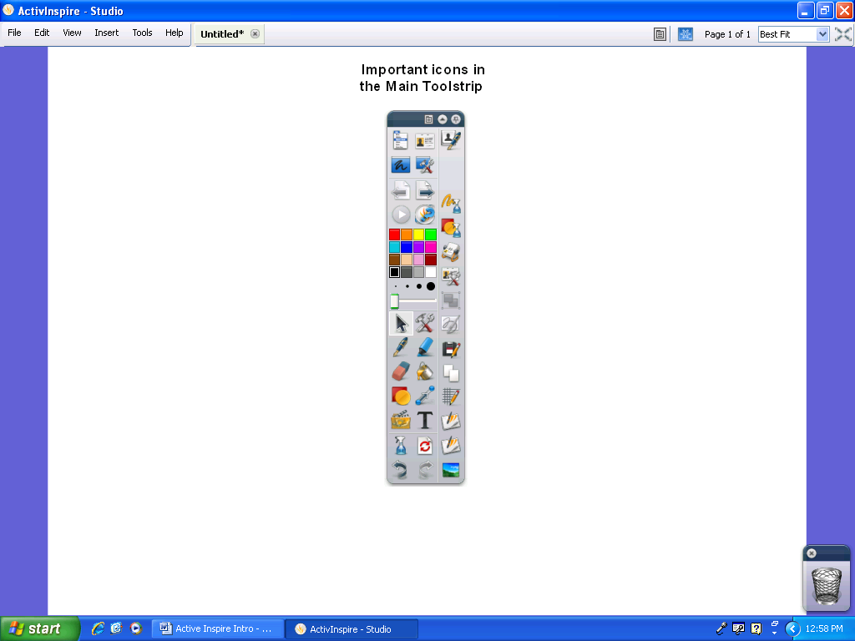
Main Menu-the most important part of the Toolstrip. Start here if you are lost. Ex. File>Save As
Select tool=mouse.
Pen and Highlighter tool=Use to write on the board. The pen and highlighter “squiggles” are called annotations.
Text tool=Use this to type.
Undo and Redo
Arrows=Navigate through flipchart pages
Clear tool= (spray bottle)
Erases Annotations (pen/marker), Objects (text and shapes), Grid, Backgrounds and Page.
Paint can=Fill tool=
changes colors of text, objects and background.
Shape tool-choose a shape and drag it diagonally on the page. Edit it by using the Select tool.
Part 1: Main Tool Strip

Part 2: Text Tool

1. Promethean basics=Promethean software is called ActivInspire.
a. Start>Programs>ActivInspire>X out of the Dashboard
b. How to type on the Promethean board:
1. Click on the T.
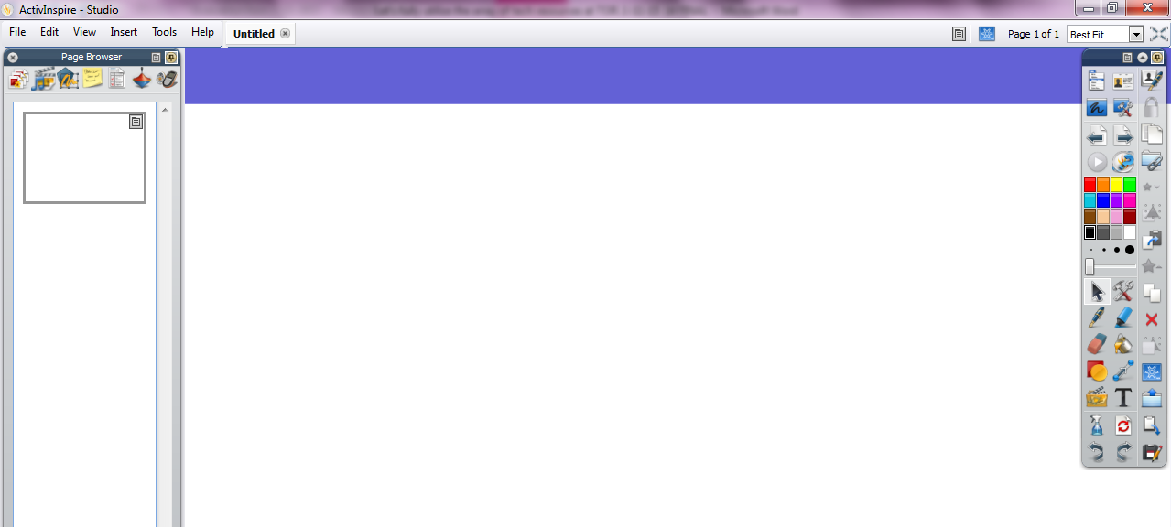

2. The icons at the top of the screen affect your text.
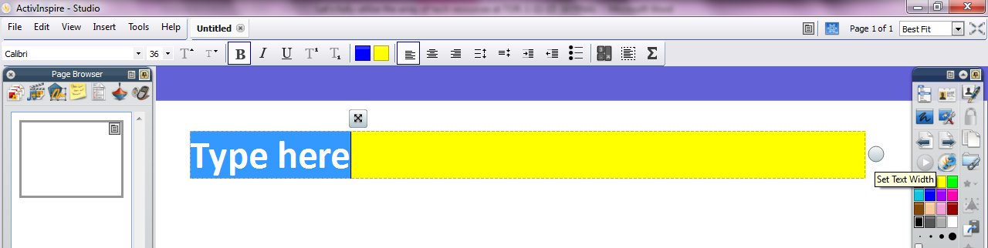
2
4
3
1
5
1. Click on the Set Text Width circle and slide the width of the text box.
2. Text box colors
  - First box=TEXT color
  - Second box=background of text box color
3. Text box Select All icon=click on this to highlight all of the text in the text box.
4. Once the textbox font is highlighted you can change the font and size of the text.
5. “Move freely” icon. Click on this icon with your mouse to move the text box around the screen.

3. How to move the text box on the screen once you’ve finished typing in it.
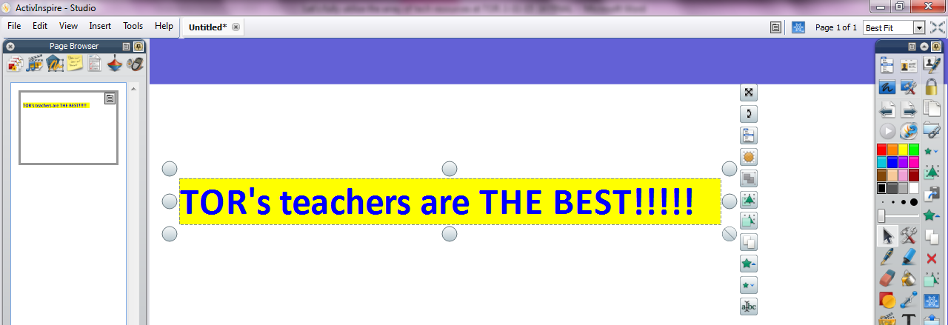
1
2
1. Click on the Select tool.
2. Click on the text box and then click on the “Move freely” X icon. Drag the text box where you would like it.
Part 3: Shape tool

How do I get shapes and lines on my page?
- Click on the (circle/square) icon in the Main Tool Strip.
- A myriad of shapes and lines appears on a column on the right side of the screen.
- Click on the shape/line that you would like and then drag on it diagonally on the flipchart. It will grow before your eyes.
- To move and/or change the appearance of your shape/line, first click on the Select tool (diagonal arrow) on the Main Tool Strip. Next, click on the shape/line. Now the shape is outlined in dots and a host of choices open up to you as to what to do with it.

Example:
Brings object forward.
Groups a bunch of objects together as one.
Sends object backwards.
Translucency slider.
Duplicates object.

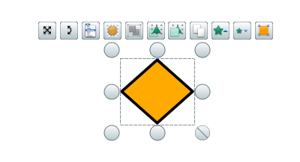
Click on this big ol’ X to move the shape.
Rotates object.
Main Menu icon.
Shrinks object.
Edits shape points=
VERY COOL!
Makes object grow bigger.
How to copy and paste pictures from the Internet=
- Internet>Copy
- Promethean>Click on the Select Tool (arrow on the Main Tool Strip)>Paste

PLEASE NOTE: The Snipping Tool is NOT a part of Promethean software. The snipping tool is on all of our networked PC computers.
Part Four: Snipping tool
How to use the Snipping Tool:
- Start>Snipping Tool
- Flag>Snipping Tool OR Flag>Type “snip” in the Search Programs box.
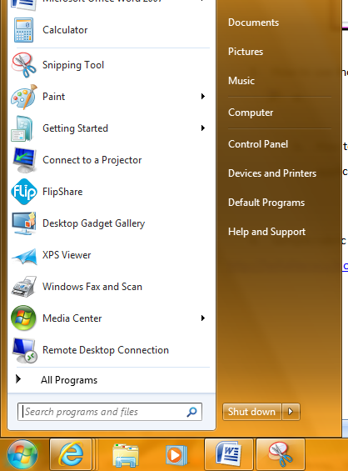
- When you click on the Snipping tool, the screen will turn grey. Drag diagonally over the area of the screen you would like to highlight.
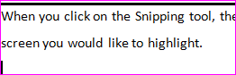
- Once you drag diagonally, the computer has automatically taken a picture of whatever was inside the rectangle. You can now click CTRL V or Right-click>Paste to paste the image anywhere.

- You can also save the image by clicking on the Floppy Disk icon. File>Save As>Click on your name on the H drive.
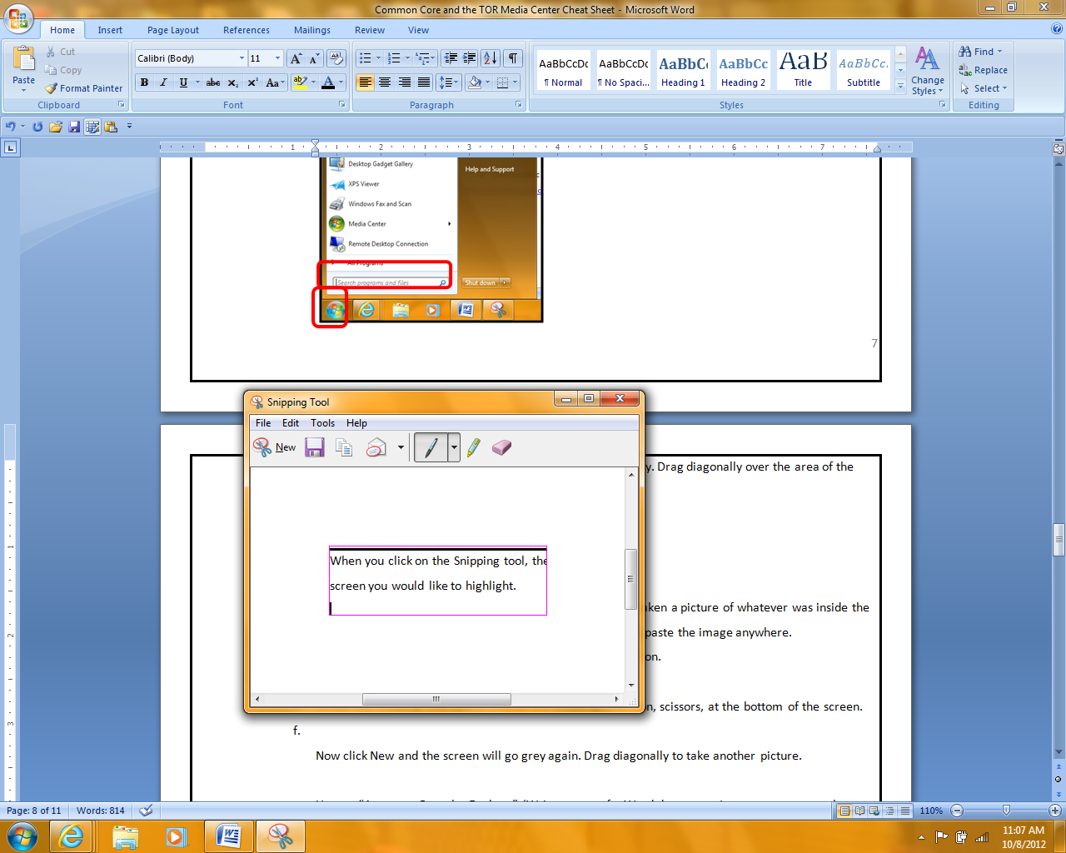
- To use the Snipping Tool again, click on the Snipping Tool icon, scissors, at the bottom of the screen.
Now click New and the screen will go grey again. Drag diagonally to take another picture. Ctrl V or Right-click>Paste to paste the new picture.

Part Five: Resource Browser
Resource Browser= A way to locate lesson building “stuff” (sounds, pictures, graphic org.) on a Promethean flipchart page.
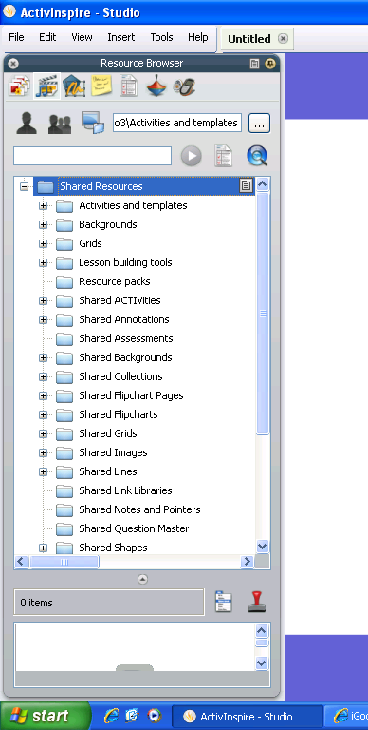
- (Top) View>Browsers
- Click on the second icon from the left, with the musical notes.
- Click on the three, suspicious looking figures to search though hundreds of shared lesson ideas.
- Click on the plus sign before a folder to see what types of resources are available. The available items will appear below.
- Double click or drag any item in the Resource Browser window to have it appear on your flipchart.

Part Six: Inserting Files, Links, Videos into your flipchart

- How to insert a Word, PowerPoint or Excel file into a Promethean flipchart.
- Insert>Link>File>Choose the file to Insert>Open
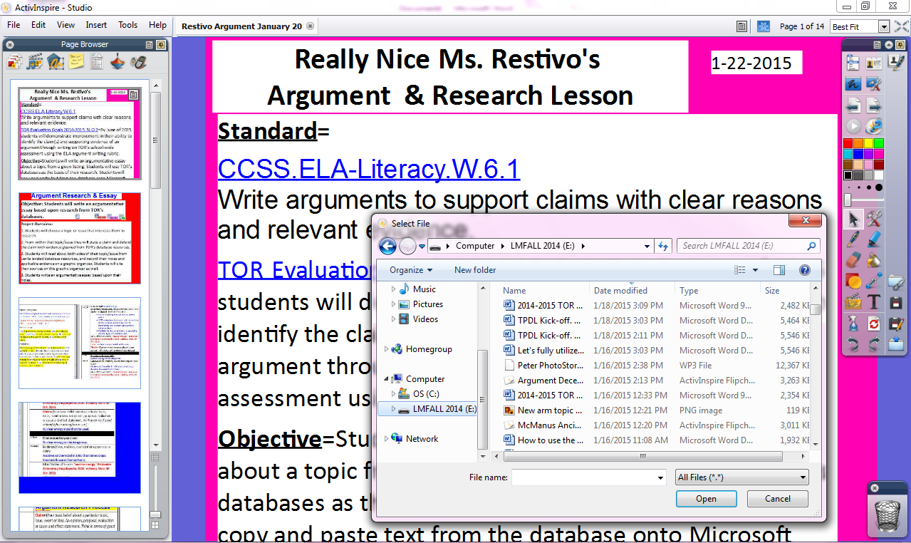
Insert> Link>File>Choose the file to insert>Open

- Click on Image Icon>Store in Flipchart>OK.
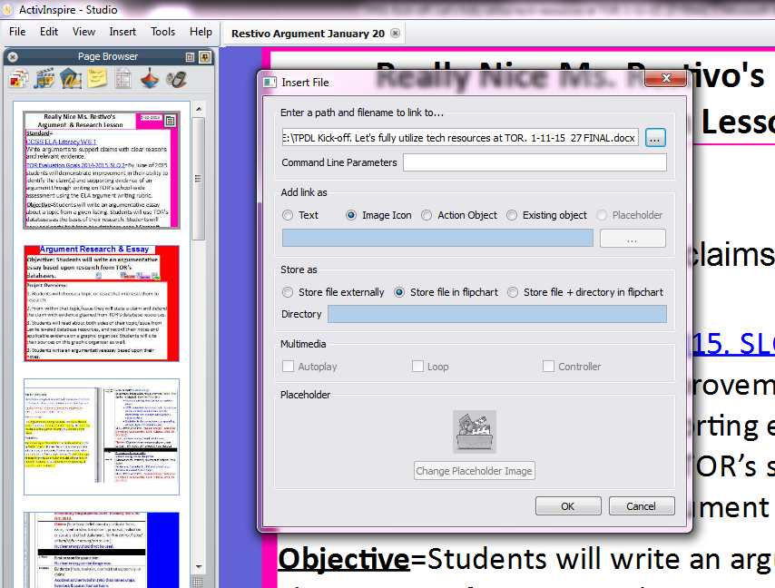
- Now your inserted file will appear as a W (Word), P (PowerPoint) or E (Excel) on your flipchart.
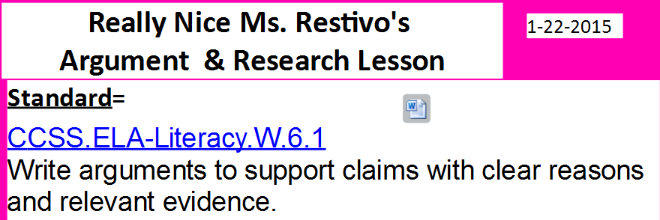
- To access the inserted file, click on the Select Tool and then click on the W, P or E. The inserted file will “magically” appear for you to utilize during your lesson. Very cool!
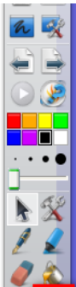
Select Tool

Part Seven: Promethean Planet

You can access entire lessons on PrometheanPlanet.com! Best of all, you can download these lessons and then edit them to suit your needs.
1. Access Promethean Planet:
http://www.prometheanplanet.com
-Create a Promethean Planet username or password if you haven’t already.
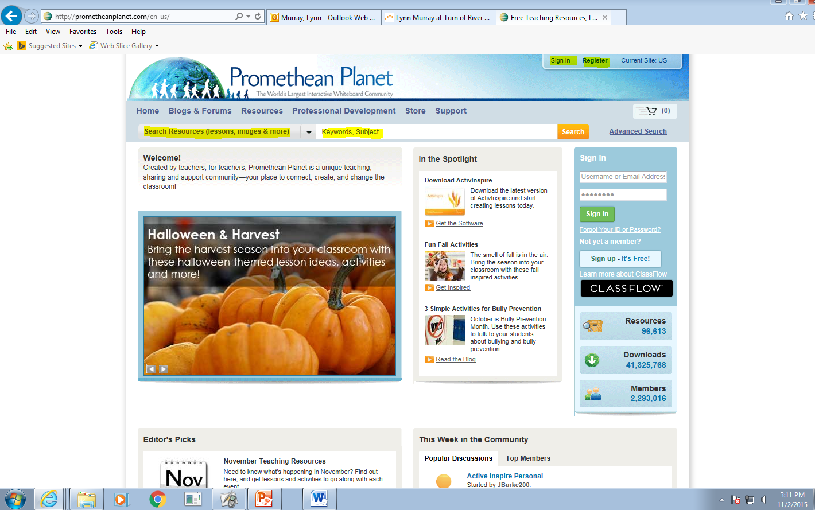

2. Search a topic that’s applicable to your classroom. Click on Preview to locate a flipchart that interests you.
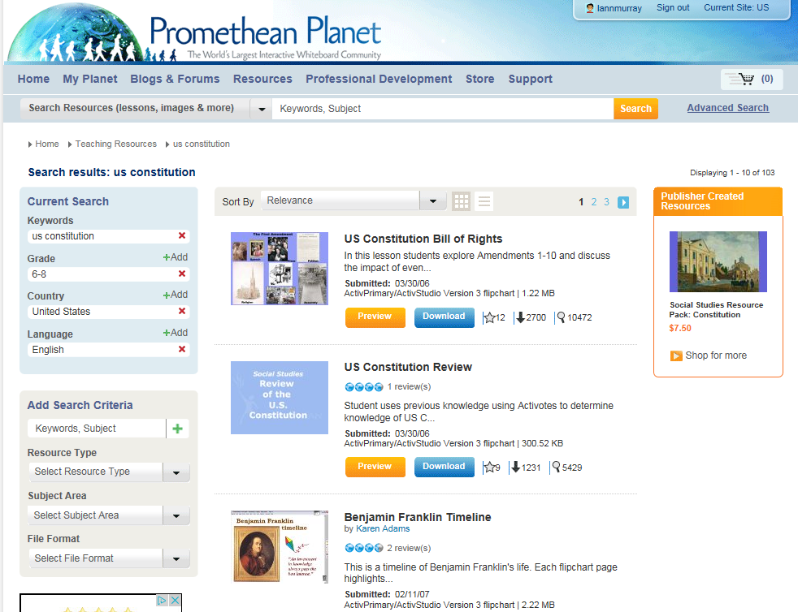

3. Click on the thumbnail view to see if the flipchart is suitable for you.
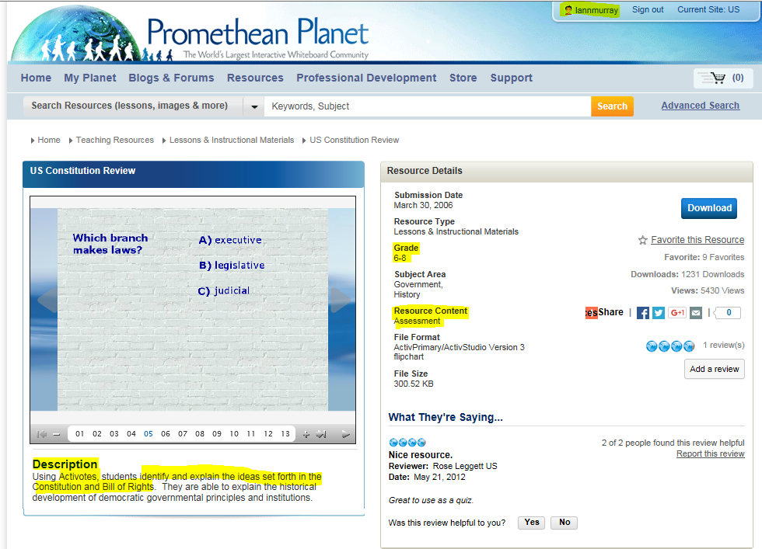

Part Eight: Annotate over the desktop

- Annotate over the desktop=it’s like writing on an old-fashioned over head projector piece of plastic that’s put over your computer screen. You save the markings that you make on the pieces of “plastic.”
- Click on the Annotate Over the Desktop icon in the top left corner of the Main Toolstrip. (It’s a blue icon with a black squiggle.) When you first click on this, your flipchart will “disappear”; don’t be alarmed. You are now in the Annotate Over the Desktop view.
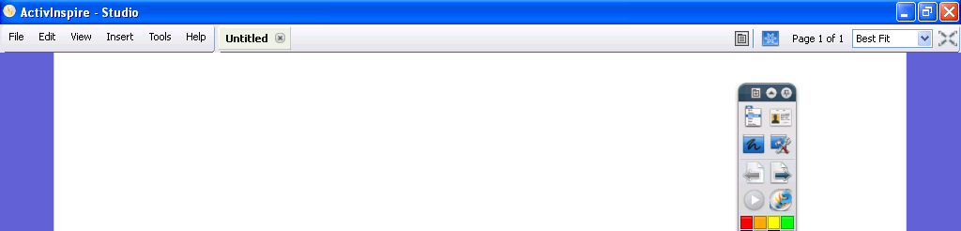
Desktop Annotate

- This is an example of an “Annotate Over the Desktop” view.
- You can tell you are in it because you can view the Main Tool Strip and you are viewing an Internet page below it.
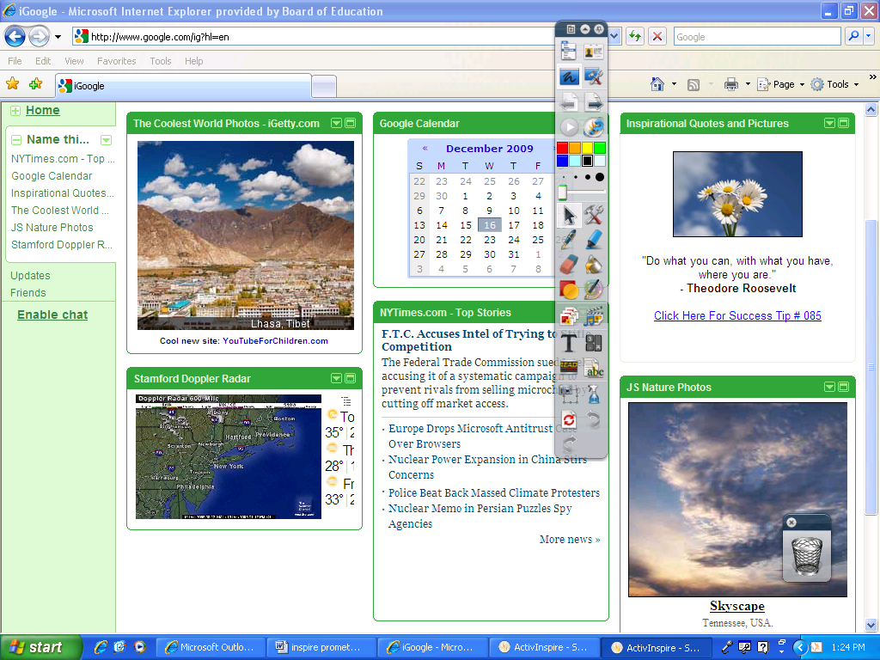
- You can use the pen, marker and text tool to write “over” the screen.
- Use the arrow on the Main Tool Strip to navigate to new blank screen of “plastic.”
  - To see your annotations, click on the File button in the upper left corner of the Main Tool Strip>View>Browsers>Click on the first blank screen icon (Page Preview icon) in the top left corner.
- To save your annotations, click on File>Save As>Pull down to the H drive>Name your annotated pages>Save.
  - Please know that you will only be saving a squiggle or annotation as a Desktop Annotation, and NOT a Promethean flipchart.
- To click back to the Promethean flipchart (and leave the Annotate Desktop view),
click on the black squiggle in the Main Tool Strip once again. 

