Let’s Get Started with Scratch!!!
Beginner’s Tutorial Created by Lynn Murray. 2012-2015.
TOR Media Center

Scratch is a “new programming language that lets you create your own interactive stories, movie, animations, games, music, and art.”

We’re going to create a BRIEF, introductory Scratch project about a curriculum- related topic of your choice.
This project will be created in three EASY steps:
  - Create a Sprite (a character or object that you program to move). (See bottom of page 2.)
  - Create a background filled with informational text boxes that describe your curriculum-related topic. (See bottom of page 7.)
  - Create a script to move your sprite. (See bottom of page 12.)

- Start>Programs>Scratch OR Flag>type Scratch.
- Layout of the Scratch screen has three parts:
- Button Screen
- Code Screen
- Stage

Layout of Scratch screen with three parts:
Categories of Buttons

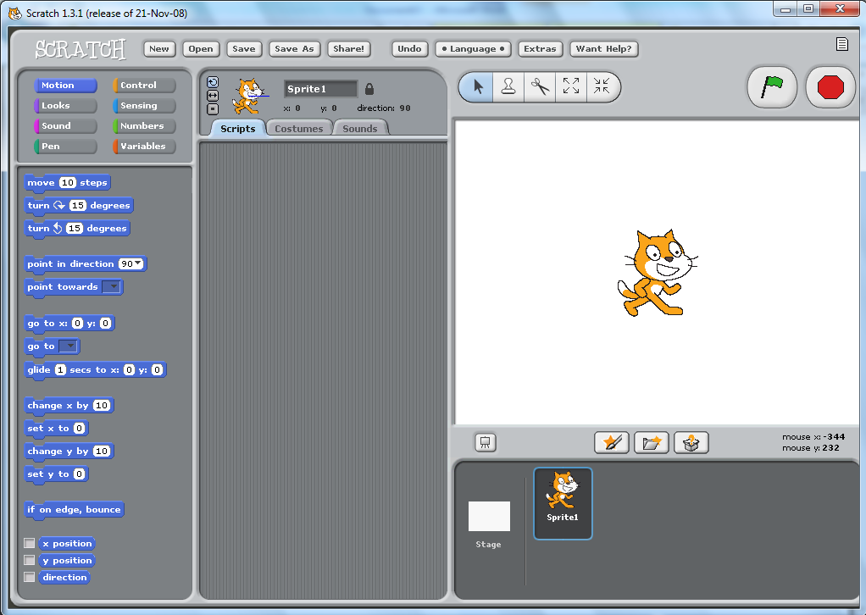
Sprite
Any character or object that you draw to move or say things.

3. Stage
Where you see your movie or game.

2. Code Screen
*Area where you piece blocks together to “write” code.
*Code=recipe in which you tell Sprites what to do.
1. Button Screen
*Buttons=Blocks
*Piece these buttons/blocks together on the code screen!

Part One=Create a Sprite.
- Sprites are the objects that you draw.
- Sprites can be=
  - Characters in a movie or game.
  - Objects that your characters interact with.
  - Anything that you want to be animated, move or interact with.

- We’re going to get rid of the default cat sprite and create our own sprite. To get rid of little kitty…
  - Right click on kitty>Delete (Bye, bye kitty ).
- Now, to make a new sprite=Click on the yellow star with the paintbrush.

- Now you are on the Paint Editor where you can draw your sprite!
Functions (from left to right)
- Top row=paint, erase, fill tool, draw rectangle, draw circle
- Bottom row=draw line, Text Tool, move a shape, stamp (duplicate), color picker (choose a color on the screen)

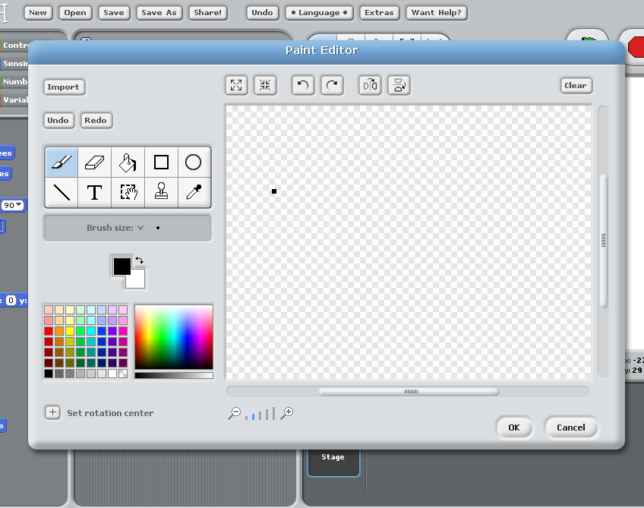

Let’s use the shape and text tool to draw our own sprite. When you are finished, click OK. (Lovely tool box cheat sheet.)
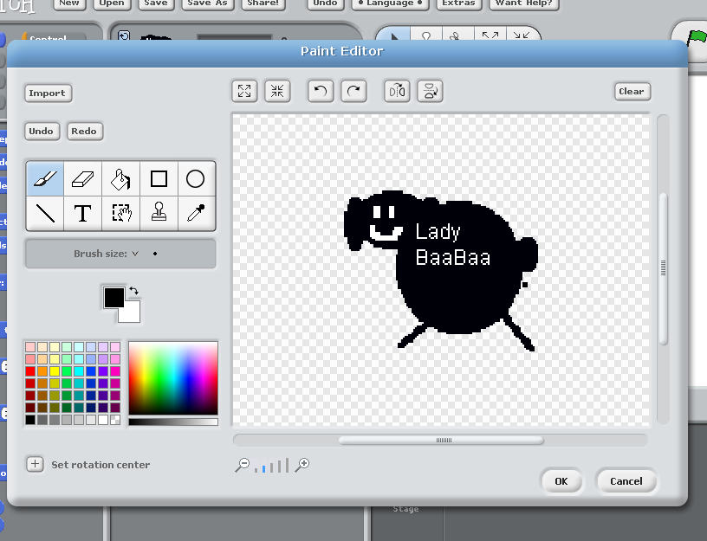
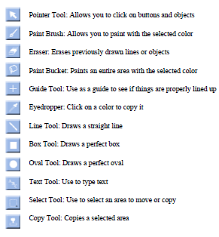
Color choices.
View of the Scratch main screen after you press OK on the paint editor.
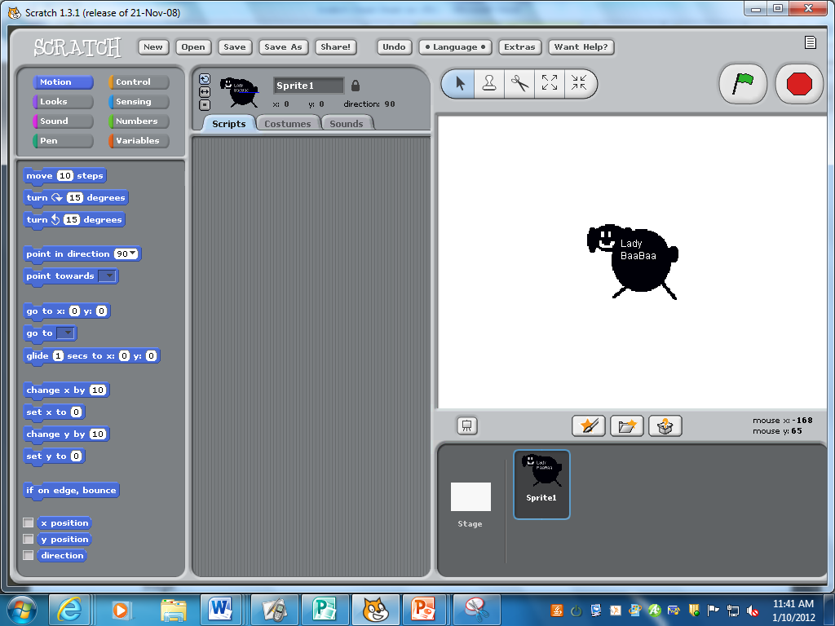

Let’s name our sprite. Highlight and delete the word Sprite 1 and replace it with another name.
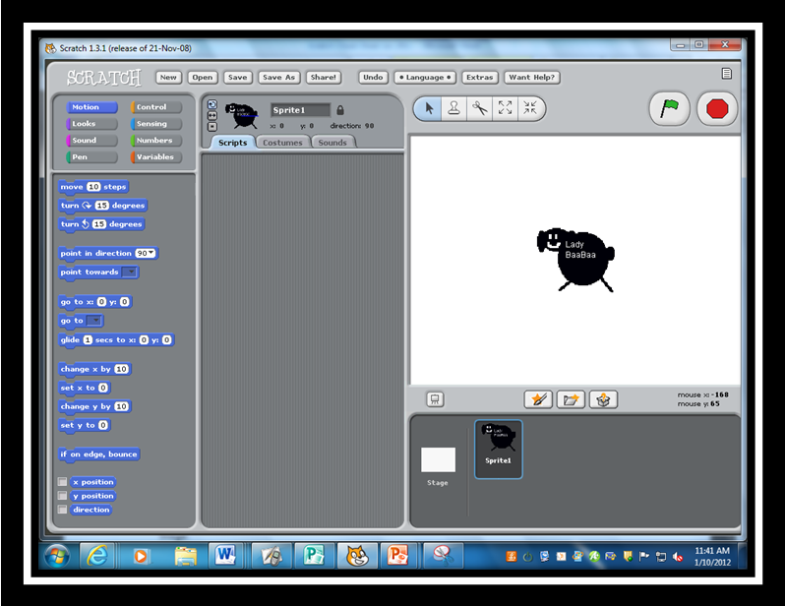
Newly named sprite.
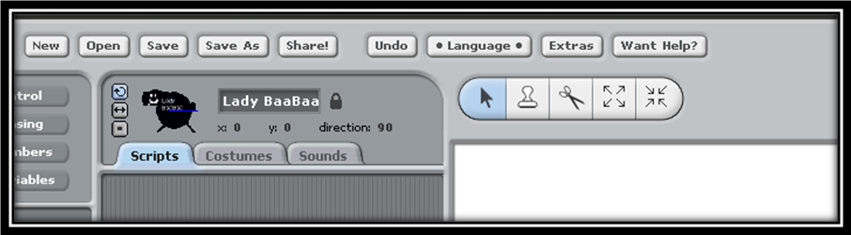

View of the newly named sprite, Lady BaaBaa.

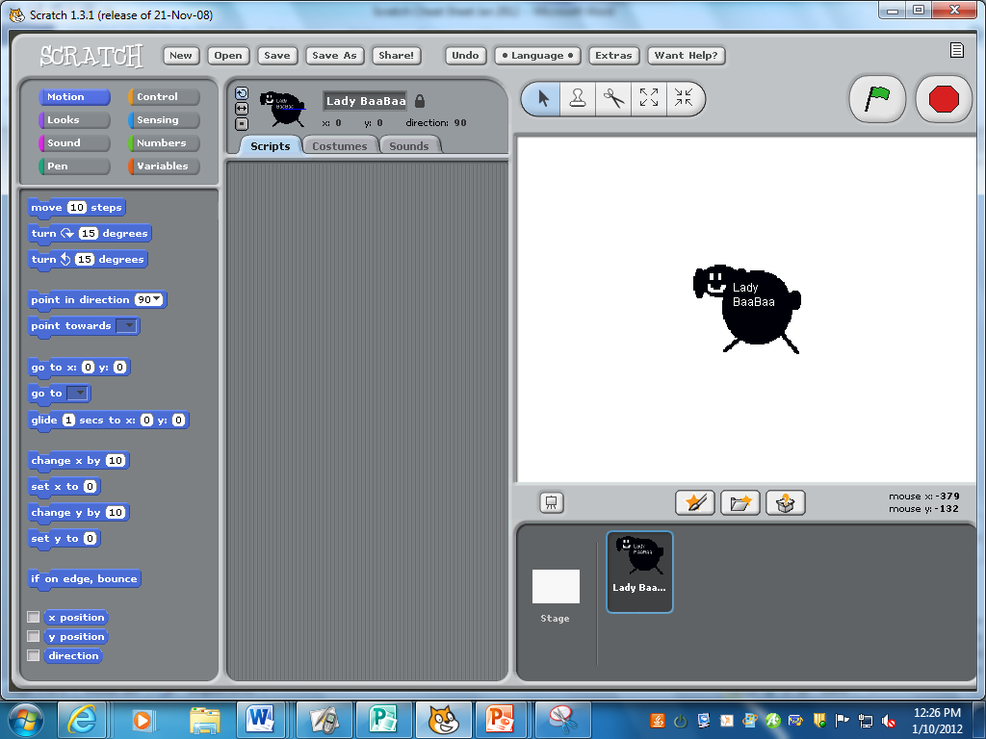

Part Two: Create a background on the stage.
- The stage can change its appearance by switching backgrounds.
- Click on the Stage icon in the bottom left corner.

Click on the backgrounds tab.
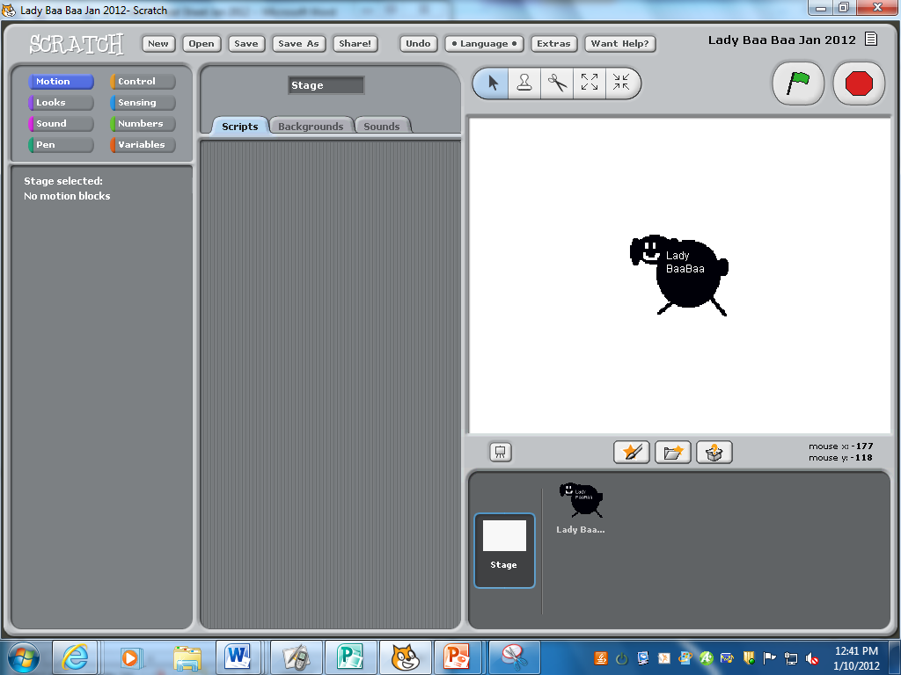
Click on Edit.
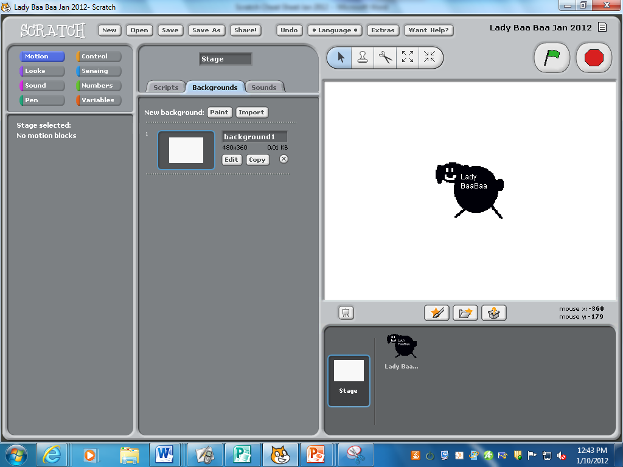

Our friend, the Paint Editor, comes up again. Click on Import to look at some preset backgrounds.
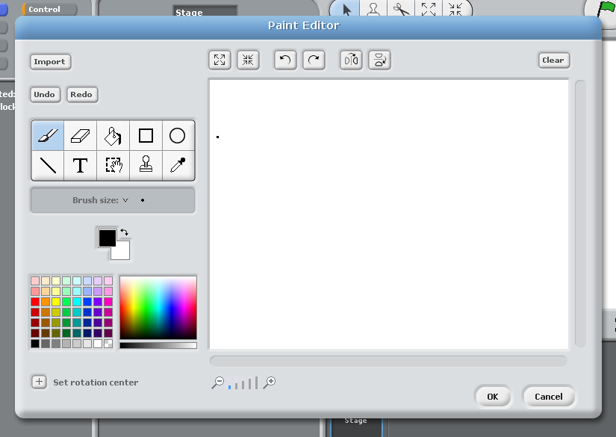
Click on Backgrounds for background images from Scratch.
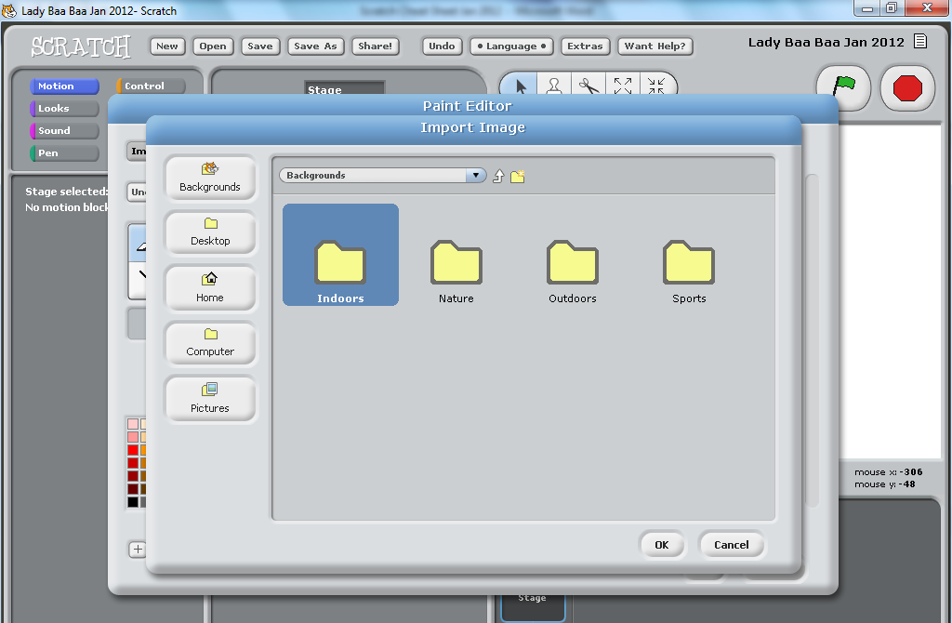

Sample Scratch images from the Indoors folder:
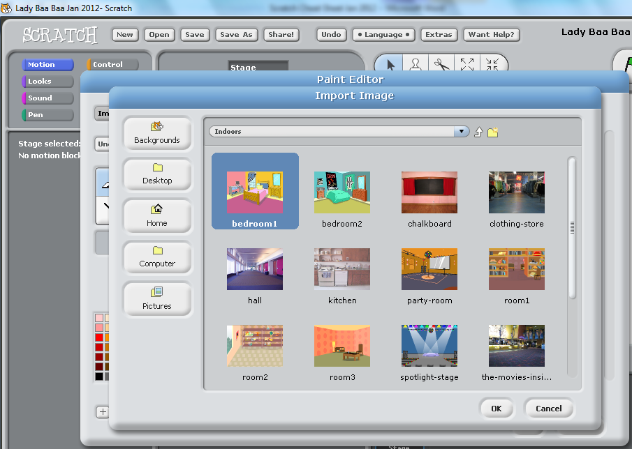
You can also draw your background. I drew the following background using the shape tool, (green rectangle for the grass and blue rectangle for the sky with a yellow circle for the sun).
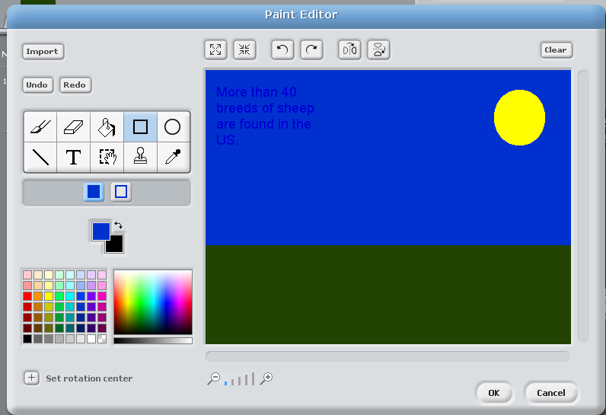

Let’s change the background name from Background 1 to one that’s more applicable (sky grass background).
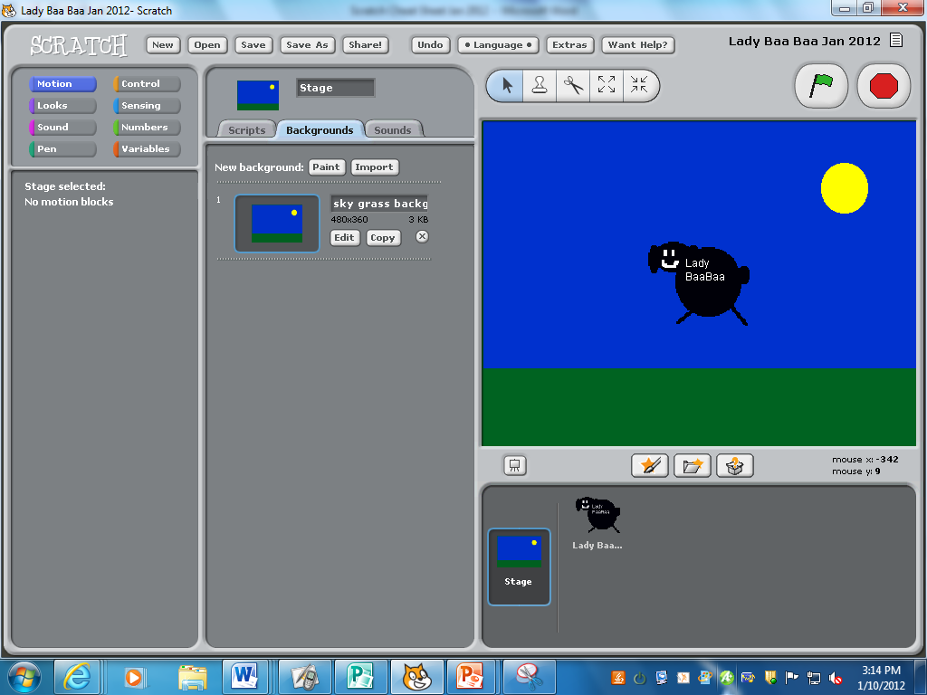
Let’s add some text boxes to the background explaining our topic.
- Click on the T.
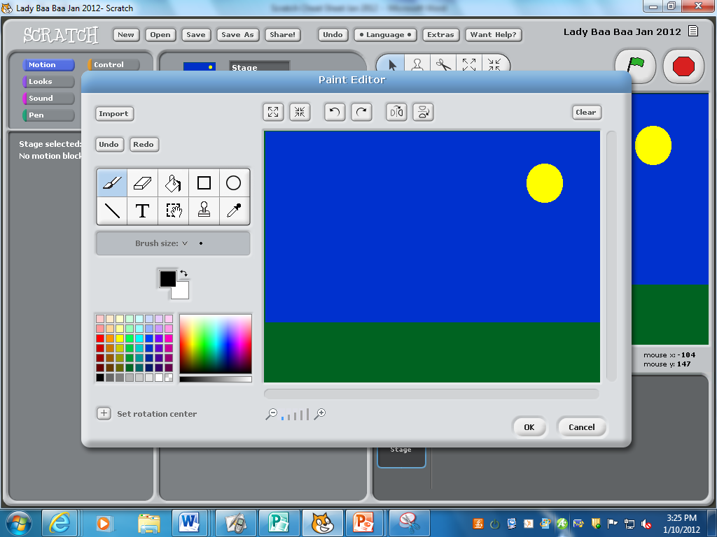

- You can move the Text Tool cursor around the page by moving the black dot. When you do so, the dot will change to a hand, allowing you to move around the background and then type.
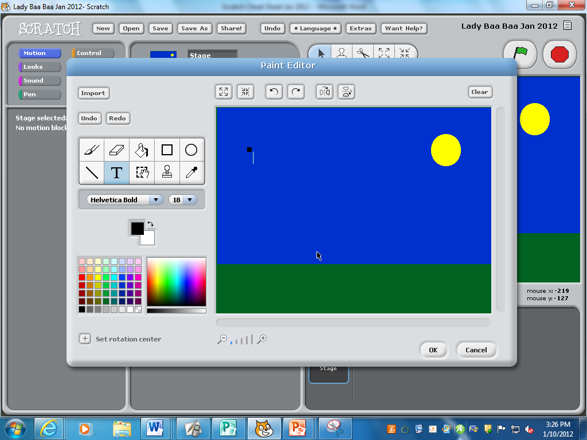
Sample text box and outline of the rectangle tool.
- Add more text boxes around the Stage to explain your curriculum-related topic!
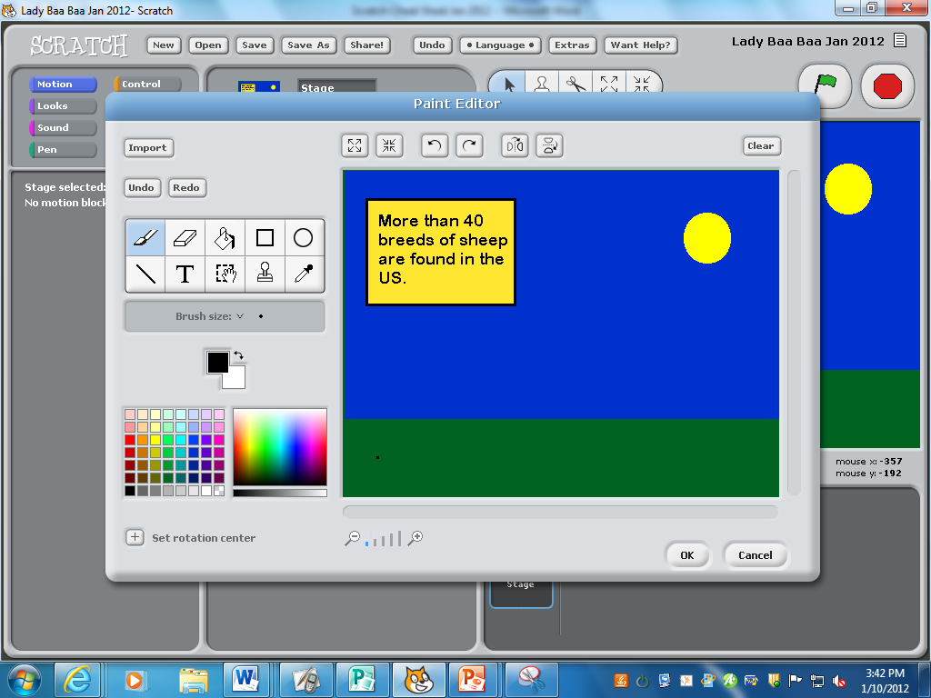

Fill
Tool=
yellow

- You can also import pictures, once you’ve saved them on your number. Click on the shrink button to make the picture smaller and on the Select tool to move it around.
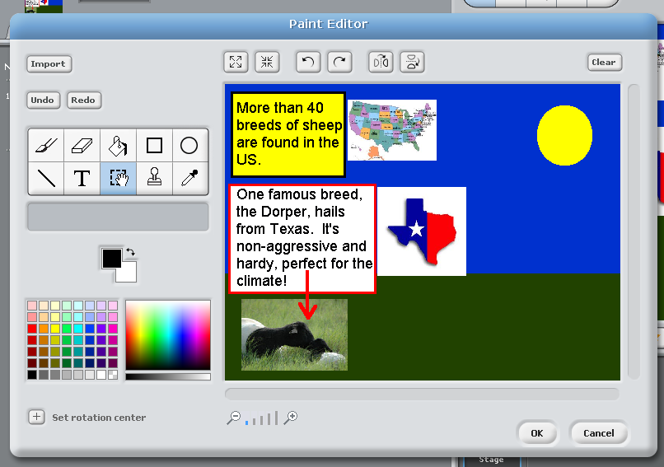

View on the main screen once you click OK.
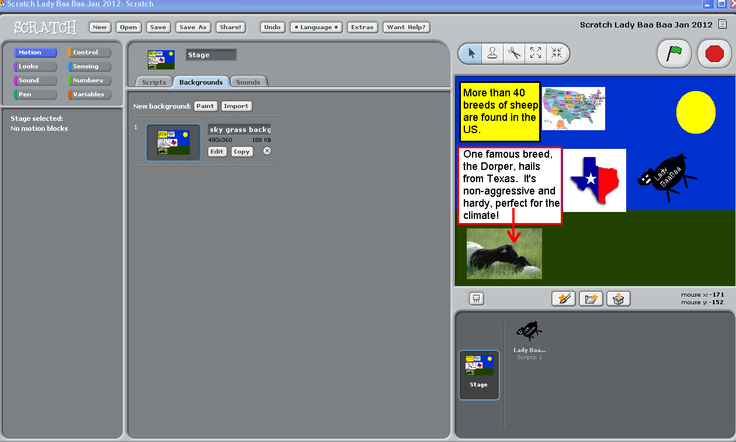

Part Three: Let’s add some actions to our sprite!

Important background information to successfully add actions to your sprite:
- Adding actions to a sprite is called writing a “script” or “code.”
- The “script” or “code” is an instruction recipe which tells your sprite what to do.
- Scratch has built in commands for moving sprites. All of these commands are located under the Motion section of the code screen.
- You need an initiating action to get started on any part of the code.

- In order to switch from the Stage screen to adding actions to your sprite…
  - First, click on your sprite (thus leaving the Stage view).
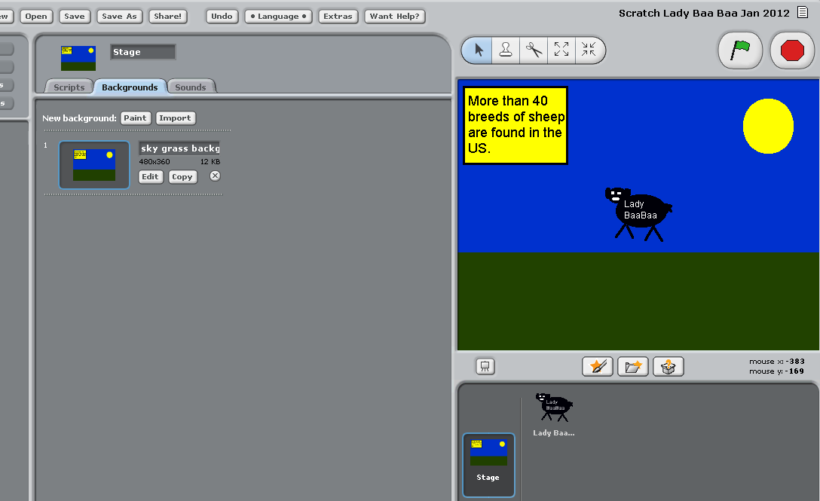
Now, in order to add the “script” or “code,” to your sprite, click on the Scripts tab.

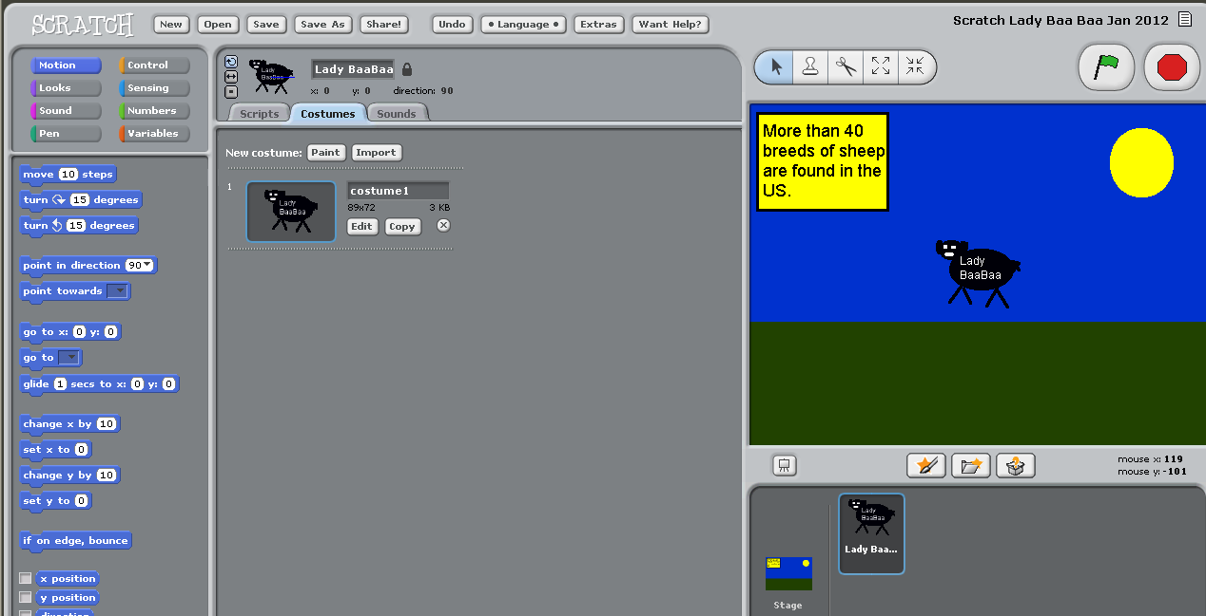
There are two important Categories of Button that you will use in order to move your sprite.
- The first one is the Control button. The control buttons allow you to initialize (start) your action.
2. The second Categories of Buttons is the Motion button. These set of buttons allow you to move your sprite. 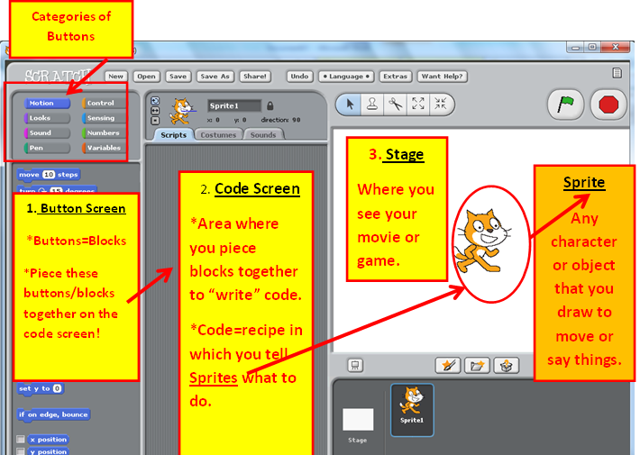

The Control button explained in detail:
  - First, click on the Control button.
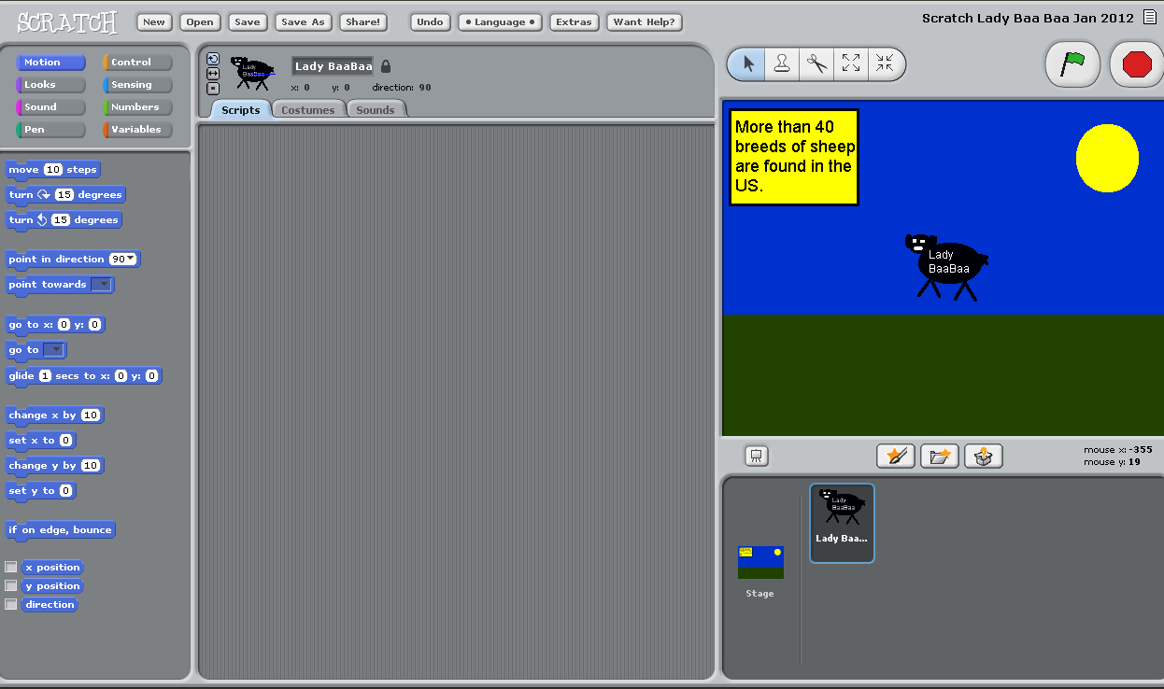

  - These are the Control button options that you have to initialize (start) your sprite’s action. Choose one (or two) that interests you.
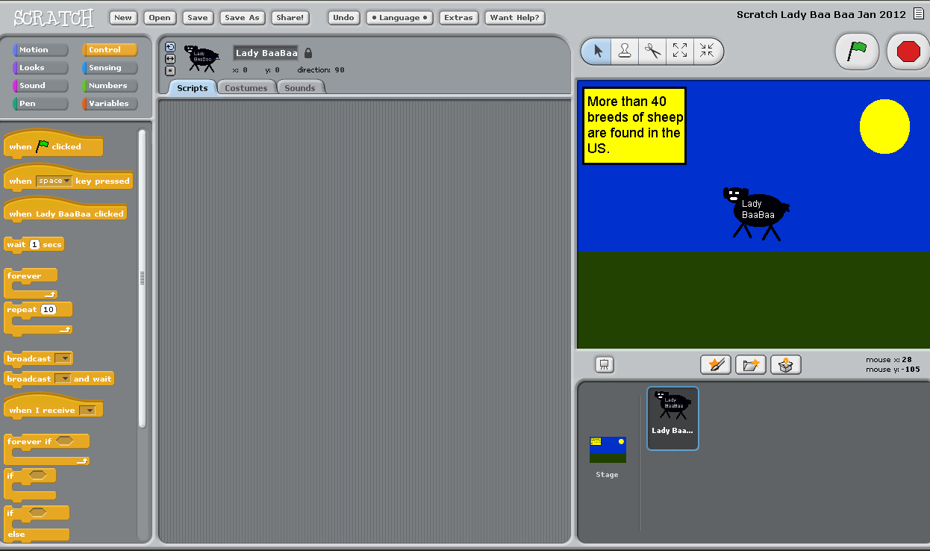

  - I’m going to drag over the Control buttons “When space key pressed” and “forever” to the Scripts/Code screen. I’m going to place these buttons together to initialize or start the code (i.e. move them closely together so they “lock.”)
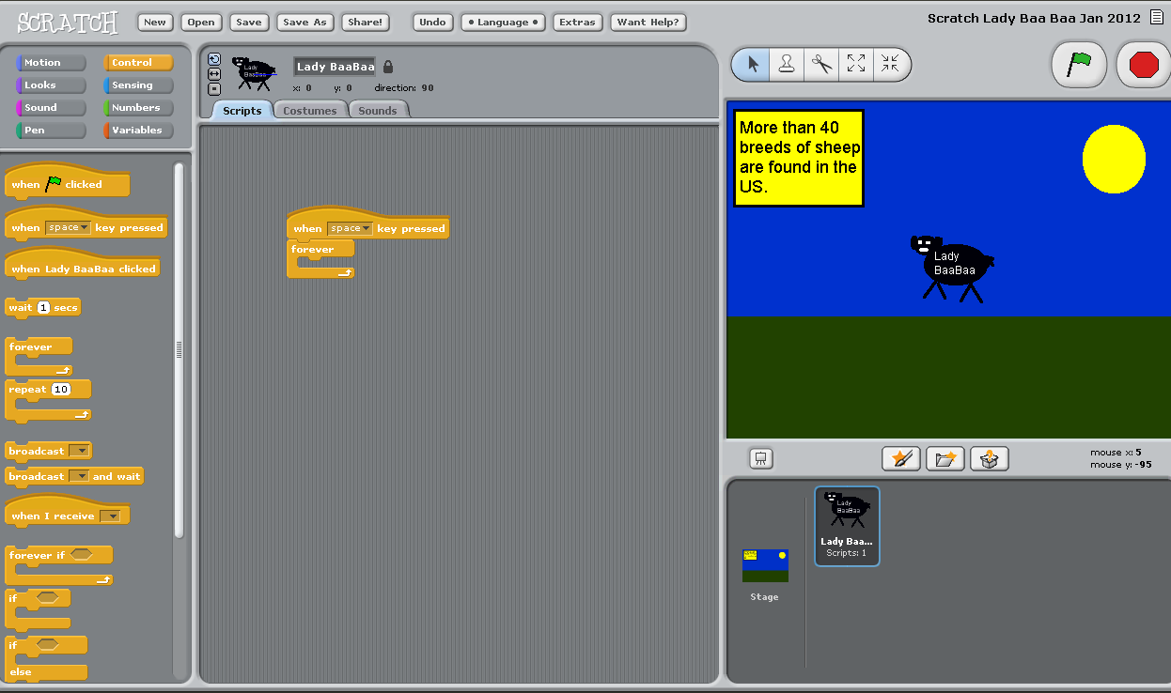

  - The Control buttons “hug” the other buttons inside of them in order to have the Script take action. In other words, the other buttons fit inside the Control buttons.
    - In the example below, first I clicked on the Control button and dragged over two Control buttons to the Scripts area.
    - Next, I clicked on the Motion button. Any of the Motion buttons below can be dragged inside of the empty space “inside” of the Control buttons.
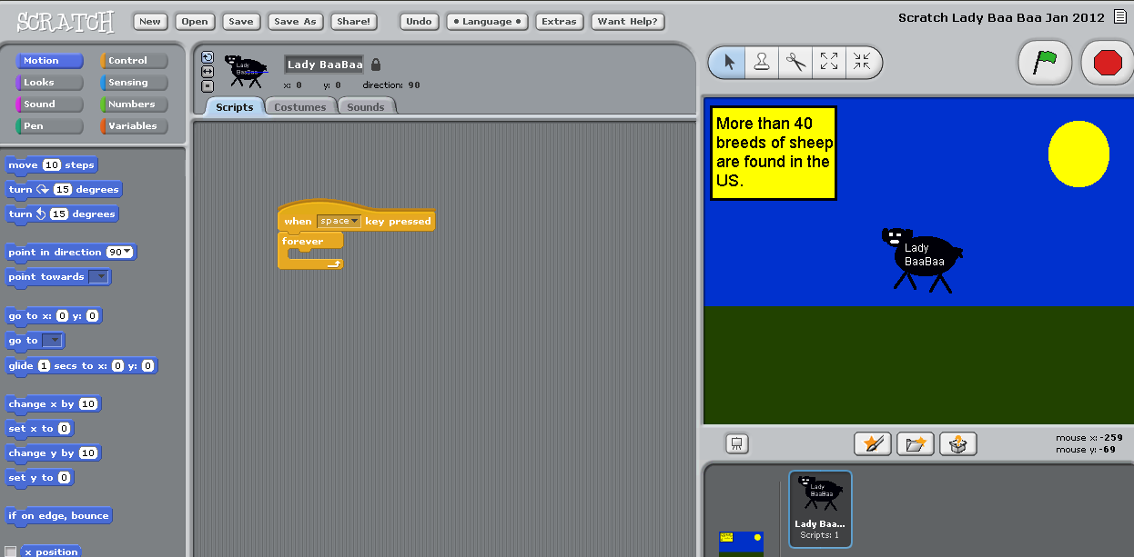
2
1
Motion button explained in detail:
- In order to make my sprite move, I must drag one of the Motion buttons inside of the “hug” of the Control button(s).
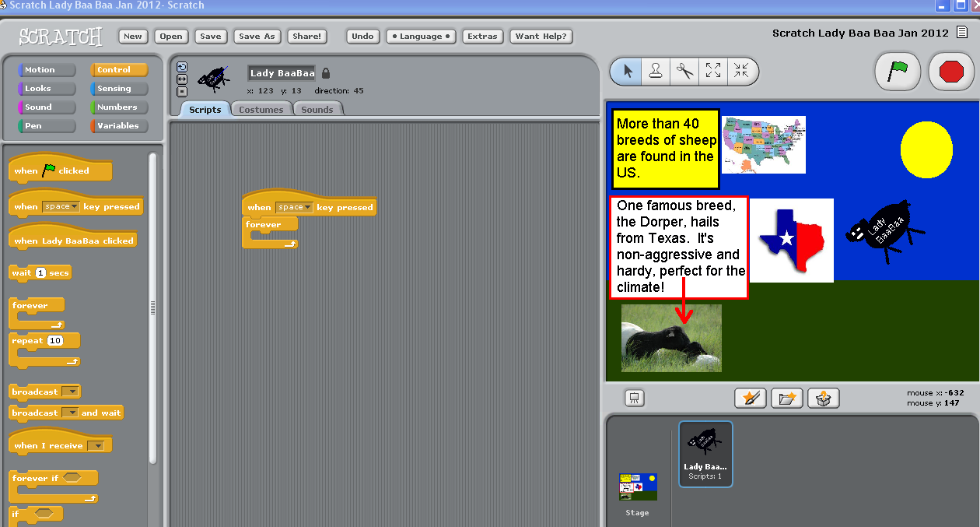
- I’m going to choose the glide and move examples to make my “Lady Baa Baa” sprite move down, around and back up the page. You may experiment at this point with your sprite and various motions.
  - Drag some Motions inside of the Control buttons to have your sprite move around the page.
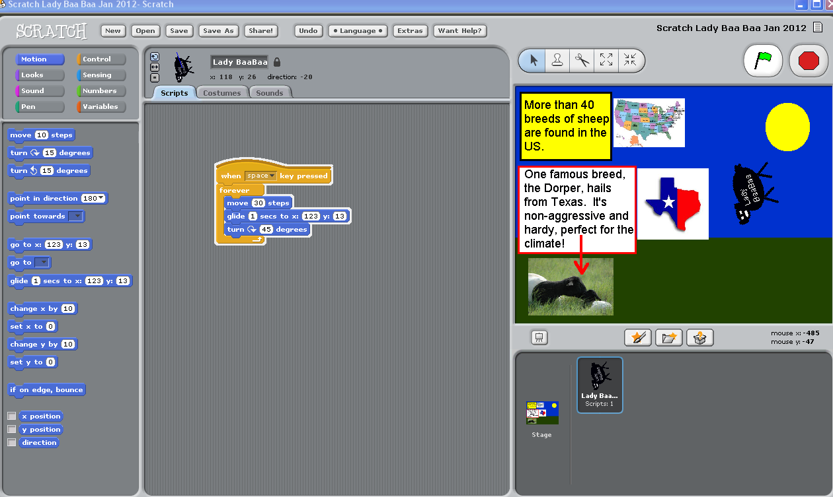
- To view your masterpiece on the “big screen” click on the Enter Presentation mode.

Presentation mode of your masterpiece:
