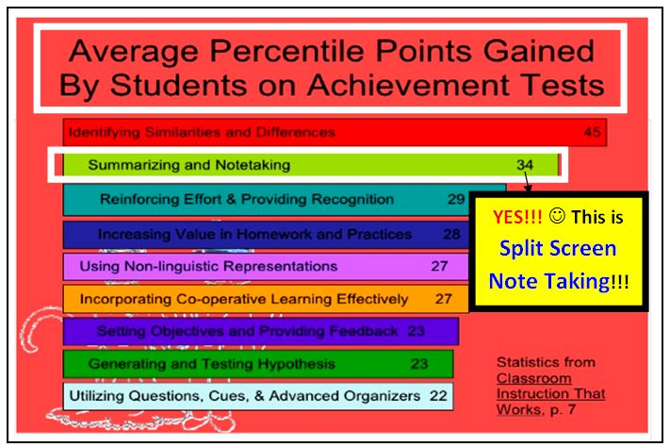
How to Write a Summary about the Civil Rights Movement
Marvelous Mrs. Mavridis’ 6th Grade ELA Classes
Document Created by Lynn Murray, TOR LMC
February 26, 2017
It’s FUN!!! It’s Easy!!! You’ve got this!!!

1 | Read over your Cornell Notes. | 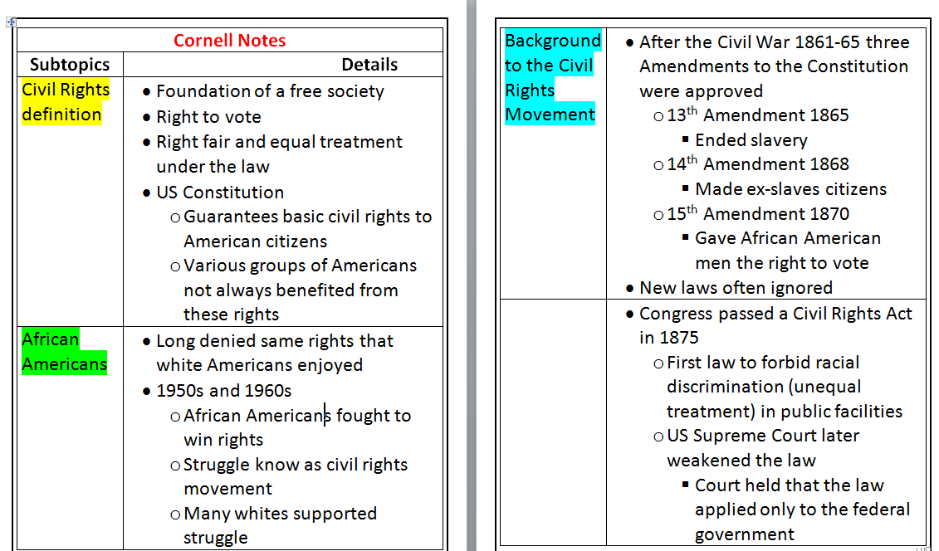
2 | Split your screen.  - Place your Cornell Notes on the LEFT.  - Place a blank new document on the RIGHT. (Ctrl N)  - Write the same heading and title on your new document.  - Keep your font size on 11. | 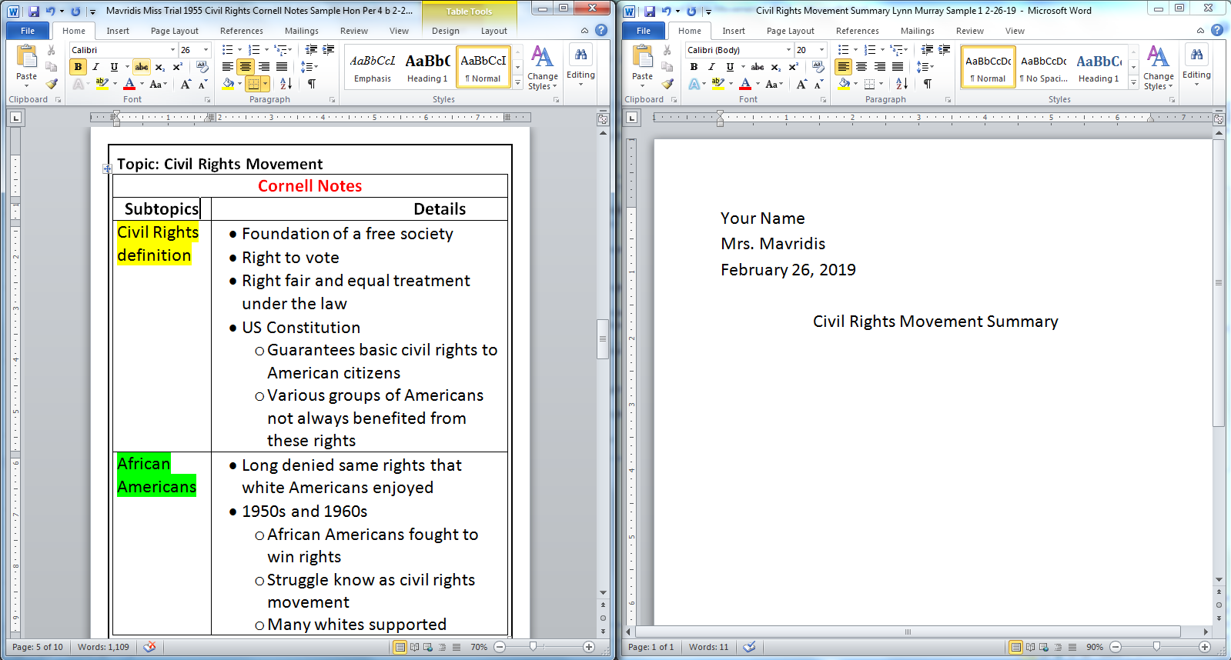
3 | Think!!!  - You are going to write a paragraph summarizing the information in your Cornell Notes.  - Write a couple of sentences for every Subtopic.  - Use details from your Cornell Notes to create your summary.  - Cross out details (abc) from your Cornell Notes as you write. | 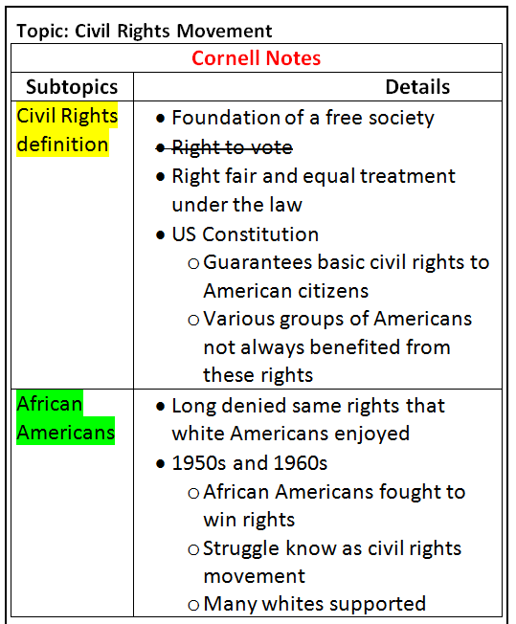 | Civil Rights Movement  Paragraph Summary Sentence Structure Steps  Marvelous Mrs. Mavridis’ ELA Classes  First sentence=First Subtopic - Civil Rights definition Topic sentence: Define Civil Rights. - Use details from your notes in your sentence. - Cross out details (abc) from your Cornell Notes as you use them.  Second sentence(s)= Second Subtopic - African Americans Write 1-2 sentences that explain how African Americans relate to Civil Rights Movement during the 1950s and 1960s. - Cross out details (abc) from your Cornell Notes as you use them.  Third sentence(s)= Third Subtopic - Background information about the Civil Rights Movement Write 2-3 sentences that explain key events leading up to the Civil Rights Movement. - Cross out details (abc) from your Cornell Notes as you use them.  Fourth sentence(s)= Fourth Subtopic - The Civil Rights Movement Begins Write 2-3 sentences that explain the beginning of the Civil Rights Movement. - Cross out details (abc) from your Cornell Notes as you use them.  Fifth sentence(s)= Fifth Subtopic - Peaceful Demonstrations Are Met with Violence Write 2-3 sentences that explain how peaceful demonstrations are met with violence. - Cross out details (abc) from your Cornell Notes as you use them.

