How to Insert Sound on Promethean ActivInspire
Created by Lynn Murray for TOR’s Super Students
December 2017

How to use the Sound Recording tool on Promethean Inspire:
- You can record your voice on your Promethean board and add it to a Promethean flipchart

- Steps to add a voice recording:
- Type something that you would like to record and include on your Promethean flipchart as a speaker icon to click on.
- Tools>More Tools>Sound recorder

- When you are ready to record, click on the red circle. Finish talking>black square.
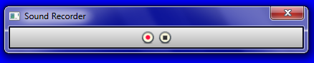
Stop
Record

- When you finish recording, a small speaker will appear on your flipchart.
- Click on the speaker by clicking on the arrow with your mouse to hear your recording.
- Don’t like it? Drag it to the trash can.
- Add your text, Cornell Notes and Publisher brochure to your flipchart.
- Insert>Link>File…
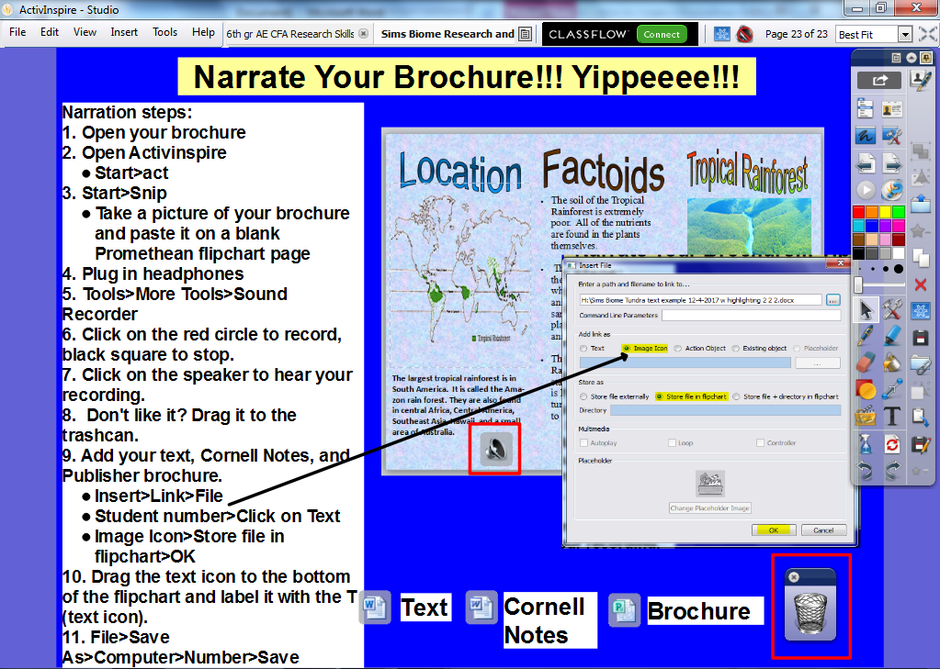
- Computer>student number
- Click on your biome text
- Follow the diagram below:
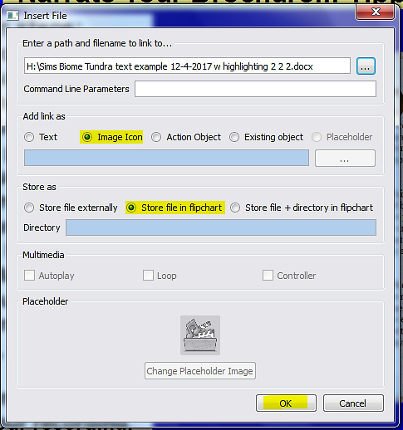
- Save your Promethean flipchart!
- File> Save As> Pull down and click on your number> Save.

