Name:
Date:

Planet Research
Cornell Notes, Resources, Citation, Summary Writing & Promethean Flipchart Instruction
Marvelous Mrs. Gonzerelli

Assignment: You will read book and database resources to research your chosen planet. After you finish your Cornell Notes you will write a summary and create a Promethean flipchart about your findings.

SPS Resources:
#1=Books on reserve

#2=Encyclopedias

#3= Grolieronline
- TORonline.org>Media Policies>Destiny link>TOR
- Scroll down to Destiny Book Catalog & SPS Database Access
- Grolier Online
  - Search your planet

#4=Newsbank
- TORonline.org>Media Policies>Destiny link>TOR
- Newsbank
- Click on the NewsBank KidsPage
  - Click on Best Matches>Search your planet
How to Write Cornell Notes:
- toronline.org>Media Policies>Destiny link>TOR>TOR Library Media Center Website
  - Download, save, and READ How to Write Cornell Notes
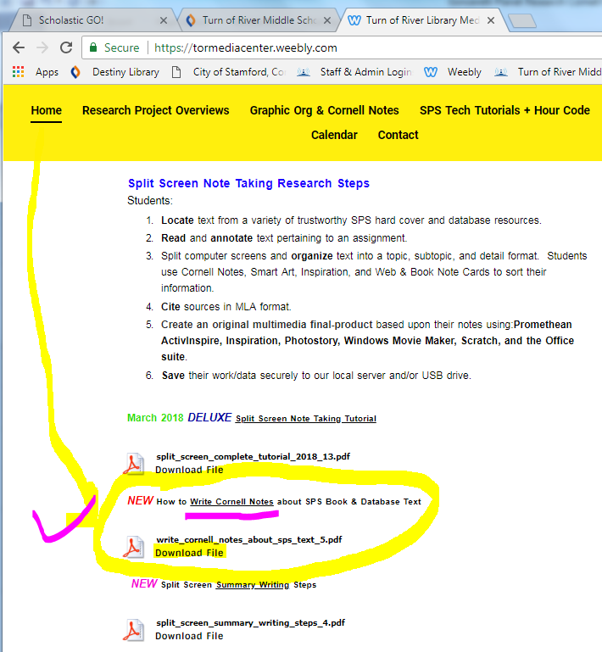>>>>>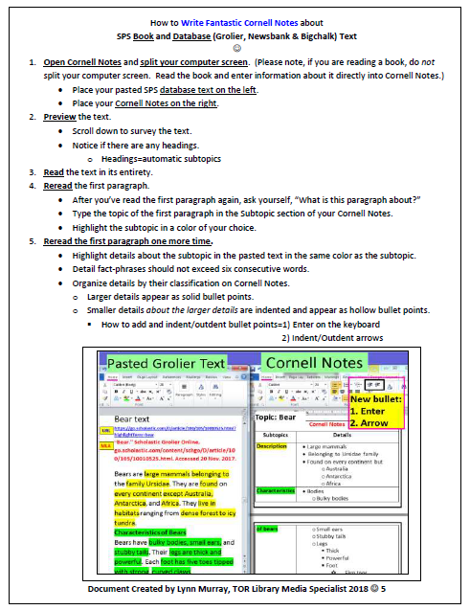
How to Cite Sources in MLA Format:
***For more information, check out TOR’s Library Media Center website.
- toronline.org>Media Policies>Destiny link>TOR>TOR Library Media Center Website>Works Cited link
Book:
Last, First. Book Title. City of publication: Publisher, Year of publication.
Print Encyclopedia:
Last, First. “Article Title.” Encyclopedia Name. City: Publisher, Year Published.
Website:
Last, First. “Article Title.” Website Title. Website Publisher, Date Month Year Published. Web. Date Month Year Accessed.

(Sample) Works Cited
"Jupiter." Scholastic Grolier Online, go.scholastic.com/content/schgo/D/article/ -h.html. Accessed 22 May. 2018.
"Jupiter Facts." Scholastic Grolier Online, go.scholastic.com/content/schgo/D/article/201/585/2015850-001.html.Accessed 22 May. 2018.
Vogt, Gregory. Jupiter, Saturn, Uranus, and Neptune. Steadwell Books, 2001.

_______________________________________________
Highlight your chosen planet:
- Mercury
- Venus
- Mars
- Uranus
- Jupiter
- Saturn
- Neptune
- Pluto

Planet:
Cornell Notes
Subtopics | Details
Name: What does its name mean?
Appearance: What does your planet look like?
Size: How big is your planet? What is your planet's mass?
Composition: What type of planet is it (is it rocky or a gas giant)? What is your planet made of?
Position in the Solar System: Where is your planet located?
Temperature: What is the temperature range your planet?
Discovery: When was your planet discovered? Who discovered it?
Something special about your planet.
Summarize your notes here:

How to write a summary about your Cornell Notes:
- toronline.org>Media Policies>Destiny link>TOR>TOR Library Media Center Website
  - Download, save and READ the Split Screen Summary Writing Steps
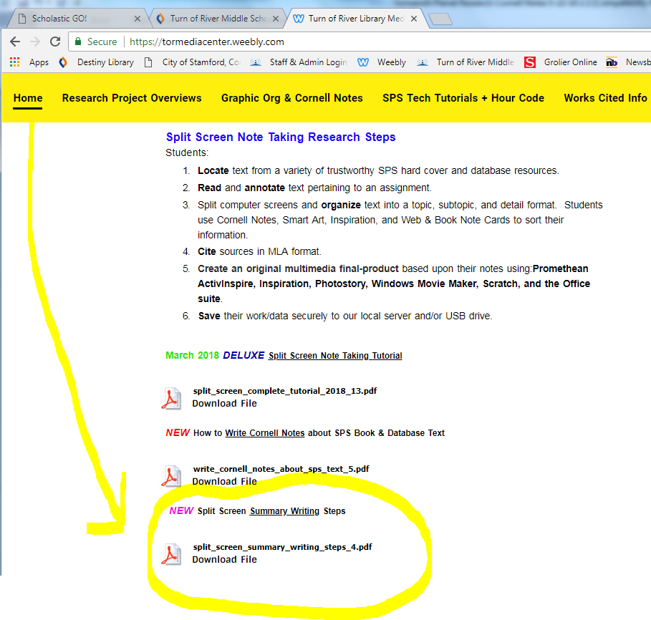

  - Follow the directions about how to write a summary based upon your notes.
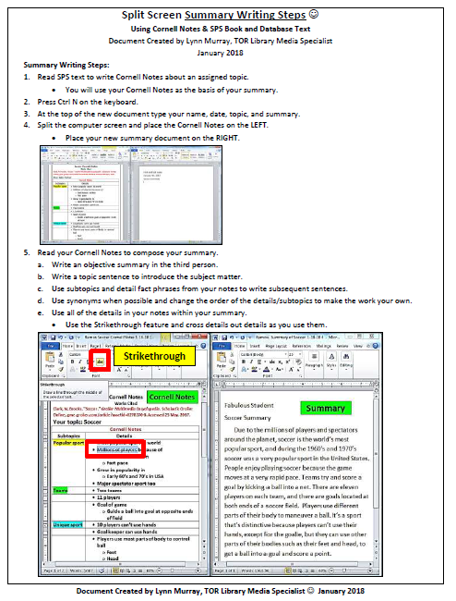
How to create a Promethean flipchart about your work:
- toronline.org>Media Policies>Destiny link>TOR>TOR Library Media Center Website>SPS Technologies link
  - Scroll down to the Promethean section.
  - Download, save and READ the Introductory and Sound tutorials.
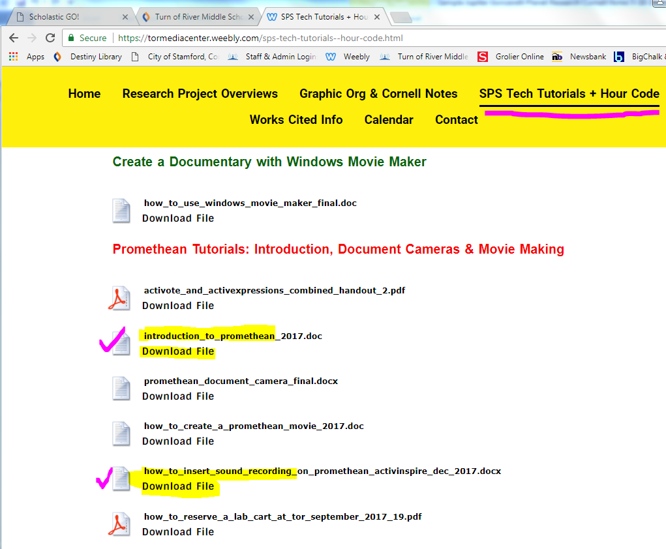

  - Introduction to Promethean tutorial:
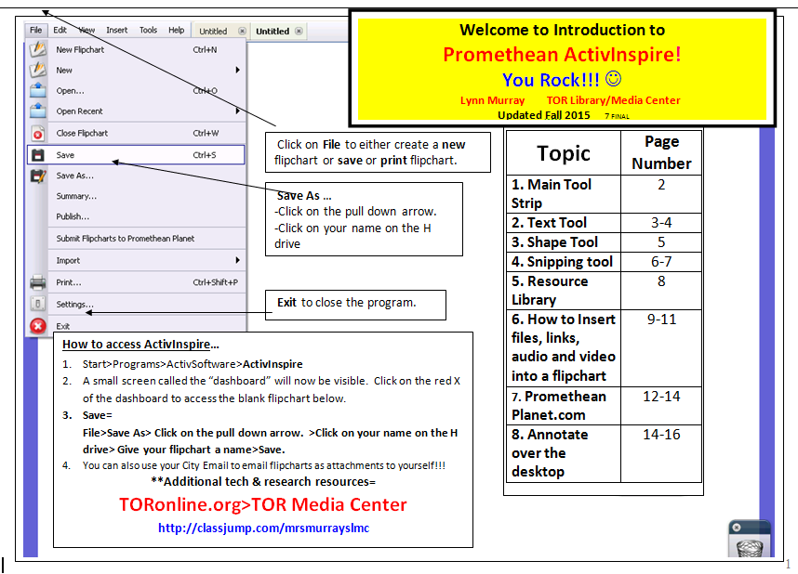
  - How to insert sound into your flipchart tutorial:
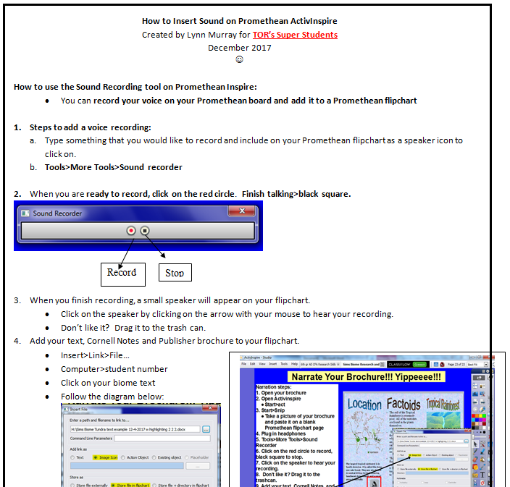

Sample Promethean Flipchart screenshots about Jupiter:


