Grolier and Newsbank text for
Grolier & Newsbank Access
- toronline.org
- Media/Policies
- TOR Media Center
- Scroll down to Destiny & SPS Database link>TOR
- Click on Grolier or Newsbank
- Search text by your reading level

The Secret Life of Bees & The Pearl Research 5
Marvelous Mrs. Fields
January 2018
Topics:
- Segregation and Jim Crow Laws
- MLK
- The Civil Rights Act of 1964
- Pearl Diving in Mexico
- The bombing of the church in Birmingham on 9/16/1963
______________________________________________________________________
- Segregation and Jim Crow Laws
- Grolier> Search: Jim Crow Laws
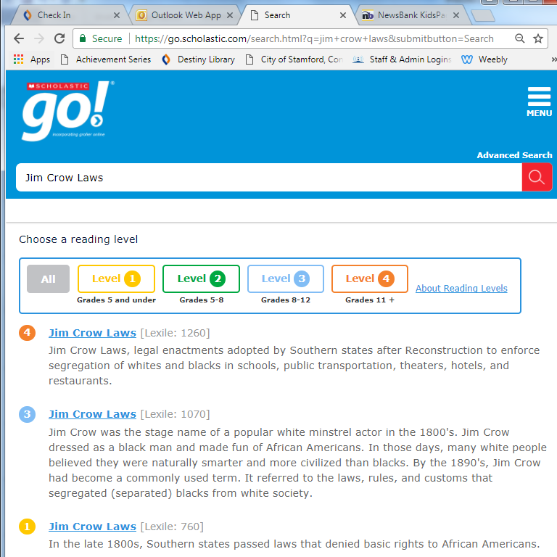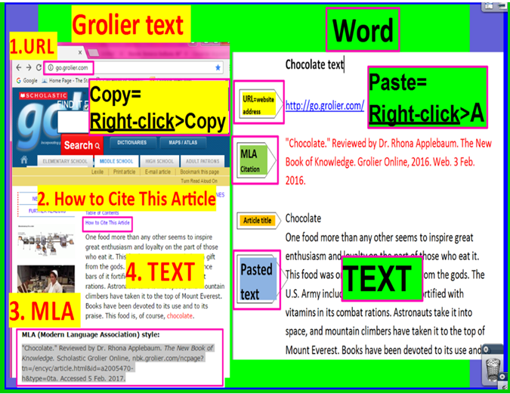
- Newsbank> Newsbank Kids Page>Search: Jim Crow Laws segregation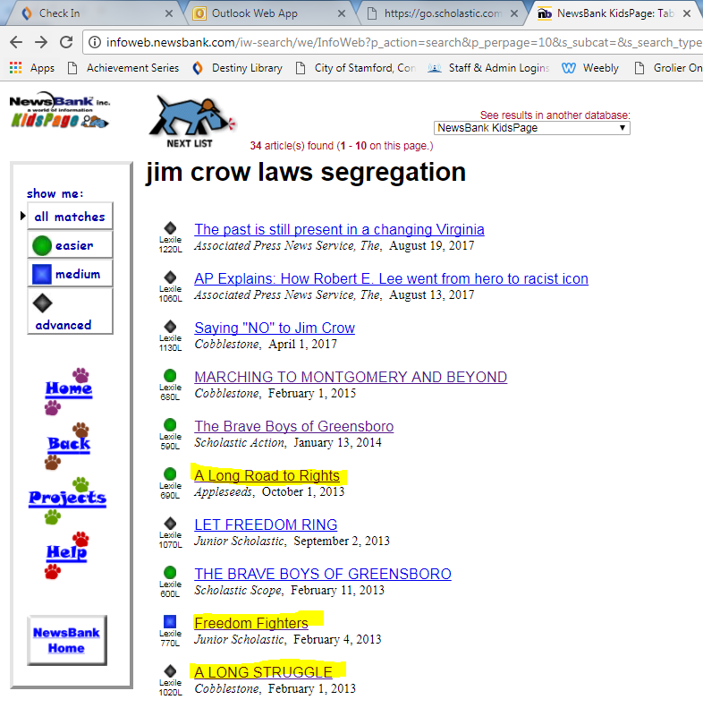

- Copy and paste the URL, MLA citation, and all of the text onto a blank text Word document.
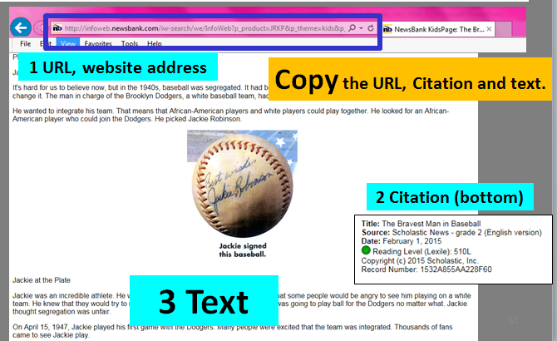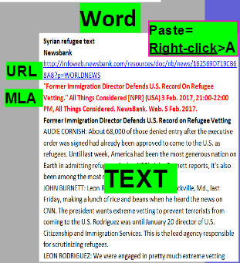
- Martin Luther King Jr.
- Grolier> Search: Martin Luther King
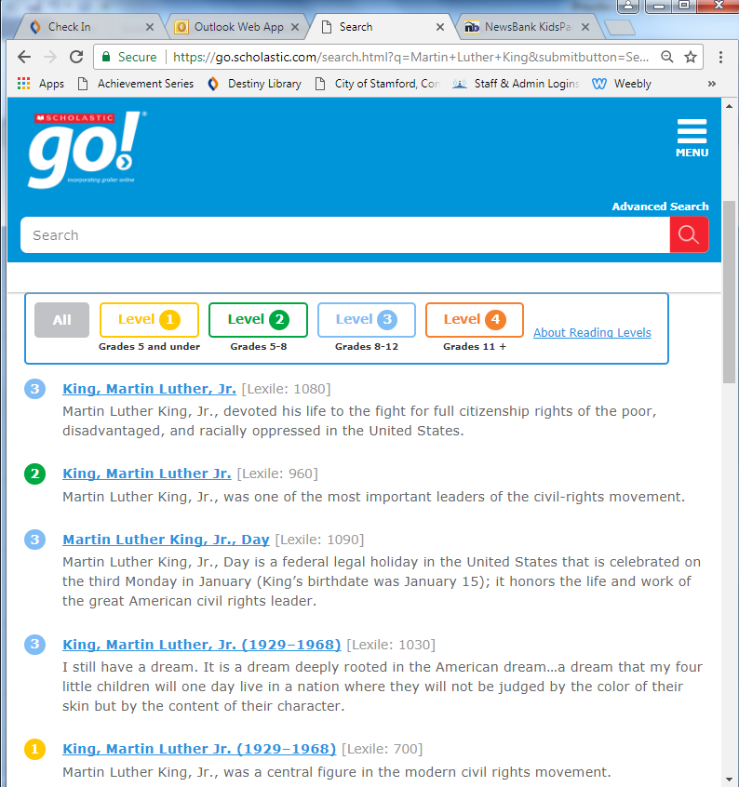

- The Civil Rights Act of 1964
- Grolier> Search: Voting
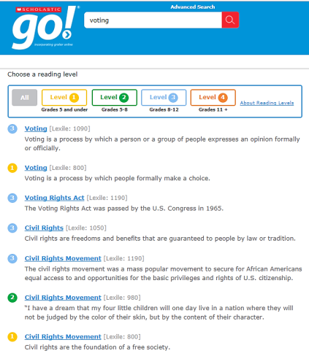
- Newsbank>Access World News
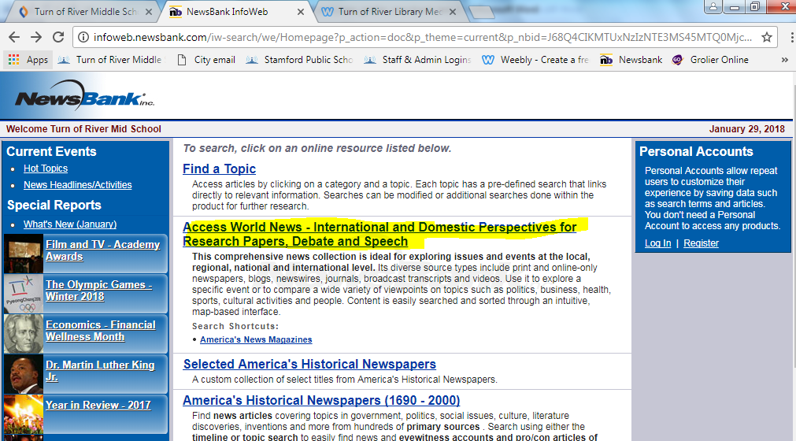
- Search: Civil Rights Act 1964 and click on Best Matches first.

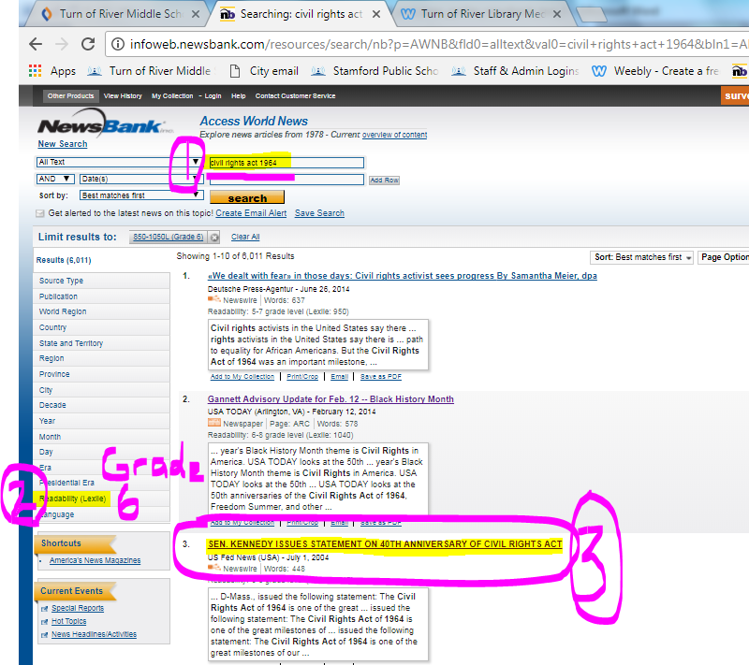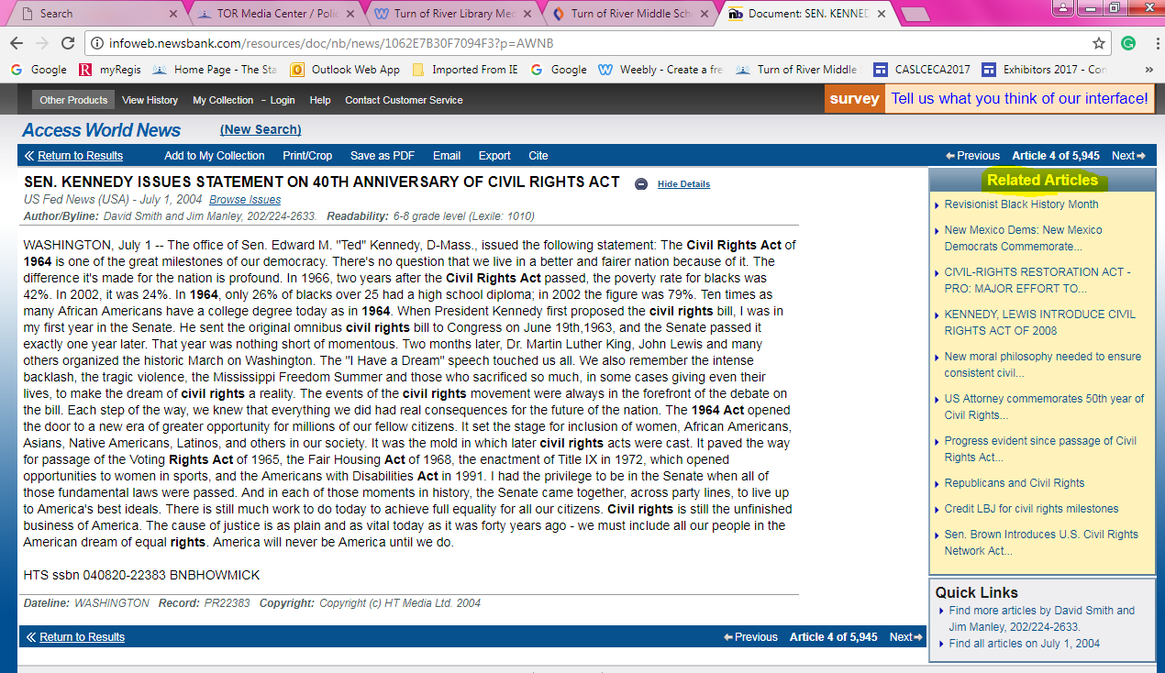
Civil Rights Act 1964

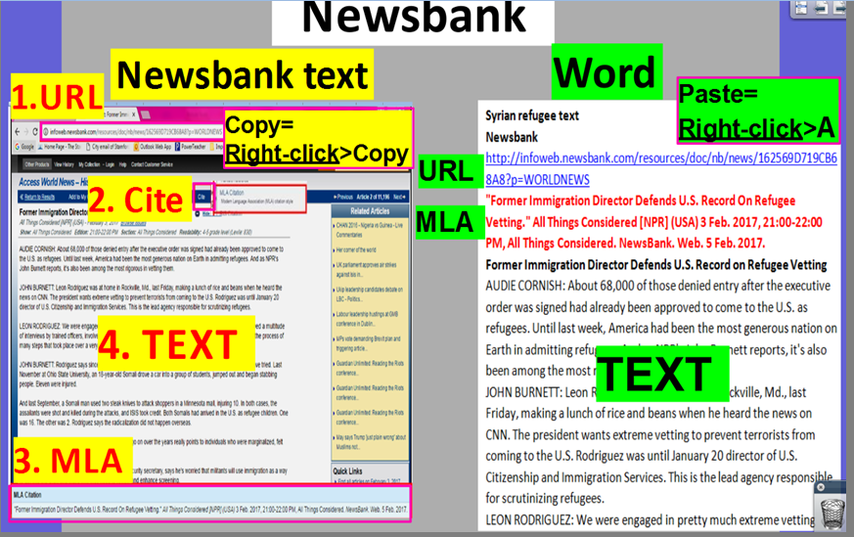
- Pearl Diving in Mexico
- Grolier> Search: pearl
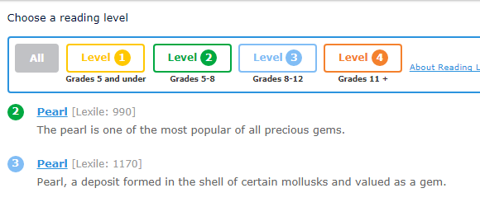

- The bombing of the church in Birmingham on 9/16/1963
- Newsbank>Access World News
- Search: Birmingham church bombing 1963 and click on Best Matches first.
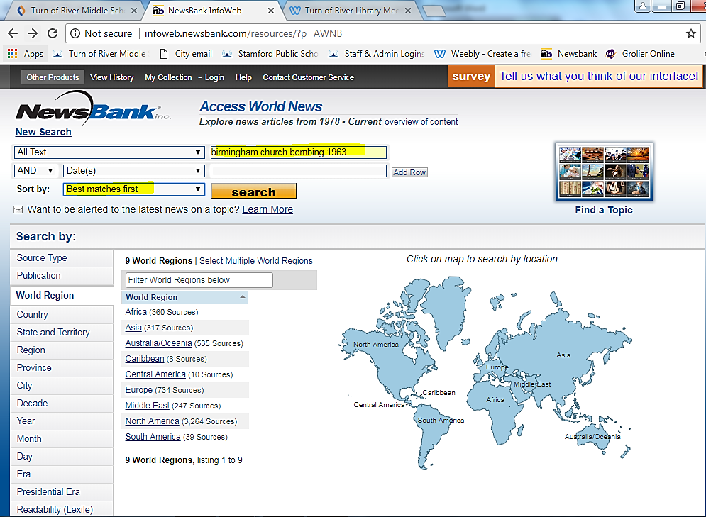
Birmingham church bombing 1963

- Click on #2 Inside the ER where four dead girls were brought 51 years ago today after a horrific church bombing
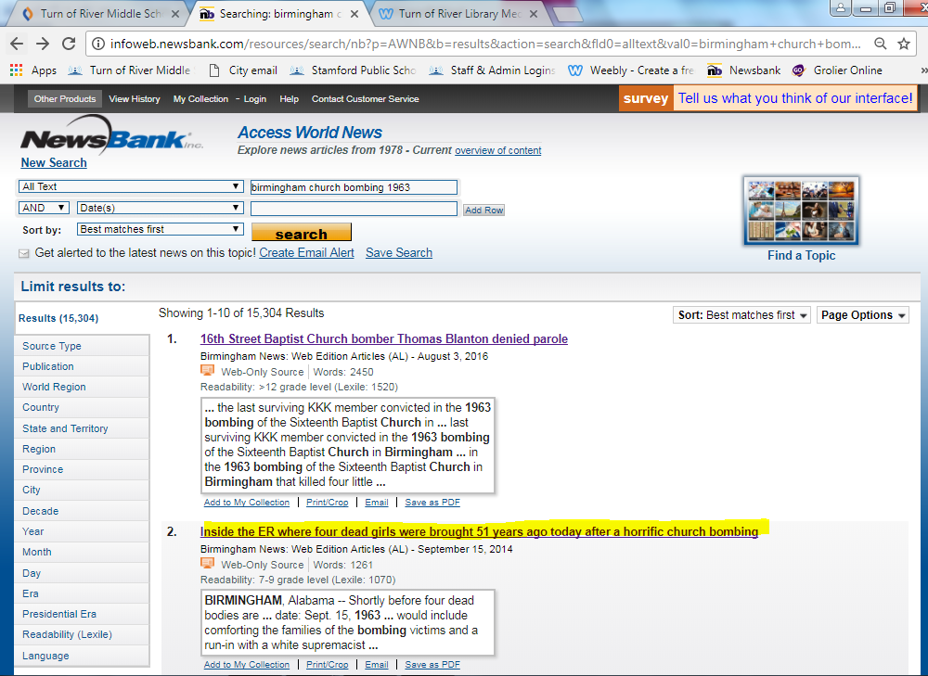
- Copy (Right-click>Copy) and paste (Right-click>A) the URL, MLA Citation and all of the text to your blank text document.
