Name:
Date:
7th Grade Argument and Research Project Overview
Fabulous Mrs. Fields ELA Classes You Rock!!!
Document Created by Lynn Murray, TOR Library Media Specialist
March 2018 7

Standard=CCSS.ELA-Literacy.W.7.1= Write arguments to support claims with clear reasons and relevant evidence.

Objective=Students will use the Split Screen Note Taking research method and write an argumentative essay about a topic from a given listing. Students will read high-quality published text from TOR’s library media center books and databases as the basis of their research. Students will locate, copy, and paste text from databases onto Microsoft Word, use the highlighter tool to annotate the text, utilize a specifically designed argument organizer as the basis of their essay, and cite their sources in MLA format.

Project Overview:
- Students will choose a topic or issue that interests them to research.
- From within that topic/issue they will state a claim and defend the claim with evidence gleaned from TOR’s hard cover book and database resources.
- Students will read about both sides of their topic/issue from SPS leveled database resources, and record their notes and applicable evidence on a specifically designed graphic organizer. Students will cite their sources on this graphic organizer as well.
- Students write an argumentative essay based upon their notes.

Important Argument Vocabulary:
- Argument=a statement of an author’s major point or position based on evidence.
- Position=the point of view that a person takes in an argument.
- Claim (simple) =your basic belief about a particular topic, issue, event or idea. It’s an opinion, proposal, evaluation, cause and effect statement or interpretation.
- Think in terms of good or bad/right or wrong/pro or con.
- Examples:
- Marathon running is beneficial for middle aged adults.
- Steroid use is harmful for high school aged students.
- The economy has affected Stamford’s downtown nightlife negatively.
- The cancellation of the November, 2012 NYC Marathon was a wise idea.
- Thesis statement (more complex) =sentence that summarizes the main point or claim of an essay or paper that is developed, supported, and explained by examples and evidence.
- Examples:
- Due to improved cardio vascular health, muscle development, and cognitive brain improvement, marathon running is extremely beneficial for middle-aged individuals.
- High school students who abuse steroids face many future health problems such as high blood pressure and heart disease, liver damage and strokes.
- Due to the damaging effects of Hurricane Sandy, the unsafe running route and the perceived hostility of the crowds, the cancellation of the 2012 NYC Marathon was a wise idea.
- Counter claim=a solid and reasonable argument that opposes or disagrees with your claim.
- You anticipate an objection and have an answer for another point of view.
- Support= specific evidence or examples to show that your claim is true.
- Evidence=facts, statistics, quotes or examples. http://valenciacollege.edu/wp/cssc/documents/TypesofEvidenceinPersuasiveFINAL.pdf
- Facts=cannot be disputed, can be proven.
- Grass is green.
- All cats are animals.
- Jumping out of airplanes without a parachute is hazardous.
- Statistics=amounts and numbers. Should come from reliable sources.
- 1.7% of Americans are underweight.
- Connecticut’s unemployment rate was 8.6% for December 2012.
- Quotes=what leading experts or authorities said about your topic.
- Dr. Smith, U.S. Surgeon General, described long term problems associated with underage drinking: “Research shows that young people who start drinking before the age of 15are five times more likely to have alcohol-related problems later in life.”
- Samantha Jones, a noted forensic specialist, stated that DNA evidence is usually indisputable.
- Examples=anecdotes from your own experience. Personal experience must be applicable, present reasonable background understanding, show a general situation and be related to the claim.

Resources to locate background information and evidence to support your claim:
- BOOKS and ENCYCLOPEDIAS!!!
  - Destiny access: toronline.org>Media Policies>Destiny link>TOR>Catalog tab>Search for books about your topic that’s written at your particular reading level
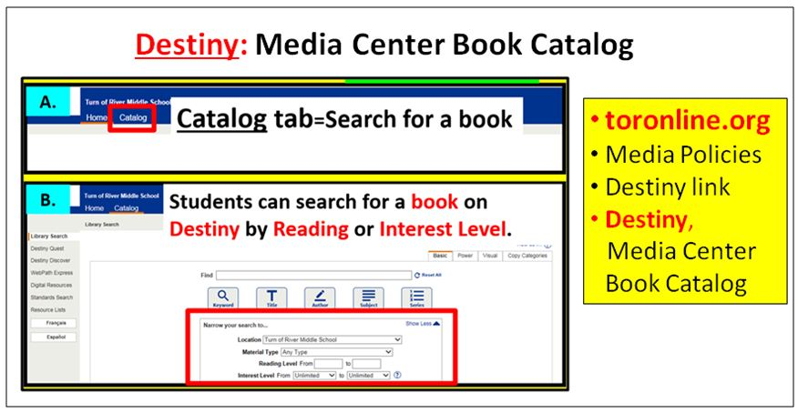
- Grolier Access: toronline.org>Media Policies>Destiny link>TOR>Grolier> Search for accurate, published online text about your topic that’s written at your particular reading level
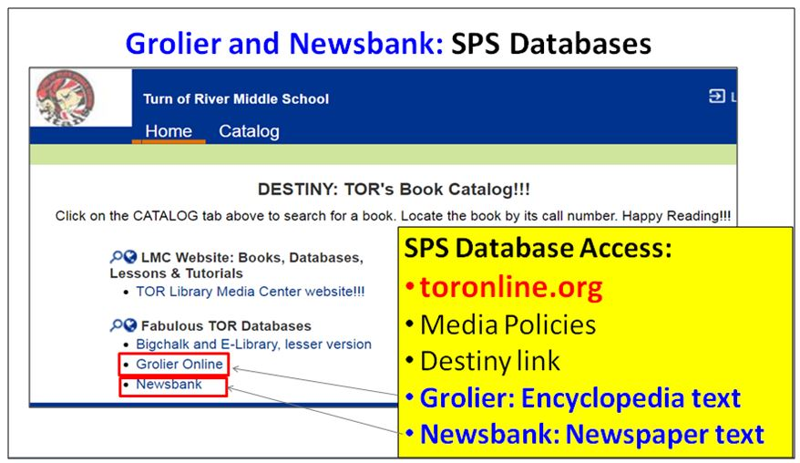
    - Copy and paste the text from Grolier to a blank Word document by following the directions below.
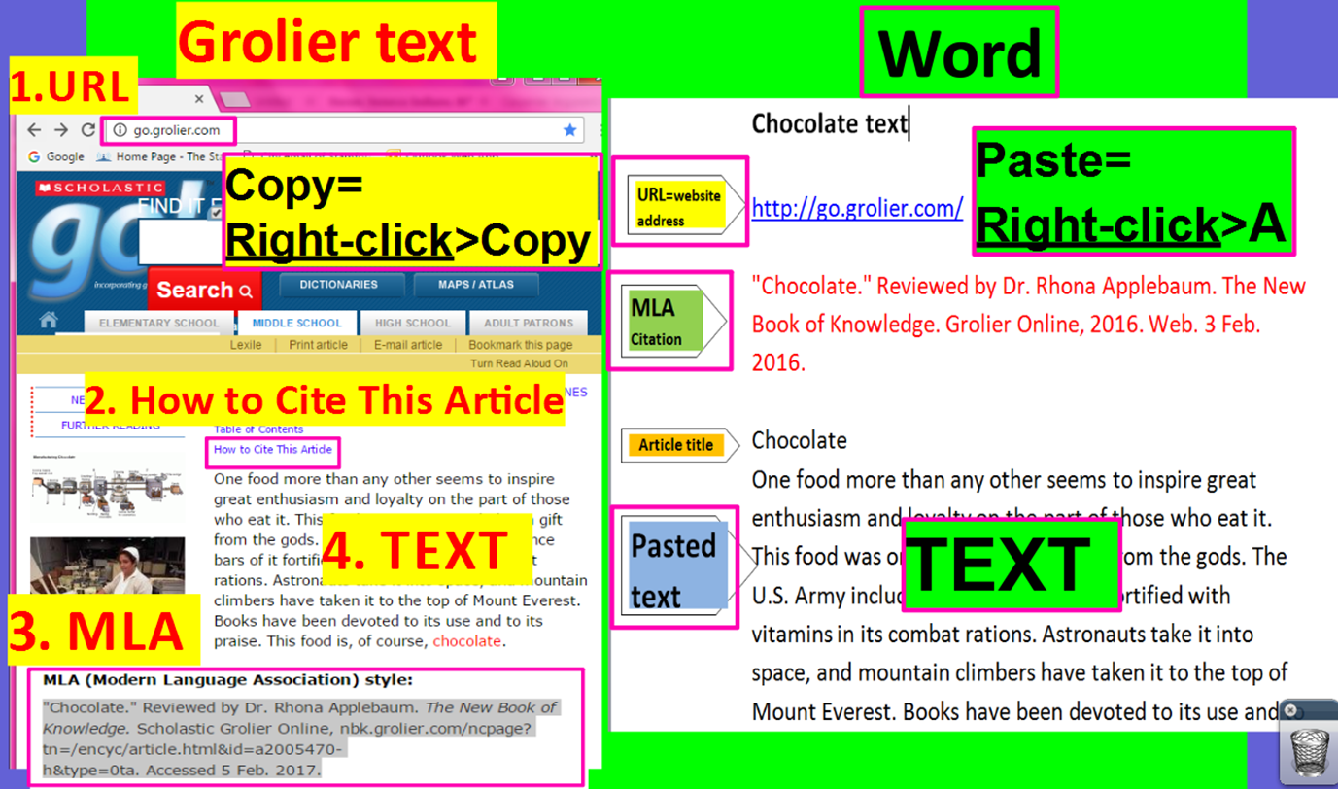
- Newsbank Access: toronline.org>Media Policies>Destiny link>TOR>Newsbank> Search for accurate, published online text about your topic that’s written at your particular reading level
  - Click on the Newsbank KidsPage link>Best Matches to find text about your topic that’s written at a lower reading level.
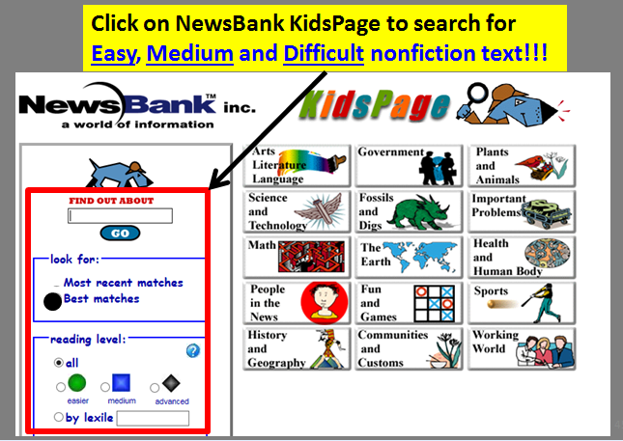>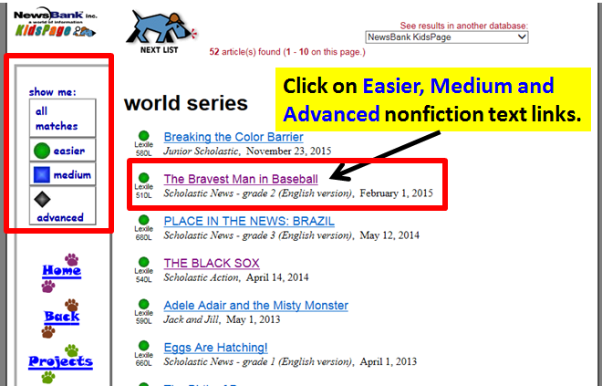
  - Copy and paste text from the Newsbank Kidspage onto Microsoft Word.
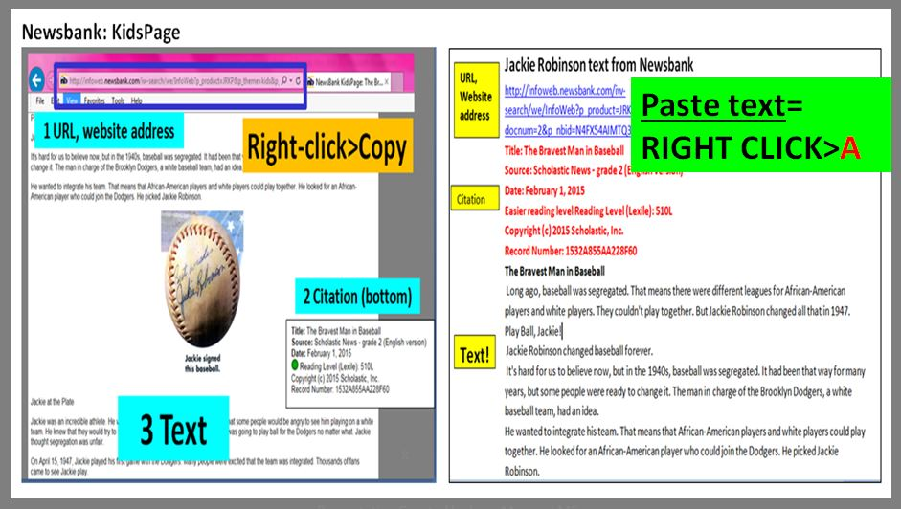
  - Click on the Access World News link to access fantastic newspaper text that’s written at your reading level from news organizations around the world!
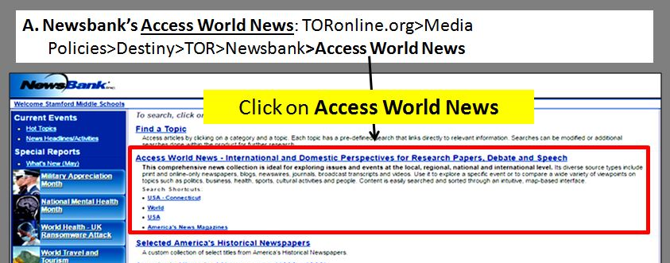
  - Search for text about your topic that’s written at a level you can understand by following the directions below:
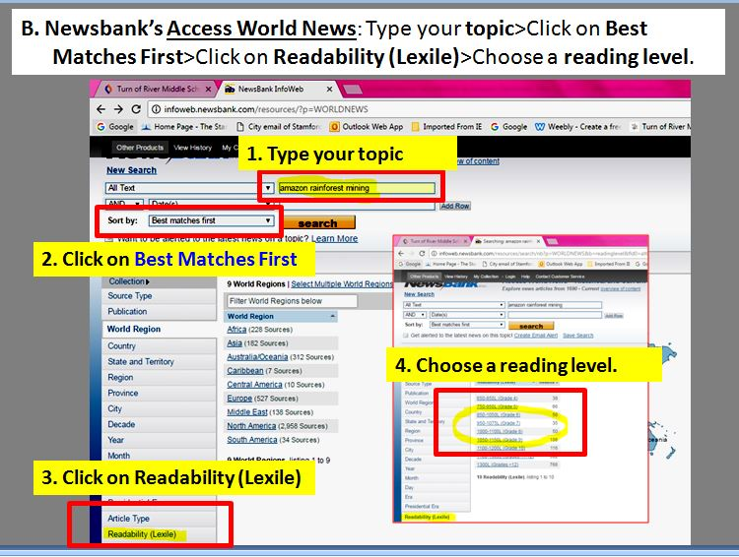
  - Read the titles and excerpts to see if the article looks good.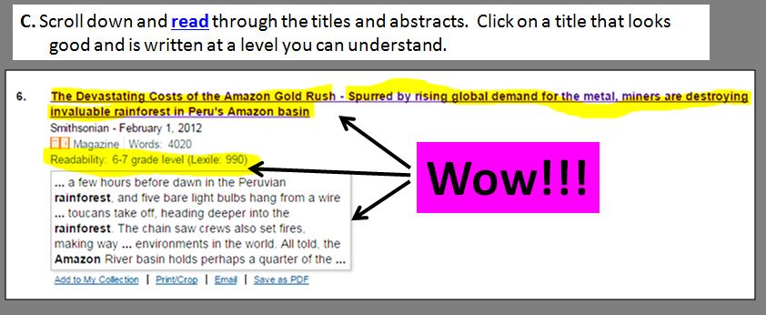
  - Copy and paste text from Access World News onto Microsoft Word.
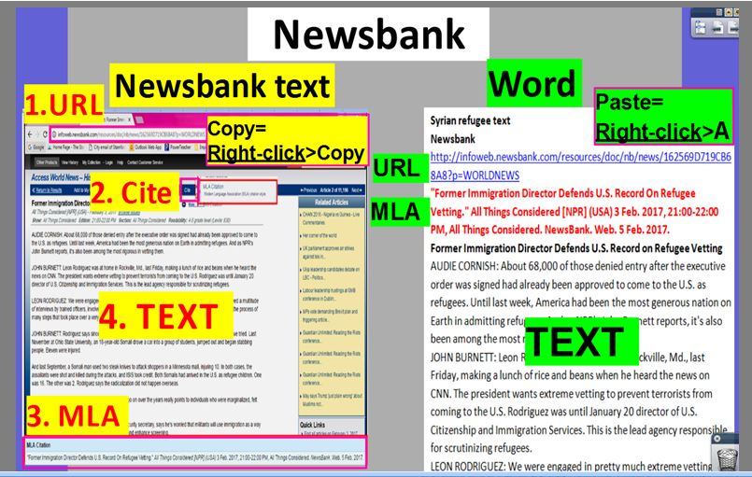
- NOT available at this time due to budget cuts: Bigchalk and E-Library
  - Bigchalk=AWESOME!!! Search through thousands of published articles about your topic from
resources like the New York Times, Time Magazine and 60 Minutes!
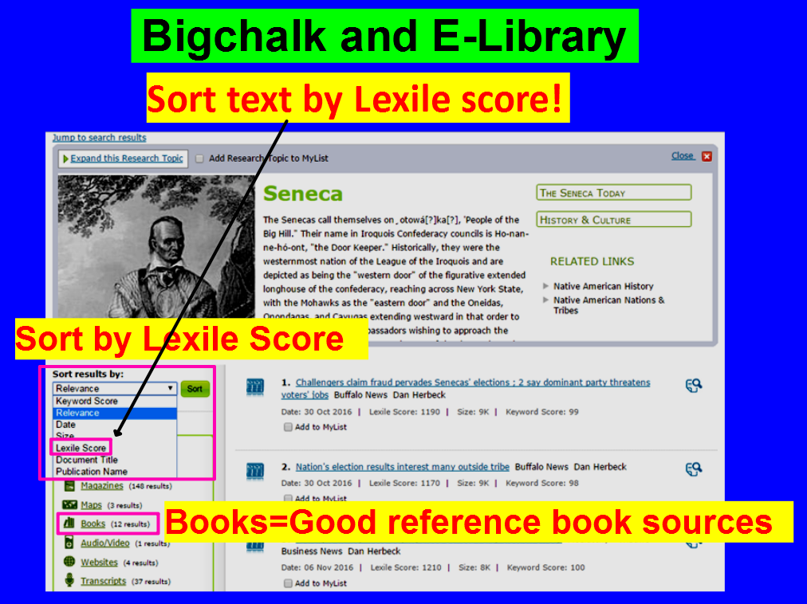
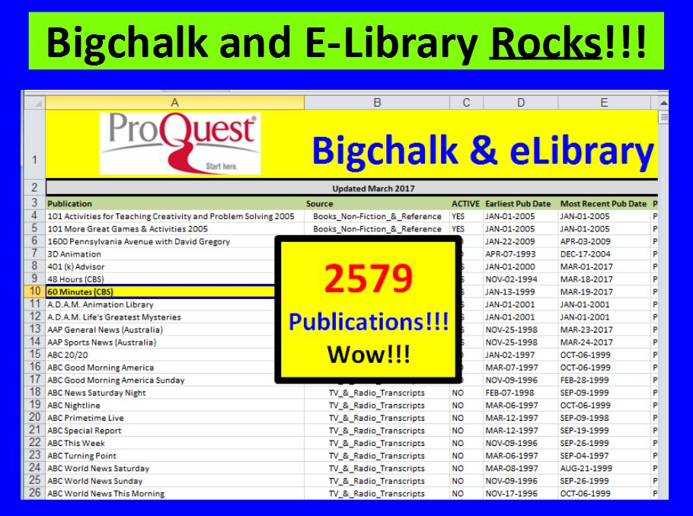
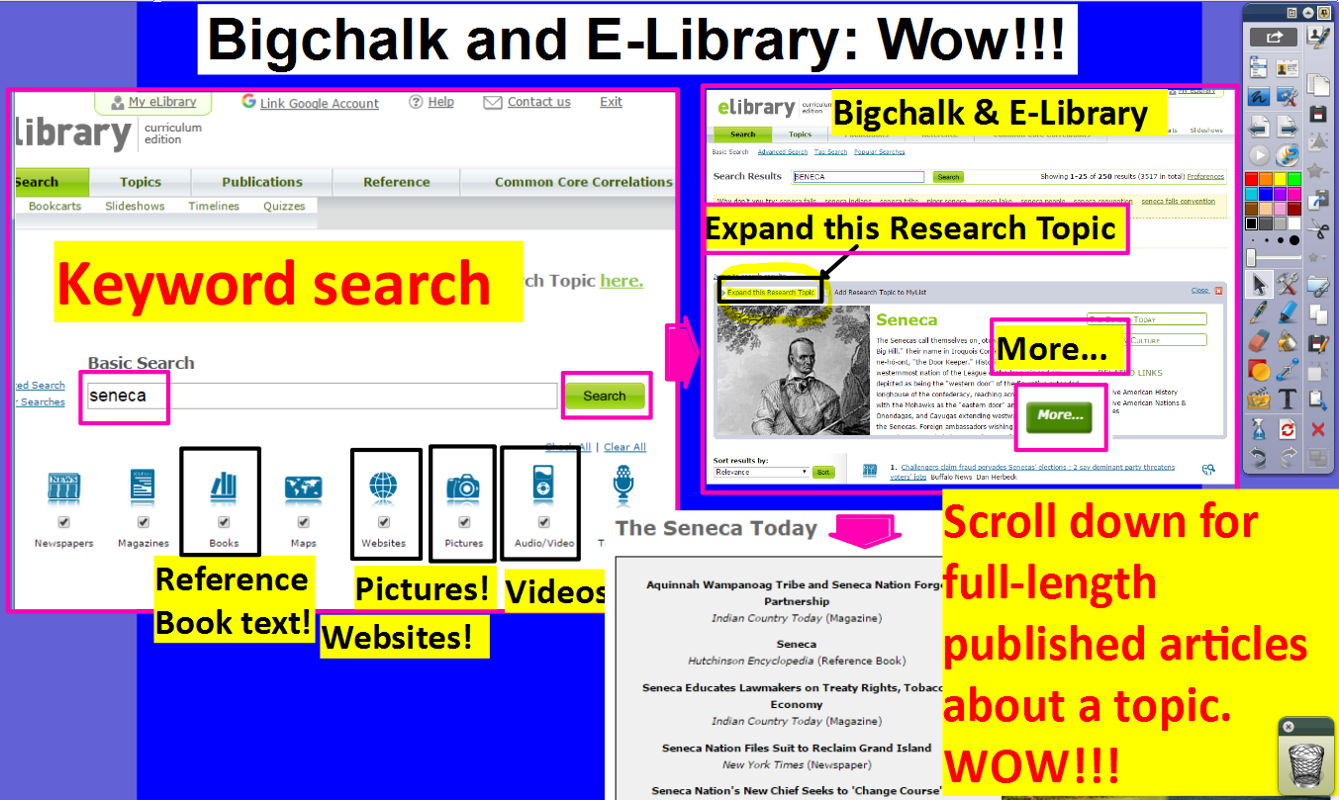

- Pro-Con.org= https://www.procon.org/
Research process:
- You will locate information about your topic and paste it on a blank word document (Ctrl N).
- Afterwards, you will split your computer screen to read, annotate, cite, and organize background information about your topic on the graphic organizer above.
- Pasted text and Graphic Organizer samples:
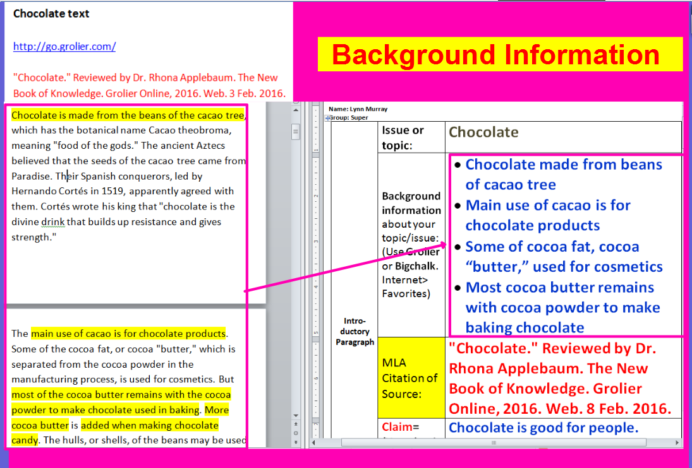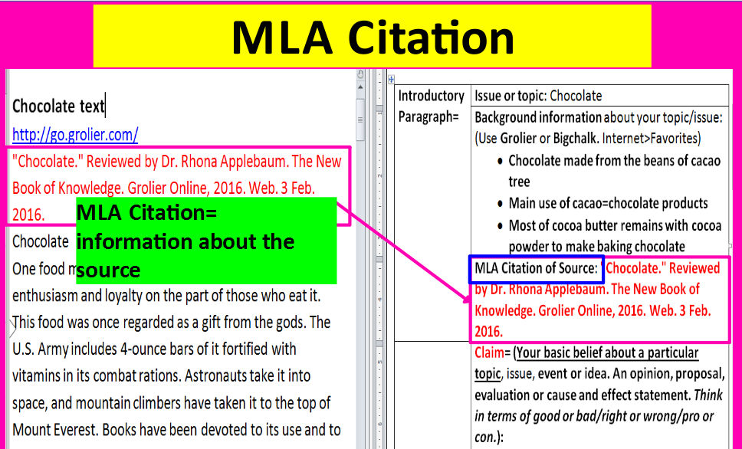
- Once your background information is complete, write a claim about the topic and locate evidence to support your claim (fact, statistic or quote). Record your evidence in the graphic organizer.
  - Fact example:
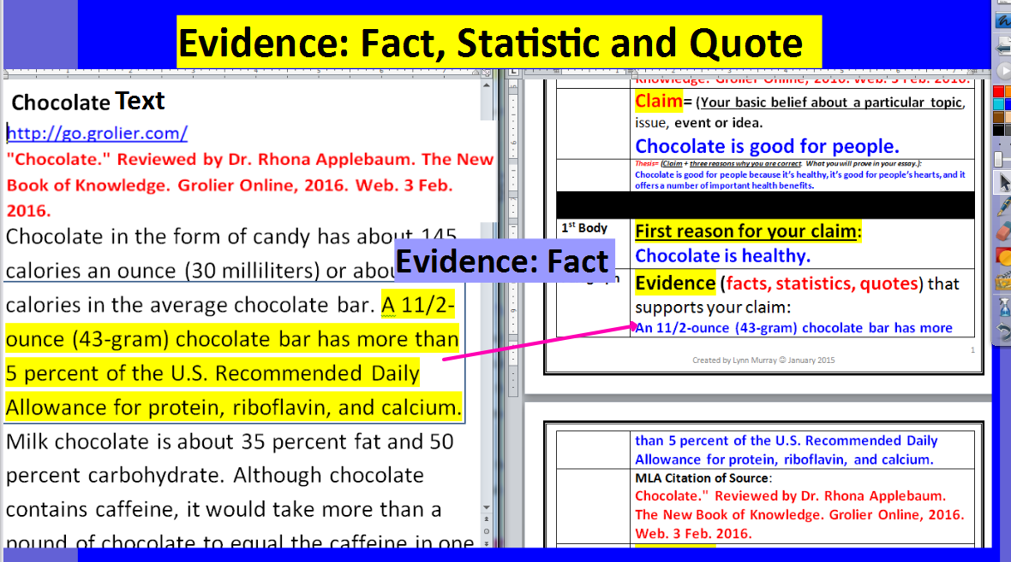
  - Quote example:
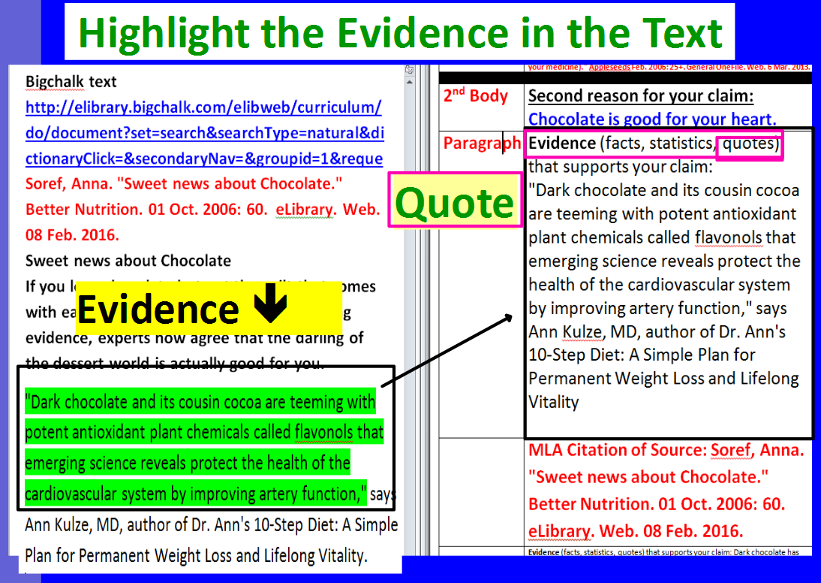

Essay writing tips:
Once your graphic organizer is complete, split your computer screen again.
- Place your graphic organizer on the left, and place a blank Word document on your right (Ctrl N).
- Read your graphic organizer to compose your argumentative essay.
- Be sure to elaborate and cite evidence within you paragraphs.
  - Thank you, Ms. Carpenter, for your FANTASTIC ESSAY!!!
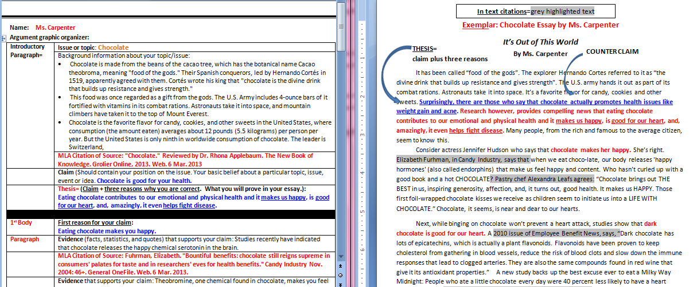

Exemplar: Chocolate Essay by Ms. Carpenter
In text citations=grey highlighted text
It’s Out of This World
COUNTER CLAIM
THESIS=
claim plus three reasons
By Ms. Carpenter

It has been called “food of the gods”. The explorer Hernando Cortes referred to it as “the divine drink that builds up resistance and gives strength”. The U.S. army hands it out as part of its combat rations. Astronauts take it into space. It’s a favorite flavor for candy, cookies and other sweets. Surprisingly, there are those who say that chocolate actually promotes health issues like weight gain and acne. Research however, provides compelling news that eating chocolate contributes to our emotional and physical health and it makes us happy, is good for our heart, and, amazingly, it even helps fight disease. Many people, from the rich and famous to the average citizen, seem to know this.
Consider actress Jennifer Hudson who says that chocolate makes her happy. She’s right. Elizabeth Furhman, in Candy Industry, says that when we eat chocolate, our body releases 'happy hormones' (also called endorphins) that make us feel happy and content. Who hasn’t curled up with a good book and a hot CHOCOLATE? Pastry chef Alexandra Leafs agrees: “Chocolate brings out THE BEST in us, inspiring generosity, affection, and, it turns out, good health. It makes us HAPPY. Those first foil-wrapped chocolate kisses we receive as children seem to initiate us into a LIFE WITH CHOCOLATE.” Chocolate, it seems, is near and dear to our hearts.
Next, while binging on chocolate won’t prevent a heart attack, studies show that dark chocolate is good for our heart. A 2010 issue of Employee Benefit News, says, “Dark chocolate has lots of epicatechins, which is actually a plant flavonoids. Flavonoids have been proven to keep cholesterol from gathering in blood vessels, reduce the risk of blood clots and slow down the immune responses that lead to clogged arteries. They are also the same compounds found in red wine that give it its antioxidant properties.” A new study backs up the best excuse ever to eat a Milky Way Midnight: People who ate a little chocolate every day were 40 percent less likely to have a heart attack or stroke, according to the study in the European Heart Journal. What great news!
COUNTERCLAIM
This is such encouraging news, and yet it’s heartbreaking that there are those who say that chocolate actually promotes health issues like weight gain and acne. Chocolate, they contend, is high in fat and is very caloric. "It all comes down to insulin," says Nell Mann, a professor of human nutrition at RMIT University in Melbourne, Australia, and the study's lead researcher. Foods with a high glycemic index cause blood sugar to rise, forcing the body to bring it down with a surge of insulin. And insulin can lead to acne, both by accelerating cell growth in the pores and stimulating oil-producing hormones called androgens. But if the total fat intake does not exceed the recommended levels, there is no reason to assume that consumption of chocolate would represent an increased risk to health. People who eat confections of any kind actually have a lower body-mass index and a smaller waist than their candy-skipping pals, researchers at Louisiana State University find. Balancing healthy eating with the occasional treat is key. And as for the risk of acne, research suggests that the flavonoids found in chocolate might help protect the skin from inflammation, or perhaps even cancer.

It’s obvious that, most importantly, chocolate helps fight disease. Yes, a Harvard study credits the antioxidants naturally found in chocolate as disease-fighters. "It's pretty, healthy, and satisfies everyone's chocolate craving," says recipe author Melanie Polk, RD, director of nutrition education at the American Institute for Cancer Research in Washington, DC. And, when you add fruit like strawberries and raspberries to chocolate, you have double the antioxidant power.
Heart protection comes from chocolate's antioxidants, called catechins that fight clot formation. (Dark chocolate has more than milk chocolate.) Oranges and raspberries contribute more antioxidants, such as vitamin C, plus fiber--all thought to fight heart disease and cancer. Psychology Today even reports that drinking hot cocoa helps lower you blood pressure!

In the final analysis, eating chocolate is not cheating; it’s actually smart. It enhances our lives in mental, emotional and physical ways. It’s that “feel good” confection that makes us happy; it also promotes heart health. Finally, munching on chocolate, rich in antioxidants, will help prevent disease. There is simply no reason to fear the calories or the onset of acne. Eaten in moderation, chocolate will not promote weight gain and may actually help your skin. What a relief! Overwhelming evidence proves that our beloved chocolate is good for us.

Possible claims for your argument: Highlight one

- Vaccines are good/bad.
- Coffee is good/bad.
- Steroids are good/bad.
- Diets are good/bad.
- Video games are good/bad.
- School should/not be year round.
- School uniforms are a good/bad idea.
- Animal performances should/not be banned in circuses.
- Fossil fuels are good/bad for America.
- Students should/not play football.
- Other---the topic of this claim must be approved first.

Your name:
Introductory Paragraph= | Issue or topic:
 | Background information about your topic/issue: (Use Grolier or Newsbank)
 | MLA Citation of Source:
 | Claim= (Your basic belief about a particular topic, issue, event or idea. An opinion, proposal, evaluation or cause and effect statement. Think in terms of good or bad/right or wrong/pro or con.):
1st Body | First reason for your claim:
Paragraph | Evidence (facts, statistics, quotes) that supports your claim:
 | MLA Citation of Source:
 | Evidence that supports your claim:
 | MLA Citation of Source:
2nd Body | Second reason for your claim:
Paragraph | Evidence (facts, statistics, quotes) that supports your claim:
 | MLA Citation of Source:
 | Evidence (facts, statistics, quotes) that supports your claim:
 | MLA Citation of Source:
3rd Body  Paragraph=  Counterclaim | Counterclaim: (What those who disagree about your claim say.)  What is the position of their claim? :
 | What reason do they have for their claim? :
 | Evidence (facts, statistics, quotes) that supports their claim:
 | MLA Citation of Source:
 | Why their evidence isn’t persuasive:
Concluding  Paragraph | Restate your claim:
 | Summary of reasons for your claim:

Argument Research Paper Outline Overview
Your essay should be 5 paragraphs, including an introduction and conclusion. The following outline will show you what to include in each paragraph.
Introduction:
- Introduce your topic. Make sure readers know what your topic is right away.
- Example: Coffee is a popular drink for adults around the world.
- Provide readers with background information about your topic. Write several sentences that define your topic and/or provide some interesting facts about your topic. You could also introduction or discuss the debate surrounding your topic.
- State your thesis. For this paper, your thesis will state your counter-claim (the strongest argument on the opposing side) and the two reasons why your claim is true. Your thesis sentence sets up your essay.
- Example: Although some people claim that drinking coffee interferes with healthy sleep patterns (the counterclaim), medical researchers have found that drinking coffee can help fight depression (reason #1) and lower the risk of developing certain types of cancer (reason 2).
- State your claim.
- Despite beliefs to the contrary, coffee is good for people.
Body Paragraph 1:
- State the first reason for your claim.
- Example: Medical researchers have learned that drinking coffee can help fight depression.
- Provide evidence that supports your claim; include the MLA citation of the source.
- Elaborate on your evidence in as many sentences as you can. (USE THE SEVEN WAYS TO ELABORATE.)
- Classes 1, 3, and 6: repeat steps 2 and 3.
Body Paragraph 2:
- State the second reason for your claim.
- Example: In addition to improving one's mood, drinking coffee can also lower one's risk of developing certain types of cancer.
- Provide evidence that supports your claim; include the MLA citation of the source.
- Elaborate on your evidence in as many sentences as you can. (USE THE SEVEN WAYS TO ELABORATE.)
- Classes 1, 3, and 6: repeat steps 2 and 3.
Body Paragraph 3: Counterclaim
- State the strongest argument (the counterclaim) you can think of on the opposing side.
- State the reason for the counterclaim. Why do people believe this?
- Provide evidence to support the opposing claim; include the MLA citation.
- Now, refute the opposing claim by forming a rebuttal. In other words, disprove the strongest argument on the other side. Tell readers why the opposing claim is not true or is not persuasive.

- Example of a counterclaim paragraph: People often claim that drinking coffee interferes with one's natural sleep patterns, making it hard for drinkers to get a good night's rest. (counterclaim) Although it is true that coffee contains caffeine (cite source for this information), and caffeine is a stimulant, if people refrain from drinking coffee after a certain hour, the caffeine one drinks in the morning will be out of one's system long before bedtime. Thus, coffee and the caffeine it contains cannot be blamed for a person's sleep problems. Since researchers have proven that coffee fights depression and lowers one's risk of developing liver and vascular cancer, it is safe to assume that the benefits of drinking coffee far outweigh the dangers. Research has proven that coffee is good for you, so go ahead and enjoy that morning cup of joe!
Conclusion:
- Restate your thesis and summarize the reasons for your claim.
Include a Works Cited page as the last page of your essay.
