Name:
Date:

2016- 2017 7th Grade Argument Research Project Overview
English Language Arts Classes
Document Created by Lynn Murray, TOR Library Media Specialist
March 2017 2

Standard=CCSS.ELA-Literacy.W.7.1= Write arguments to support claims with clear reasons and relevant evidence.

Objective=Students will use the Split Screen Note Taking research method and write an argumentative essay about a topic from a given listing. Students will read high-quality published text from TOR’s library media center books and databases as the basis of their research. Students will locate, copy, and paste text from databases onto Microsoft Word, use the highlighter tool to annotate the text, utilize a specifically designed argument organizer as the basis of their essay, and cite their sources in MLA format.

Project Overview:
- Students will choose a topic or issue that interests them to research.
- From within that topic/issue they will state a claim and defend the claim with evidence gleaned from TOR’s hard cover book and database resources.
- Students will read about both sides of their topic/issue from SPS leveled database resources, and record their notes and applicable evidence on a specifically designed graphic organizer. Students will cite their sources on this graphic organizer as well.
- Students write an argumentative essay based upon their notes.

Important Argument Vocabulary:
- Argument=a statement of an author’s major point or position based on evidence.
- Position=the point of view that a person takes in an argument.
- Claim (simple) =your basic belief about a particular topic, issue, event or idea. It’s an opinion, proposal, evaluation, cause and effect statement or interpretation.
- Think in terms of good or bad/right or wrong/pro or con.
- Examples:
- Marathon running is beneficial for middle aged adults.
- Steroid use is harmful for high school aged students.
- The economy has affected Stamford’s downtown nightlife negatively.
- The cancellation of the November, 2012 NYC Marathon was a wise idea.
- Thesis statement (more complex) =sentence that summarizes the main point or claim of an essay or paper that is developed, supported, and explained by examples and evidence.
- Examples:
- Due to improved cardio vascular health, muscle development, and cognitive brain improvement, marathon running is extremely beneficial for middle-aged individuals.
- High school students who abuse steroids face many future health problems such as high blood pressure and heart disease, liver damage and strokes.
- Due to the downturn of the economy, the downtown nightlife in Stamford, CT has suffered, and has resulted in a decline in restaurant, theatre and movie attendance.
- Due to the damaging effects of Hurricane Sandy, the unsafe running route and the perceived hostility of the crowds, the cancellation of the 2012 NYC Marathon was a wise idea.
- Counter claim=a solid and reasonable argument that opposes or disagrees with your claim.
- You anticipate an objection and have an answer for another point of view.
- Support= specific evidence or examples to show that your claim is true.
- Evidence=facts, statistics, quotes or examples. http://valenciacollege.edu/wp/cssc/documents/TypesofEvidenceinPersuasiveFINAL.pdf
- Facts=cannot be disputed, can be proven.
- Grass is green.
- All cats are animals.
- Jumping out of airplanes without a parachute is hazardous.
- Statistics=amounts and numbers. Should come from reliable sources.
- 1.7% of Americans are underweight.
- Connecticut’s unemployment rate was 8.6% for December 2012.
- Quotes=what leading experts or authorities said about your topic.
- Dr. Smith, U.S. Surgeon General, described long term problems associated with underage drinking: “Research shows that young people who start drinking before the age of 15are five times more likely to have alcohol-related problems later in life.”
- Samantha Jones, a noted forensic specialist, stated that DNA evidence is usually indisputable.
- Examples=anecdotes from your own experience. Personal experience must be applicable, present reasonable background understanding, show a general situation and be related to the claim.

Resources to locate background information and evidence to support your claim:
Location #1=Destiny Book Catalog and hardcover encyclopedias
TORonline.org>Media Policies>TOR Media Center>SCROLL DOWN to Destiny Book Catalog and SPS Databases>TOR>Destiny tab
    - Search your argument topic/issue.
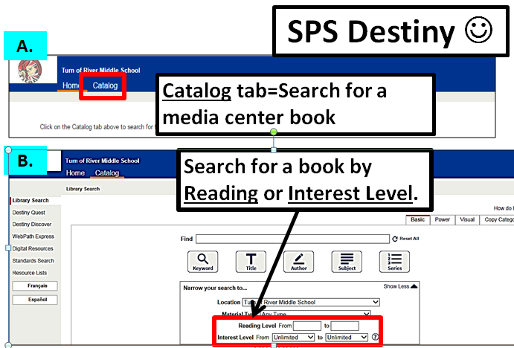
Location #2=Grolier. Locate background information about your topic that’s written at your reading level.
TORonline.org>Media Policies>TOR Media Center>SCROLL DOWN to Destiny Book Catalog and SPS Databases>TOR>Grolier
- Type “Your topic” into the Search box.
  - You can access Grolier at home! See Mrs. Murray for a printed listing of database usernames/passwords.
    - Search your argument topic/issue.
Location #3=Bigchalk and Elibrary. Locate published articles about your topic that are written at your reading level.
TORonline.org>Media Policies>TOR Media Center>SCROLL DOWN to Destiny Book Catalog and SPS Databases>TOR>Bigchalk and E-Library
- Click on Curriculum Edition
- Type “Your topic” into the Search box.
  - You can access Bigchalk and e-library at home! See Mrs. Murray for a printed listing of database usernames/passwords.
        - Search your argument topic/issue.

Possible claims for your argument:

- Vaccines are good/bad.
- Coffee is good/bad.
- Steroids are good/bad.
- Diets are good/bad.
- Video games are good/bad.
- School should/not be year round.
- School uniforms are a good/bad idea.
- Animal performances should/not be banned in circuses.
- Fossil fuels are good/bad for America.
- Students should/not play football.
- Other---the topic of this claim must be approved first.

Graphic organizer for your argument:
Introductory Paragraph= | Issue or topic:
 | Background information about your topic/issue: (Use Grolier or Bigchalk)
 | MLA Citation of Source:
 | Claim= (Your basic belief about a particular topic, issue, event or idea. An opinion, proposal, evaluation or cause and effect statement. Think in terms of good or bad/right or wrong/pro or con.):
1st Body | First reason for your claim:
Paragraph | Evidence (facts, statistics, quotes) that supports your claim:
 | MLA Citation of Source:
 | Evidence that supports your claim:
 | MLA Citation of Source:
2nd Body | Second reason for your claim:
Paragraph | Evidence (facts, statistics, quotes) that supports your claim:
 | MLA Citation of Source:
 | Evidence (facts, statistics, quotes) that supports your claim:
 | MLA Citation of Source:
3rd Body  Paragraph=  Counterclaim | Counterclaim: (What those who disagree about your claim say.)  What is the position of their claim? :
 | What reason do they have for their claim? :
 | Evidence (facts, statistics, quotes) that supports their claim:
 | MLA Citation of Source:
 | Why their evidence isn’t persuasive:
Concluding  Paragraph | Restate your claim:
 | Summary of reasons for your claim:

Research process:
- You will locate information about your topic and paste it on a blank word document (Ctrl N).
- Afterwards, you will split your computer screen to read, annotate, cite, and organize background information about your topic on the graphic organizer above.
- You will research articles about your topic on Grolier and Bigchalk and E-Library.
  - Grolier and Bigchalk contain thousands of articles from published accurate resources about curriculum-related articles that are written at YOUR reading level!!! How exciting!!!
  - Include the MLA Citation from your pasted text underneath your Background information.
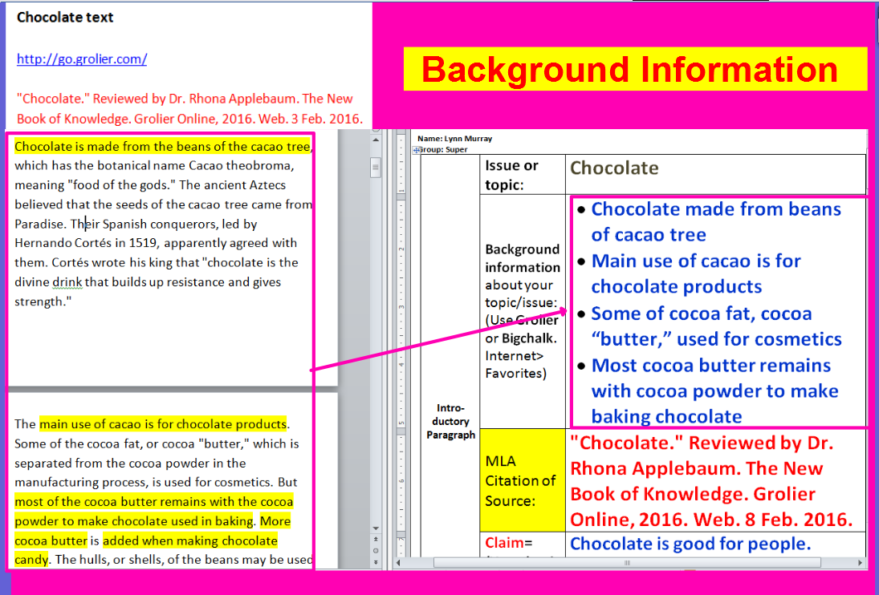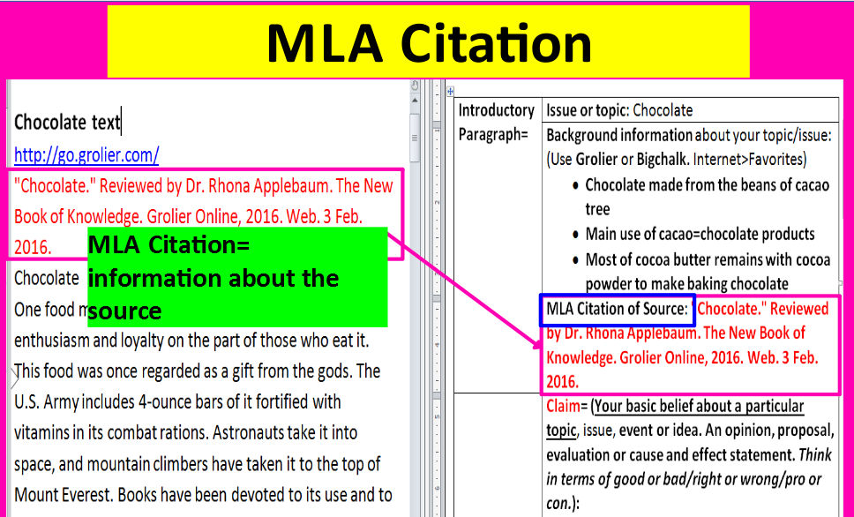

- Once your background information is complete, write a claim about the topic and locate evidence to support your claim (fact, statistic or quote). Record your evidence in the graphic organizer.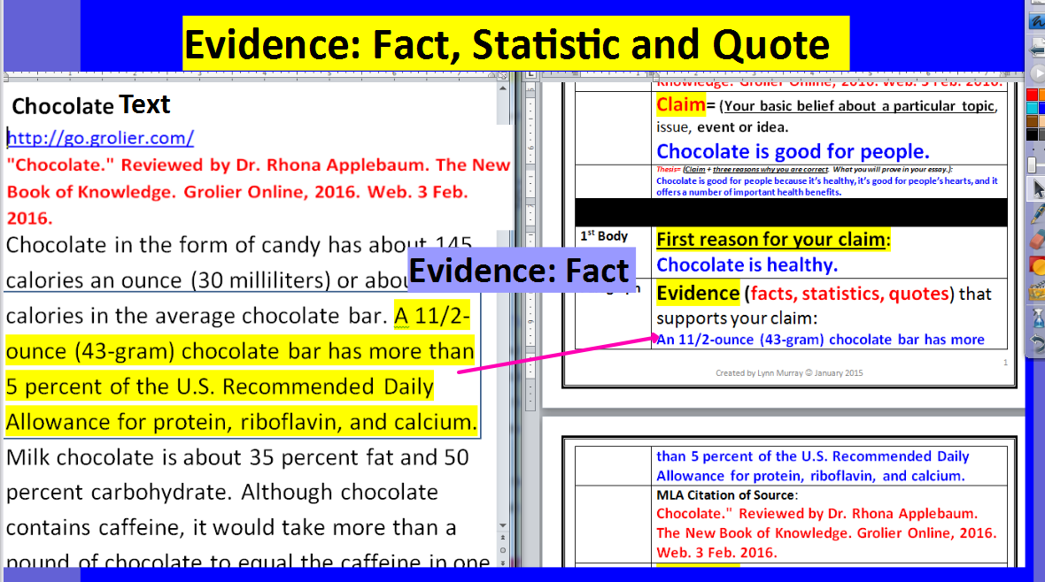 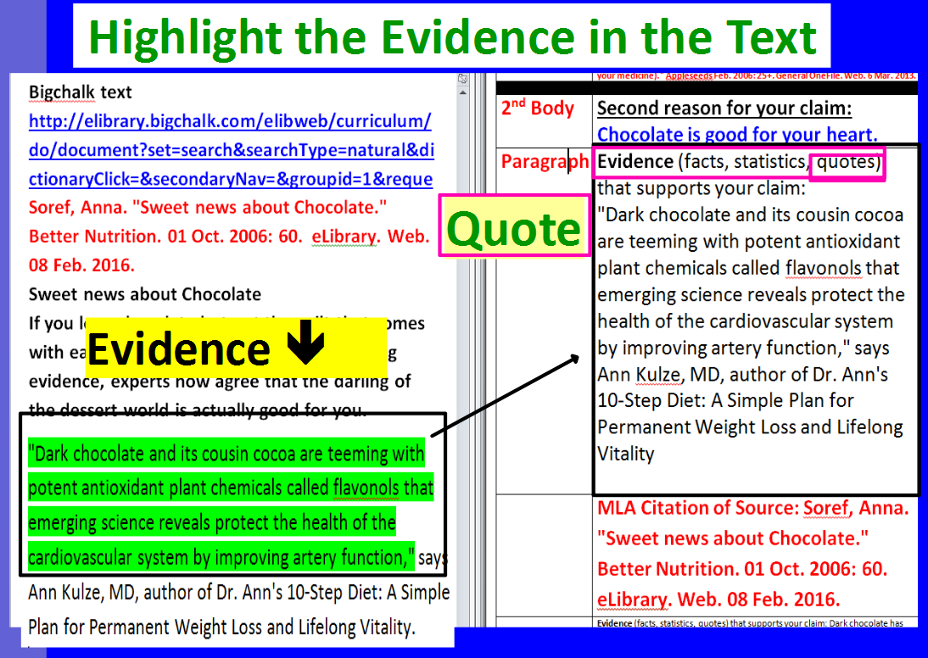

- Grolier Access: toronline.org>Media Policies>TOR Media Center Website>Scroll down to Destiny & SPS Databases>TOR>Grolier
  - Search for background information about your topic that’s written at your reading level. WOW!!!
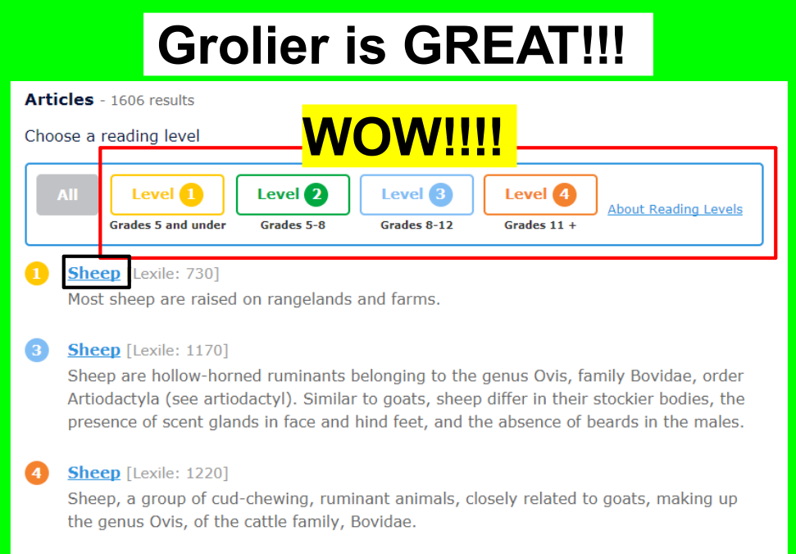
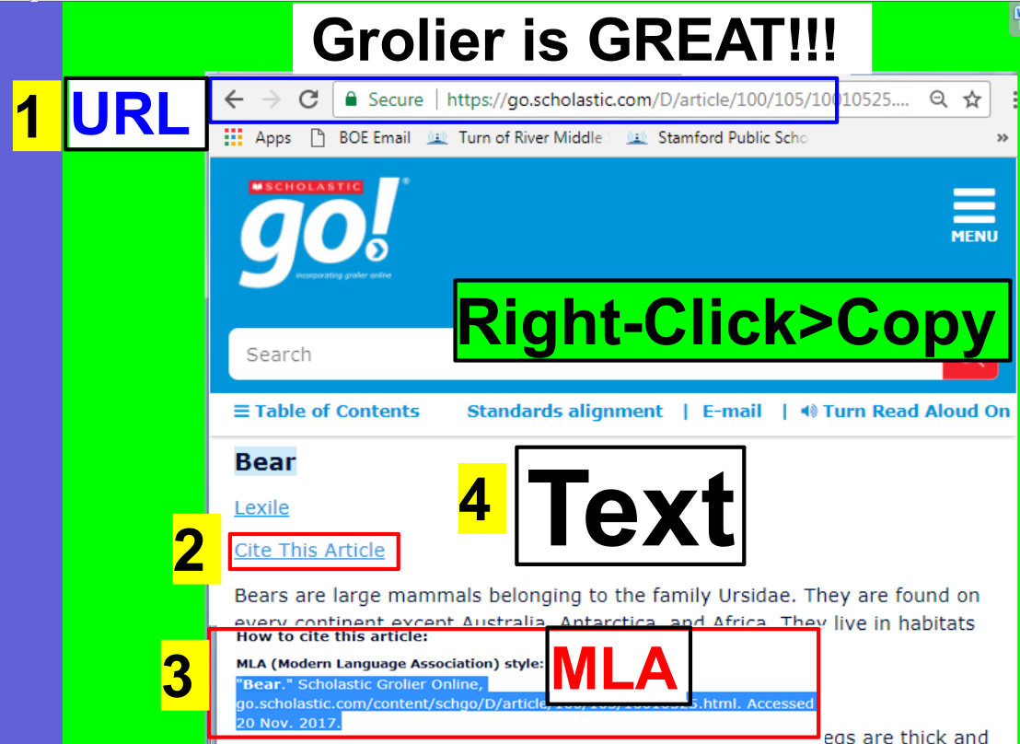
  - Copy and paste the text from Grolier to a blank Word document by following the directions below.
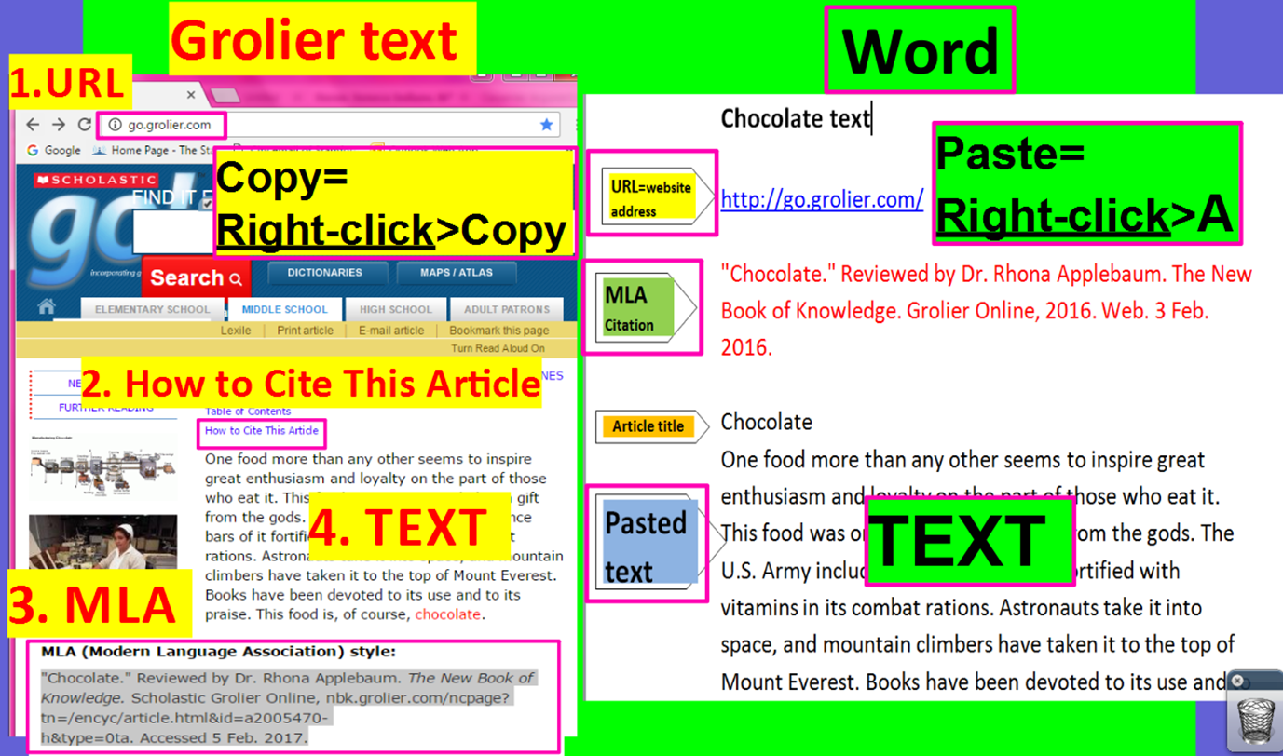
- Bigchalk and E-Library Access: toronline.org>Media Policies>TOR Media Center Website>Scroll down to Destiny & SPS Databases>TOR>Bigchalk and E-Library
  - Search through thousands of published articles on Bigchalk about your topic from resources like the New York Time and 60 Minutes!
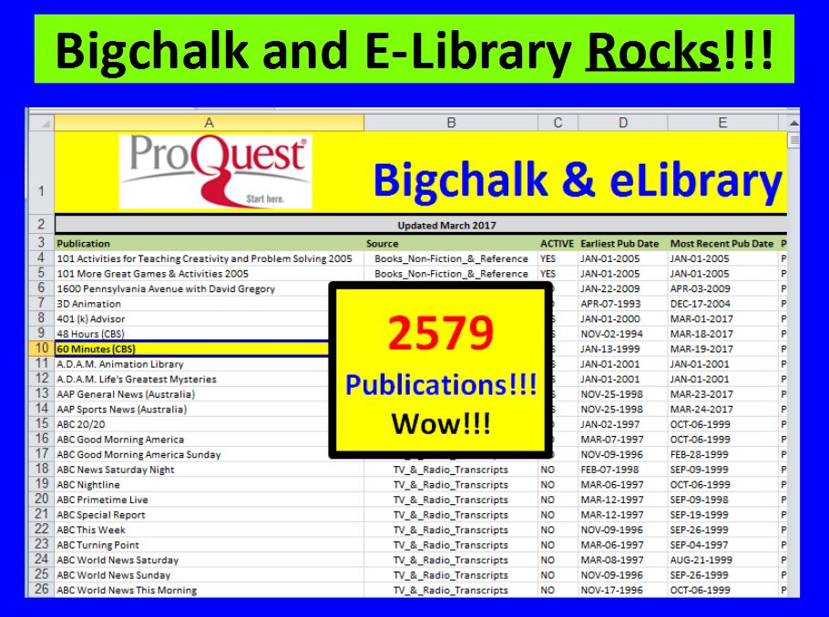
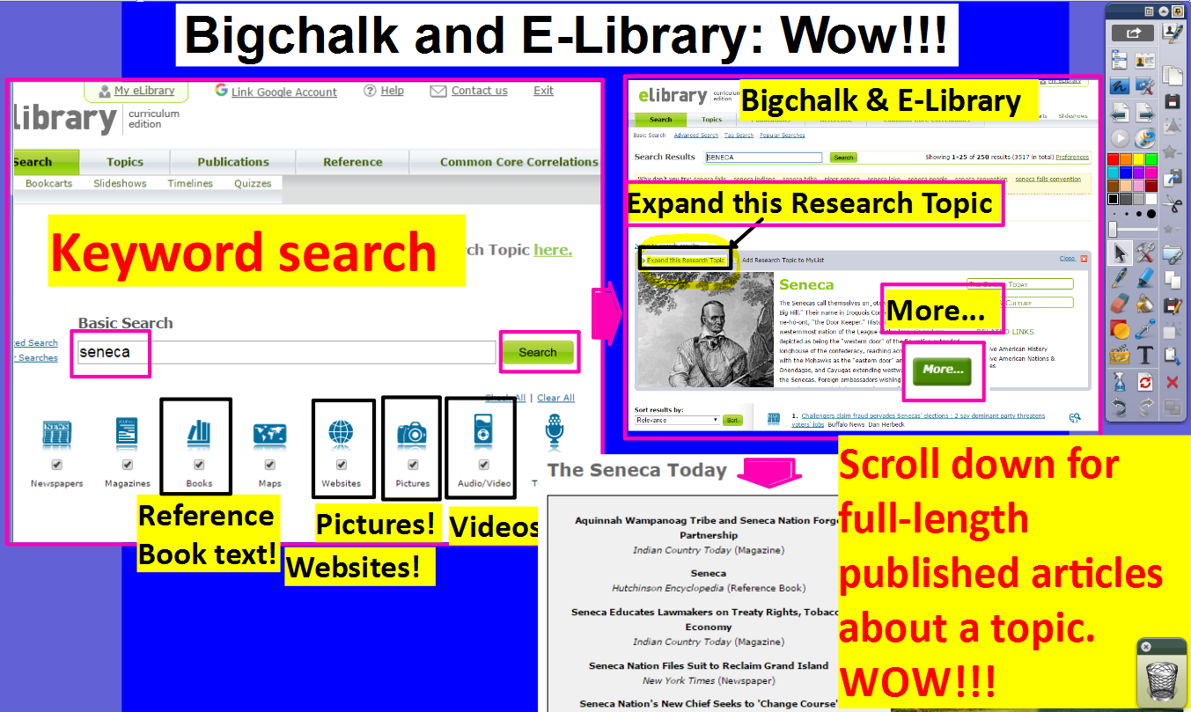
  - You can search for a topic on Bigchalk by its Lexile score. Fantastic!!!
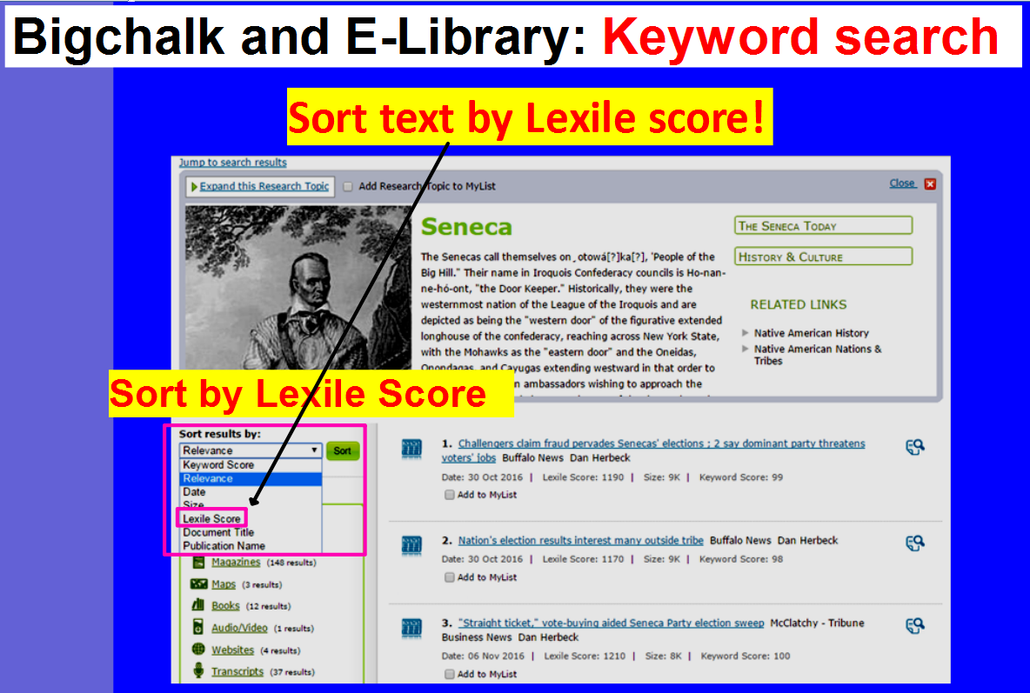

- Copy and paste the text from Bigchalk to a blank Word document (Ctrl N). by following the directions below. 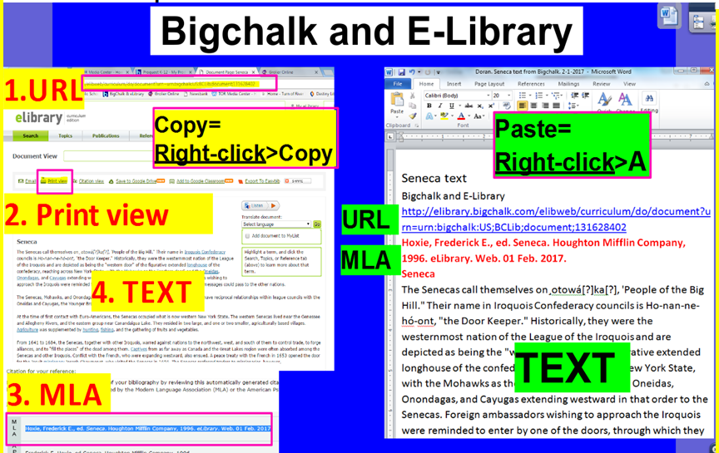

Essay writing tips:
Once your graphic organizer is complete, split your computer screen again.
- Place your graphic organizer on the left, and place a blank Word document on your right (Ctrl N).
- Read your graphic organizer to compose your argumentative essay.
- Be sure to elaborate and cite evidence within you paragraphs.
  - Thank you, Ms. Carpenter, for your FANTASTIC ESSAY!!!
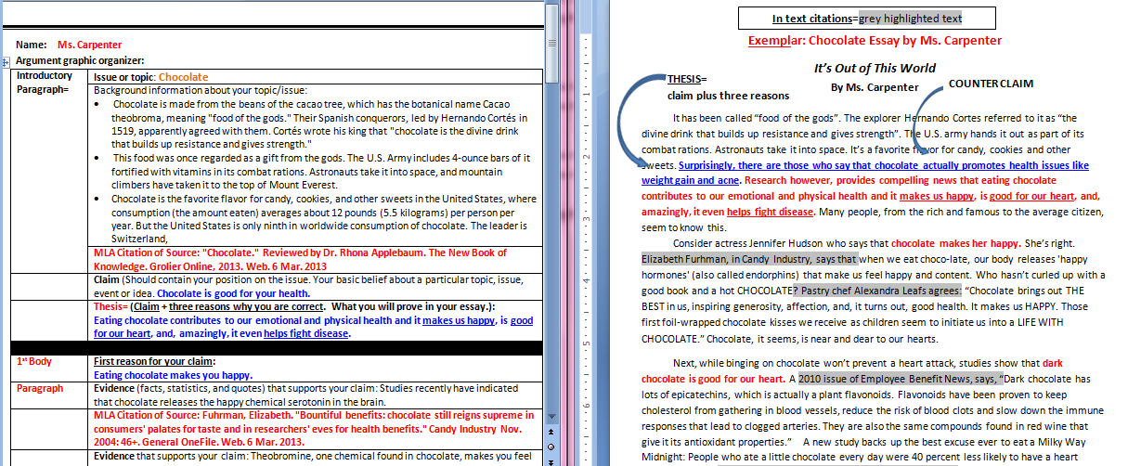

- Include a Works Cited page as the last page of your essay. 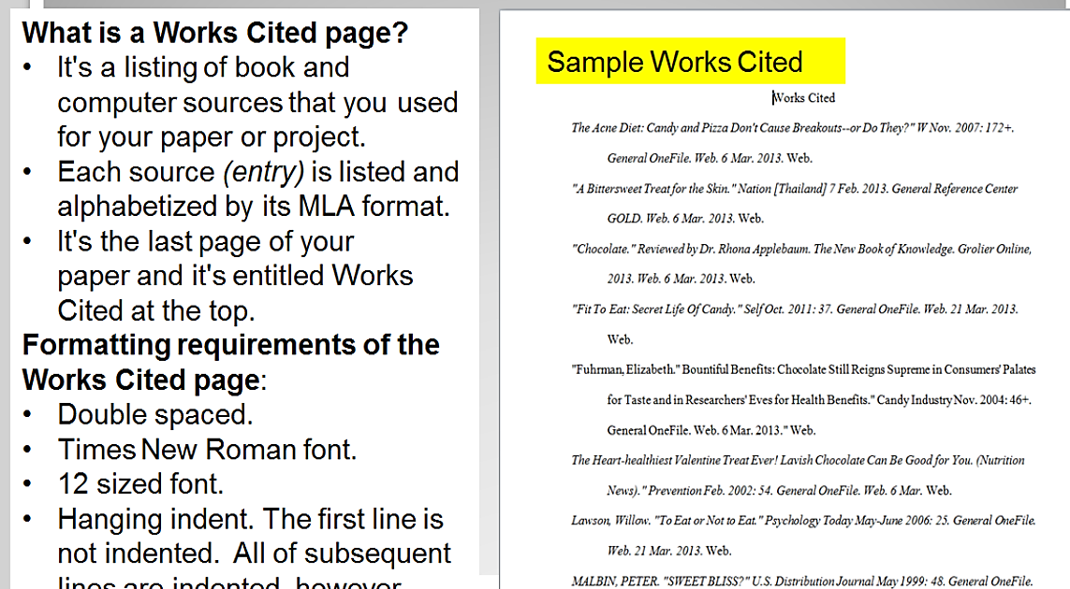
Exemplar: Chocolate Essay by Ms. Carpenter
In text citations=grey highlighted text
It’s Out of This World
COUNTER CLAIM
THESIS=
claim plus three reasons
By Ms. Carpenter

It has been called “food of the gods”. The explorer Hernando Cortes referred to it as “the divine drink that builds up resistance and gives strength”. The U.S. army hands it out as part of its combat rations. Astronauts take it into space. It’s a favorite flavor for candy, cookies and other sweets. Surprisingly, there are those who say that chocolate actually promotes health issues like weight gain and acne. Research however, provides compelling news that eating chocolate contributes to our emotional and physical health and it makes us happy, is good for our heart, and, amazingly, it even helps fight disease. Many people, from the rich and famous to the average citizen, seem to know this.
Consider actress Jennifer Hudson who says that chocolate makes her happy. She’s right. Elizabeth Furhman, in Candy Industry, says that when we eat choco-late, our body releases 'happy hormones' (also called endorphins) that make us feel happy and content. Who hasn’t curled up with a good book and a hot CHOCOLATE? Pastry chef Alexandra Leafs agrees: “Chocolate brings out THE BEST in us, inspiring generosity, affection, and, it turns out, good health. It makes us HAPPY. Those first foil-wrapped chocolate kisses we receive as children seem to initiate us into a LIFE WITH CHOCOLATE.” Chocolate, it seems, is near and dear to our hearts.
Next, while binging on chocolate won’t prevent a heart attack, studies show that dark chocolate is good for our heart. A 2010 issue of Employee Benefit News, says, “Dark chocolate has lots of epicatechins, which is actually a plant flavonoids. Flavonoids have been proven to keep cholesterol from gathering in blood vessels, reduce the risk of blood clots and slow down the immune responses that lead to clogged arteries. They are also the same compounds found in red wine that give it its antioxidant properties.” A new study backs up the best excuse ever to eat a Milky Way Midnight: People who ate a little chocolate every day were 40 percent less likely to have a heart attack or stroke, according to the study in the European Heart Journal. What great news!
COUNTERCLAIM
This is such encouraging news, and yet it’s heartbreaking that there are those who say that chocolate actually promotes health issues like weight gain and acne. Chocolate, they contend, is high in fat and is very caloric. "It all comes down to insulin," says Nell Mann, a professor of human nutrition at RMIT University in Melbourne, Australia, and the study's lead researcher. Foods with a high glycemic index cause blood sugar to rise, forcing the body to bring it down with a surge of insulin. And insulin can lead to acne, both by accelerating cell growth in the pores and stimulating oil-producing hormones called androgens. But if the total fat intake does not exceed the recommended levels, there is no reason to assume that consumption of chocolate would represent an increased risk to health. People who eat confections of any kind actually have a lower body-mass index and a smaller waist than their candy-skipping pals, researchers at Louisiana State University find. Balancing healthy eating with the occasional treat is key. And as for the risk of acne, research suggests that the flavonoids found in chocolate might help protect the skin from inflammation, or perhaps even cancer.

It’s obvious that, most importantly, chocolate helps fight disease. Yes, a Harvard study credits the antioxidants naturally found in chocolate as disease-fighters. "It's pretty, healthy, and satisfies everyone's chocolate craving," says recipe author Melanie Polk, RD, director of nutrition education at the American Institute for Cancer Research in Washington, DC. And, when you add fruit like strawberries and raspberries to chocolate, you have double the antioxidant power.
Heart protection comes from chocolate's antioxidants, called catechins that fight clot formation. (Dark chocolate has more than milk chocolate.) Oranges and raspberries contribute more antioxidants, such as vitamin C, plus fiber--all thought to fight heart disease and cancer. Psychology Today even reports that drinking hot cocoa helps lower you blood pressure!

In the final analysis, eating chocolate is not cheating; it’s actually smart. It enhances our lives in mental, emotional and physical ways. It’s that “feel good” confection that makes us happy; it also promotes heart health. Finally, munching on chocolate, rich in antioxidants, will help prevent disease. There is simply no reason to fear the calories or the onset of acne. Eaten in moderation, chocolate will not promote weight gain and may actually help your skin. What a relief! Overwhelming evidence proves that our beloved chocolate is good for us.

