Name:
Date:
Declaration of Independence
Cornell Notes
Marvelous Mr. DeFilippo & Ms. Bourgoin
October 2019

Objective: Students will locate, read, annotate, organize, cite and write Cornell Notes about the Declaration of Independence

Resources: Destiny: toronline.org > Media Policies >TOR Media Website > TOR
- Books and encyclopedias
- Databases: Grolier and Newsbank
  - Grolier: Search Declaration of Independence
    - Click on the first choice

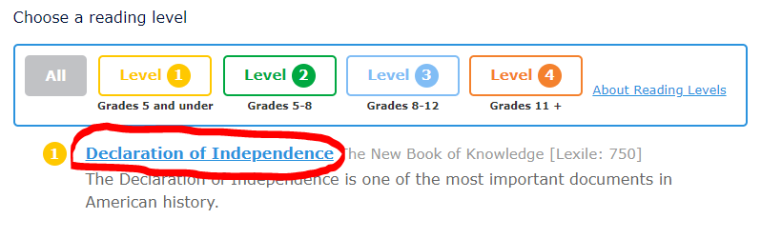
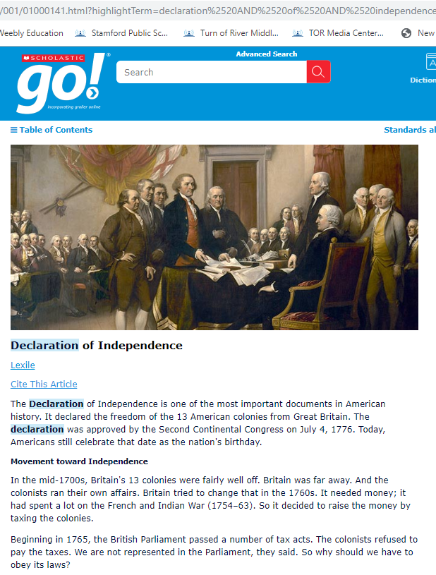

How to write Cornell Notes about SPS text:
- Open TOR Library Media Center Cornell Notes.
- Ctrl N=New Word Document.
- Write Declaration of Independence Text at the top of the blank Word document.
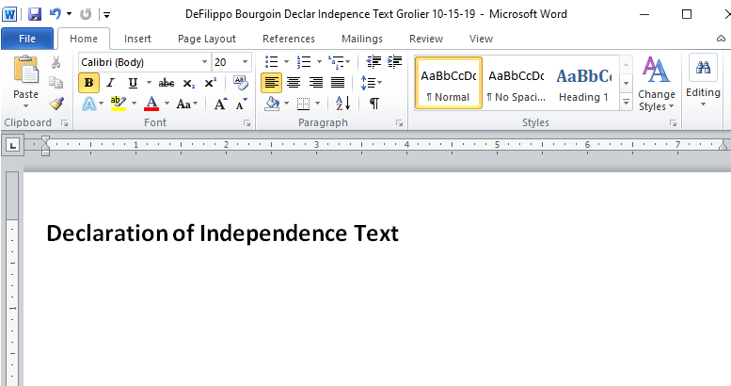
- Copy (Right-click>Copy) and Paste (Right-click>A) the:
- URL, MLA Citation, and ALL of the text.
Declaration of Independence Text
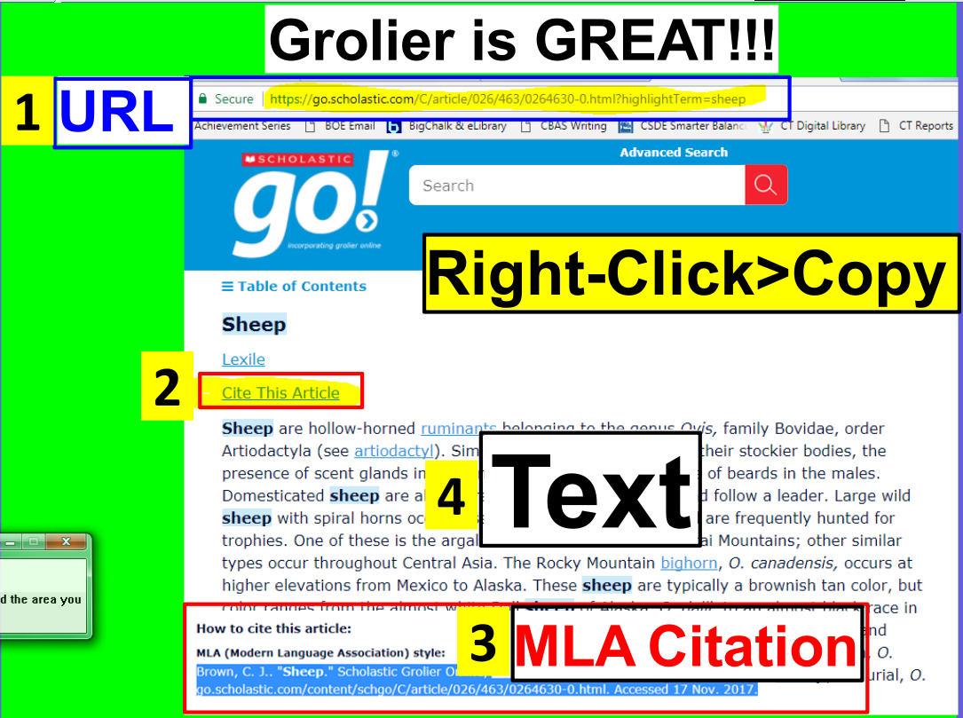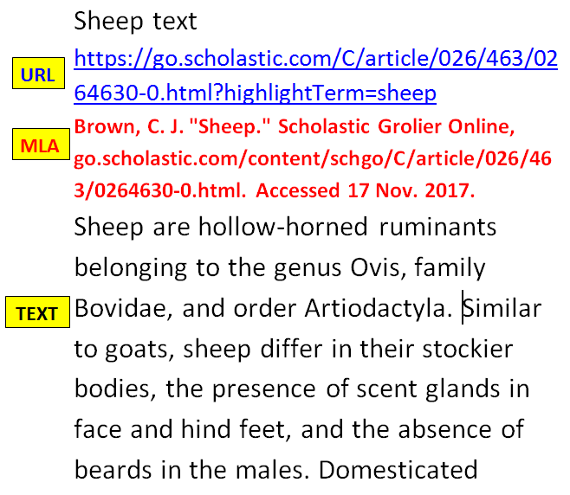
Paste: Right-click>A
Grolieronline

- Split the computer screen, and read, annotate, organize, cite and write about SPS text to create an original piece of work.
- Split your computer screen.
- Place your pasted SPS database text on the left.
- Place your Cornell Notes on the right.
- Preview the text.
- Scroll down to see how long it is.
- Notice if there are any headings.
  - Headings=automatic subtopics
- Read the text in its entirety.
- Reread the first paragraph.
- After you’ve read the first paragraph again, ask yourself, “What is this paragraph about?”
- Type the topic of the first paragraph in the Subtopic section of your Cornell Notes.
- Highlight the subtopic in a color of your choice.
- Reread the first paragraph one more time
- Highlight details about the subtopic in the pasted text in the same color as the subtopic.
- Detail fact-phrases should not be longer than six consecutive words in length.
- Organize details by their classification on Cornell Notes.
  - Larger details are solid bullet points.
  - Smaller details about the larger details are indented and appear as hollow bullet points.
    - How to add and indent/outdent bullet points=1) Enter on the keyboard 2) Indent/Outdent arrows
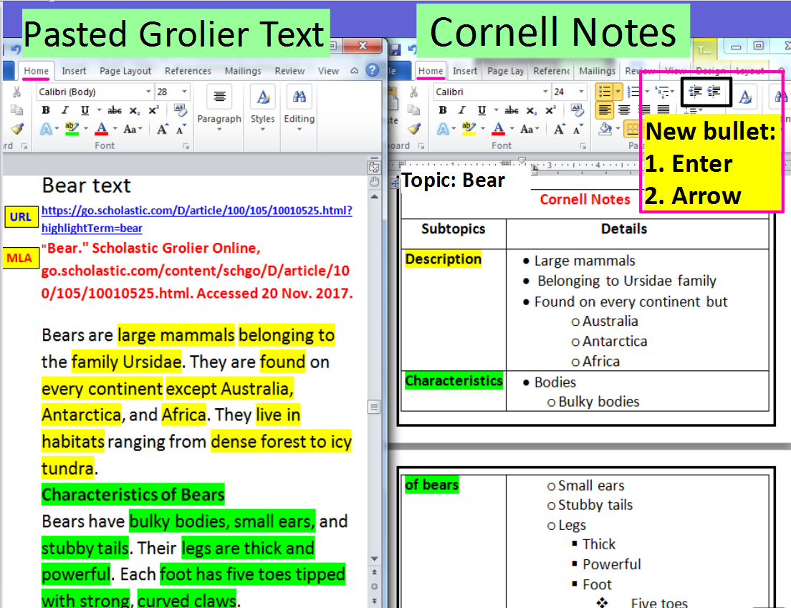
Topic: Declaration of Independence
Cornell Notes
"Declaration of Independence." Scholastic GO!, go.scholastic.com/content/schgo/D/article/010/001/01000141.html. Accessed 15 Oct. 2019.
Subtopics | Details
Summary
Movement Towards Independence
The Declaration
Ideals of Government
Charges against the King
Summarize your notes:

