Name: Date:

Culture Fair Summary, Rubric and Cornell Notes
Seitter & Sheeran
Project summary=Page 1
Grading rubric=Page 2
Cornell Notes=Pages 3-5
10-6-2016 6

- Culture Fair Project Summary:
Select a Country to research, and create a project to share with your classmates. You will present your project at our Multicultural Festival on October 26th. Be creative, and have fun!
Your project will contain two parts.
Part 1: POSTER/PRESENTATION BOARD
Your poster must include the name of your country along with an introductory paragraph containing basic information about the country (including location, population, and language/s spoken)
Your board must also contain a minimum of 8 of the following things:
- A map of your country (either printed or drawn)
- The national flag
- Political system
- Art, music, & Literature
- Food
- Customs & Traditions
- Religions
- Holidays
- Currency
- Landmarks
- Climate
- Interesting facts about the country/culture
Part 2: ADDITIONAL DISPLAY (Choose AT LEAST 1 of the following):
- Bring in a traditional food item (with enough samples to feed at least 30 people)
- Traditional Dress
- Traditional Music
- Traditional Game
- Traditional Dance

- Grading rubric:
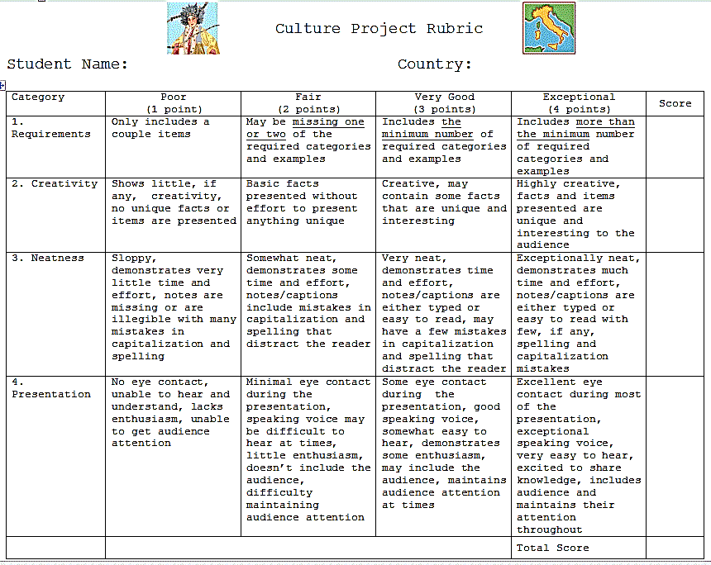

- Cornell Notes:
Country Research Cornell Notes 4
Resources:
- Day 1=Hard cover books: non-fiction books about an individual country, reference books and encyclopedias
- Use our fantastic hard cover encyclopedias and reference books on reserve to locate information about your country.
- Use Destiny, our school’s media center book catalog, to locate a book about your country.
- toronline.org>TOR Media Center>Scroll down and click on Destiny>TOR>Catalog tab>Search the name of your country>Locate the book about your country by its call number in our shelves.
- Once you locate information about your country, READ the article, and write the facts about your country in the Details section of your Cornell Notes on page two. (fact phrases/details=6 words or less)
- Day 2=Wonderful non-fiction database resources!!!!
- Grolier online=Internet Explorer>Favorites>Grolier Online>Search for your country
- Bigchalk and E-Library= Internet Explorer>Favorites>Bigchalk and E-Library>E-Library Curriculum Edition>Search for your country
- Take a printed copy of the database usernames/passwords underneath the light switch in the media center to access these fantastic, wonderful and outstanding databases at home.
- Steps to split the screen: Non-fiction database text will be on the left and Cornell Notes will be on the right.
- CTRL N>Type the name of your country and the word “text” at the top of your blank document. Sample: Poland text
- Locate an article about your country from Grolier and then Bigchalk.
- Highlight the URL of the first article>Right-click>Copy the URL.
- Click on the country text document on Word at the bottom of the screen.
- Right-click>regular click on the (A) adjacent to Paste to paste the URL.
- Click back on Grolier or Bigchalk at the bottom of the screen and locate the article’s MLA citation.
- Highlight the MLA citation>Right-click>Copy the MLA citation.
- Click on the country text document on Word at the bottom of the screen.
- Right-click>regular click on the (A) adjacent to Paste to paste the MLA citation underneath the URL.
- Click back on Grolier or Bigchalk at the bottom of the screen and locate text about your country.
- Highlight this text and Right-click>Copy the text about your country.
- Click on the country text document on Word. Click on the (A) adjacent to Paste.
- Save both documents to your number: File>Save As>Computer>Number>SAVE.
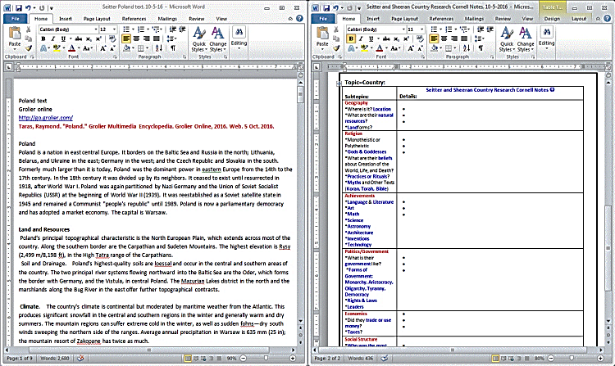
- Click and hold the text document and drag it to the left. Click and hold the Cornell Notes document and drag it to the right.
Split-screen result>

Seitter & Sheeran Culture Fair Cornell Notes

Pasted Grolier database text: Cornell Notes sample:
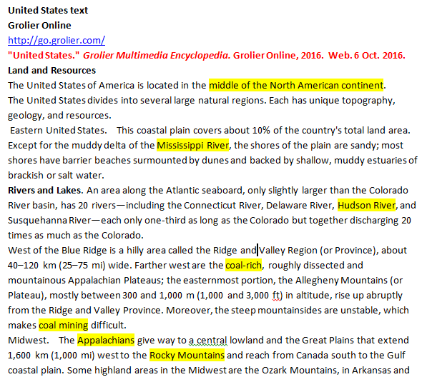  MLA Citation | 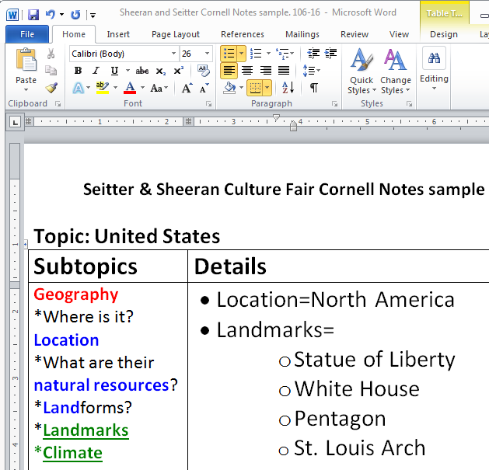

Topic=Country: Dominican Republic
Subtopics: | Seitter and Sheeran Country Research Cornell Notes  Details:
Geography  *Where is it? Location  *What are their natural resources?  *Landforms?  *Landmarks  *Climate | - -  - -
Religion
*Religions
*Monotheistic or Polytheistic
*Gods & Goddesses
*What are their beliefs about Creation of the World, Life, and Death?
*Practices or Rituals?
*Myths and Other Texts (Koran, Torah, Bible)
Achievements
*Language & Literature
*Art
*Music
*Math
*Science
*Astronomy
*Architecture
*Inventions
*Technology
Political system /Government
*What is their government like?
*Forms of Government: Monarchy, Aristocracy, Oligarchy, Tyranny, Democracy
*Rights & Laws
*Leaders
Economics
*Did they trade or use money?
*Taxes?
* Currency
Social Structure
*Who was the most important in their society?
*Who has status /power in society?
*Food
*Customs
* Traditions
*Holidays
Flag
Map
Interesting facts:

