Name: Date:
2018-2019 Marvelous Mr. Avroch’s AE Class
Debatable Topics Research Paper
Document Created by Mrs. Murray ☺ January 2019

Objective: Students will locate, read, annotate, organize, cite, and write about a debatable topic relevant to books read in class. Students will use their notes about the topic to write a research paper that explains the relationship between the topic and the books they’ve read.

Topics: Highlight your topic.
- Is the cost of college too high?
- Should cigarettes be illegal?
- Should laws limit children under the age of 18 from using Social Media?
- Are cell phones dangerous?
- Do video games cause violent behavior?
Important Argument Vocabulary:
- Argument=a statement of an author’s major point or position based on evidence.
- Position=the point of view that a person takes in an argument.
- Claim (simple) =your basic belief about a particular topic, issue, event or idea.
- It’s an opinion, proposal, evaluation, cause and effect statement or interpretation.
- Think in terms of good or bad/right or wrong/pro or con.
- Examples:
- Marathon running is beneficial for middle aged adults.
- Steroid use is harmful for high school aged students.

- Thesis statement =sentence that summarizes the main point or claim of an essay or paper that is developed, supported, and explained by examples and evidence. It lists the three reasons that supports the claim.
- Examples:
- Due to improved cardio vascular health, muscle development, and cognitive brain improvement, marathon running is extremely beneficial for middle-aged individuals.
- High school students who abuse steroids face many future health problems such as high blood pressure and heart disease, liver damage and strokes.

- Evidence=facts, statistics, quotes, or examples.
- Facts=cannot be disputed, can be proven.
- Grass is green.
- All cats are animals.
- Jumping out of airplanes without a parachute is hazardous.
- Statistics=amounts and numbers. Should come from reliable sources.
- 1.7% of Americans are underweight.
- Connecticut’s unemployment rate was 8.6% for December 2012.
- Quotes=what leading experts or authorities said about your topic.
- Dr. Smith, U.S. Surgeon General, described long term problems associated with underage drinking: “Research shows that young people who start drinking before the age of 15are five times more likely to have alcohol-related problems later in life.
Topic and Resources:
- Is the cost of college too high?
Newsbank=toronline.org>Media Policies>TOR Media Website>Scroll Down to Destiny link>TOR>Newsbank>Access World News
- Search: college costs
- Click on Best Matches (left) and Lexile>Your reading level
- Locate an article about your topic.
- Copy and paste (Right-click>A) the article’s URL, MLA citation and text to a blank Word document (Ctrl N).
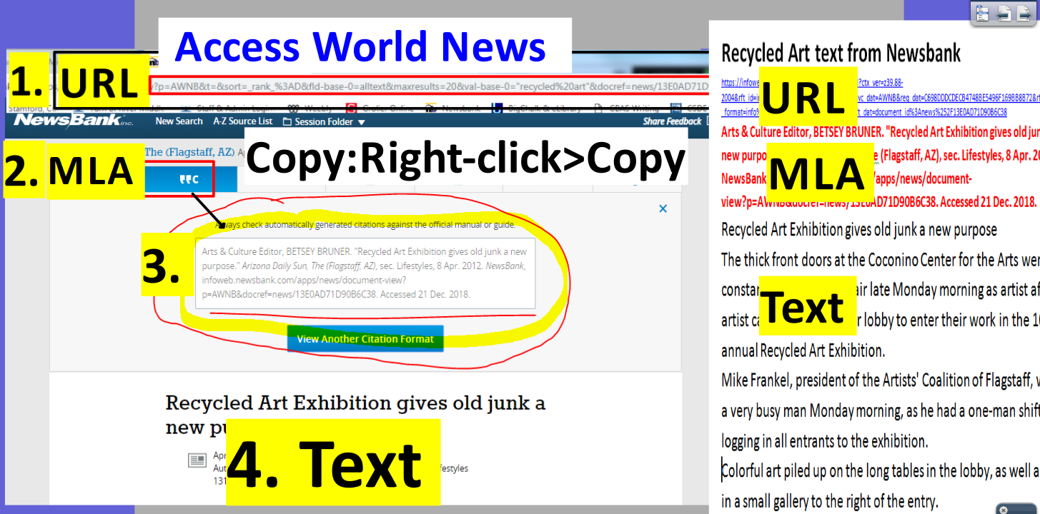
- Should cigarettes be illegal?
Newsbank=toronline.org>Media Policies>TOR Media Website>Scroll Down to Destiny link>TOR>Newsbank>Access World News
- Search: cigarettes illegal health reasons
- Click on Best Matches (left) and Lexile>Your reading level
- Locate an article about your topic.
- Copy and paste (Right-click>A) the article’s URL, MLA citation and text to a blank Word document (Ctrl N).
- Should laws limit children under the age of 18 from using Social Media?
Newsbank=toronline.org>Media Policies>TOR Media Website>Scroll Down to Destiny link>TOR>Newsbank>Access World News
- Search: laws protect children social media dangers
- Click on Best Matches (left) and Lexile>Your reading level
- Locate an article about your topic.
- Copy and paste (Right-click>A) the article’s URL, MLA citation and text to a blank Word document (Ctrl N).

- Are cell phones dangerous?
Newsbank=toronline.org>Media Policies>TOR Media Website>Scroll Down to Destiny link>TOR>Newsbank>Access World News
- Search: cell phone dangers
- Click on Best Matches (left) and Lexile>Your reading level
- Locate an article about your topic.
- Copy and paste (Right-click>A) the article’s URL, MLA citation and text to a blank Word document (Ctrl N).

- Do video games cause violent behavior?
Newsbank=toronline.org>Media Policies>TOR Media Website>Scroll Down to Destiny link>TOR>Newsbank>Access World News
- Search: video games violent behavior
- Click on Best Matches (left) and Lexile>Your reading level
- Locate an article about your topic.
- Copy and paste (Right-click>A) the article’s URL, MLA citation and text to a blank Word document (Ctrl N).
Split the computer screen:
- Place the text on the left and the graphic organizer below on the right.
- Read the text and search for evidence to support your claim and three reasons.
- Annotate the evidence (fact, statistic or quote) in the same color as the reason in the graphic organizer.
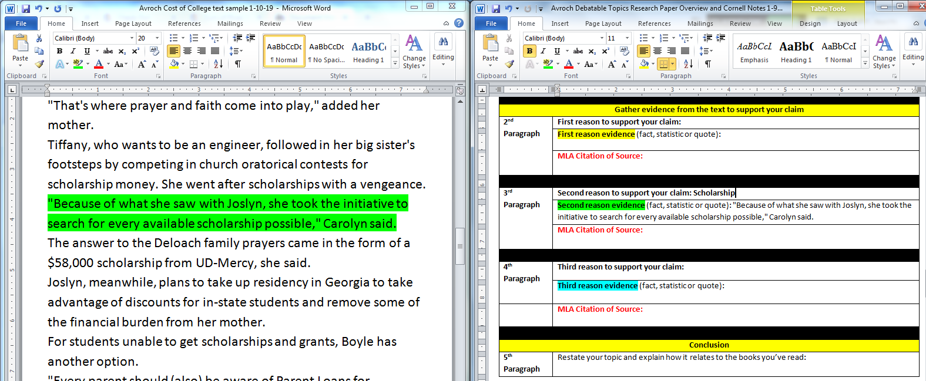
Pasted Newsbank Text
Argument Graphic Organizer

Argument Graphic Organizer:
Introductory Paragraph
Introductory  Paragraph | Topic = (Copy and paste the topic here.)
Introductory  Paragraph | Claim= Your basic belief about a particular topic, issue, event or idea.  - An opinion, proposal, evaluation or cause and effect statement.  - Think in terms of good or bad/right or wrong/pro or con.
Introductory  Paragraph | Claim
Introductory  Paragraph | Reasons for claim |  | First reason for claim:
Introductory  Paragraph |  |  | Second reason for claim:
Introductory  Paragraph |  |  | Third reason for claim:
Introductory  Paragraph | Thesis statement =sentence that summarizes the main point or claim of an essay or paper that is developed, supported, and explained by examples and evidence.
Introductory  Paragraph | Thesis statement
Gather evidence from the text to support your claim
2nd Paragraph | First reason to support your claim:
2nd Paragraph | First reason evidence (fact, statistic or quote):
2nd Paragraph | MLA Citation of Source:
3rd Paragraph | Second reason to support your claim:
3rd Paragraph | Second reason evidence (fact, statistic or quote):
3rd Paragraph | MLA Citation of Source:
4th Paragraph | Third reason to support your claim:
4th Paragraph | Third reason evidence (fact, statistic or quote):
 | MLA Citation of Source:
Conclusion
5th Paragraph | Restate your topic and explain how it relates to the books you’ve read:

Paragraphs for your paper: Split the computer screen and place your graphic organizer on the left and a blank document on the right. Use the notes from your graphic organizer to compose your research paper.

1. Introduction:
- First sentence=State your topic either positively or negatively. (Topic=Is the cost of college too high?)
  - Example: College is affordable.
- Sentences 2-4=Explain how your topic relates to the books you’ve read.
  - Example: Many students in the book Schooled by Clarence Superstar thought the cost of college was affordable if they worked hard. The main character, Julia, worked really hard in middle school and high school to earn an academic scholarship, plus she had a job after school that allowed her to put some money away for it.
- The last sentence of your paragraph=your claim and thesis statement.
  - Claim=your opinion about the topic.
    - Claim example=College is affordable.
  - Thesis statement= a sentence that supports your claim and lists what you’re going to prove in the next three body paragraphs.
    - Thesis statement example=Although many people think the cost of college is too high, I don’t believe it is because there are Financial Aid packages (first reason), scholarships (second reason), and work programs (third reason) available to help make it affordable.
2. Body paragraph #2:
- Explain why you think the first reason of your claim is correct.
  - Example: There are many Financial Aid packages that make college affordable.
- Cite evidence from your research to support the first reason of your claim.
  - Example: According to Wally Smith, a Financial Aid representative from Valentine University, a number of Financial Aid packages exist to make college affordable.

3. Body paragraph #3:
- Explain why you think the second reason of your claim is correct.
  - Example: Many students who work hard in elementary, middle, and high school are able to receive academic scholarships that greatly lessen the cost of college.
- Cite evidence from your research to support the second reason of your claim.
  - Example: Hazel Smith, a student from Colorado, was able to receive a four year scholarship due to her outstanding grades and test scores.

4. Body paragraph #4:
- Explain why you think the third reason of your claim is correct.
  - Example: Students are able to work on campus to offset the cost of college.
- Cite evidence from your research to support the first reason of your claim.
  - Example: John Doe from the University of Pleasantville worked in the Admissions office and gym to earn money to offset the cost of tuition.

5. Paragraph #5: Conclusion
  - Restate your topic and explain how it relates to the books you’ve read.

Name: Date:
2018-2019 Marvelous Mr. Avroch’s AE Class
Debatable Topics Research Paper
Document Created by Mrs. Murray ☺ January 2019

NEW Locate information on Newsbank to support your claim!!! ☺
Topic and Resources:
- Is the cost of college too high?
Newsbank=toronline.org>Media Policies>TOR Media Website>Scroll Down to Destiny link>TOR>Newsbank>Access World News
- Search: college costs
- Click on Best Matches (left) and Lexile>Your reading level
- Locate an article about your topic.
- Copy and paste (Right-click>A) the article’s URL, MLA citation and text to a blank Word document (Ctrl N).
NEW on 1-15-19
Yes, the cost is too high articles:
- College costs too high
  - https://infoweb.newsbank.com/apps/news/document-view?p=AWNB&t=readinglevel%3A0850-1050%21850-1050L%2B%2528Grade%2B6%2529&sort=_rank_%3AD&fld-base-0=alltext&maxresults=20&val-base-0=college%20costs%20%22too%20high%22%20%22affordable%22&docref=news/16A124838BA66818

- FOR MANY, COLLEGE IS SLIPPING OUT OF REACH< \ SOARING COSTS ARE CLOSING DOORS FOR THE MIDDLE CLASS. STUDENTS COMMONLY< TAKE ON SUBSTANTIAL DEBT. IN THE FUTURE, INCOME, NOT MERIT, WILL DETERMINE< CHOICE. AMONG THE POOR, ONLY THE MOST GIFTED WILL HAVE OPTIONS.
https://infoweb.newsbank.com/apps/news/document-view?p=AWNB&t=readinglevel%3A0850-1050%21850-1050L%2B%2528Grade%2B6%2529&sort=_rank_%3AD&fld-base-
- COLLEGE COSTS ARE TOO HIGH, SAY TEENS
  - https://infoweb.newsbank.com/apps/news/document-view?p=AWNB&t=readinglevel%3A0850-1050%21850-1050L%2B%2528Grade%2B6%2529&sort=_rank_%3AD&fld-base-0=alltext&maxresults=20&val-base-0=college%20costs%20%22too%20high%22%20%22affordable%22&docref=news/0EAE8D0358CA633E
  - 0=alltext&maxresults=20&val-base-0=college%20costs%20%22too%20high%22%20%22affordable%22&docref=news/0EB32D1B6CDF4DD9

No, the cost isn’t too high, it’s affordable articles:
- Effort, perseverance pay off - Aid puts college degree within reach
  - https://infoweb.newsbank.com/apps/news/document-view?p=AWNB&t=readinglevel%3A0850-1050%21850-1050L%2B%2528Grade%2B6%2529&sort=_rank_%3AD&fld-base-0=alltext&maxresults=20&val-base-0=college%20work%20study%20hard%20scholarship%20loan%20&docref=news/0EB772844B9B093C
- Cutting the cost of college education - There are thousands of scholarship opportunities available but it requires dedication to pursue them
  - https://infoweb.newsbank.com/apps/news/document-view?p=AWNB&t=readinglevel%3A0850-1050%21850-1050L%2B%2528Grade%2B6%2529&sort=_rank_%3AD&fld-base-0=alltext&maxresults=20&val-base-0=college%20work%20study%20hard%20scholarship%20loan%20&docref=news/11133AD0F3ACADE3

- HOG IT! - CORRALLING COLLEGE CASH
  - https://infoweb.newsbank.com/apps/news/document-view?p=AWNB&t=readinglevel%3A0850-1050%21850-1050L%2B%2528Grade%2B6%2529&sort=_rank_%3AD&fld-base-0=alltext&maxresults=20&val-base-0=college%20work%20study%20hard%20scholarship%20loan%20&docref=news/0EB4FB65CBB7795E
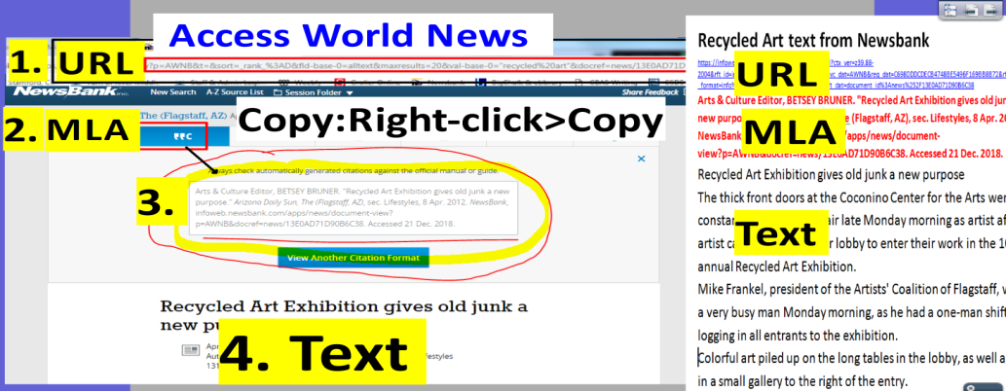

- Should cigarettes be illegal?
Newsbank=toronline.org>Media Policies>TOR Media Website>Scroll Down to Destiny link>TOR>Newsbank>Access World News
- Search: cigarettes illegal health reasons
- Click on Best Matches (left) and Lexile>Your reading level
- Locate an article about your topic.
- Copy and paste (Right-click>A) the article’s URL, MLA citation and text to a blank Word document (Ctrl N).
NEW on 1-15-19
Yes, cigarettes should be illegal articles:
- SHOULD CIGARETTES BE MADE ILLEGAL?
  - https://infoweb.newsbank.com/apps/news/document-view?p=AWNB&t=readinglevel%3A0850-1050%21850-1050L%2B%2528Grade%2B6%2529&sort=_rank_%3AD&fld-base-0=alltext&maxresults=20&val-base-0=cigarettes%20should%20be%20illegal%20health%20risks&docref=news/1016099B4025F26A
- Students full of ideas to keep youths from lighting up
  - https://infoweb.newsbank.com/apps/news/document-view?p=AWNB&t=readinglevel%3A0850-1050%21850-1050L%2B%2528Grade%2B6%2529&sort=_rank_%3AD&fld-base-0=alltext&maxresults=20&val-base-0=cigarettes%20illegal%20health%20risks%20%20addictive&docref=news/14A434CAED52DC08
- IN THE SPOTLIGHT - NATIONAL SMOKEOUT DAY
  - https://infoweb.newsbank.com/apps/news/document-view?p=AWNB&t=readinglevel%3A0850-1050%21850-1050L%2B%2528Grade%2B6%2529&sort=_rank_%3AD&fld-base-0=alltext&maxresults=20&val-base-0=cigarettes%20illegal%20health%20risks%20%20addictive%20cancer%20death&docref=news/10676BA3304E61A5

No, cigarettes should not be illegal articles:
- Butting in or looking out? - Area pharmacies ready for end of tobacco sales, but smokers are fuming mad
  - https://infoweb.newsbank.com/apps/news/document-view?p=AWNB&t=readinglevel%3A0850-1050%21850-1050L%2B%2528Grade%2B6%2529&sort=_rank_%3AD&fld-base-0=alltext&maxresults=20&val-base-0=cigarettes%20should%20be%20illegal%20&docref=news/1362ECD85F1949D8
- IT'LL BE A DRAG, many smokers say, but higher tax won't stop them // Some expect to break law, not habit
  - https://infoweb.newsbank.com/apps/news/document-view?p=AWNB&t=readinglevel%3A0850-1050%21850-1050L%2B%2528Grade%2B6%2529&sort=_rank_%3AD&fld-base-0=alltext&maxresults=20&val-base-0=cigarettes%20illegal%20choice%20&docref=news/10D98F0D6789CFB5
- Legislation filed to raise cigarette taxes
  - https://infoweb.newsbank.com/apps/news/document-view?p=AWNB&t=readinglevel%3A0850-1050%21850-1050L%2B%2528Grade%2B6%2529&sort=_rank_%3AD&fld-base-0=alltext&maxresults=20&val-base-0=cigarettes%20illegal%20choice%20states%20tax&docref=news/0F9B572942F60F91
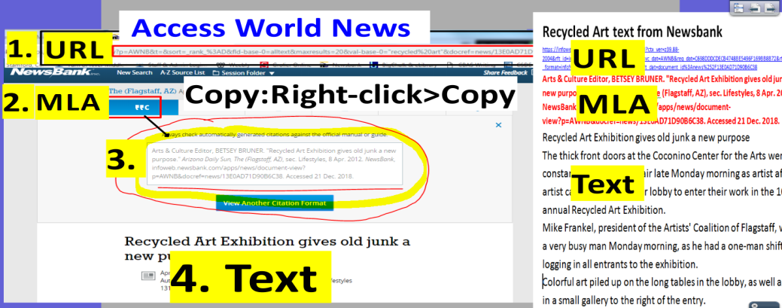

- Should laws limit children under the age of 18 from using Social Media?
Newsbank=toronline.org>Media Policies>TOR Media Website>Scroll Down to Destiny link>TOR>Newsbank>Access World News
- Search: laws protect children social media dangers
- Click on Best Matches (left) and Lexile>Your reading level
- Locate an article about your topic.
- Copy and paste (Right-click>A) the article’s URL, MLA citation and text to a blank Word document (Ctrl N).
NEW on 1-15-19
Yes, there should be laws preventing children under from using Social Media articles:
- Cellphones and social media can be dangerous
  - https://infoweb.newsbank.com/apps/news/document-view?p=AWNB&t=readinglevel%3A0850-1050%21850-1050L%2B%2528Grade%2B6%2529&sort=_rank_%3AD&fld-base-0=alltext&maxresults=20&val-base-0=%22social%20media%22%20positive%20effects%20children%20connect%20&docref=news/169DD26F21465368
- NOT 'LIKING' MESSENGER KIDS
  - https://infoweb.newsbank.com/apps/news/document-view?p=AWNB&t=readinglevel%3A0850-1050%21850-1050L%2B%2528Grade%2B6%2529&sort=_rank_%3AD&fld-base-0=alltext&maxresults=20&val-base-0=%22social%20media%22%20negative%20effects%20laws%20children%20&docref=news/169C38A7AB415570
- CYBER SAFETY ADVOCATE SPEAKS TO ROCKAWAY TWP. KIDS - DISCUSSES DANGERS OF SOCIAL MEDIA
  - https://infoweb.newsbank.com/apps/news/document-view?p=AWNB&t=readinglevel%3A0850-1050%21850-1050L%2B%2528Grade%2B6%2529&sort=_rank_%3AD&fld-base-0=alltext&maxresults=20&val-base-0=%22social%20media%22%20negative%20effects%20children%20&docref=news/1677802C449EC8F8

No, there shouldn’t be laws preventing children under from using Social Media articles:
- Screens aren’t completely bad for kids
  - https://infoweb.newsbank.com/apps/news/document-view?p=AWNB&t=readinglevel%3A0850-1050%21850-1050L%2B%2528Grade%2B6%2529&sort=_rank_%3AD&fld-base-0=alltext&maxresults=20&val-base-0=%22social%20media%22%20positive%20effects%20children%20connect%20&docref=news/16C6C71503E5D938
- Smartphones are changing the teenage years — for better and worse
  - https://infoweb.newsbank.com/apps/news/document-view?p=AWNB&t=readinglevel%3A0850-1050%21850-1050L%2B%2528Grade%2B6%2529&sort=_rank_%3AD&fld-base-0=alltext&maxresults=20&val-base-0=%22social%20media%22%20positive%20effects%20children%20good%20for%20them&docref=news/1668B8AD267594C0
- Social media and your mental health
  - https://infoweb.newsbank.com/apps/news/document-view?p=AWNB&t=readinglevel%3A0850-1050%21850-1050L%2B%2528Grade%2B6%2529&sort=_rank_%3AD&fld-base-0=alltext&maxresults=20&val-base-0=%22social%20media%22%20positive%20effects%20children%20connect%20&docref=news/162AB53C02498E58
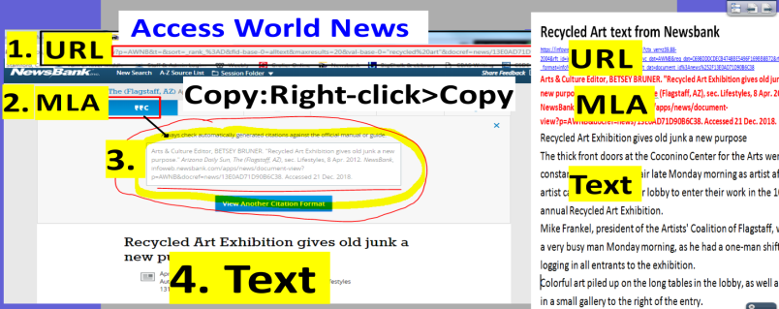

- Are cell phones dangerous?
Newsbank=toronline.org>Media Policies>TOR Media Website>Scroll Down to Destiny link>TOR>Newsbank>Access World News
- Search: cell phone dangers
- Click on Best Matches (left) and Lexile>Your reading level
- Locate an article about your topic.
- Copy and paste (Right-click>A) the article’s URL, MLA citation and text to a blank Word document (Ctrl N).
NEW on 1-15-19
Yes, cell phones are dangerous articles:
- CELL PHONE DANGERS
  - https://infoweb.newsbank.com/apps/news/document-view?p=AWNB&t=readinglevel%3A0850-1050%21850-1050L%2B%2528Grade%2B6%2529&sort=_rank_%3AD&fld-base-0=alltext&maxresults=20&val-base-0=cell%20phone%20dangers%20risks&docref=news/0EDCA33401C17EC5
- A recent study finds ninety-five percent of Americans are now using cell phones, prompting public health officials in California to issue groundbreaking guidelines to limit exposure to cell phone radiation.
  - https://infoweb.newsbank.com/apps/news/document-view?p=AWNB&t=readinglevel%3A0850-1050%21850-1050L%2B%2528Grade%2B6%2529&sort=_rank_%3AD&fld-base-0=alltext&maxresults=20&val-base-0=cell%20phone%20dangers%20risks&docref=news/168E3D73E7E637D8
- GIVING A KID A CELL PHONE MAY NOT BE SMART
  - https://infoweb.newsbank.com/apps/news/document-view?p=AWNB&t=readinglevel%3A0850-1050%21850-1050L%2B%2528Grade%2B6%2529&sort=_rank_%3AD&fld-base-0=alltext&maxresults=20&val-base-0=cell%20phone%20dangers%20risks&docref=news/10BF03BFAAE5DB78

No, cell phones are not dangerous articles:
- Follow tips reducing cell-phone dangers
    - https://infoweb.newsbank.com/apps/news/document-view?p=AWNB&t=readinglevel%3A0850-1050%21850-1050L%2B%2528Grade%2B6%2529&sort=_rank_%3AD&fld-base-0=alltext&maxresults=20&val-base-0=cell%20phone%20dangers%20risks&docref=news/0EB0F3E135766A94
  - Teens Communicate - Young people make new cell phone technology their own
    - https://infoweb.newsbank.com/apps/news/document-view?p=AWNB&t=readinglevel%3A0850-1050%21850-1050L%2B%2528Grade%2B6%2529&sort=_rank_%3AD&fld-base-0=alltext&maxresults=20&val-base-0=cell%20phones%20good%20for%20kids%20independent&docref=news/1446415D641960F8

  - teens_and_cell_phones.1st
    - https://infoweb.newsbank.com/apps/news/document-view?p=AWNB&t=readinglevel%3A0850-1050%21850-1050L%2B%2528Grade%2B6%2529&sort=_rank_%3AD&fld-base-0=alltext&maxresults=20&val-base-0=cell%20phones%20good%20for%20kids%20independent&docref=news/1476BEFFF2D1F2E0

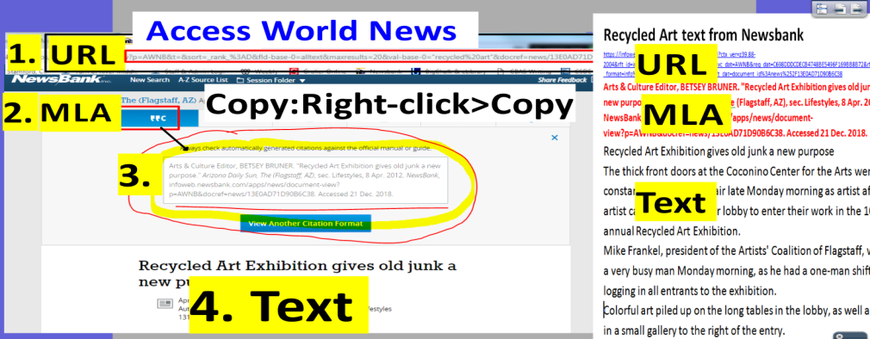

- Do video games cause violent behavior?
Newsbank=toronline.org>Media Policies>TOR Media Website>Scroll Down to Destiny link>TOR>Newsbank>Access World News
- Search: video games violent behavior
- Click on Best Matches (left) and Lexile>Your reading level
- Locate an article about your topic.
- Copy and paste (Right-click>A) the article’s URL, MLA citation and text to a blank Word document (Ctrl N).

NEW on 1-15-19
Yes, video games cause violent behavior articles:
- STUDIES FIND LINK BETWEEN VIDEO GAMES, VIOLENCE
  - https://infoweb.newsbank.com/apps/news/document-view?p=AWNB&t=readinglevel%3A0850-1050%21850-1050L%2B%2528Grade%2B6%2529&sort=_rank_%3AD&fld-base-0=alltext&maxresults=20&val-base-0=video%20games%20violent%20behavior&docref=news/0EB76CAE8470F3C4
- VIOLENT VIDEO GAMES A HEARTLESS HOBBY
  - https://infoweb.newsbank.com/apps/news/document-view?p=AWNB&t=readinglevel%3A0850-1050%21850-1050L%2B%2528Grade%2B6%2529&sort=_rank_%3AD&fld-base-0=alltext&maxresults=20&val-base-0=video%20games%20violent%20behavior&docref=news/1088D3D5352C3181
- Video games affect children's aggressiveness
  - https://infoweb.newsbank.com/apps/news/document-view?p=AWNB&t=readinglevel%3A0850-1050%21850-1050L%2B%2528Grade%2B6%2529&sort=_rank_%3AD&fld-base-0=alltext&maxresults=20&val-base-0=video%20games%20violent%20behavior&docref=news/13DED5A7408FAD40

No, video games do not cause violent behavior articles:
- Age Restrictions Sought for Video Game Sales
  - https://infoweb.newsbank.com/apps/news/document-view?p=AWNB&t=readinglevel%3A0850-1050%21850-1050L%2B%2528Grade%2B6%2529&sort=_rank_%3AD&fld-base-0=alltext&maxresults=20&val-base-0=video%20games%20violent%20behavior&docref=news/14CD6F124B8CD068
- Can Good Come Of Video Games?
  - https://infoweb.newsbank.com/apps/news/document-view?p=AWNB&t=readinglevel%3A0850-1050%21850-1050L%2B%2528Grade%2B6%2529&sort=_rank_%3AD&fld-base-0=alltext&maxresults=20&val-base-0=video%20games%20violent%20behavior&docref=news/1493EDAC4619C868

- GAMES'S ON - FACE-TO-FACE COMPETITION ADDS SOCIAL SKILLS TO THE COMPUTER WORLD
  - https://infoweb.newsbank.com/apps/news/document-view?p=AWNB&t=readinglevel%3A0850-1050%21850-1050L%2B%2528Grade%2B6%2529&sort=_rank_%3AD&fld-base-0=alltext&maxresults=20&val-base-0=video%20games%20violent%20behavior&docref=news/101F47272B7D3E49



