Scratch and GRAPES Cheat-Sheet
Created by Lynn Murray
December 2015
Project overview:
There are three main steps to using Scratch: | - Create a Sprite (a character or object that you program to move).  - Create a background filled with informational text boxes that describe your curriculum-related topic.  - Create a script to move your sprite.
Specific project steps: | - Save pictures related to GRAPES to our number  - Open Scratch  - Create a grape sprite  - Create a background on the stage that includes text boxes to represent each letter of GRAPES  - Create a script to move the grape on the stage
Specific project steps explained in great detail:
- Save pictures related to GRAPES to our number. | - Split your screen so your Cornell Notes are on the right, and Google Chrome is on the right  - Google.com/images  - Search a picture that represents each concept of GRAPES and SAVE the PICTURE TO YOUR NUMBER.  - Right-click on the picture>SAVE IMAGE  - Computer  - Click your number  - Give the picture a name  - Open>SAVE
- Open Scratch | Start>Programs>Scratch OR Flag>type Scratch.
- Create a “grape” sprite
Search a grape and save it to your number | Search a single grape and save it to your number  - Right-click on the picture>SAVE IMAGE  - Computer  - Click your number  - Give the picture a name>grape  - Open>SAVE
We’re going to get rid of the default cat sprite and create our own "grape" sprite. | To get rid of little kitty…  - Right click on kitty>Delete (Bye, bye kitty).  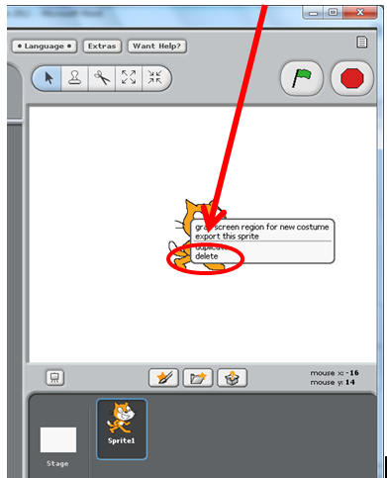
To make a new sprite, we’re going to open our grape. | c. To make a new sprite, we’re going to open our grape  - Click on the middle folder  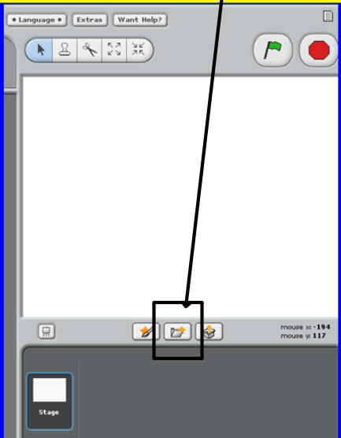
Click on Computer>  H>  Find your grape | d. 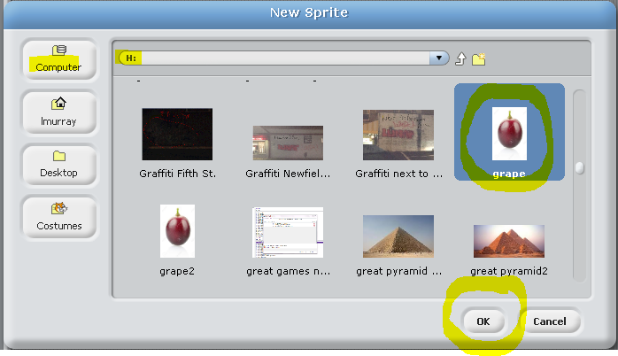
Right-click on the grape  >Resize | 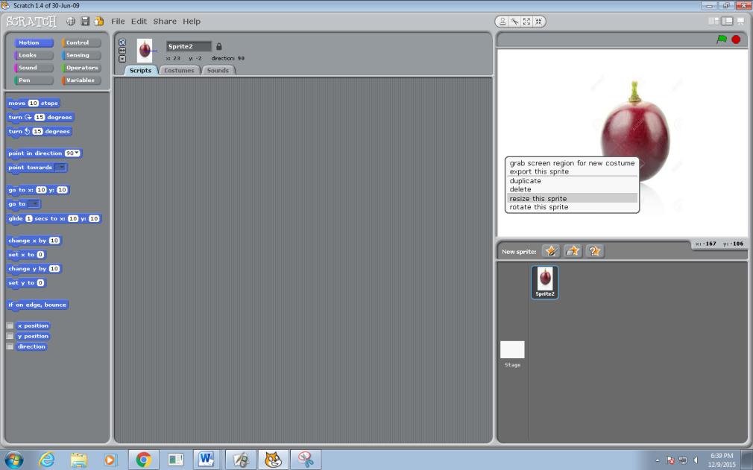
Move the grape to make it smaller by clicking on the arrows.
Let’s name our sprite. Highlight and delete the word Sprite 1, and call yours grape | 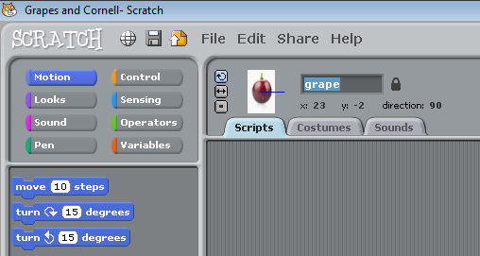
View of your newly named sprite, grape. | 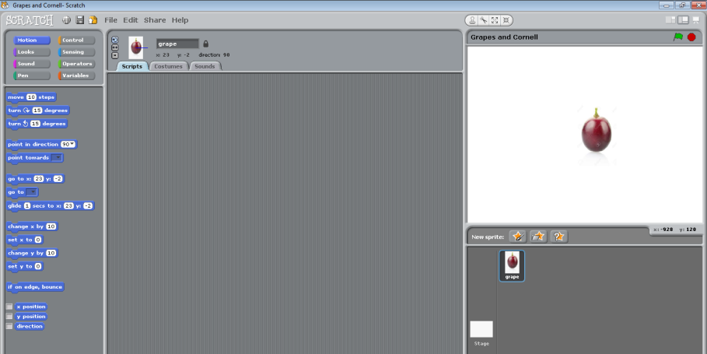
4. Create a background on the stage that includes text boxes to represent GRAPES.
- The stage can change its appearance by switching backgrounds.  - Click on the Stage icon. | 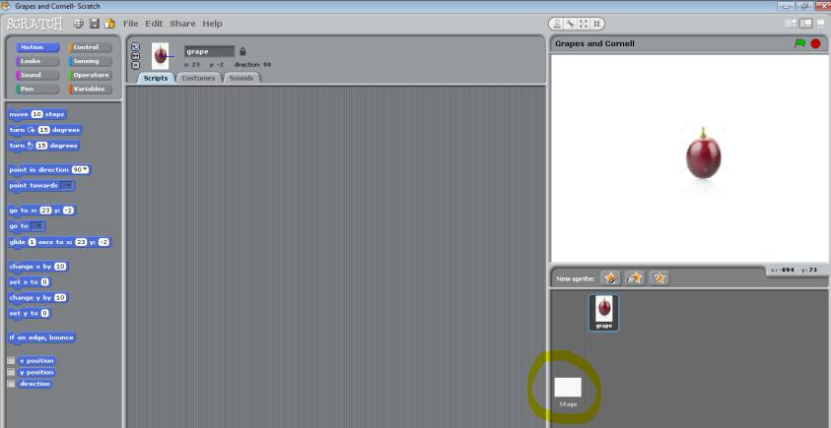
Click on the Backgrounds tab. | 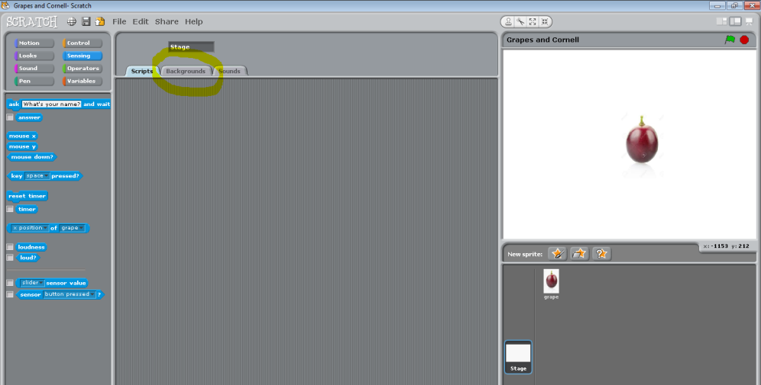
Click on Edit | 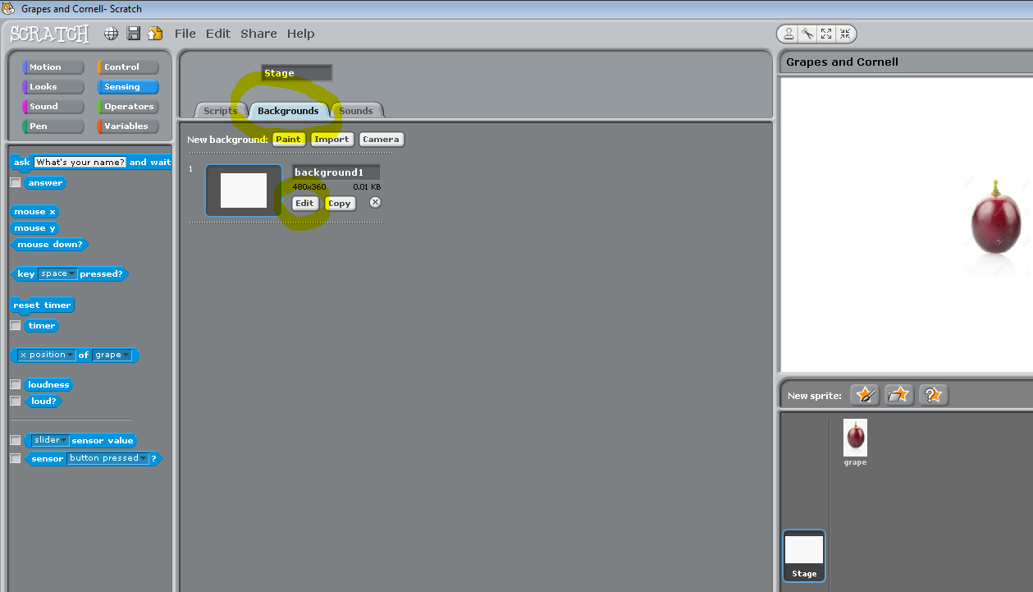
Paint the background=  - Click on Fill tool (paint bucket).  - Choose a color.  - Click on the big square. (paint can)  - OK | 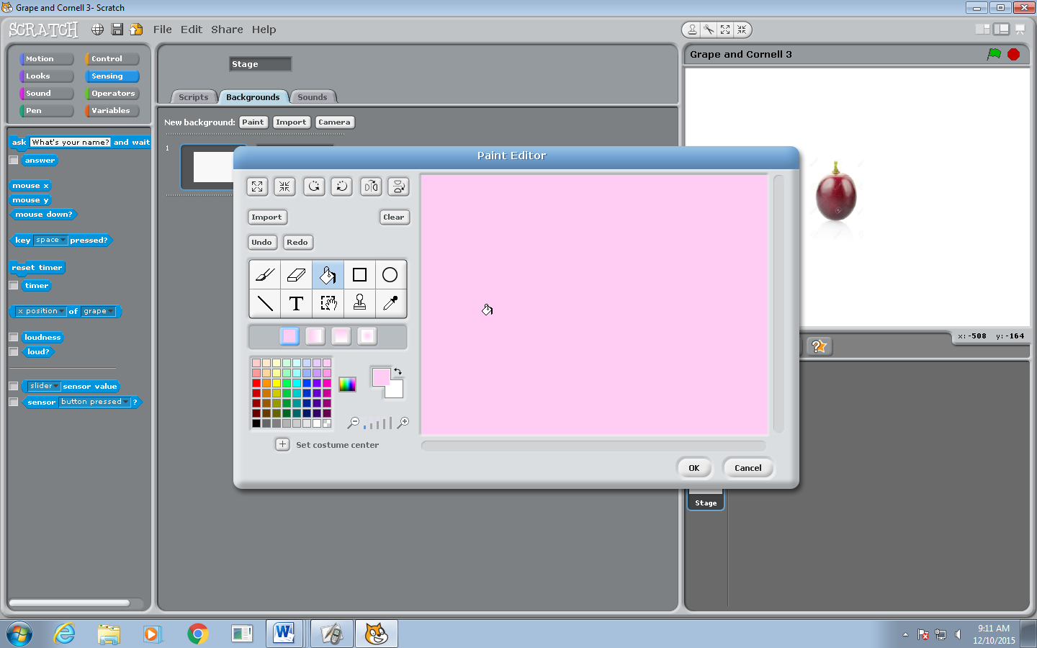
View after you create the new stage | 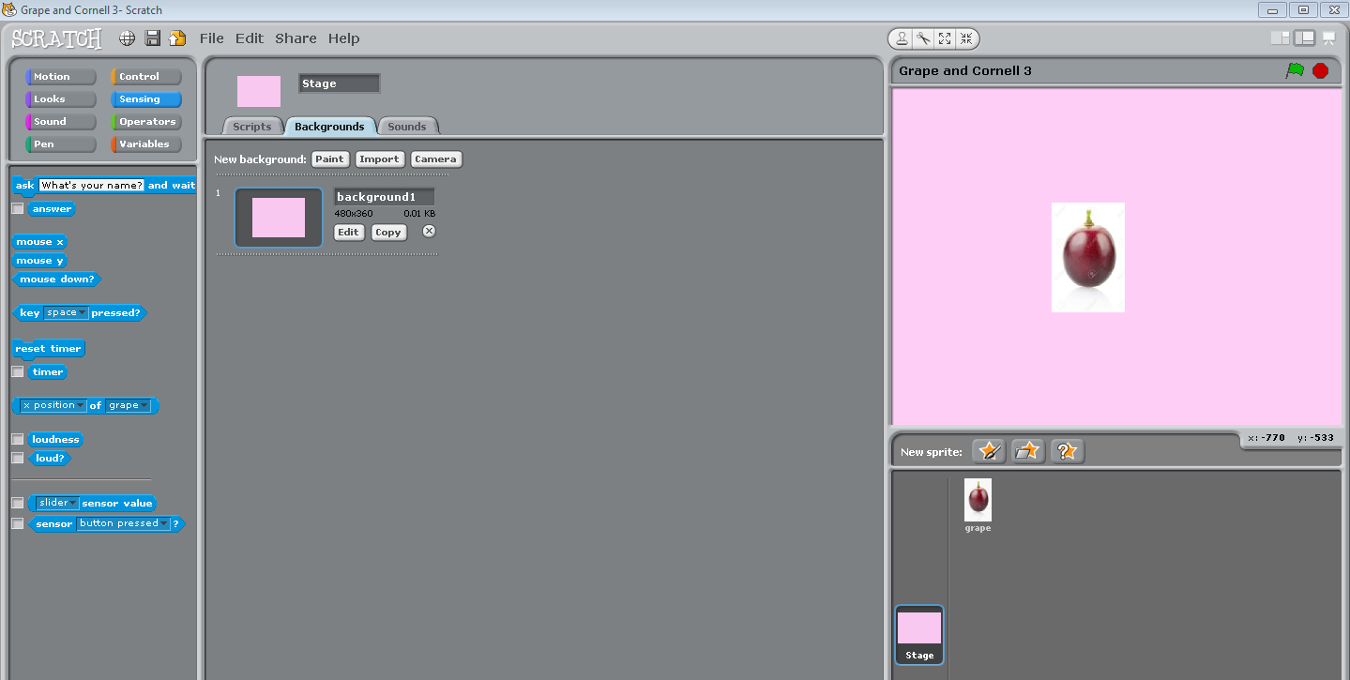
Let’s add some text boxes.  - Click on edit  - Click on T  - Click on the screen and move your text box | 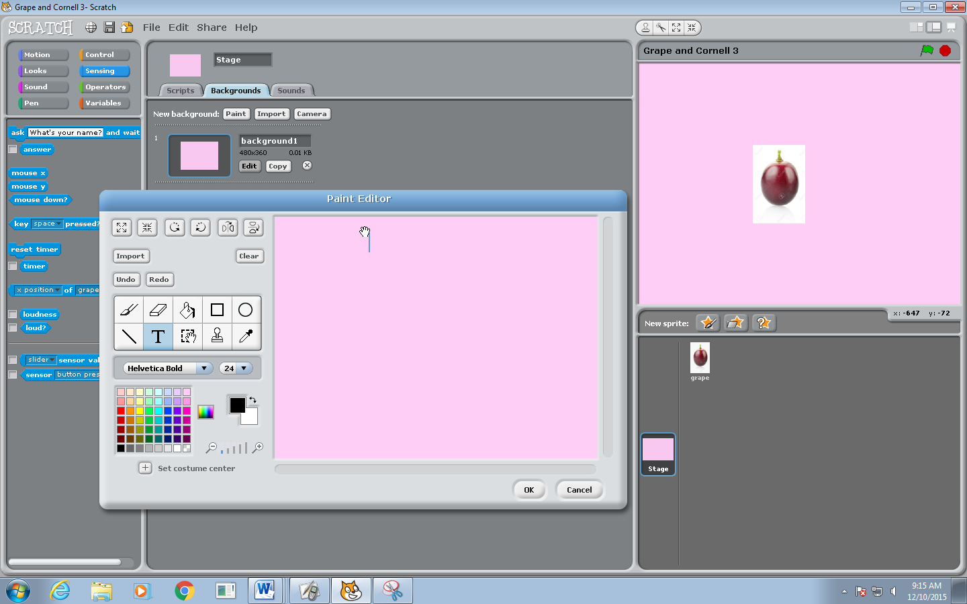
Type GRAPES>OK | 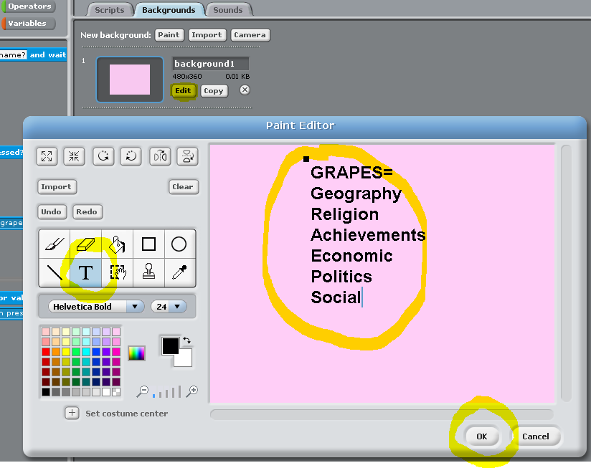
(If we have time!!!)  You can also import pictures and move them around.  -Edit>Import  -Computer  -H  -Look for the picture  -OK | 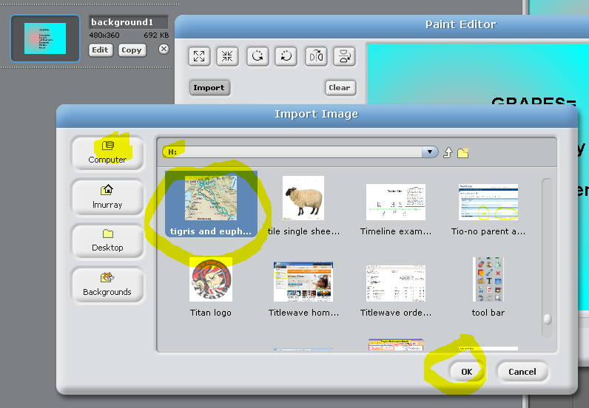
(If we have time.)  View of background with a picture once you move the picture around. | 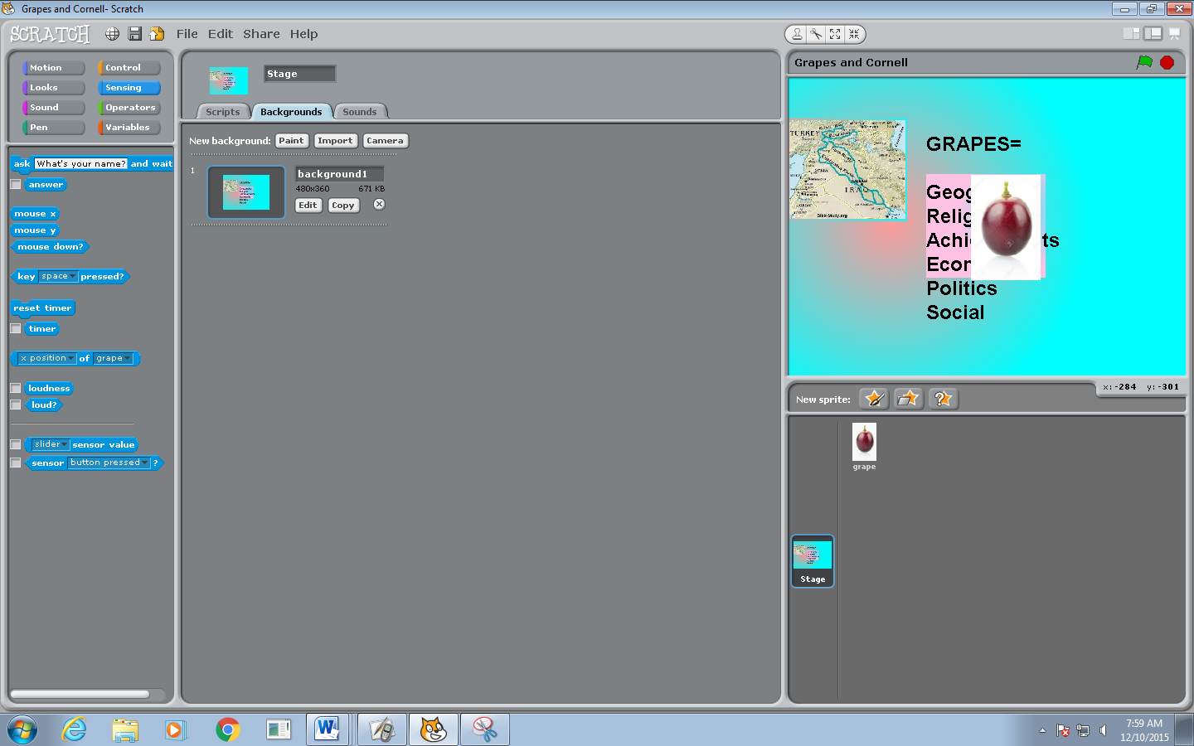
- Create a script to move the grape on the stage
To leave the stage view, click on the sprite at the bottom. | 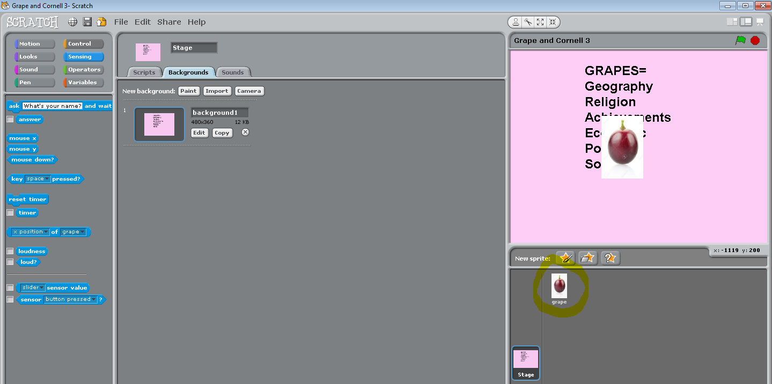
In order to make the sprite move, click on the Scripts tab. | 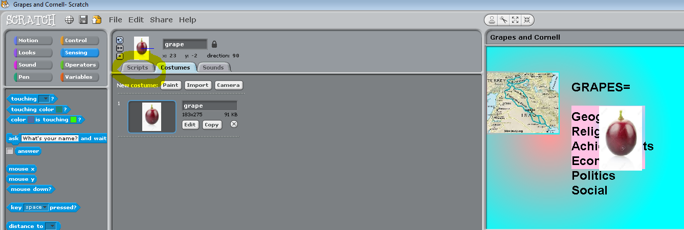
Background information about adding actions to your grape sprite | Important information about how to to successfully add actions to your sprite:  - Adding actions to a sprite is called writing a “script” or “code.”  - The “script” or “code” is an instruction recipe which tells your sprite what to do.  - Scratch has built in commands for moving sprites. All of these commands are located under the Motion section of the code screen.  - You need an initiating action to get started on any part of the code.  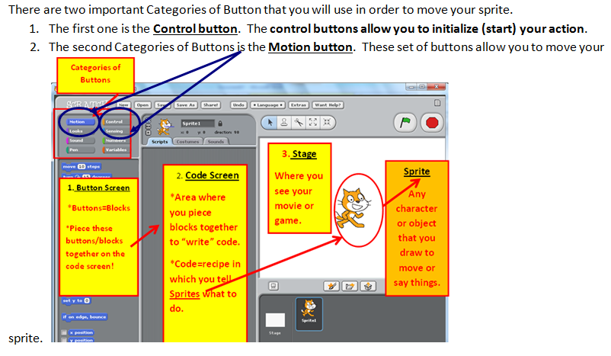
Control button=  Click on this first to initiate the action. | 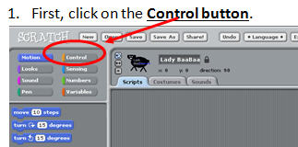
Choose a Control button(s) that interests you. | 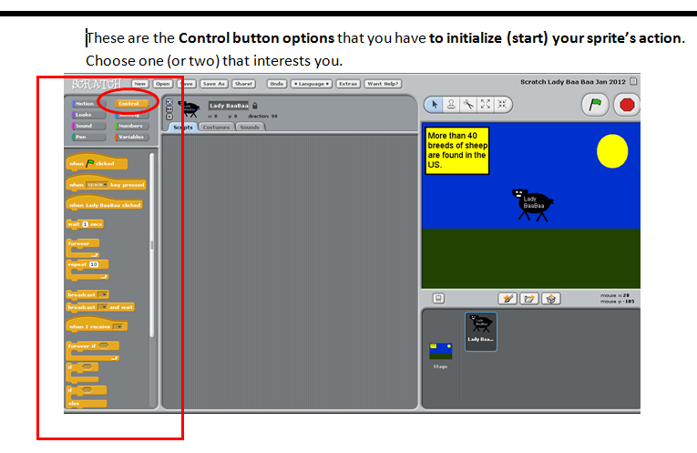
Drag over one or two Control buttons that interest you. | 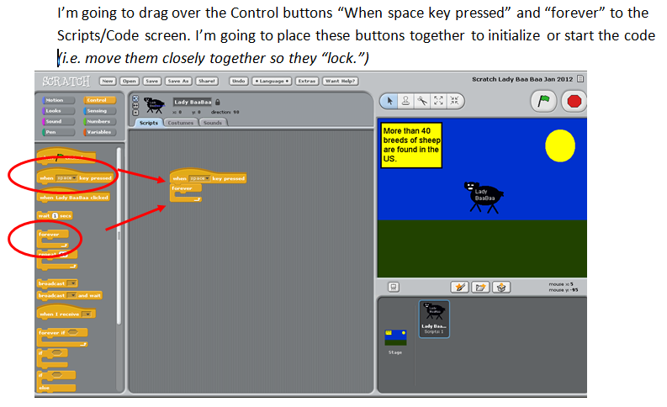  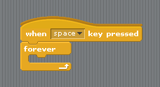
Control buttons explained. | The Control buttons “hug” the other buttons inside of them in order to have the Script take action. In other words, the other buttons fit inside the Control buttons.  - In the example below, first I clicked on the Control button and dragged over two Control buttons to the Scripts area.  - Next, I clicked on the Motion button. Any of the Motion buttons below can be dragged inside of the empty space “inside” of the Control buttons.  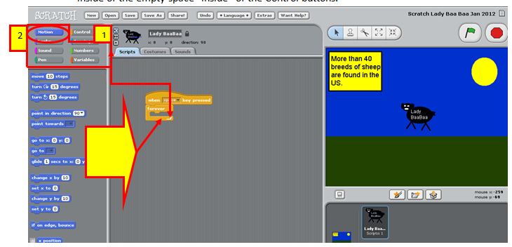
Motion button explained in more detail. | Motion button explained in more detail:  - In order to make my sprite move, I must drag one of the Motion buttons inside of the “hug” of the Control button(s).  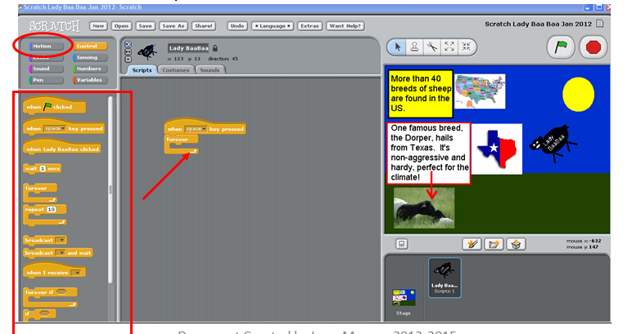
Motion button explained in even greater detail. | I’m going to choose the glide and move examples to make my “Lady Baa Baa” sprite move down, around and back up the page. You may experiment at this point with your sprite and various motions.  - Drag some Motions inside of the Control buttons to have your sprite move around the page.  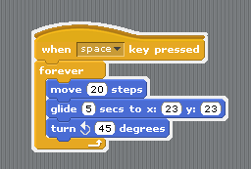  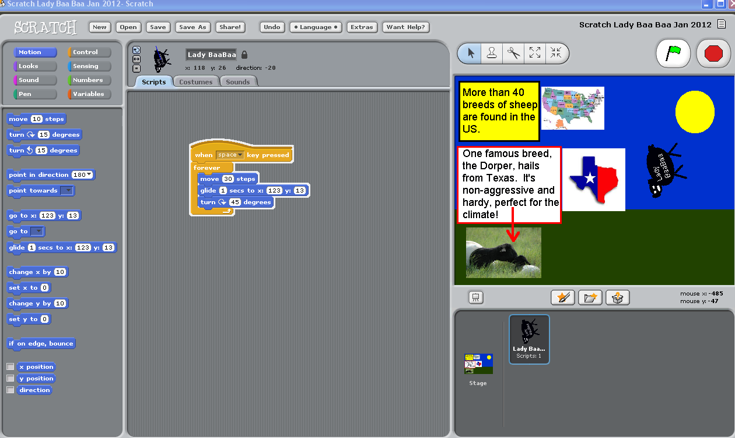
View of the sprite in action!!! | 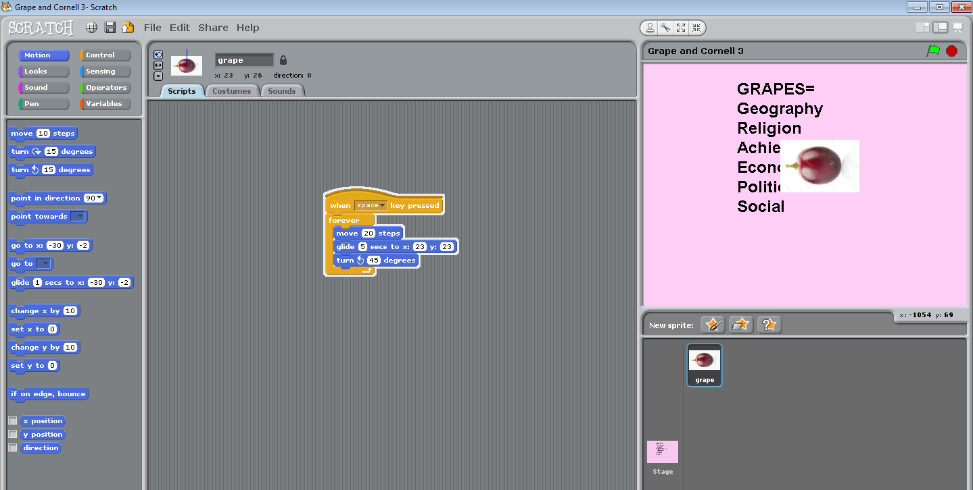
View your masterpiece | To view your masterpiece on the “big screen” click on the Enter Presentation mode.  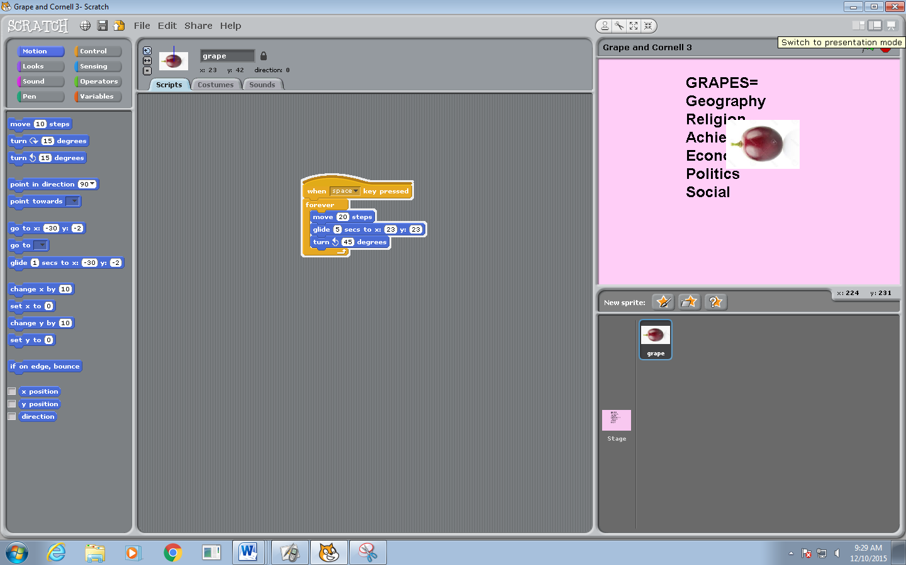
View of full screen-presentation mode GRAPE masterpiece. | 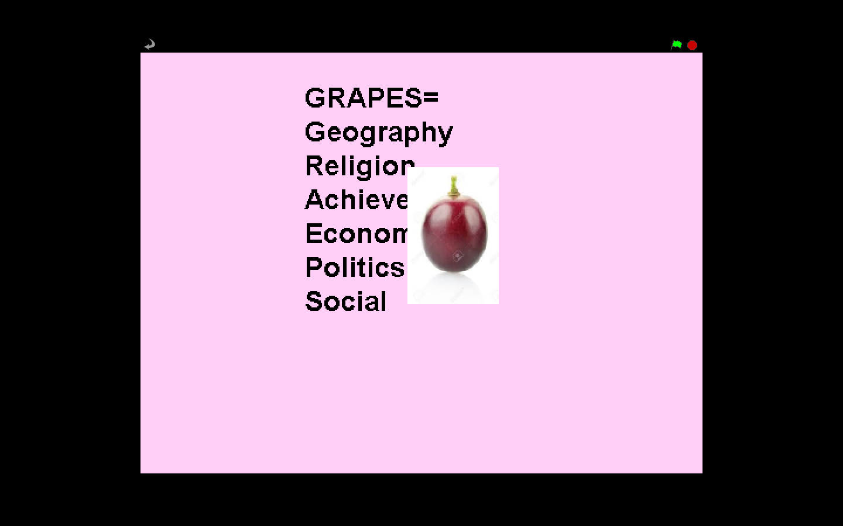
SAVE your masterpiece!!! | -File  -SAVE AS  -Computer  -H  -Give the project a name=GRAPES and Cornell  -OK  