Name:
Newsbank and Grolier “Lexiled”
Text Comparison Project
☺
Magical Mrs. Colleran and Mrs. Murray
November, 2012 (5)
Objective: Students will compare and contrast two nonfiction texts.
Project steps overview:
1. Students will use Newsbank.com or Grolier.com to locate two “Lexiled” articles about the same topic.
2. Students will copy and paste information from Newsbank/Grolier onto Microsoft Word. Students will copy and paste the website address of each article at the top of their pasted text.
- Students will use Easybib.com to properly cite the article’s source. They will copy and paste the citation from Easybib.com onto the top of their Venn diagram.
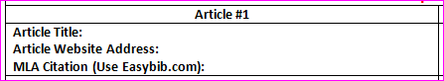
3. Students will read each article, carefully, looking at the article’s text features to help determine its meaning.
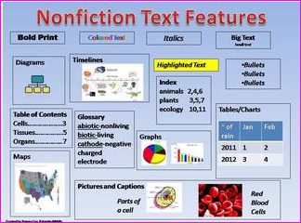
4. Next, students will determine the article’s text structure: Description, Sequence, Comparison, Cause & Effect, and Problem & Solution.
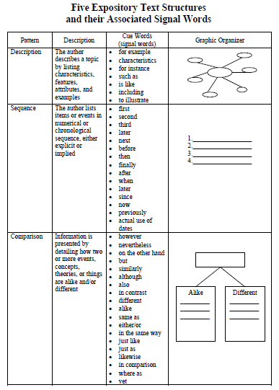
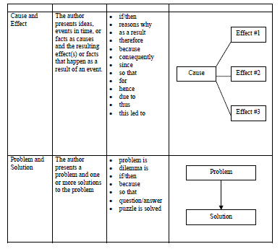

5. Students will read each article again and highlight the subtopic and supporting details.
- Students will transfer their notes onto their graphic organizer.
6. Students will compare and contrast two nonfiction texts.
- Students will answer the following question in a well thought out response:
“Describe the difference between the two articles citing text evidence.”
Project steps elaborated…
Step #1= Students will use Newsbank.com to locate two articles about the same topic.
- At TOR…Internet>Favorites>TRN Online Subscription folder>Newsbank

- At home… http://infoweb.newsbank.com
username: stamfordmiddle
password: stamfordmiddle
- Newsbank homepage: Click on the NewsBank KidsPage.
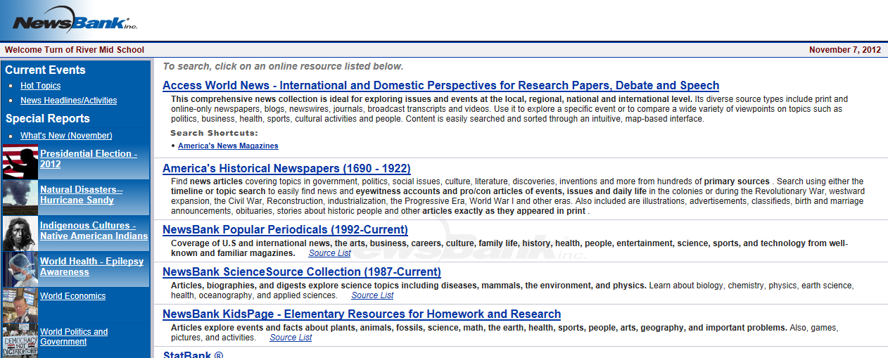
- You can search Newsbank for articles and corresponding lexile levels!
Lexile levels: www.lexile.com
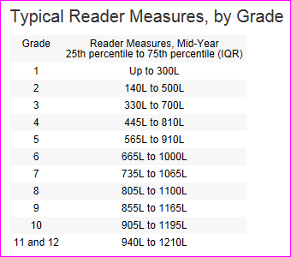
We’ll first search for an individual topic, by all lexile levels.
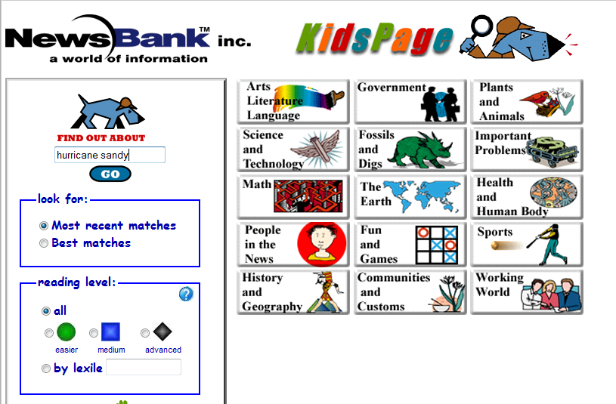
Results for searching all lexile levels:
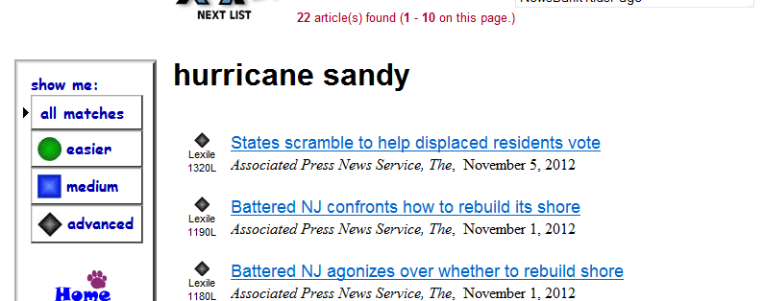
Advanced lexile level too high? Click on medium.
- Another way to search for a topic by lexile level is through the subject categories. Click on an area that interests you. I chose Health and Human Body.
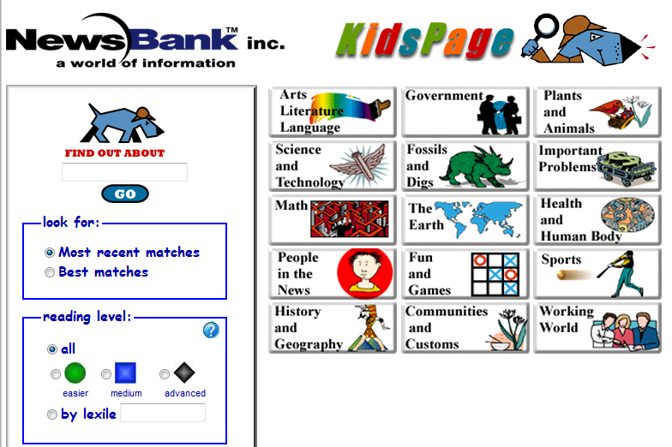
Results for Health and Human Body subject area. I clicked on Mind and Brain.
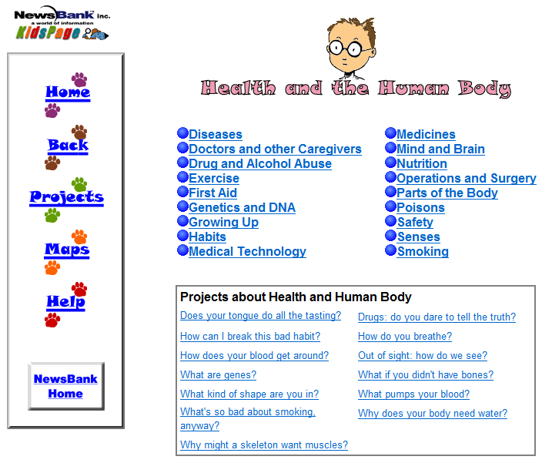
Results for the Mind and Brain category:
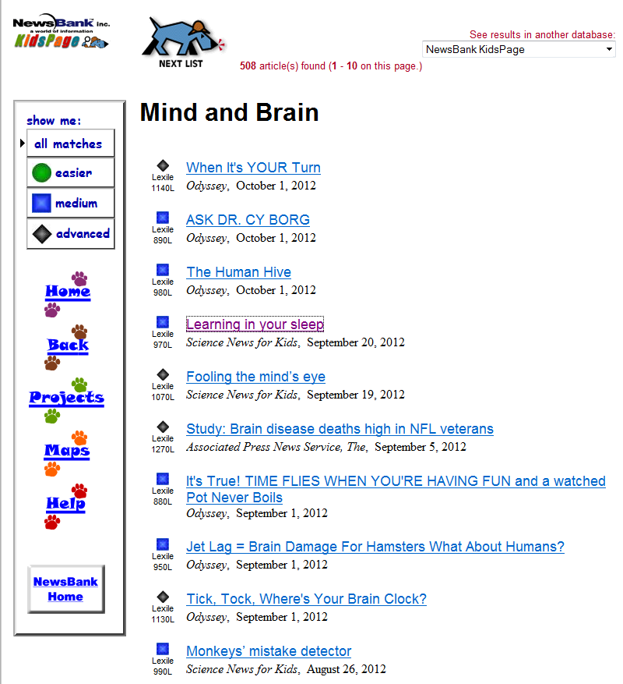
Perfect! I can definitely excel at this!
Text from Learning in Your Sleep:
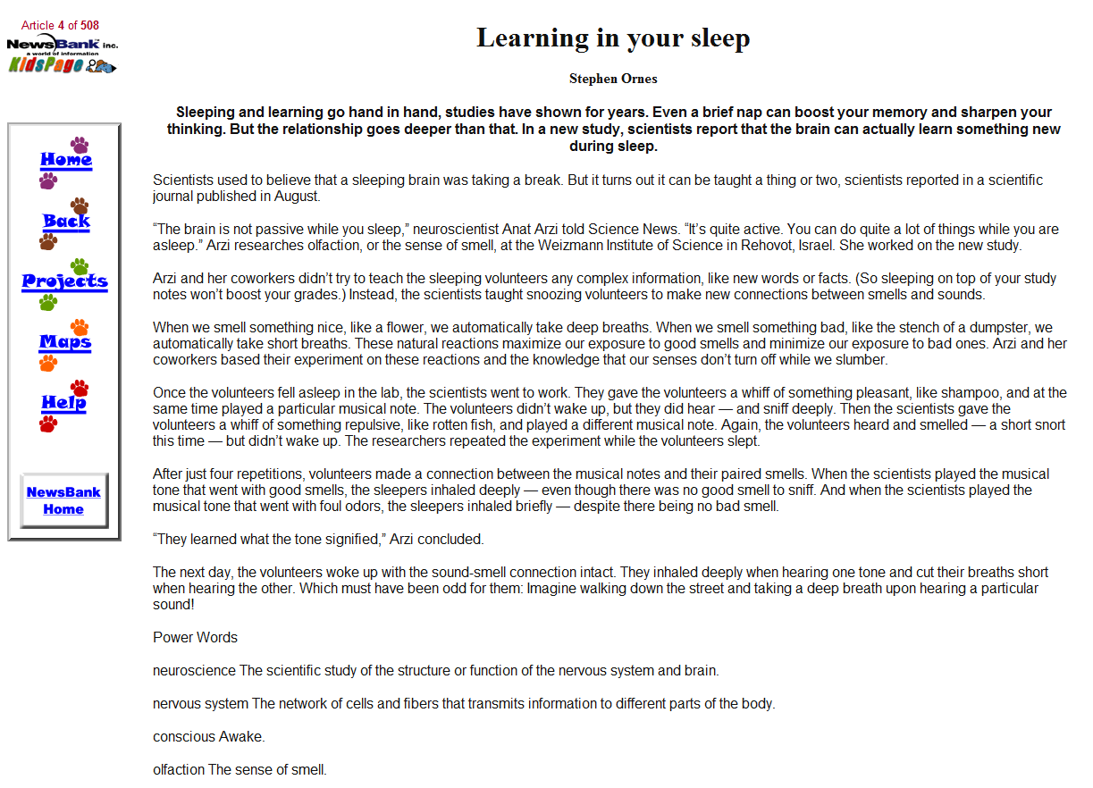
Step 2: Students will copy and paste information from Newsbank.com onto Microsoft Word.
- Students will copy and paste their website address at the top of their pasted text.
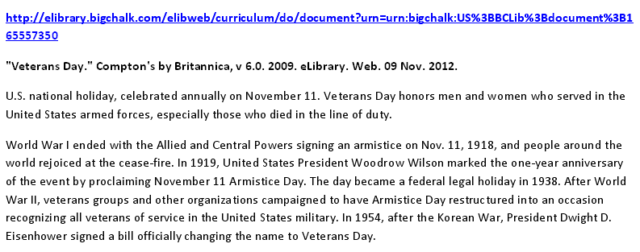
Grolier.com=a Lexile-leveled online encyclopedia.

At TOR=Internet>Favorites>TRN Online folder>Grolier
At home=http://auth.grolier.com/login/go_login_page.html?bffs=N
- Username=sps2
- Password=sps2

Steps to search your topic using Grolier, an electronic encyclopedia:
- Type your topic in the Search box>Enter.
- Results for searching sheep with corresponding lexile levels:
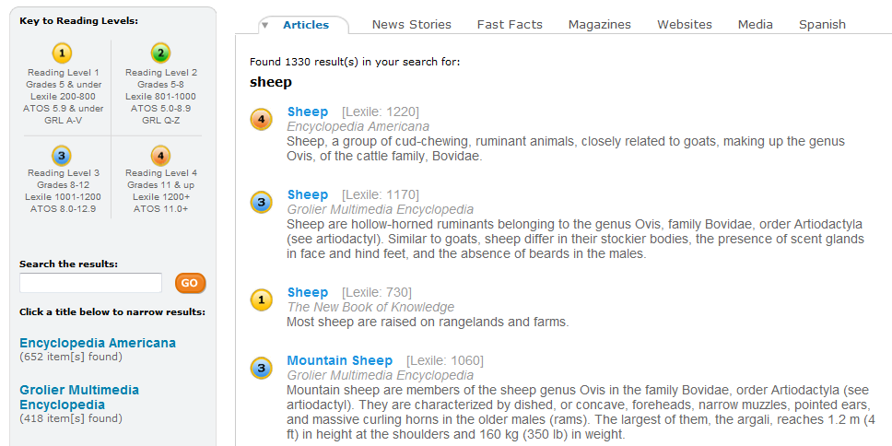
Steps to copy/paste text from Newsbank.com or Grolier to Microsoft Word.
- Open a new Microsoft Word document. Ctrl N.
- Highlight the website address from Newsbank.com.
  - Highlight the address>Right-click over the address>Copy.
- Click on Microsoft Word.
  - Right-click>Paste>A>ENTER! The Internet address will now turn blue and will automatically be turned into a hyperlink.
- Click back on the Internet.
- Highlight the article’s text.
- Right-click>Copy.
- Click back on Word and Right-Click>Paste>A.
Step #3: Students will read each article, carefully, looking at the article’s text features to help determine its meaning.
Step #4: Next, students will determine the article’s text structure: Description, Sequence, Comparison, Cause & Effect, and Problem & Solution.
- Students will use the text structure chart on the following page (8) and record their response the accompanying text structure and notes page.
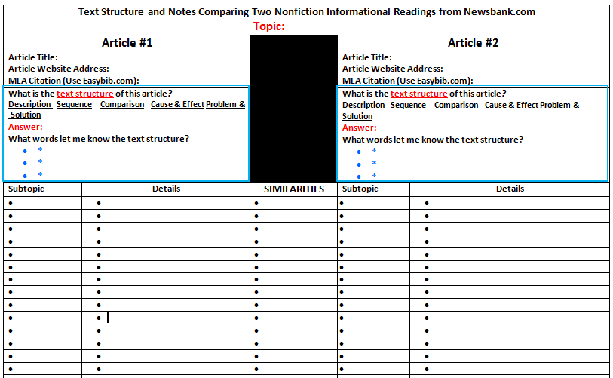
OR
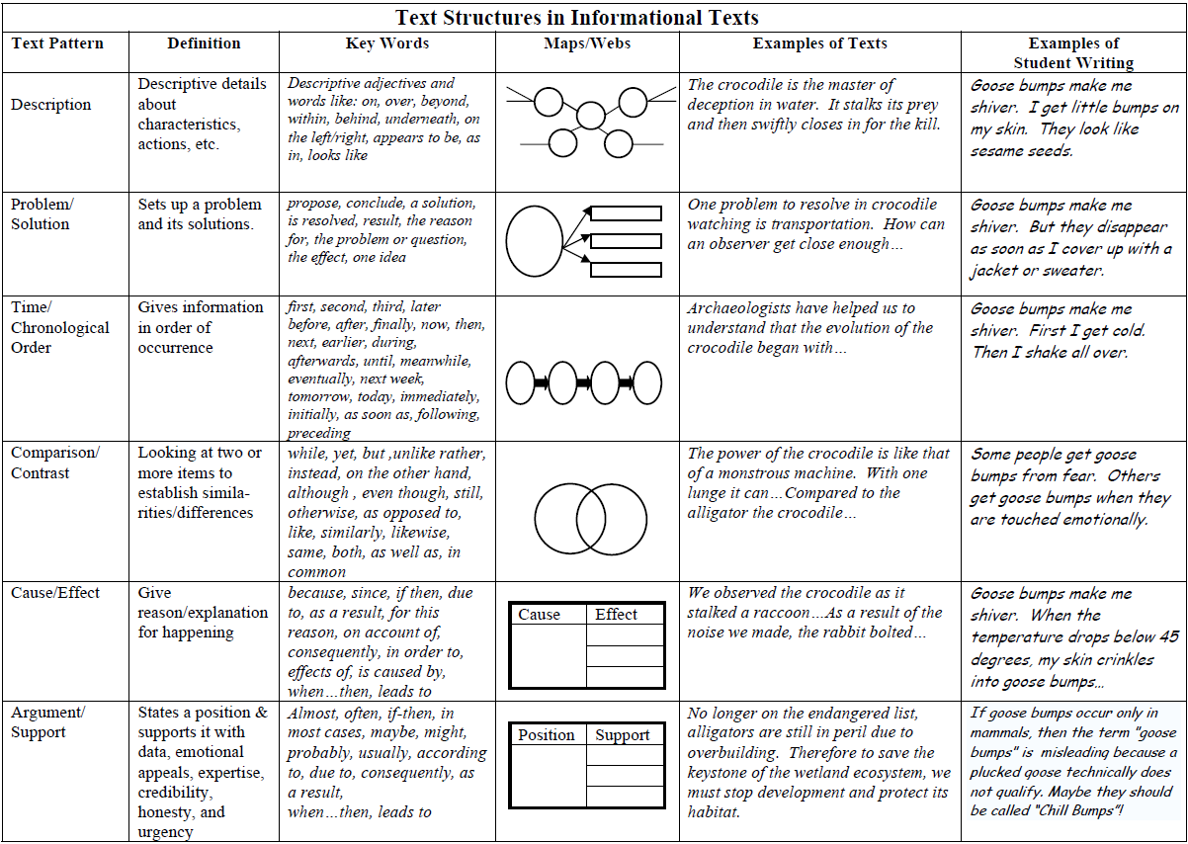

Step #5: Students will read each article again and highlight facts from a paragraph’s topic sentence as well as its supporting details.
- Students will transfer their notes to their graphic organizer.
Students will split the screen so their notes are on one side and their graphic organizer is on the other.
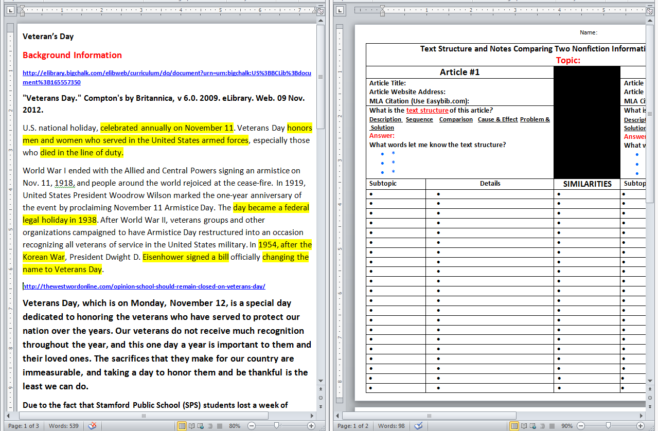
Sample of structure and topic comparison:
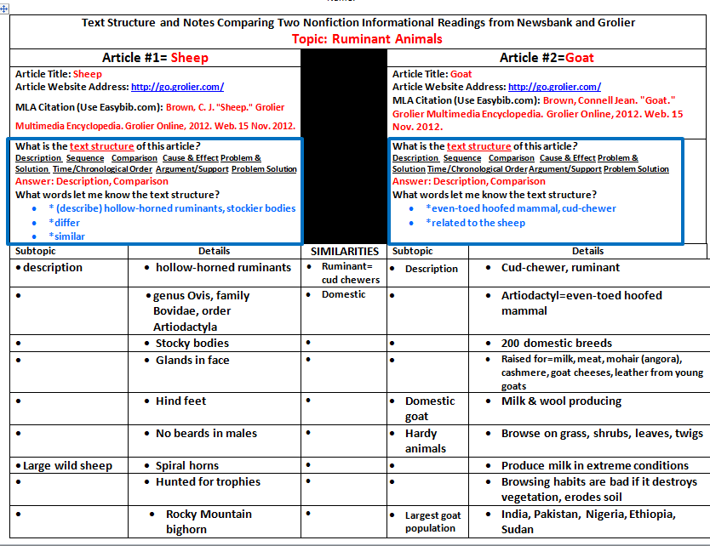
Step #6: Students will compare and contrast two nonfiction texts.
- Answer the following question in an essay:
“Describe the difference between the two articles citing text evidence.”
- Students will split the screen again and use their notes as the basis of their response.
