How to Create a Documentary Using Windows Movie Maker
Created by Lynn Murray, Media Specialist, TOR Middle School
Overview:
- Create a script based on your note cards.
- Collect pictures and “fix” them on Microsoft Office Picture Manager. Once they are “fixed” save them to your number.
- Open Windows Movie Maker and import your pictures in the order of your script.
- Add titles before, after or on the pictures.
- Add your narration by speaking your script.
- Save your project as a movie.
- Watch and admire your hard work. Good job! You Rock!

Steps Explained:
- Create a script based on your note cards.
  - Cut out and organize your note cards by Keyword. For example, put all of the Who, Describe or When cards into separate piles.
  - Based on your piles of information, begin typing what you will say about your question/subtopics.

Sample script:
Keyword-Describe (Picture of a shearing station)
Smith: Prior to 1915, sheep were shorn by hand on local farms. After 1915, however, herders began bringing their flocks to huge shearing stations located throughout Australia and New Zealand.
Keyword-Who (Picture of Lynn Murray)
Jones: In 2009, a relative newcomer emerged on the scene as a sheep shearing genius. Her name, Lynn Murray. Lynn introduced the “Sheeromatic” to a group of sheep shearers in Australia in February, 2009. By early 2011 word had spread through out the herding world and Murray soon found sitting upon a “Sheeromatic” empire.

- Collect pictures reflecting the pictures in your script.
  - Right click on the picture>Save Picture As> Pull down and click on your number>Save.
  - To “fix” any pictures, open Microsoft Office> Microsoft Office Tools>Office Picture Manager.
    - File>Locate Pictures.
    - Click on Edit>Resize (if the picture is too big, put it on a smaller %) and/or Auto Correct at the top.
    - File>Save As>Save the picture as a revised version on your number.
- Open Windows Movie Maker and import your pictures in the order of your script.
  - Start>Programs>Windows Movie Maker.
  - File>Import Into Collections>Locate your pictures at your number.
  - Drag the picture down into the order that you would like into the Storyboard below.
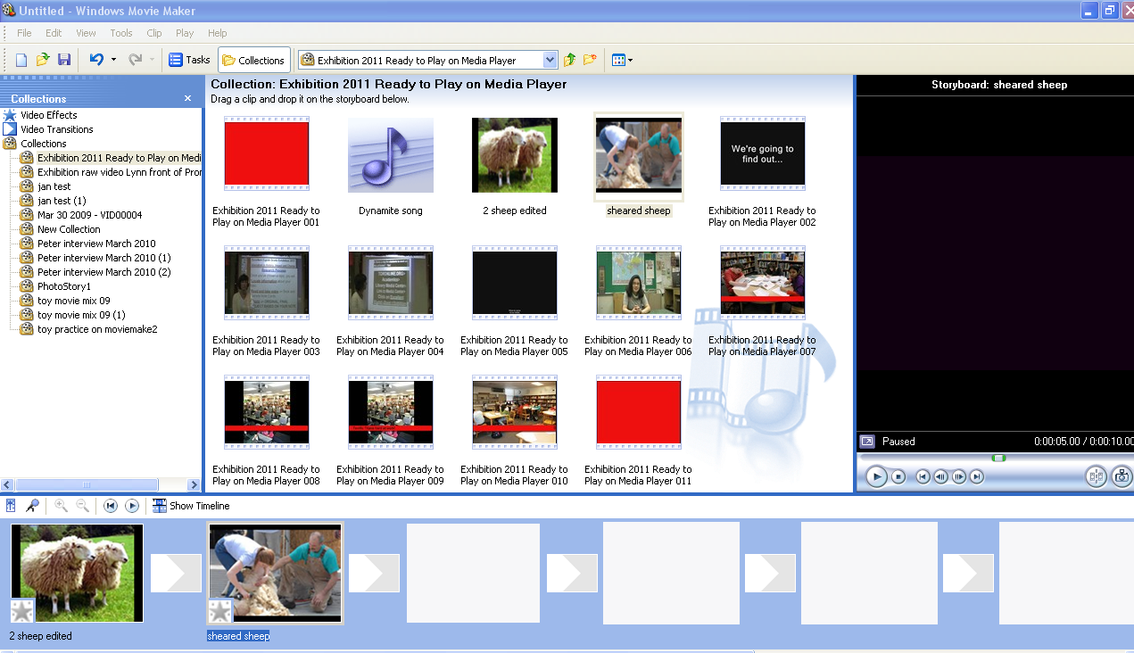
- Add titles before, after or on the pictures.
  - Tools>Titles and Credits
  - You will be greeted by a myriad of intriguing choices. Click on Title at the Beginning of the Movie.
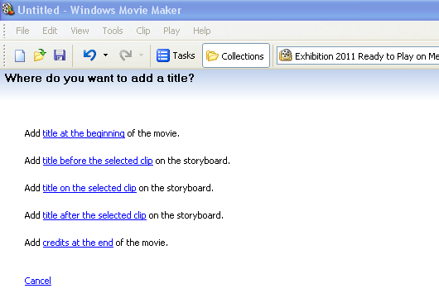
c. Type your movie’s title in the top box. Type your name, TOR Exhibition, June,
2011 in the bottom box.
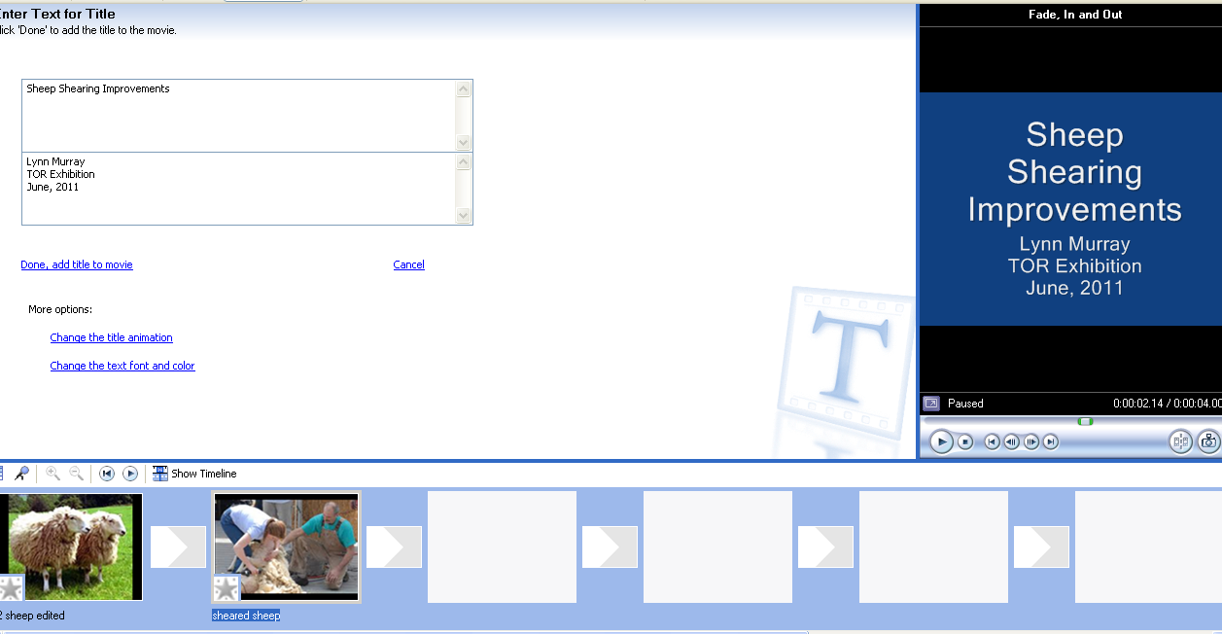
  - To make changes to the text, click on Change the text font and color. Make changes by clicking on the options next to Font, Color, Size and Position. When you like the new changes, click on Done, add title to movie.
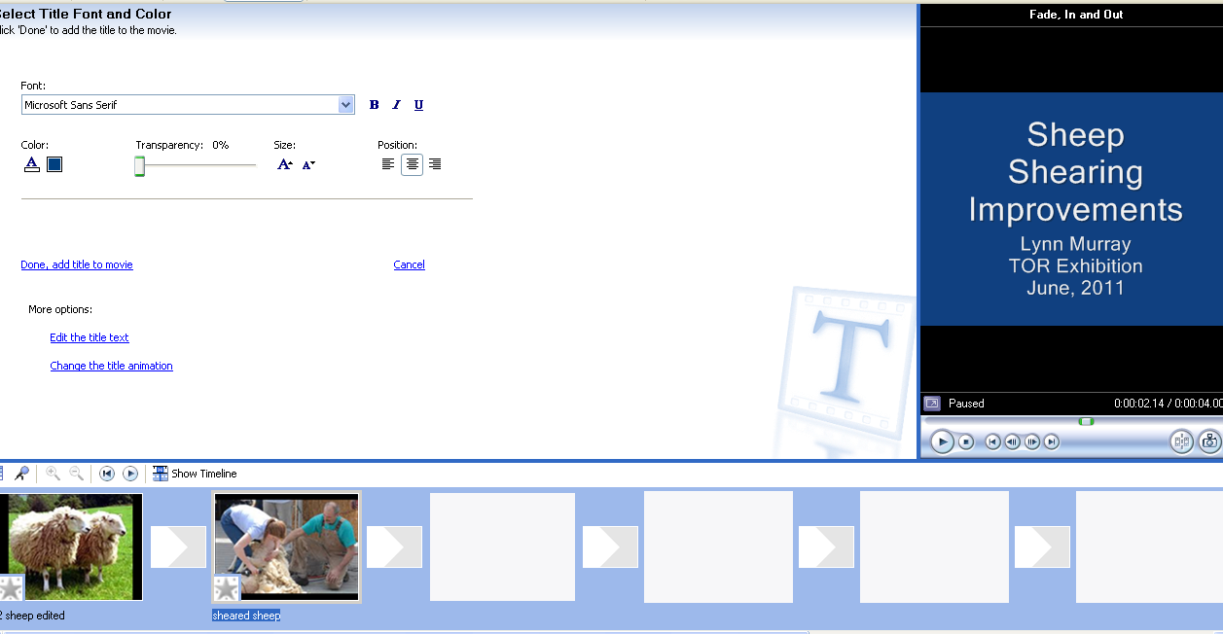

  - Changed title.
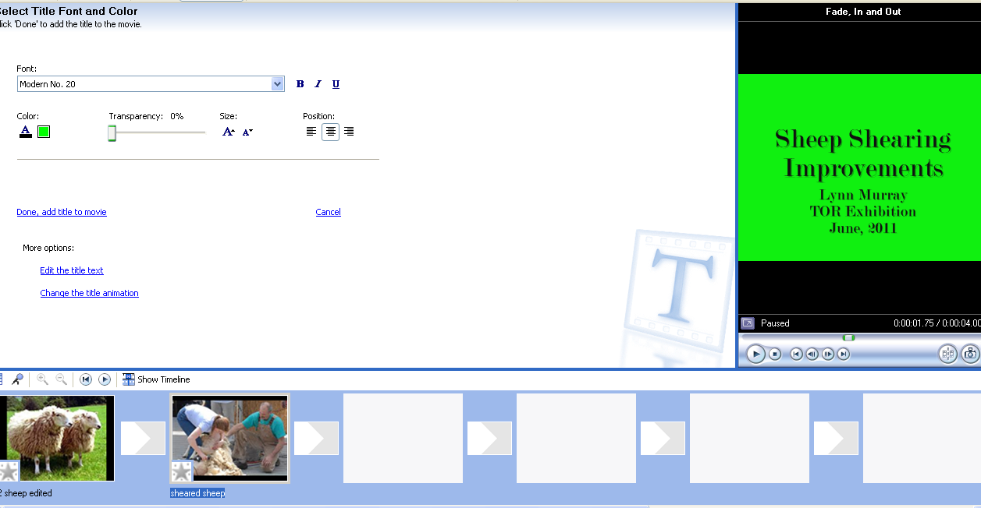
- Add your narration by saying your script into a microphone.
  - Click on Show Timeline.
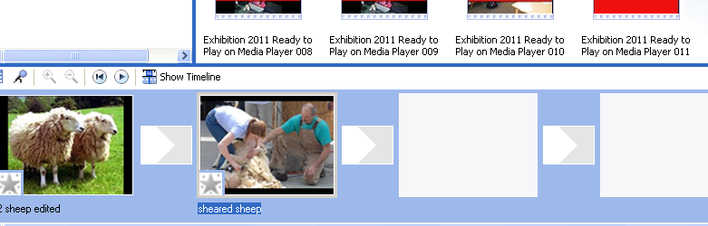
  - This is the Timeline view. This view shows you the seconds/minutes length of the
pictures. The blue line is called the insertion point. You may start adding your
narration at the insertion point.
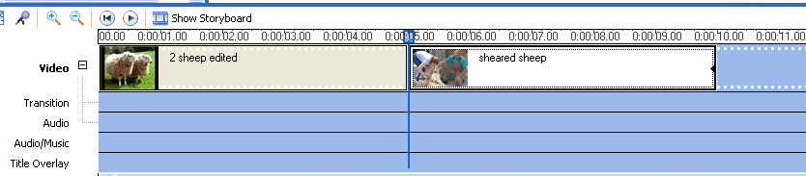

  - You may adjust how many seconds your picture appears by clicking at the end of it.
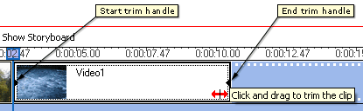
  - To add narration to your picture, first plug in the microphone to the computer. Next, move the insertion point to where you would like to start talking.
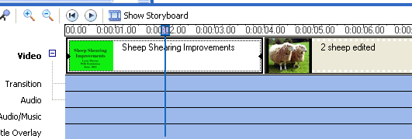
  - Tools>Narrate timeline. When you are ready to begin, click on Start Narration. When you are finished, click on Stop Narration.
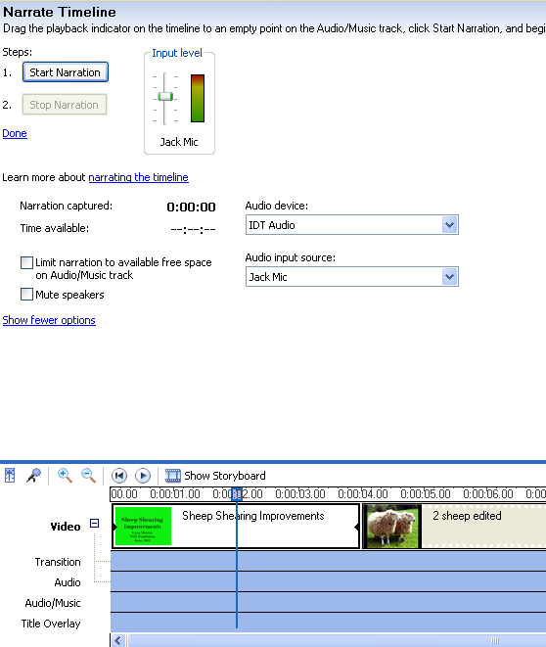

  - When you click on Stop Narration, you will be prompted to save your narration. Save your narration to your ID number.

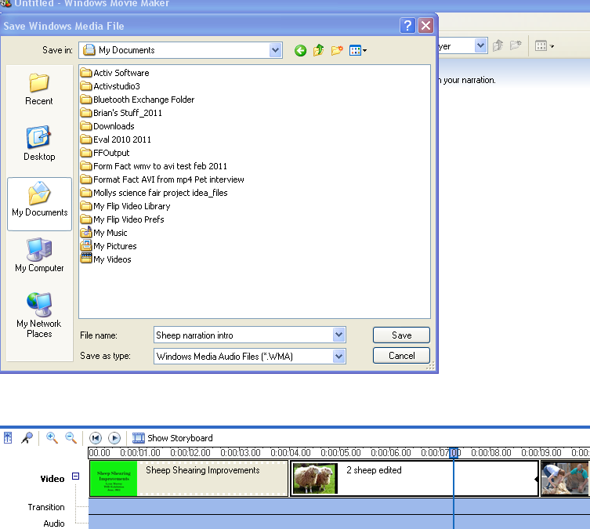
000444555

  - After you save your narration, your timeline narration will be visible here. Slide the insertion point over it to hear it. If you’d like to cut the narration, right click on the narration>cut. The blue insertion point line plays all of the layers at the same time. Right now the title, “Sheep Shearing Improvements” and “Sheep narration intro” would be playing.
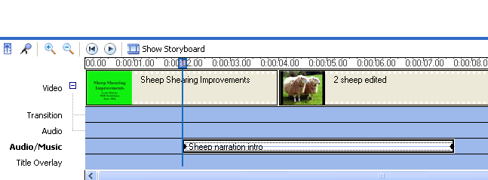
  - To add more narration, slide the blue insertion line to where you would like to begin talking. Click on Narrate Timeline when you are ready.
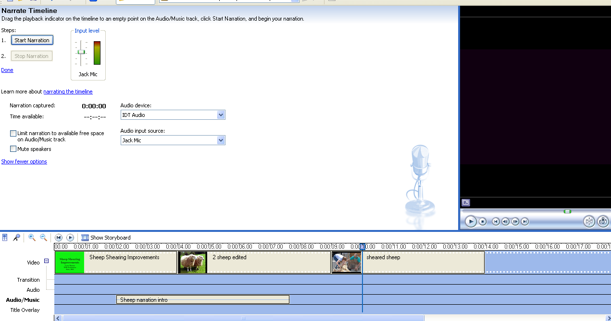
- Save your project as a movie.
  - Save your project as you go along. File>Save Project As>Save to your number. You can view it full screen by clicking here.
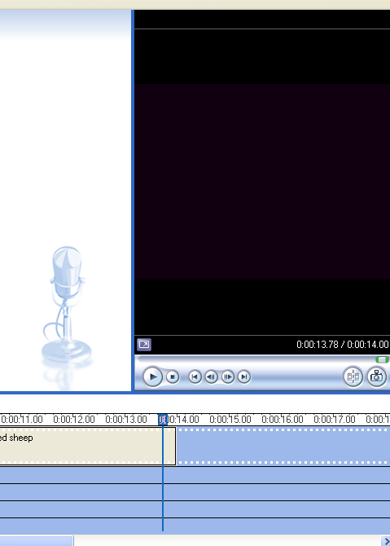
  - When you’d like to view it as a completed movie, saved as an AVI file, File>Save Movie File>My Computer>Next.
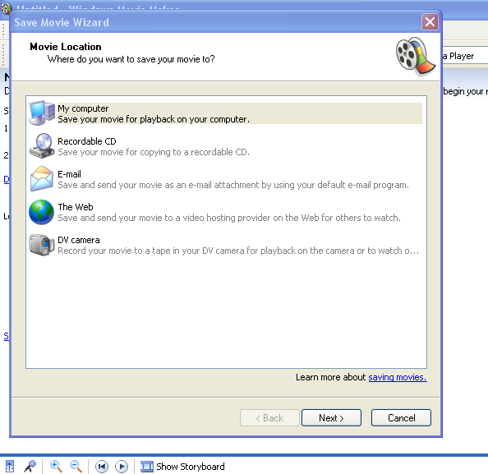

c. Give your movie a name. Browse and save it to your number.

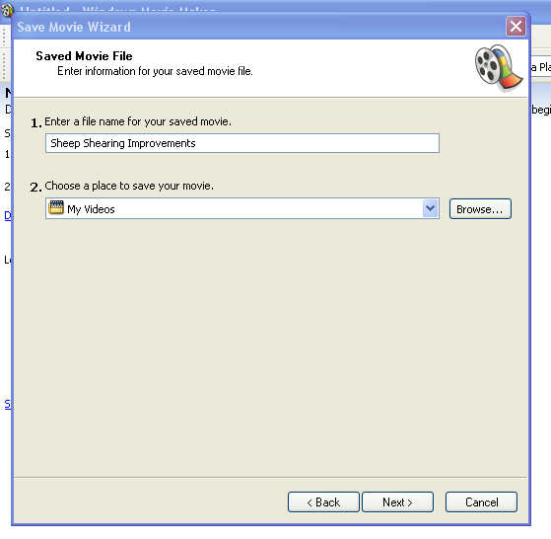

777990000

  - Save your movie as Best Quality for playback on my computer.

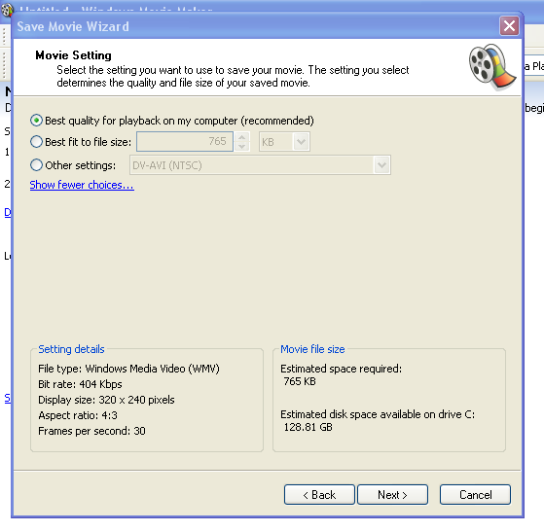
  - Your movie will now be viewed on Windows Media Player. Click on Finish.
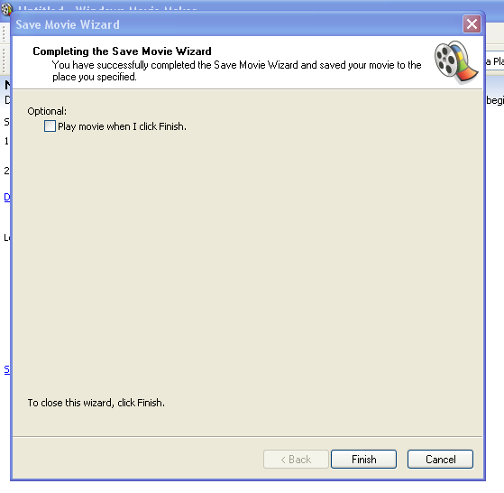
  - To Save or Open movies to Windows Media Player, first right-click on Windows Media Player in the upper left corner of the screen. Then, File>Open to open a movie, or File>Save As to save a movie.


