Research Paper Overview about Holes
and the Setting of Western Texas
Marvelous Mrs. Doran 6th Grade AE
December 2016 2

Objective: Students will write a research paper about the setting of West Texas that’s found in the book Holes. Students will begin their work by researching the land of western Texas by using the media center’s nonfiction text resources. Students will read, annotate, cite and write about the land by utilizing Cornell Notes as a text aid. Afterwards they will identify and write about items found in the setting that allow the main character of Holes, Stanley, to persevere.
Research paper overview contents:
- West Texas Cornell Notes=pages 1-3
- Setting and Holes Research Paper Organizer (Citing Evidence)=pages 3-4
- Citing Evidence Helpers (Thank you, Elba Sims!!!)=page 4
- Research Paper Skeleton (Paragraph Contents)=pages 5-6
- Research Paper Requirements (Formatting and Works Cited help)=pages 6-12
a. West Texas Cornell Notes
Start flag>Computer>TRNsharedW>Date modified>TOR Library Media Center folder>Date modified>Doran Texas 2016 folder>West Texas Cornell Notes
West Texas Cornell Notes Delightful Mrs. Doran
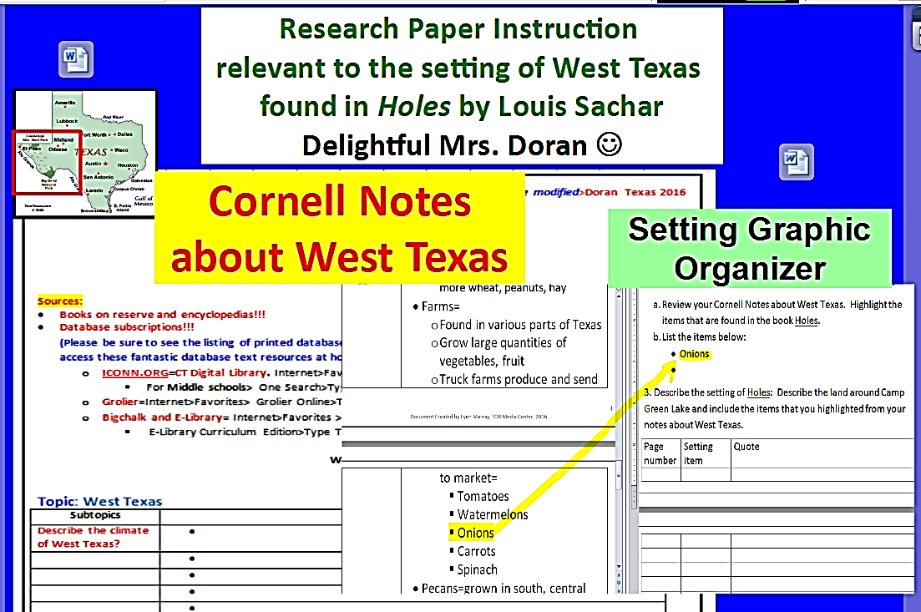
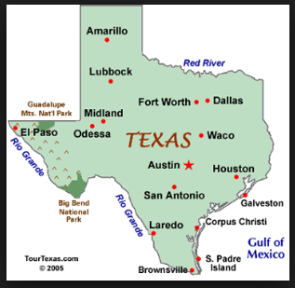

Sources:
- Books on reserve and encyclopedias!!!
- Database subscriptions!!!
(Please be sure to see the listing of printed database usernames and passwords under the light switch so you can access these fantastic database text resources at home!!!)
  - ICONN.ORG=CT Digital Library. Internet>Favorites>TRN Online Folder>CT Digital Library
    - For Middle schools> One Search>Type Texas
  - Grolier=Internet>Favorites> Grolier Online>Type Texas
  - Bigchalk and E-Library= Internet>Favorites >Bigchalk and E-Library
    - E-Library Curriculum Edition>Type Texas>Click on Expand this Research Topic
Works Cited
Topic: West Texas
Subtopics | Details:
Describe the land regions of Texas.
Describe the West Gulf Coastal Plain of Texas?
Describe the climate of West Texas?
Describe some of the plant and animal life found in Texas?
Describe some of the natural resources found in Texas.
Describe some of the agriculture grown in Texas.
Summary of your notes:

b. Setting and Holes Research Paper Organizer (Citing Evidence)
Mrs. Doran’s Research Paper Outline about West Texas
and the book Holes by Louis Sachar
11-29-2016

Research paper question: How does the setting of West Texas affect Stanley, the main character of Holes?
1. Holes is a book about:

2. Describe the land, climate and wildlife found in West Texas:
- Review your Cornell Notes about West Texas. Highlight the items that are found in the book Holes.
- List the items below:
- Onions

3. Describe the setting of Holes: Describe the land around Camp Green Lake and include the items that you highlighted from your notes about West Texas.
Page number | Setting item | Quote
4. How does the setting of West Texas affect Stanley, the main character of Holes?
c. Citing Evidence Helpers (Thank you, Elba Sims!!!)
Citing Evidence Helpers
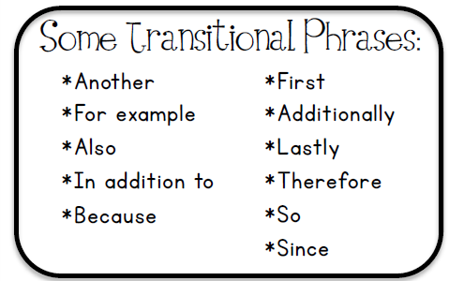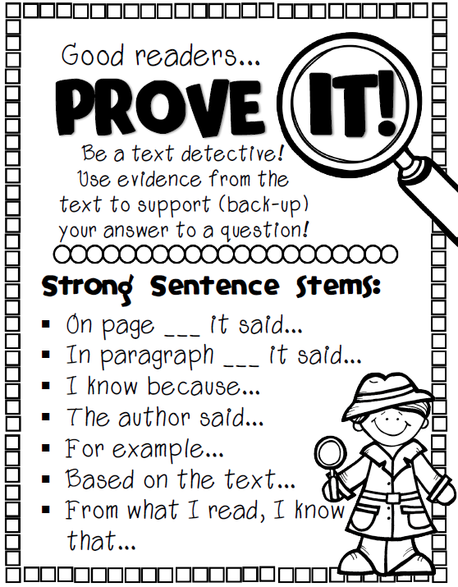 | 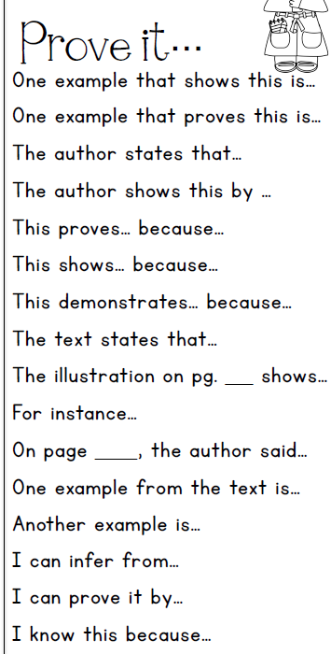

d. Research paper skeleton

Holes Research Paper Skeleton
Mrs. Doran
11-30-2016

Your research paper will answer the question:
How does the setting of West Texas positively affect Stanley, the main character of Holes?
Paragraph one: Introduction
- Write a topic sentence that includes the book Holes and the book’s setting of West Texas.
Example: Holes is a book about a teenage boy, Stanley, who is sent to a detention camp in West Texas for a crime he did not commit.
Type your topic sentence:

- Write two or three sentences that summarize what the story is about.
Example: Holes is also about a boy who is living with a curse…
Type your brief summary of Holes:

- Write one or two sentences about the setting of Camp Green Lake in West Texas.
Example: Camp Green Lake is located in the western area of Texas. It’s an extremely hot, dry and mountainous area of the state that contains a few agricultural products and animals.
Type your description of the setting found in Holes:

- The last sentence of an introductory paragraph is known as a thesis statement.
- Thesis statement=
  - A thesis statement summarizes the main point of a research paper.
  - A thesis statement is developed, supported, and explained in subsequent paragraphs by means of examples and evidence.
Example: The mountains, onions and lizards found in the harsh setting of West Texas positively affect Stanley in a number of ways.
Type your thesis statement:

Paragraph two: Explain the importance of Stanley climbing the big mountain in the story. Use evidence from the text to support (back up) your answer.

Paragraph three: Explain the importance of Stanley eating onions in the story. Use evidence from the text to support (back up) your answer.

Paragraph four: Explain the importance of the lizards not biting Stanley in the story. Use evidence from the text to support (back up) your answer.

Paragraph five: Conclusion
Write a paragraph that summarizes and explains how climbing the mountain eating onions, and avoiding lizard bites helped make Stanley a better person.

e. Research paper requirements (formatting and Works Cited assistance)
Research Paper Requirements
Marvelous Mrs. Doran
12-5-2016

Research paper guidelines= a research paper has two parts that are stapled together to form one packet:
1. The research paper.
2. The Works Cited page. (The Works Cited page was previously called the Bibliography. Works Cited includes both book and computer sources; a bibliography just includes a listing of book sources.)

1. Research paper requirements
- Research paper formatting requirements:
  - Open a new blank Word document.( Ctrl N)
- Double spaced and Times New Roman, 12 font.
  - Ctrl A>Click here on the double headed arrow>Click on 2.0.
- Insert page numbers in the bottom right corner.
  - Insert tab at top>Page number>Bottom of page>Plain Number 3
Then, click on Close Header and Footer at the top
B. Research papers usually include a title page. In an effort to save paper, we’re going to include the title of the research paper at the top of our paper.

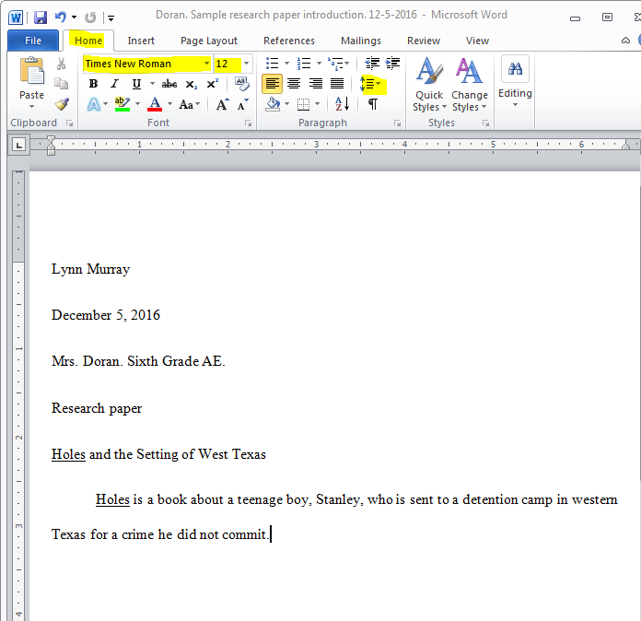
1
2.0

2. Create a Works Cited page in MLA format. Students will use database MLA citations and Easybib.com to create a Works Cited page.
  - Create a Bibliography/Works Cited page using Easybib.com, CitationMachine.org or Bibme.org to cite your sources.
  - Use TOR’s media center website for complete tutorials about how to use Easybib.com, CitationMachine.org or Bibme.org.
  - TORonline.org>TOR Media Center>Scroll Down to Destiny book catalog>Click on TOR>Click on Easybib

How to Cite Books Using Easybib.com
- www.easybib.com
Click on the book tab>Enter the ISBN number from Holes>Click on Cite It.
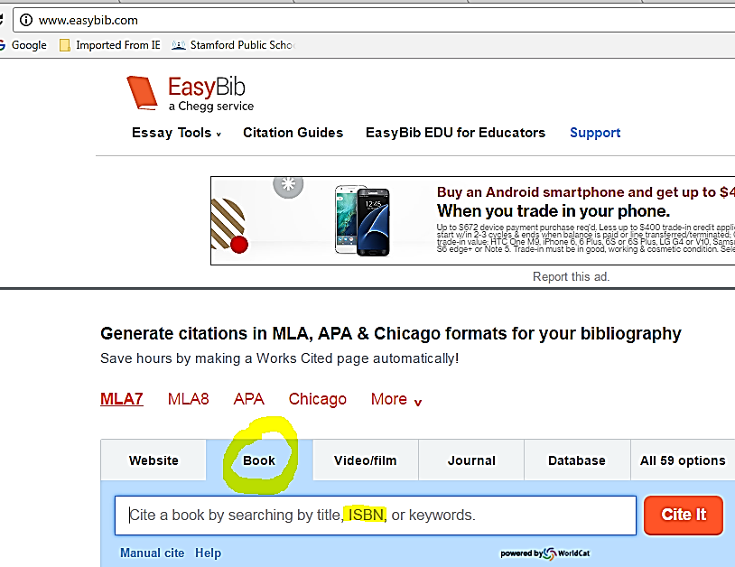
- Click on Cite This.
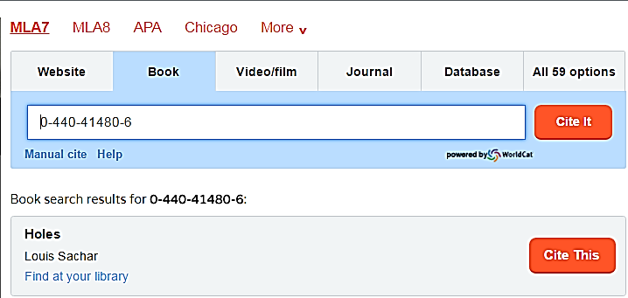

3. Continue to the Final Step:
Enter the ISBN number of the book Holes.
4. Scroll down and click on Create Citation.
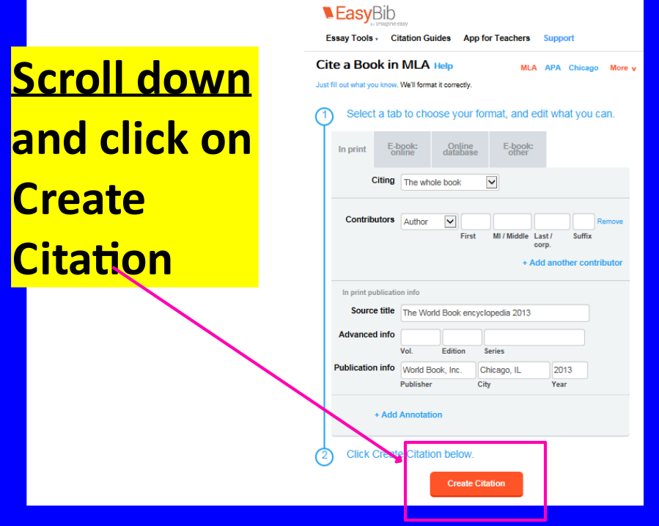

5. Copy and paste your MLA Citation to the last page of your research paper.
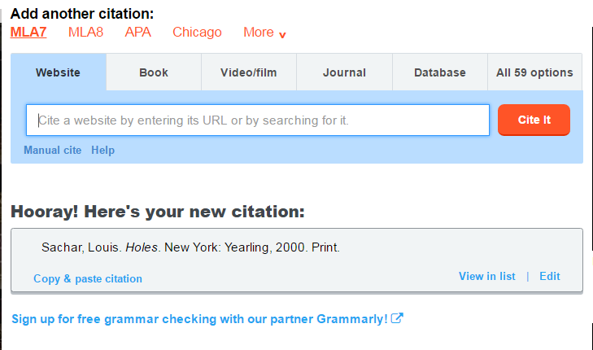
3. Copy and paste the MLA citation from the Grolier text about West Texas along with the citation from Holes.
Kennamer, Lorrin G., Jr., and Robert H. Ryan. "Texas." Reviewed by David G. McComb. The New Book of Knowledge. Grolier Online, 2016. Web. 21 Nov. 2016.
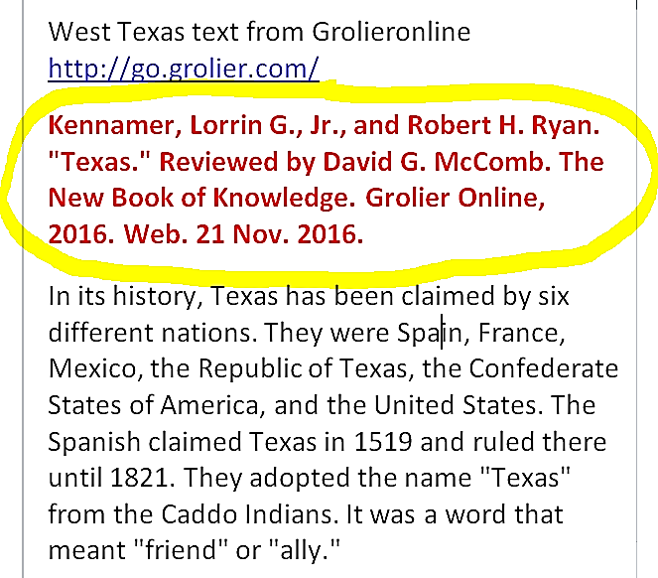
Sachar, Louis. Holes. New York: Yearling, 2000. Print.

4. The Works Cited page is the last page of your research paper.
Sample Works Cited page:
Works Cited
Kennamer, Lorrin G., Jr., and Robert H. Ryan. "Texas." Reviewed by David G. McComb. The New Book of Knowledge. Grolier Online, 2016. Web. 21 Nov. 2016.
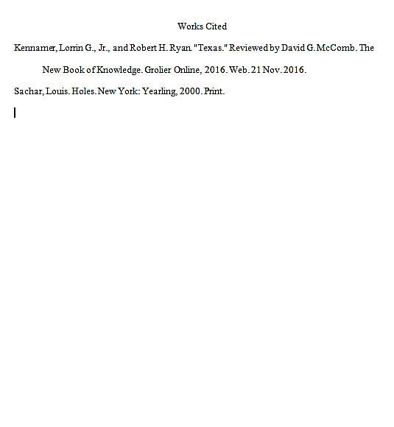
Sachar, Louis. Holes. New York: Yearling, 2000. Print.

