Name:
20th Century Gallery Project (7th Grade)
Your assignment is to create an informational poster about a 20th Century composer/piece. The due dates are as follows:
TBA

Grading
This project will count for 25 percent of your 4th quarter grade. Your poster will be graded using a rubric. All projects are expected by the aforementioned due date. Late projects will lose points and may not be accepted past the due date.

The Project
This project has two focuses, a 20th century composer and one of their pieces. You poster must include:
- A portrait of your composer
- Biographical information (via the Research Guide)
- Information about your piece (via the Research Guide)
- A drawing based on your piece
- A QR code link to your piece (provided for you)
- Proper citations (on the backside of your project)

Be creative! The design of your gallery piece is just as important as the research that goes into creating it!

Resources:
toronline.org>TOR Media Center>Scroll down to Destiny Book Catalog & SPS Database Access>Grolier and Bigchalk and Elibrary
- Copy and paste all of the information about your composer to a blank new document (Ctrl N)
Grolier | Word
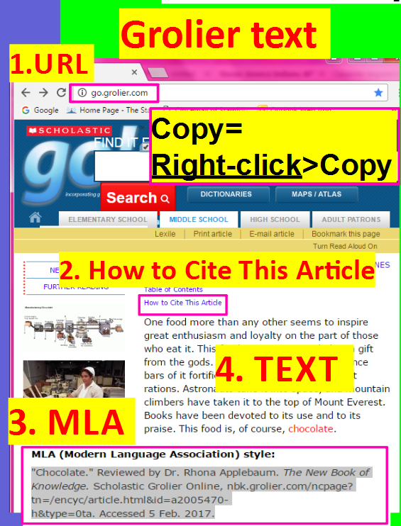 | 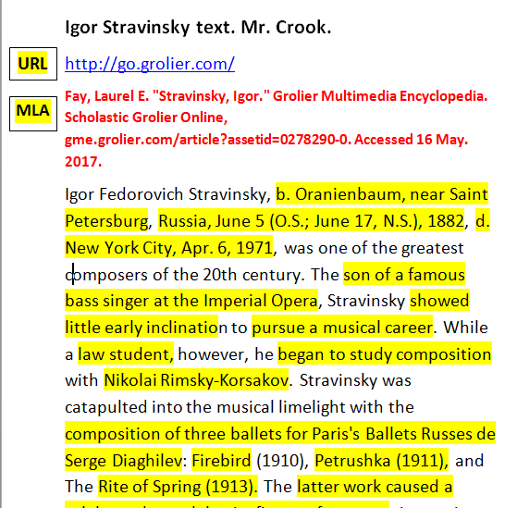
Musiced.about.com > search “20th century composers” > click “20th Century Composers - Composers of the 20th Century”

http://www.naxos.com/composerlist.asp?periodid=20th%20Century

http://www.naxos.com/composerlist.asp?periodid=Contemporary

Research Guide
This is the information that should be included on your poster. Again, this should be done neatly, so that it is easily legible. Fill out this information FIRST, and then decide how to present it on your poster.
__________________________________________________________

Name of your Composer:

- Date of Birth: ______________________________
- Date of Death (if applicable): _____________________________
- Country of Origin: ___________________________
- What kind of music did your composer primarily create? (For example; solo voice, choral, orchestral, etc.) _______________________________________________________________________________________________________________________________________________________________

- When and how did your composer begin their musical training? _______________________________________________________________________________________________________________________________________________________________

- What is your composer’s primary instrument? _______________________________________________________________________________________________________________________________________________________________

- What are your composer’s most famous works? _________________________________________________________________________________________________________________________________________________________________________________________________________________________________________________________________________
- What is the most important thing that we should know about your composer? ____________________________________________________________________________________________________________________________________________________________________________________________________________________

__________________________________________________________
Name of your Piece

- In what year did your piece debut?_______________
- What kind of music is it? (solo vocal, choral, orchestral, chorus & orchestra, etc.) __________________________________________________________________________________________________________
- What was the composer’s inspiration to write the piece? (poem, book, painting, etc.) __________________________________________________________________________________________________________
- What is unique about this composition? (instrumentation, notation, non-traditional use of an instrument, minimalism, impressionism, atonality, etc.) ____________________________________________________________________________________________________________________________________________________________________________________________________________________

Citations

Cite all resources (websites, books, articles, etc.) you used in your research below:
________________________________________________________________________________________________________________________________________________________________________________________________________________________________________

QR Codes
Find your composer’s name below. The QR code with it is a link to your piece.

The Rite of Spring
By
Igor Stravinsky
Carmina Burana
By
Carl Orff
Glassworks
By
Philip Glass
The Planets
By
Gustave Holst
Wild Purple
By
Joan Tower
Music for 18 Musicians
By
Steve Reich
Romeo & Juliet
By
Sergei Prokofiev
The Banshee
By
Henry Cowell

Wind Quartet Op. 26
By
Arnold Schoenberg
Bolero
By
Maurice Ravel
Threnody for the Victims of Hiroshima
By
Krzysztof Penderecki
Symphony No. 7 – Leningrad
By
Dmitri Shostakovich
”4’33”
By
John Cage

