College Prep 2013 Eighth Grade Language Arts Poetry Research Paper Overview,
PLUS the CCSS! How Exciting!!!
Wonderful Mrs. Wilson, Gorgeous Mrs. Greco and Mrs. Murray

Project objective: Students will write a research paper about a poet or Harlem Renaissance artist.
- Students will use both print and video sources for their research and note the benefits and detractors of both mediums.
- Students will create thesis statements about their poet/artist to focus their writing.
- Students will cite their sources in MLA format and create in-text citations within the paragraphs or their paper.
Essential question: Explain the significance of your poet/artist.
Table of Contents and Poetry Research Paper Overview
Page # | Project  Step # | Students will…
 |  | Introductory steps:
Page 2 | Step #1 | Read about the Poetry Paper’s correlations to the CCSS Standards.  - Quarter 4—Informational Reading and Informational/Explanatory Writing
Page 2 | Step #2 | Define poetry vocabulary words.
 |  | Steps to compose a research paper masterpiece:
Page 3 | Step #3 | Choose a poet or Harlem Renaissance artist.
Page 4 | Step #4 | Create a research question and thesis statement about a chosen poet/artist.
Page 3 | Step #5 | Locate sources.  - Sources include hard cover books, district-purchased databases, approved websites and videos.
Pages  7-9 | Step #6 | Read, highlight and organize notes.  - As students read about their poet/artist, they will highlight fact phrases and record their highlighted facts onto a terrific text organizer.
Pages  10-11 | Step #7 | Learn how to paraphrase, summarize and quote source information correctly.  - Plus…students will learn how to write in-text citations within the paragraphs of their papers.
Pages  12-15 | Step #8 | Write a research paper masterpiece based upon their notes.
Pages  15-18 | Step #9 | Create a Works Cited page in MLA format.  - Students will use database MLA citations and Easybib.com to create a wonderful Works Cited page.

Step #1: Read about the project correlations to the CCSS Standards
Quarter 4—Informational Reading and Informational/Explanatory Writing
CCSS for Writing
W.8.7 Conduct short research projects to answer a question (including a self-generated question), drawing on several sources and generating additional related, focused questions that allow for multiple avenues of exploration
W.8.8 Gather relevant information from multiple print and digital sources; using search terms effectively; assess the credibility and accuracy of each source; quote or paraphrase the data and conclusions of others while avoiding plagiarism and following a standard format for citation.
W.8.9 Draw evidence from literary or informational texts to support analysis, reflection, and research.
RI 8.7 Integration of Knowledge and Ideas. Evaluate the advantages and disadvantages of using different mediums (e.g., print or digital text, video, multimedia) to present a particular topic or idea
Step #2: Define poetry vocabulary words.
Poetic Device Word Bank: Use the following sites to help you define terms: (Use Ctrl F to find a particular term on the webpage.)
http://www.pbs.org/newshour/extra/features/jan-june00/poetryboxdevicesexamples.html
http://uwc.utexas.edu/node/69
http://homepage.smc.edu/meeks_christopher/SOUND%20DEVICES%20USED%20IN%20POETRY.htm
http://www.nku.edu/~ocallaghant/courses/206/poetic_devices.htm
Type the definition next to each poetic device:
- alliteration= the repetition of consonant sounds at the beginning of words.
- concrete poem=
- connotation=
- couplet=
- denotation=
- diction=
- enjambment=
- figurative language=
- free verse=
- imagery=
- metaphor=
- narrative poem=
- onomatopoeia=
- personification
- point of view=
- quatrain=
- rhyme (rhyme scheme)=
- rhythm=
- simile=
- sonnet=
- stanza
- symbol=
- theme=
- tone=
Step 3: Choose a Poet or Harlem Renaissance Artist from the first two columns.
Famous Poets | Harlem Renaissance Artists | Rockin’ Resources
Adams , Sarah Fuller Flower  Alcott , Louisa May  Alvarez, Julia  Angelou, Maya  Austen, Jane  Browning, Elizabeth Barrett  Burns, Robert  Byron, Lord  Carroll , Lewis  Collins, Billy  Cummings, E.E.  Dickinson, Emily  Dove, Rita  Emerson , Ralph Waldo  Frost, Robert  Giovanni, Nikki  Kipling , Rudyard  Longfellow , Henry Wadsworth  Naruda, Pablo  Nye, Naomi Shihab  Plath, Sylvia  Pretlusky, Jack  Poe, Edgar Allen  Shakespeare, William  Silverstein, Shel  Soto , Gary  Teasdale , Sara  Trethewey, Natasha  Walker, Alice  Wilde , Oscar  Wheatley , Phyllis  Whitman, Walt  Williams, William Carlos  Wordsworth , William  Yeats , William Butler | Writers  Cullen, Countee  Fauset, Jessie  Hughes, Langston (poet)  Hurston, Zora Neale  McKay, Claude  Nugent, Richard Bruce  Thurman, Wallace  Toomer, Jean  Intellectuals  Dubois, WEB  Garvey, Marcus  Johnson, James Weldon  Locke, Alain LeRoy  Schamburg, Arthur  Musicians  Armstrong, Louis  Basie, William ‘Count’  Ellington, Duke  Holiday, Billie  Smith, Bessie  Webb, Chick  Dancers  Baker, Josephine  The Nicholas Brothers  Robinson, Billy ‘Bonjangles’  Artists  Barnes, Ernie  Delaney, Beuford  Douglas, Aaron  Hayden, Palmer  Jones, Lois Mailou  Motley, Archibald | How to locate beautiful hard cover books!!!  - Destiny Library System=  - Internet>Favorites>Destiny Library System  - Click on TOR>Click on the Catalog tab.  - Type your poet’s name in the Search box>Enter.  - Wonderful World book Encyclopedias!!! Hooray!!!!!  Lovely, trustworthy, “Lexiled” databases:  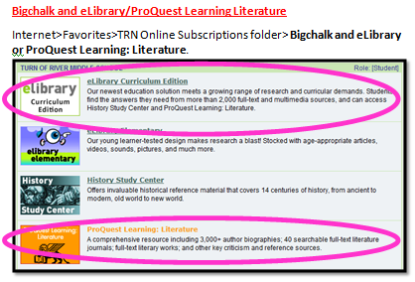  Check off Books, Videos and Websites for information about your poet/artist on eLibrary Curriculum Edition.  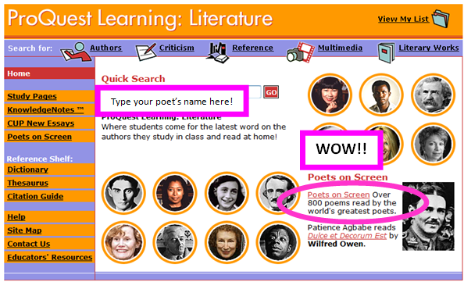  - Grolier.com  - Internet>Favorites>TRN Online folder>Grolier  - CT Digital Library=ICONN.ORG  - Internet>Favorites>TRN Online folder>CT Digital Library  Additional Reliable Websites:  Good poetry websites:  Searchedu.com  http://searchedu.com/  Poets.org  http://www.poets.org/  Videos of Poems Said Aloud  http://www.favoritepoem.org/  Harlem Renaissance Websites  http://www.readwritethink.org/files/resources/lesson_images/lesson252/websites.html
Step #4: Students will create a research question and thesis statement about their poet/artist.
Students will create a research question to focus their writing.
College prep classes sample research questions:

Choose one of the sample research questions below. You will answer this question in your paper.

a. What’s the overall message of your poet’s work?
    - Describe your poet’s personal life.
    - Describe your poet’s professional life.
    - Describe your author’s style of writing. Which poetic devices were used most often in their work?
    - Choose one of your author’s poems. Copy and paste the poem. Analyze this poem. What’s its message?

b. How is my author’s life apparent in their writing?
    - Describe your poet’s personal life.
    - Describe your poet’s professional life.
    - Describe your author’s style of writing. Which poetic devices were used most often in their work?
    - Choose one of your author’s poems. Copy and paste the poem. Analyze this poem. What’s its message?

Copy and paste your research question (a or b listed above) here:

- Students will create a thesis statement to prove in their paper.

College prep classes sample thesis statements:
- My poet’s message of “blank” is evident in their writing.
- My poet’s experiences are evident in their writing.

Type your thesis statement (a or b listed above) here:

Step #5 Locate sources.
- Sources include hard cover books, district-purchased databases and approved websites and videos.
- Use the third column on page three, entitled Rockin’ Resources, to locate reliable sources about your poet/artist.

Step#6 Read, highlight and organize notes.
•As students read about their poet/artist, they will highlight fact phrases and record their highlighted facts onto a terrific text organizer.

ALL OF YOUR INFORMATION FROM THE INTERNET SHOULD BE PASTED ONTO ONE WORD DOCUMENT!
- Number your pages=Insert (top)>Page number>Bottom of page.
Copy your Internet information to a blank Microsoft Word page.
- Ctrl N=Blank new Word page.
- Internet page>Highlight the paragraphs about your topic OR Ctrl A for the entire page>Right click>Copy
- Word>Right click>Click on the A (for unformatted text)
- Copy and paste your web site’s URL to the top of the blank Microsoft Word page. Click Enter to make the website address turn blue.
- READ THE TEXT!!!!
- Highlight the who, what, where, when, why (5W) fact phrases in SIX words or less about subtopics in the left column. 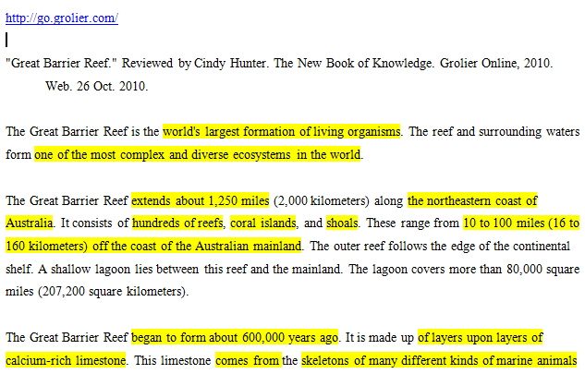

Students will split the screen to see what details they need to highlight.
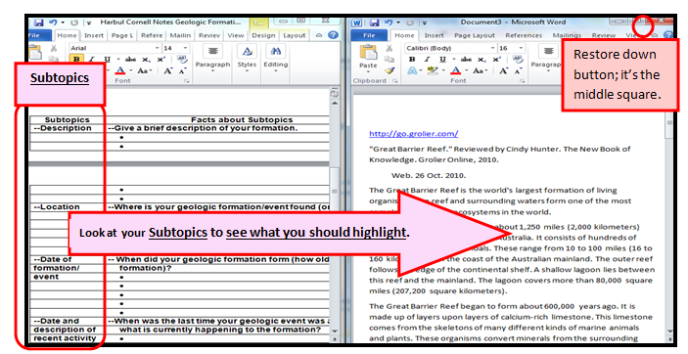

An example of highlighted facts transferred onto a previous text organizer.
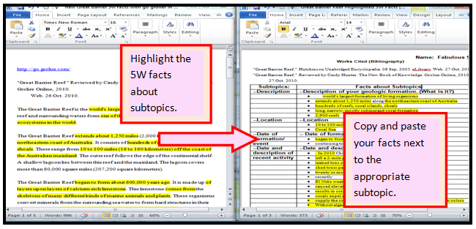

Use the “Perfect Poetry Paper’s Terrific Text Organizer” below (pages 7-9) to organize your highlighted notes.
- Each line should not exceed six words.
- The exception? Direct quotations. Copy and paste an entire sentence and put “quotation marks” around the sentence.

College Prep Perfect Poetry Paper’s Terrific Text Organizer
MLA citation, URL and ISBN # Definitions=
MLA citation=Modern Language Association’s correct style of citing a website, book, newspaper, magazine or video. Beautiful Bigchalk, gorgeous Grolier and cool Connecticut Digital Library “do” the correct citation for you; it’s found at the bottom of the page listed under MLA Citation. Copy and paste it next to Source:.
URL=the website address. Copy and paste the URL below if you use a website OUTSIDE OF Bigchalk, Grolier and the Connecticut Digital Library. You can copy and paste it again onto easybib.com to create the MLA citation above.
ISBN#=the 13 digit number found on the back of the title page of the book. Type it into easybib.com and click on the Books tab to create the MLA citation.

College Prep Perfect Poetry Paper’s Terrific Text Organizer
Personal life
Each bulleted line should not exceed SIX WORDS! This means YOU, fabulous Research Rock Star!!!!
Family/
Childhood/
Education
Source: MLA citation, URL or ISBN #
Adulthood
Source: MLA citation, URL or ISBN #
Influences
Source: MLA citation, URL or ISBN#
How they started writing
Source: MLA citation, URL or ISBN#
Challenges
Source: MLA citation, URL or ISBN#
Accomplishments
Source: MLA citation, URL or ISBN#
Analyze a poem, fabulous Research Rock Star!
Copy and paste a poem by your author to your notes page and read it. Answer the following questions about your chosen poem.
What’s the message of the poem? How do you know? Cite text evidence.
What are some poetic devices used in this poem? |  |  | Give examples of these devices from your poem.
Evaluate the advantages and disadvantages of using different mediums
RI 8.7 Integration of Knowledge and Ideas. Evaluate the advantages and disadvantages of using different mediums (e.g., print or digital text, video, multimedia) to present a particular topic or idea.
Re-read the written version of your poem. |  |  |  | Find a video of someone reading the same poem aloud.
Source: |  |  |  | Source:
Advantages |  | Disadvantages |  | Advantages | Disadvantages

Step #7= Learn how to perfectly paraphrase, summarize and quote source information.
Plus…learn how to create incredible in-text citations from Internet and print sources.

The information below is based on the brilliance of nice people from Purdue University: http://owl.english.purdue.edu/owl/resource/563/01/and http://bcs.bedfordstmartins.com/resdoc5e/RES5e_ch08_s1-0001.html

How to paraphrase, summarize or quote source information:
Paraphrase | Summarize | Quote
- Slightly condense a large block of information INTO YOUR OWN WORDS.  - You would make the original text slightly shorter in length.  Specifically you would:  - Look at a bulleted section of notes and create a topic sentence that introduces the subject matter.  - Create the subsequent sentences of the paragraph based on the supporting bulleted details from your notes. | - Take a large piece of text and put the main ideas INTO YOUR OWN WORDS.  - A summary is significantly shorter than paraphrased text.  Specifically you would:  - Look at a longer bulleted listing of notes and create a sentence that summarizes the main points of the notes. | - A piece of text that is identical to the source text.  - “The original text is surrounded by nifty quotation marks.”  - No more than 10% of your paper should use quotations.  Specifically you would:  - Find a sentence that beautifully supports your thesis statement.  - “Surround the original text with quirky quotation marks in your paragraph.”
How to create in-text citations for paraphrased, summarized or quoted source text:
The Basics:
- What is an in-text citation?
- An in-text citation refers to the source that you used in your paraphrased, summarized or quoted text.
- You would mention the in-text citation, or the source that you used, in the paragraph that you are composing.
- GENERALLY, you would mention a source in a sentence of an online source and use (parentheses) at the end of a sentence for a print source.
- How would I write an in-text citation from an online source?
- You would create a signal phrase in a sentence that sets up the source or in-text citation, in your sentence.
- Examples of in-text citations from authors, articles and websites.
  - Ex. According to Lynn Murray, shepherds are an underappreciated group in society.
- Lynn Murray is the author.
- According to Lynn Murray is the signal phrase.
- Ex. The article “To Shear or Not to Shear,” stated that overgrown wool is the leading cause of blindness among spring lambs.
- “To Shear or Not to Shear” is the article title.
- Use quotation marks for article titles.
- The article “To Shear or Not to Shear, stated is the signal phrase.
- Ex. According to an online poll, Love Your Lamb was voted the number one website for shepherds.
- Love Your Lamb is the website title
- Website titles are italicized.
- According to an online poll is the signal phrase.
- What’s the difference between an in-text citation and a Works Cited page?
- An in-text citation mentions the source that you used in the paragraphs of your research paper.
- A Works Cited page is the last page of your research paper. It is an alphabetized listing of sources that you used to write your paper.
- How is an in-text citation related to the Works Cited page?
- In-text citations and the Works Cited page are intertwined!
  - The in-text citation in your paragraph should reference (mention) the same source in your Works Cited page.
  - In fact, look at your MLA citation to figure out how to write your in-text citation.
  - You would look at the first entry in an MLA citation (author name, article name or website name) to figure out how to reference it.
  - Example of an MLA citation from a Works Cited page:
I would mention Lynn Murray’s name, who is the author, in my in-text citation.
Ex. According to Lynn Murray, shepherds are an underappreciated group in society.
- How would I write an in-text citation from a print source?
- Print sources generally use (parentheses) to denote in-text citations at the end of a sentence.
- You would include the page number or the author inside the parentheses.
- If you use a print source, you can mention the author’s name in a signal phrase and just write the page number in parentheses at the end of the sentence.
  - Ex. Bopeep noted sheep enjoy eating clover over grass five to one. (77)
- Or, you can omit a signal phrase and include the author and page number in parentheses at the end of the sentence.
  - Ex. Shepherding is a life-long passion of many middle school media specialists (Littlelamb 30).

Step #8 Write a research paper masterpiece based on your notes!
Overview of research paper writing steps:
- Make sure that the sources on your Terrific Text Organizer are in the correct MLA format before you start writing your paragraphs.
- If you used Grolier, Bigchalk or the Connecticut Digital Library be sure to look at the bottom of the webpage source for the correct MLA citation.
  - If you used a website OUTSIDE of our databases, copy and paste the URL of the website onto easybib.com to create the correct MLA citation.
  - If you used a book source, copy and paste the ISBN# onto easybib.com. Be sure to click on the Book tab before you scroll down and click on Create Citation.

- Split the screen so your notes are on one side and a blank Microsoft Word page is on the other.
YOUR NOTES + YOUR BRILLIANT WORDS=ORIGINAL PAPER!
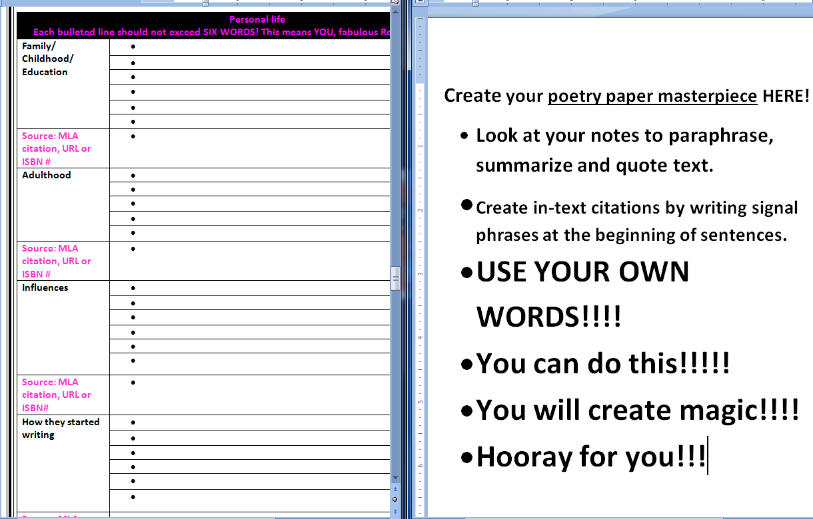
Source: Look to see if your source is an author, article title or website. Use the source for the signal phrase in your paragraph. Ex. According to Mary Littlelamb, sheep are far superior to goats.

- You should use a formal “third person” point of view when you are writing. Your paper should sound like an unbiased encyclopedia article. Refer to your poet by their last name, or as “he or she.” Do not use the informal “I” (first person), or “you” (second person).

- Formatting requirements=Double spaced, Times New Roman, 12 sized font, one inch margins.

- Research paper skeleton:

- Research paper skeleton elaborated:
First section=first paragraph of your paper:
- First sentence=Topic sentence.

      - Introduce your poet to the reader.
      - Include when and where they were born and state what they are most known for.

- Second through fourth sentences=Background information about your poet.
  - Include their most famous works.
  - Include what makes your poet unique.

- Last sentence of your first paragraph=your thesis statement.

  - You will prove your thesis statement with evidence from your graphic organizer for the remainder of the paper!

  - ORGANIZE YOUR PARAGRAPHS AROUND YOUR THESIS STATEMENT!

Sample first paragraph:
Lynn Murray
Wonderful Mrs. Wilson/Gorgeous Mrs. Greco
May 14, 2012
Emily Dickinson
TOR Eighth Grade Poetry Paper
Emily Dickinson was a prolific American poet from Amherst, Massachusetts who was born in 1830 and died in 1886. She is most known for her unconventional style of poetry, as well as for her reclusive lifestyle. Her most celebrated works include: "A Bird Came Down the Walk" and "No Autumn's Intercepting Chill." The people who Dickinson came into contact with, as well as the powerful experiences in her life, had a tremendous effect on her writing.
2. Second section of the paper=Create paragraphs about your poet’s personal information.
- You will create paragraph(s) based on each section of your graphic organizer.
- Use your notes as the basis of your paragraphs!
- Create paragraphs about:

Personal information.
  - Family/Childhood/Education
  - Adult life
  - Other (ex. Influences, How they started writing, Challenges)

- Use transitions to link your paragraphs.

3. Third section of the paper=Create paragraphs about your poet’s body of work.
- You will create paragraph(s) based on each section of your graphic organizer.
- Use your notes as the basis of your paragraphs!
- Create paragraphs about:
Body of work.
    - Describe your author’s style of writing.
    - What poetic devices are used in their writing?
    - What are their more famous works?

Choose one poem to analyze.
- Write the title of this poem.
- What’s the message of the poem?
- What are some poetic devices used in this poem?

Fourth section of your paper=Conclusion. Restate your thesis statement and summarize how you proved it in your paper.
Step #9: Create a Works Cited page in MLA format.
Students will use database MLA citations and Easybib.com to create a wonderful Works Cited page.
  - Create a Bibliography/Works Cited page using Easybib.com, CitationMachine.org or Bibme.org to cite your sources.
  - Use TOR’s media center website for complete tutorials about how to use Easybib.com, CitationMachine.org or Bibme.org.
http://classjump.com/m/mrsmurrayslmc/?section=classes&class_id=131981
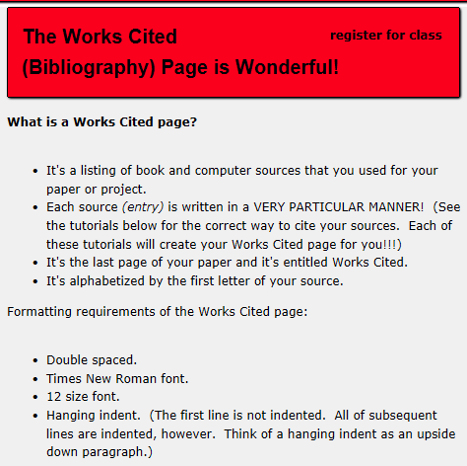

d. Sample tutorial from http://classjump.com/m/mrsmurrayslmc/?section=classes&class_id=131981
about how to use Easybib.com:
How to Cite Websites Using Easybib.com
- www.easybib.com
Copy and paste the website address (URL) that you used for your research here. Next, click on Cite this.

- Your screen will look like this. SCROLL DOWN.
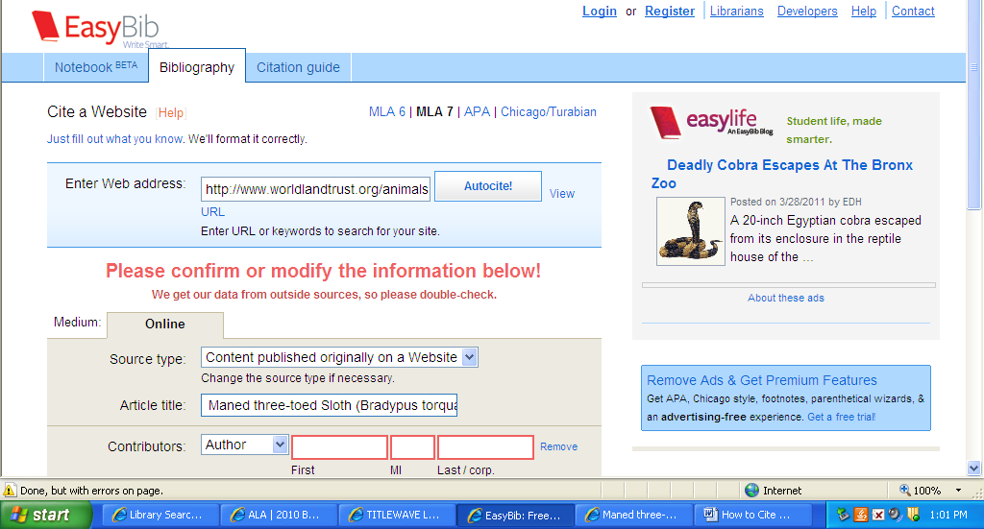

- At the bottom of the screen, click on CREATE CITATION.
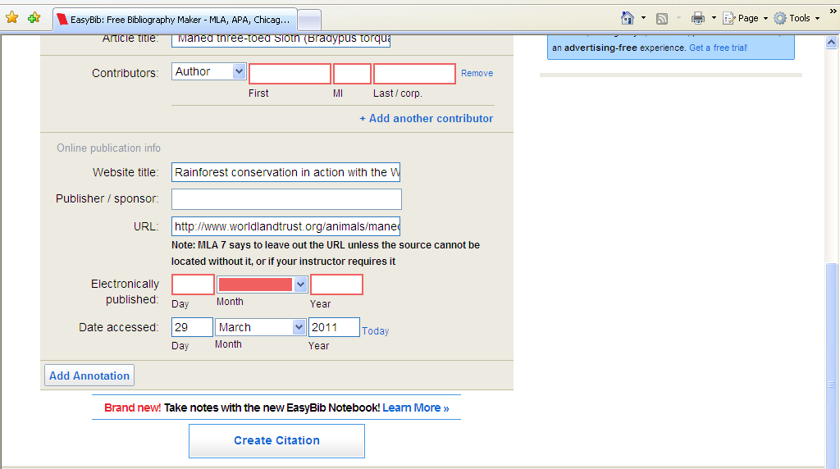
- Copy and paste this “Citation Added” section to a separate Works Cited page. Remember to alphabetize all entries of a Works Cited page by the first letter of the entry. If you’ve used more than one source, you may continue adding more website addresses or book titles to the Cite this box.
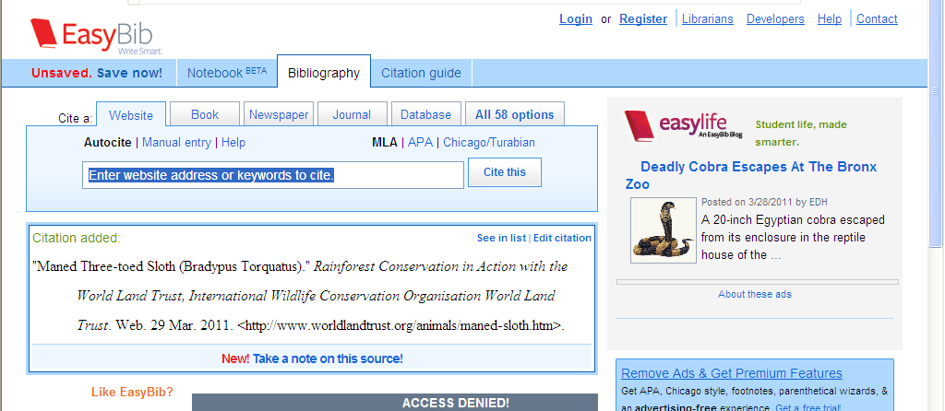

- Sample Works Cited page from Easybib.com. Click on Copy and Paste. OR Save as Word Doc.

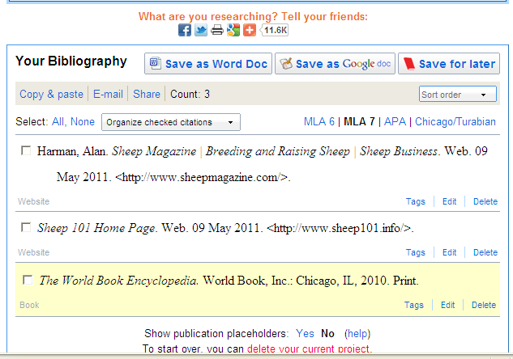
6. Sample Works Cited page example from Easybib.com, copy and pasted to Microsoft Word:
Works Cited
Harman, Alan. Sheep Magazine | Breeding and Raising Sheep | Sheep Business. Web. 09 May 2011.
<http://www.sheepmagazine.com/>.
Sheep 101 Home Page. Web. 09 May 2011. <http://www.sheep101.info/>.
The World Book Encyclopedia. World Book, Inc.: Chicago, IL, 2010. Print.

